Setup E-ISuite Site web client shortcut
Note: This is for Site Version E-ISuite
Verify the IP address (should be a static) on the Site E-ISuite server.
Modify the IP address by going to the Properties
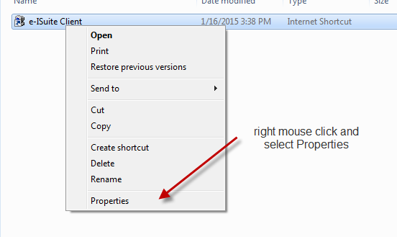
Change the IP address to match the one on your E-ISuite Server.
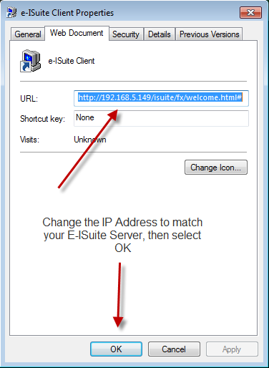
The shortcut can be placed on the desktop of the computers being used to access the E-ISuite Site Server.

