Satellite Inventory
and
Setup Instructions

Kit inventory
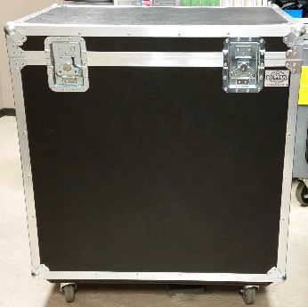
- Big Case (Pic 1)
Pic 1
- Dish (Pic 2)
- Boom Arm(s) connected with the Tria (Pic 3)
- Base (Pic 4)
- COAX Cable (Pic 5)
- Modem with Power Cord (Pic 6)
- Network Patch Cable (Pic 7)
- 1/2 Socket Wrench (Pic 8)
- Power Strip (no picture)
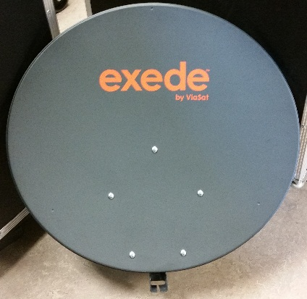
Pic 2

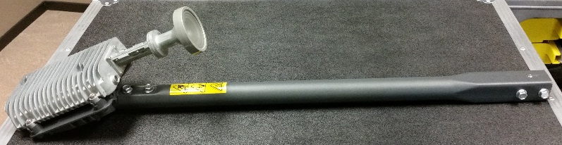
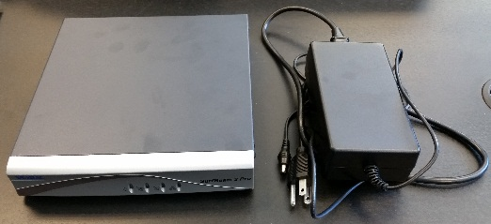
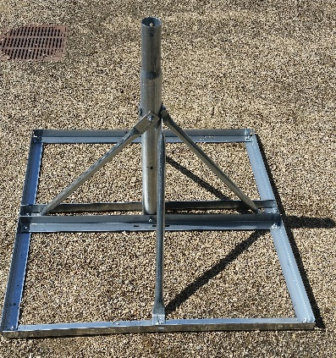
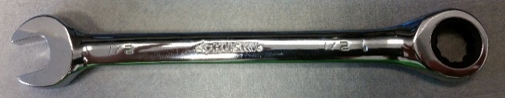
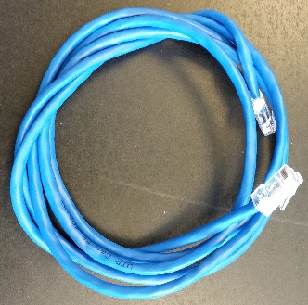
Pic 3
Pic 6
Pic 4
Pic 5
Pic 8
Pic 7
Satellite Dispatch
Expedition Communications: Sales and Support 877-410-8101.
Recommend Apps to Download before Deployment:
- Android:
- Clinometer + bubble level or similar level app
- Compass app by gabenative or similar compass app
- MITe

- iPhone:
  - iHandy Level and a compass should be already installed on the iPhones
Satellite Set Up Procedures
- Satellite Setup:
- Set the base on the ground and quickly check that all bolts are tightened. Deploy the base on as level ground as possible. (NOTE: The key to a quick setup is getting the base as level as possible) A level or level app would be a good app to help accomplish this by setting it on top of the base pole (figure 1). Once the base is as level as possible, it is suggested you anchor the base with spikes / sandbags, parachute cord, etc. to keep it as stable as possible.
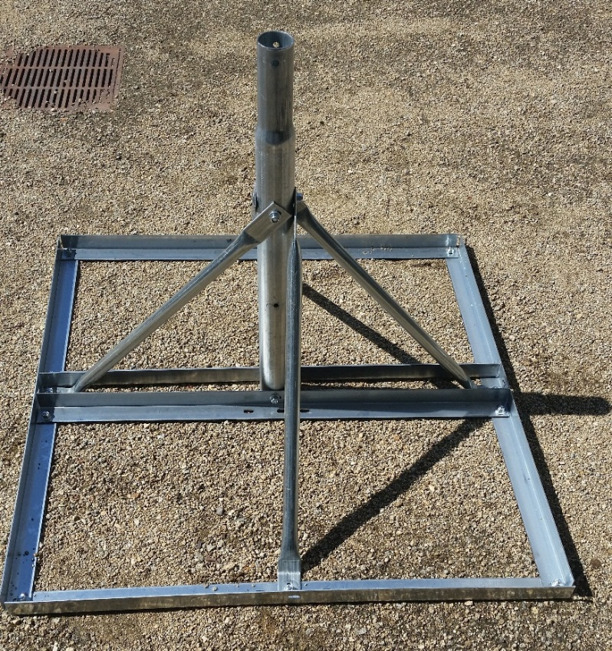
Figure 1
- Place Satellite dish (figure 2) on the base (do not tighten bolts)
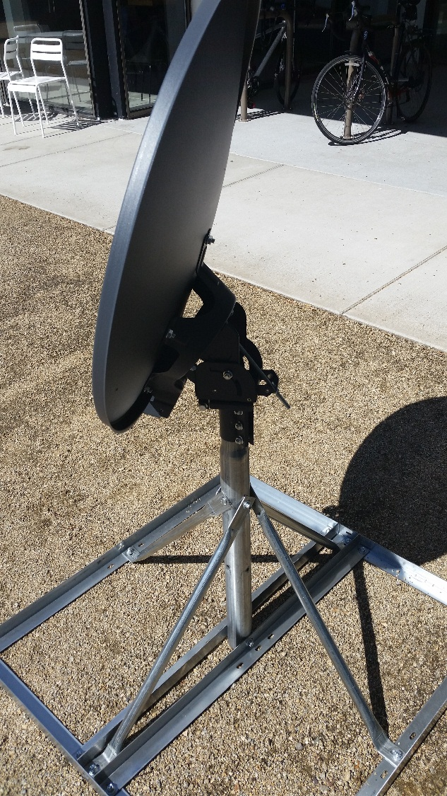
Figure 2

- Remove the four bolts from the end of the boom arm(s) (figure 3) and insert arm(s) at the bottom of the dish (figure 4). Screw in the four bolts (figure 5), but do not tighten them all until all four bolts have been started. Figure 6 shows the boom arm(s) in place. (Please make sure these are screws back into the boom arm(s) after breakdown).
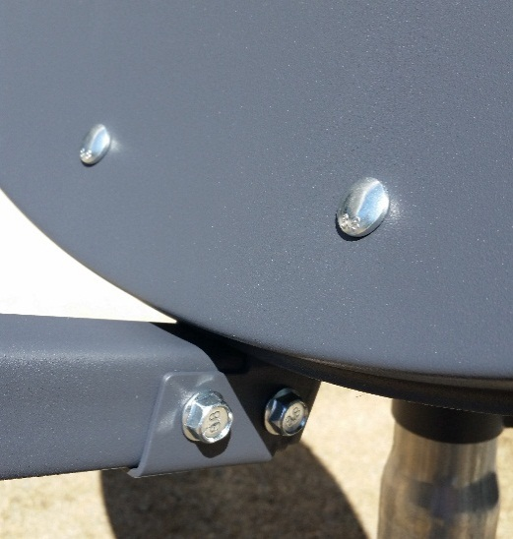
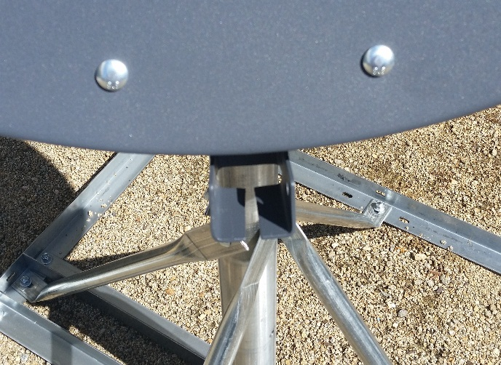
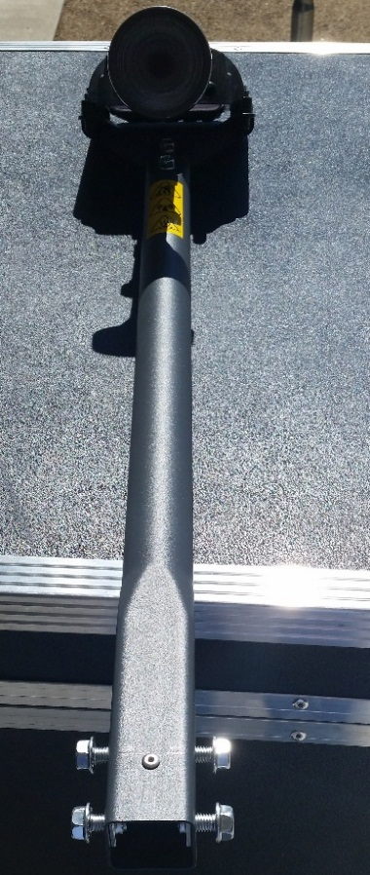
Figure 5
Figure 4
Figure 3

Figure 4

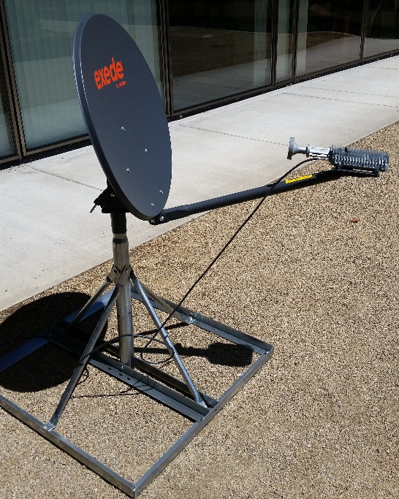
Figure 6

- Locate a state map and find your deployment location.
  - Match this location with the Install Keys and Beam Maps document (a separate document located with these instructions). In this document, there are two different network maps. The ViaSat-1 Beam Map are spot beams for the ViaSat-1 coverage area. The highest terminal speeds will be achieved under these beams. The other map is for the Augmentation Beam coverage area. While these beams provide high speed service, if you have a choice in regions where the ViaSat-1 and Augmentation beams overlap, one will want to select the spot beam number from the ViaSat-1 Beam Map.
  - To locate the degree needed, follow the curved lines that run above and below your location on the beam map. There will be a two degree difference between each set of lines. If your location is close to the middle of these two lines, use the degree number that would show between the two listed degrees (i.e. if your location is between 36 and 38 degrees, use the 37th degree). If you location is near one degree line or the other, use that degree. The dish has degrees (figure 8) listed on its pendulum and needs to be matched to the degree you have chosen. A guideline (figure 9) will show the degree selected on the pendulum. The long bolt (figure 7) on the back of the disk can be used to move the satellite dish to the proper degree needed. Loosen the nut (figure 7-a) on top of the long bolt and then use the bottom nut (figure 7-b) to adjust the dish up or down to the correct degree. Leave the two side bolts (figure 8) loose until instructed to tighten later on in the instructions. (NOTE: If obstructions are in the way between the line of site of the satellite and the dish, a new location will need to be found.)
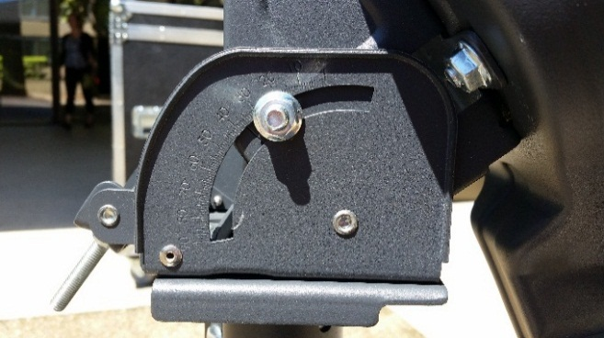
- Using a compass or compass app (NOTE: if you use the compass app, please stand away from the dish and other objects to get a more accurate reading. If need be, have someone stand 15 feet in front of the dish and hold their hand up to show the correct location to point the dish to). Point the dish at -115.1 West (Magnetic heading 155 degrees S-SE). This is the general direction that is needed to connect to the ViaSat-1 satellite. You will fine tune it from this position later on in the directions. (NOTE: make sure to calibrate your compass if using the app before using)
Figure 8
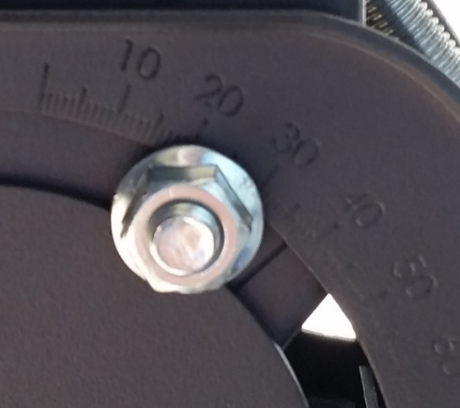
Figure 7-b

Figure 7-a
Figure 9
- Remove the black rubber cap (figure 10) (NOTE: the cap could be placed in the fins of the tria (figure 12) to keep from losing it) from the tria and attach one end of the coax cable (figure 11) to the tria (figure 12).

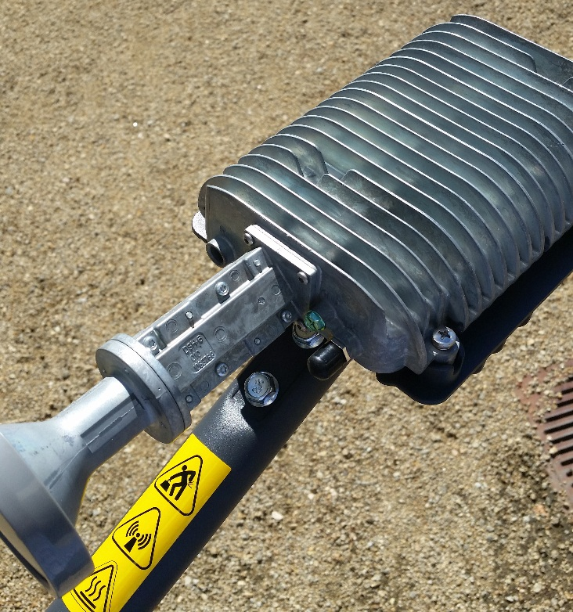

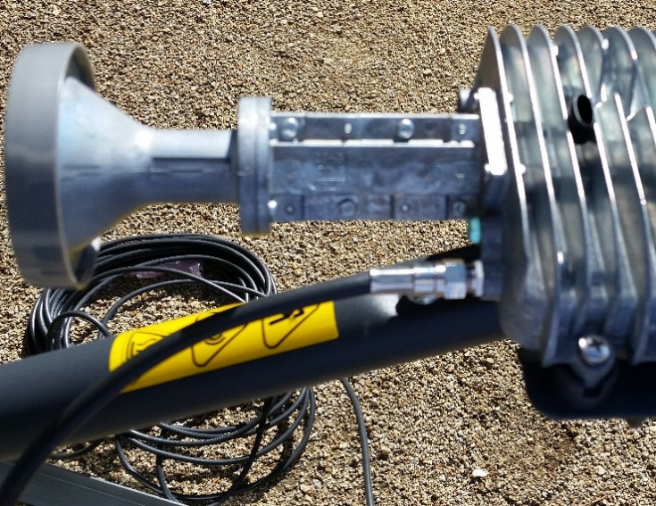
Figure 11
Figure 10
Figure 12
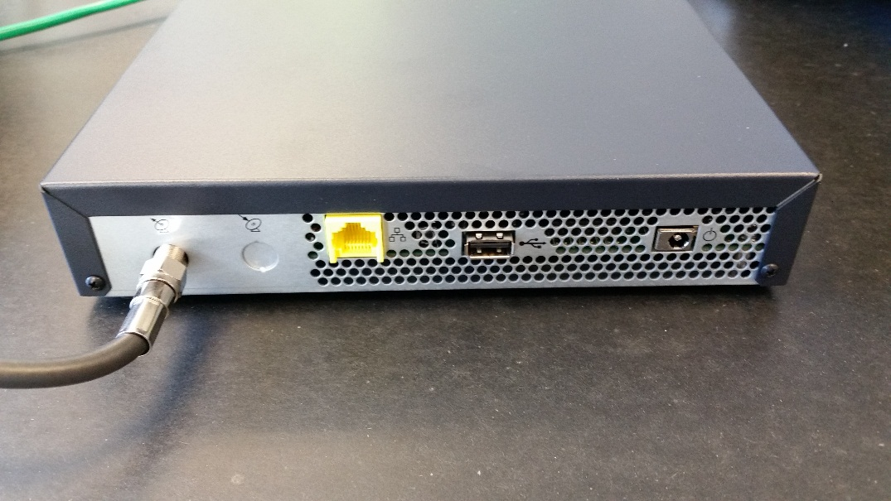
- Run the other end of the coax to modem. (NOTE: make sure there isn’t a tripping hazard where the coax is laying – burying the cord is a good option)
Figure 13

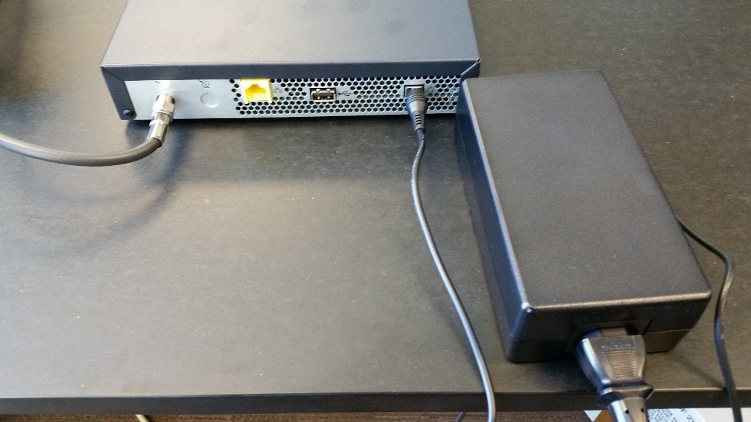
- Plug in the power cord (figure 14) to the modem.
Figure 14

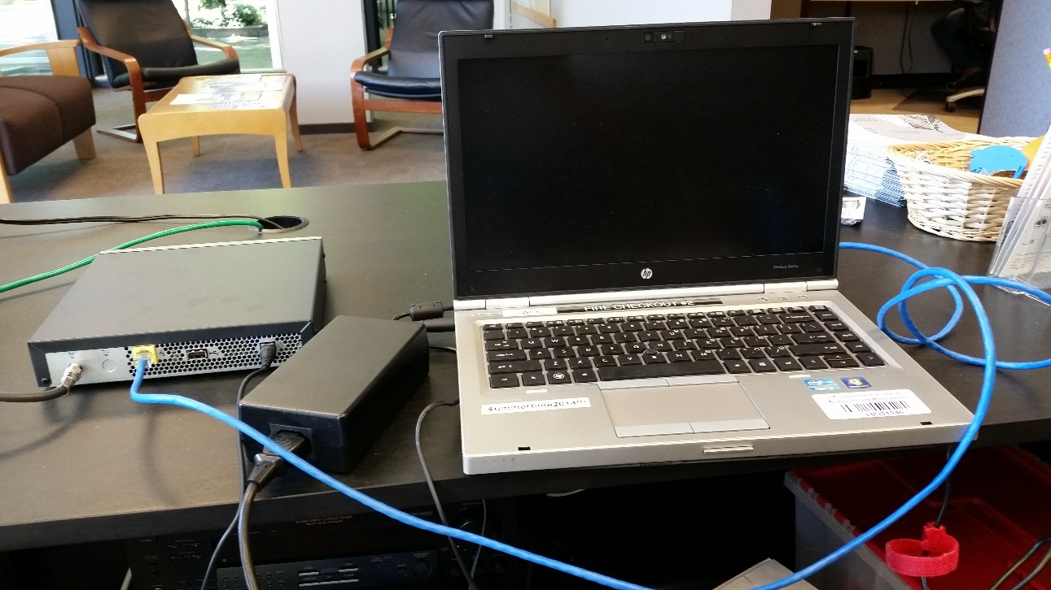
- Connect the modem to a laptop’s NIC using the blue patch cable.
Figure 15

- Log onto the laptop and open a web browser. Log into the modem using this web address HTTP://192.168.100.1/install (figure 13) and enter the selected 16 character beam key, then click the right arrow. (NOTE: you will need to tab to the next box after entering in each set of four characters)
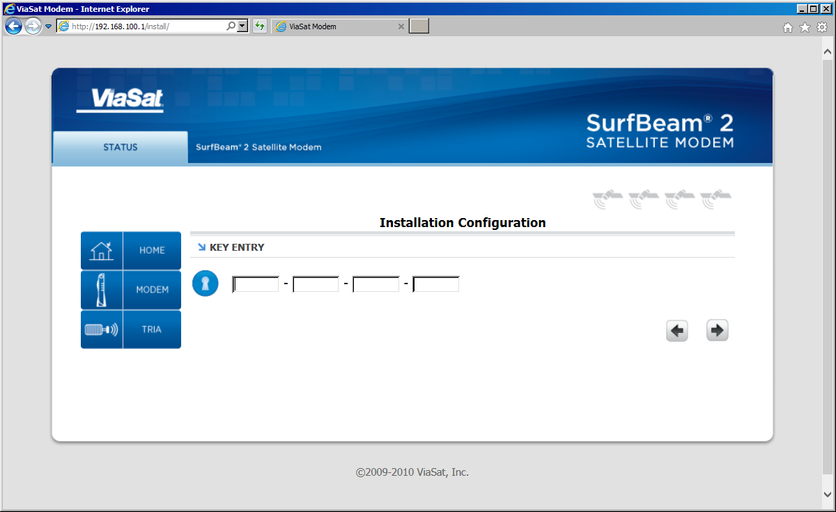
Figure 13
Figure 16

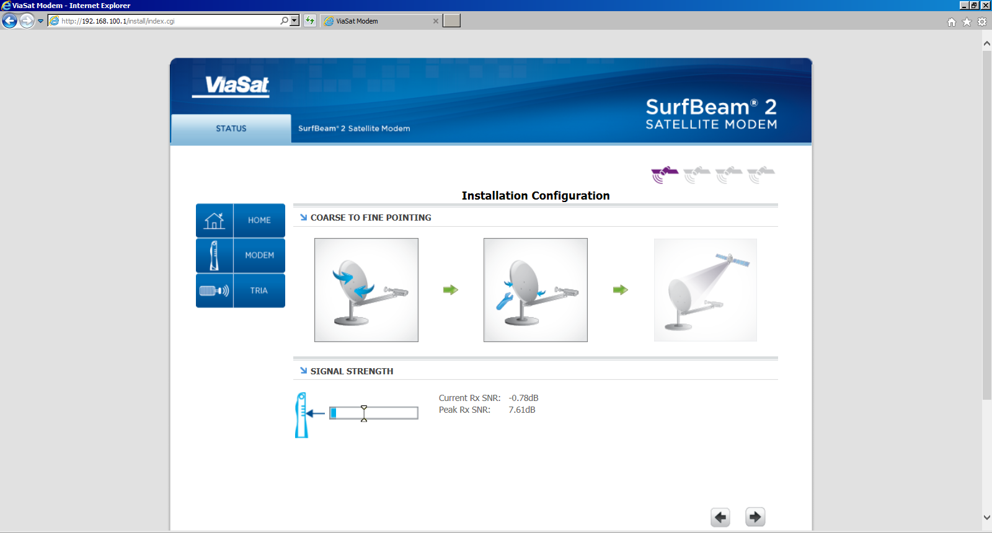
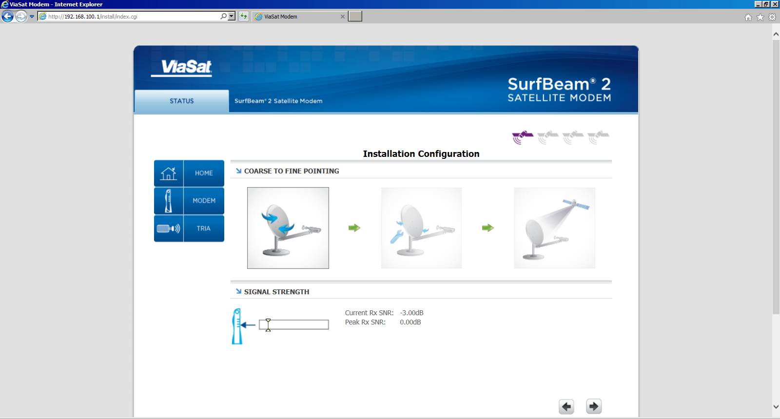
- Two people will make this step easier, but can be accomplished by one person. Send one person out to the dish, which should be emitting a heartbeat sound, and have the other person at the computer monitoring the webpage (figure 17). With the boom arms at the approximate elevation, slowly start sweeping the dish a little left or right until the tones beat faster (an obvious difference) or becomes a solid tone. The person monitoring the webpage can have the second person stop moving the dish once the middle icon highlights on the web page (figure 18). Once this icon is highlighted, the tone solid tone will be found using the fine adjustments. Continue to step L.
Figure 18
Figure 17
- Tighten down the three bolts attached at the base if the dish (figure 19) – (NOTE: Avoid moving the dish to keep the tone and webpage icon from changing. It is best if you tighten the middle bolt first before tightening the other two to help keep from moving the dish)
- Once the base bolts (figure 19) are tightened, slowly turn the horizontal fine adjustment bolt (figure 20) and/or the vertical fine adjustment bolt (figure 21) to find the solid tone needed for connection. The webpage will show the last icon highlighted (figure 21) with a green check when successful. Once the solid tone is found, each fine adjustment bolts can be SLOWLY turned each direction until the strongest possible signal is found. The person at the computer can check the signal strength (figure 21) until the highest possible signal is found and then click the right arrow button (figure 21) (NOTE: if you are off by a 1/2 degree, it is off by 190 miles from the satellite)
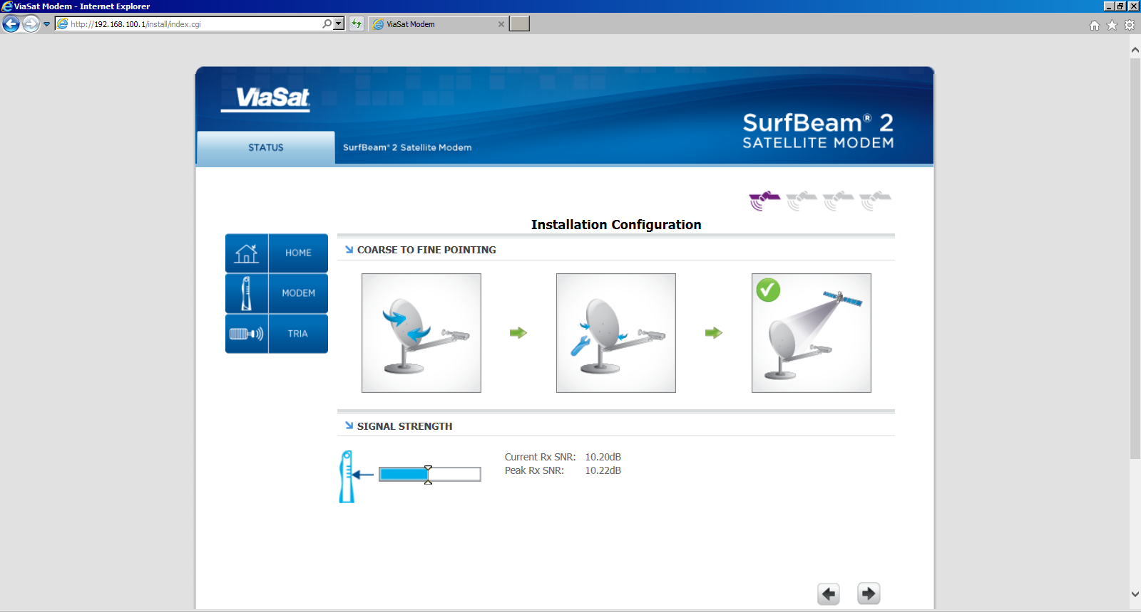
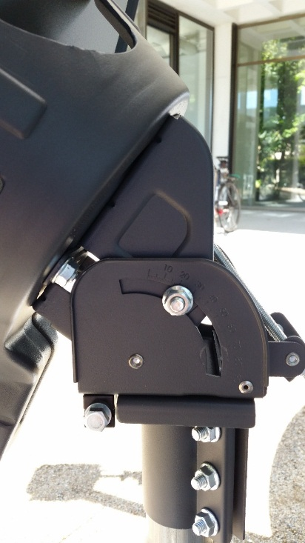
Figure 22
Figure 21
Figure 20
Figure 19
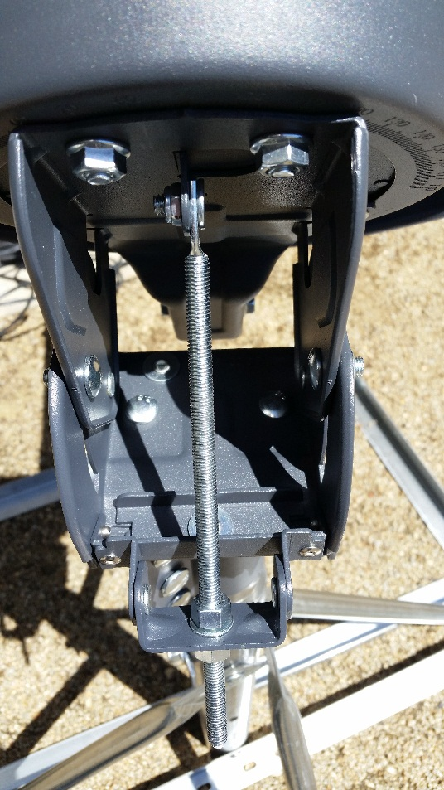
- Now that the signal is found, you need to tighten all bolts to keep the dish from moving out of its current position. The top bolt (figure 23) on the vertical fine adjust needs to be move down the metal base and tightened. The bolts (figure 24) on both sides of the vertical alignment need to be tightened.
Figure 24
Figure 23

- Once all the bolts are tightened down, go to the computer and click on the Modem Icon (figure 25) and check the status of the modem. Wait for all icons to turn green. (NOTE: This can take up to a couple of minutes. It is possible that the modem reboots after being up for a short time do to a firmware update. If it does reboot, it will come right back up and no input is needed by the tech.)
Figure 25
Figure 25
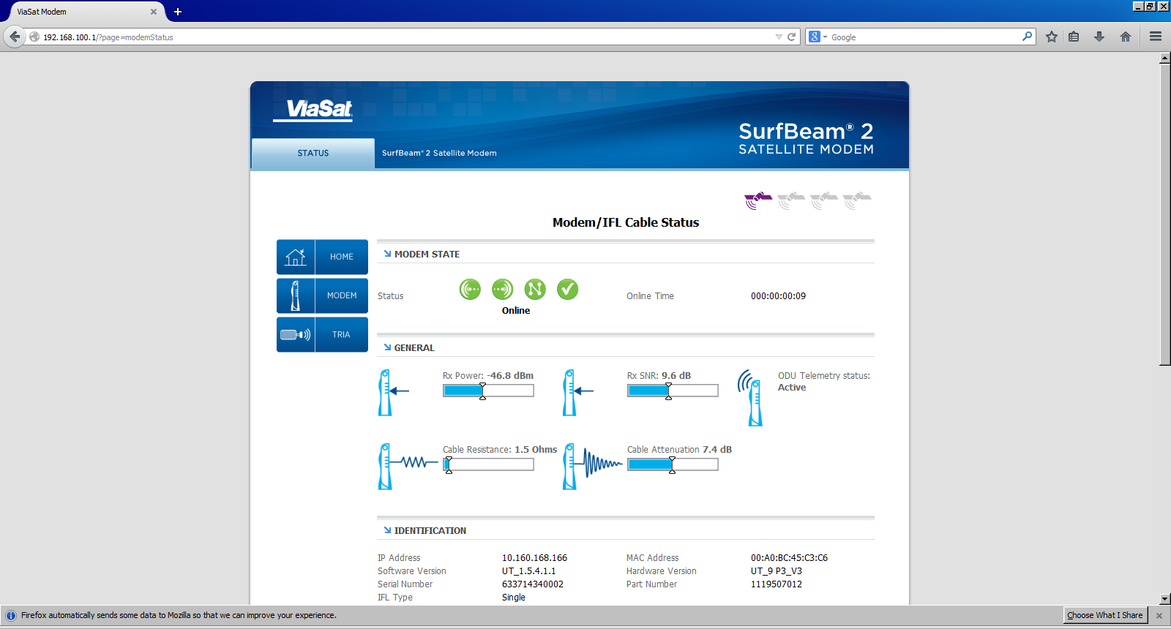
Figure 26

To test speed, go to: http://speedtest.via-satellite.net/. A regular speedtest is NOT a good basis for speed when testing a Sat system. It does not take into account latency and jitter.

