ITSS 2016 – PicoStationM2

Exercise #1: Router –One to Many Connection

What you will need to complete this training exercise:

1 - PicoStationM2 Access Point (AP) with Injector (power supply)
1 - Linksys Router
3 - Cat 5 patch cables
1 - Paperclip or small tool (to reset the PicoStation)
1 - Laptop computer

- Connect the Injector to an a/c power source
- Attach 2 Cat 5 patch cords to the injector, one in each port
- Connect the other end of the patch cord in the POE (Power Over Ethernet) jack to the AP
- Connect the other end of the patch cord in the LAN(Local Area Network) jack to the laptop Ethernet port
- Reset the PicoStationM2 AP to clear any existing configuration
  - Use the end of a paper clip or small tool to depress the reset button, which is located to the right of the RJ45 jack on the AP
  - Hold the reset button (10-12 seconds) until multicolored LEDs light up. Release the button once the lights come on
- Access Change Adapter Settings area in the Network and Sharing Center on your laptop
  - Disable the wireless adapter
  - Configure the Local Area Connection adapter with a static IP address: 192.168.1.[GROUP #]
- Open a web browser, type the HTTP://192.168.1.20 into the address bar and press enter

- If the following message comes up just click on “Continue to this website”
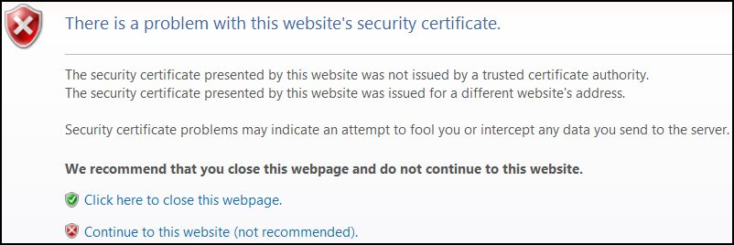

- Log in with Username: ubnt and Password: ubnt
- Select Country: UNITED STATES and Language: English
- Check the “I agree to the terms of use” box at the bottom left and click Login at bottom right
- The First tab you will see is MAIN. There may be a box in the bottom right corner asking you to change the password. Click the Dismiss button as the password should not be changed at this time.
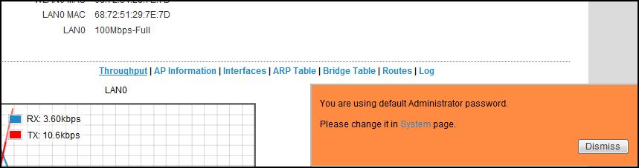
- Click on the WIRELESS tab
- In the WIRELESS window set only the following parameters. Do not change any others
  - Under Basic Wireless Settings
    - Wireless mode: Access Point
    - SSID: ITSS_ group[group#]
    - Channel Width: 20MHz
  - Under Wireless Security
    - Security: WPA-AES
    - WPA Authentication: PSK
    - WPA Preshared Key: ITSS*Group[group#]

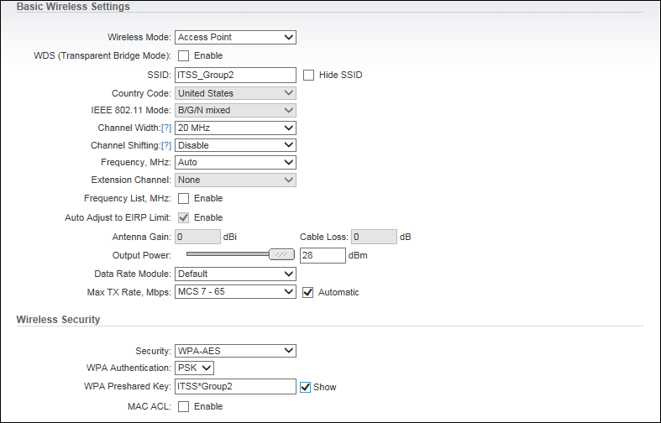

- Click Change button at the bottom of the screen to lock in the changes
- Wait to click Apply at the top of screen until all changes on all tabs are locked in

- Now click on the tab to the far left with the airMAX symbol
- In this window set only the following parameters. Do not change any others
  - airMAX Settings
    - airMAX: uncheck(to disable)
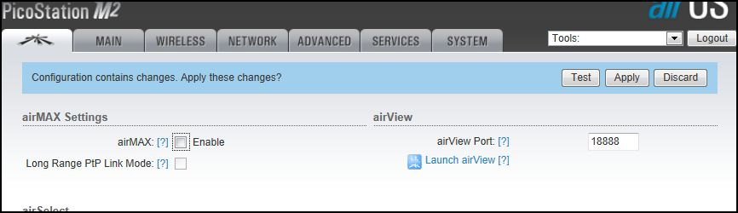
- Click Change button at the bottom of the screen to lock in the changes
- Wait to click Apply at the top of screen until all changes on all tabs are locked in

- Now click on the NETWORK tab
- Under the NETWORK Window set only the following parameters
  - Network mode: Router
  - Under WAN Network Settings
    - WAN IP Address: DHCP
    - NAT: Enable

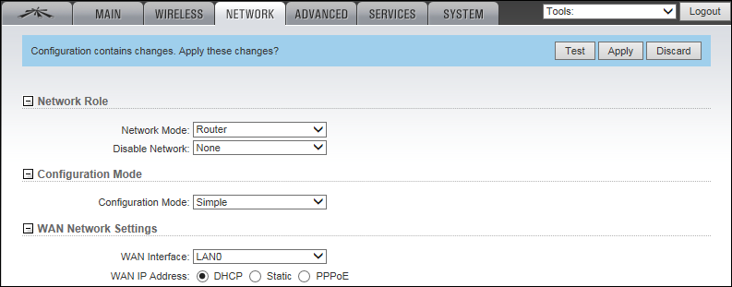

  - Under LAN Network Settings
    - IP Address: 192.168. [group #].254
    - Netmask: 255.255.255.0
    - DHCP Server: Enabled
    - Range Start: 192.168. [group #].50
    - Range End: 192.168.[group #].250
    - Netmask: 255.255.255.0
    - DNS Proxy: Enable

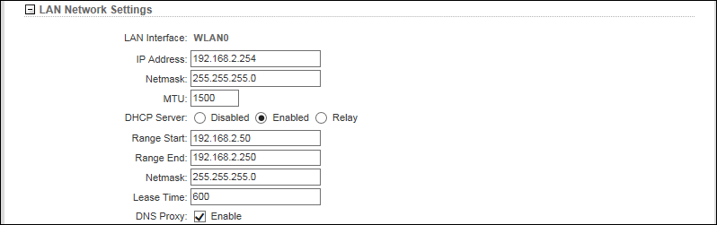

- Click Change button at the bottom of the screen to lock in the changes
- Now click Apply at the top of screen to complete all changes.

- Test your Settings
  - Unplug the Cat 5 cable from the laptop and plug it into an active internet connection.
  - Enable the laptop wireless adapter
  - Connect to the wireless bridge you just set up. Please be patient as the PicoStation may take a minute to restart and allow connection
  - Once you connect, test for access to the internet

Exercise #2: Bridge

Find another Team to partner up with. One will be BASE CAMP and other will be REMOTE CAMP. After successfully completing the exercise, reverse Base and Remote roles within the two Teams.

What you will need to complete this training exercise:

2 - PicoStationM2 Access Points (AP) with Injector (power supply)
1 – Ethernet switch
5 - Cat 5 patch cables
1 - Paperclip or small tool (to reset the PicoStation)
1 - Laptop computer
Part 1 – BASE CAMP
- Setup the BASE CAMP Access Point (AP)
  - Connect the Injector to an a/c power source
  - Attach 2 Cat 5 patch cords to the injector, one in each port
  - Connect the other end of the patch cord in the POE (Power Over Ethernet) jack to the AP
  - Connect the other end of the patch cord in the LAN(Local Area Network) jack to the laptop Ethernet port
- Reset the AP unit to clear any existing configuration
  - Use the end of a paper clip or small tool to depress the reset button, which is located to the right of the RJ45 jack on the AP
  - Hold the reset button (10-12 seconds) until multicolored LEDs light up. Release the button once the lights come on
- Access Change Adapter Settings area in the Network and Sharing Center on your laptop
  - Disable the wireless adapter
  - Configure the Local Area Connection adapter with a static IP address: 192.168.1.30
- Open a web browser, type the HTTP://192.168.1.20 into the address bar and press enter
- If the following message comes up just click on “Continue to this website”

- Log in with Username: ubnt and Password: ubnt
- Select Country: UNITED STATES and Language: English
- Check the “I agree to the terms of use” box at the bottom left and click Login at bottom right
- The First tab you will see is MAIN. There may be a box in the bottom right corner asking you to change the password. Click the Dismiss button as the password should not be changed at this time.

- Click on the WIRELESS tab
- In the WIRELESS window set only the following parameters. Do not change any others
  - Under Basic Wireless Settings
    - Wireless mode: Access Point
    - WDS(Transparent Bridge Mode: Check(Enable)
    - SSID: ITSS_Base_Camp[group#]
  - Under Wireless Security
    - Security: WPA-AES
    - WPA Authentication: PSK
    - WPA Preshared Key: ITSS*BaseCamp[group#]

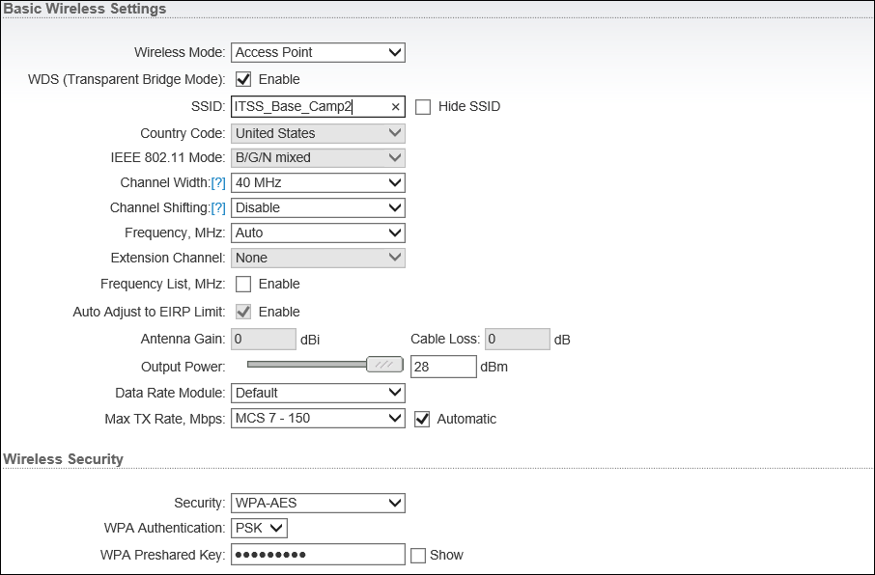

- Click Change button at the bottom of the screen to lock in the changes
- Wait to click Apply at the top of screen until all changes on all tabs are locked in

- Now click on the tab to the far left with the airMAX symbol
- In this window set only the following parameters. Do not change any others
  - airMAX Settings
    - airMAX: Enable
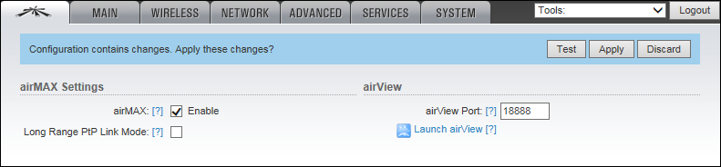
- Click Change button at the bottom of the screen to lock in the changes
- Wait to click Apply at the top of screen until all changes on all tabs are locked in

- Now click on the NETWORK tab
- In the NETWORK window set only the following parameters. Do not change any others
  - Under Network Role
    - Network mode: Bridge
  - Under Network Settings
    - Manage IP Address: Static
    - IP Address: 192.168.1.[group#]

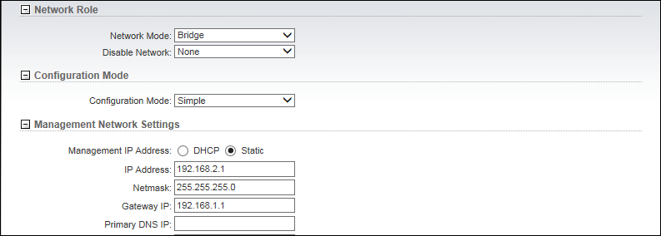

- Click Change button at the bottom of the screen to lock in the changes
- Now click Apply at the top of screen to finalize all changes
- Unplug the Cat 5 cable from the laptop and plug it into an active internet connection

Part 2 – REMOTE CAMP

- Now setup the REMOTE CAMP Access Point (AP)
  - Connect the Injector to an a/c power source
  - Attach 2 Cat 5 patch cords to the injector, one in each port
  - Connect the other end of the patch cord in the POE (Power Over Ethernet) jack to the AP
  - Connect the other end of the patch cord in the LAN(Local Area Network) jack to a switch
  - Connect another Cat5 cable from the laptop to another port on the switch

- Reset the AP unit to clear any existing configuration
  - Use the end of a paper clip or small tool to depress the reset button, which is located to the right of the RJ45 jack on the AP
  - Hold the reset button (10-12 seconds) until multicolored LEDs light up. Release the button once the lights come on
- Open a web browser, type the HTTP://192.168.1.20 into the address bar and press enter
- If the following message comes up just click on “Continue to this website”

- Log in with Username: ubnt and Password: ubnt
- Select Country: UNITED STATES and Language: English
- Check the “I agree to the terms of use” box at the bottom left and click Login at bottom right

- The First tab you will see is MAIN. There may be a box in the bottom right corner asking you to change the password. Click the Dismiss button as the password should not be changed at this time.

- Click on the WIRELESS tab
- In the WIRELESS window set only the following parameters. Do not change any others
  - Under Basic Wireless Settings
    - Wireless mode: Station
    - WDS(Transparent Bridge Mode: Check(Enable)
  - Under Wireless Security
    - Security: WPA-AES
    - WPA Authentication: PSK
    - WPA Preshared Key: ITSS*BaseCamp[BASE CAMP group #]
- Now click on the Select next to the SSID box
- A box will pop up. Find and select the SSID of the BASE CAMP AP
- Click the Lock to AP button at the bottom of this box. You may need to scroll down.

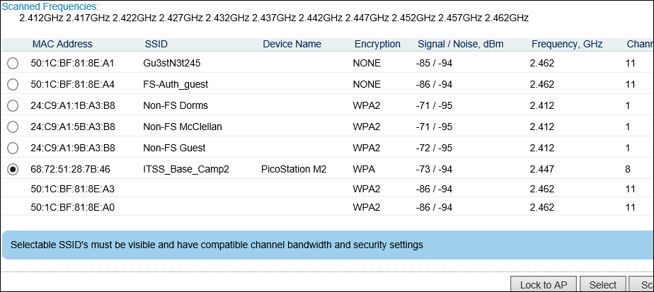

- The SSID field should be filled now with the SSID of the first AP

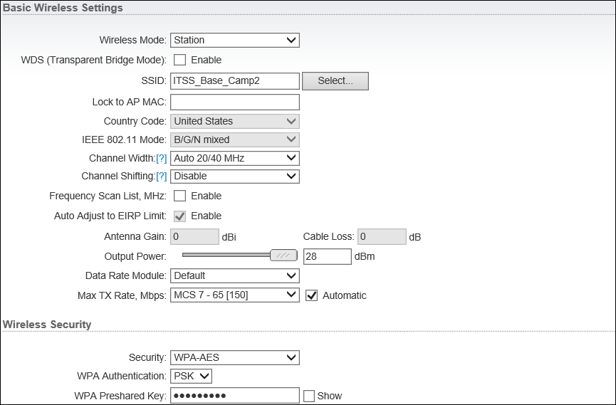

- Click Change button at the bottom of the screen to lock in the changes
- Wait to click Apply at the top of screen until all changes on all tabs are locked in

- Now click on the tab to the far left with the airMAX symbol
- In this window set only the following parameters. Do not change any others
  - airMAX Settings
    - airMAX Priority: None
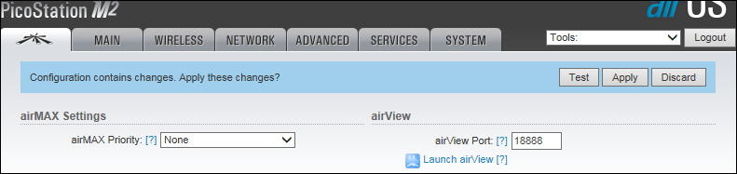
- Click Change button at the bottom of the screen to lock in the changes
- Wait to click Apply at the top of screen until all changes on all tabs are locked in
- Now click on the NETWORK tab
- In the NETWORK window set only the following parameters. Do not change any others
  - Under Network Role
    - Network mode: Bridge
  - Under Network Settings
    - Manage IP Address: Static
    - IP Address: 192.168.1.[group#]

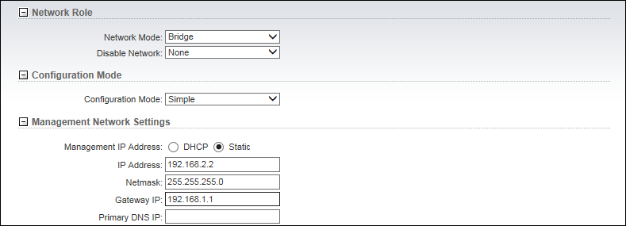

- Click Change button at the bottom of the screen to lock in the changes
- Now click Apply at the top of screen to finalize all changes
- Test your Settings
  - Configure the REMOTE CAMP laptop Local Area Connection adapter to obtain an IP address automatically (DHCP)
  - Connect the laptop and the REMOTE CAMP AP to a switch
  - Open a browser to test for access to the internet Please be patient as the PicoStation may take a minute to restart and allow connection

If time permits, you can also try this exercise with multiple REMOTE CAMP groups. One group will set up as the BASE CAMP and all other groups will setup as REMOTE CAMPS.

