Finding EISuite All Modules Courses

- Go to http://www.nationalfiretraining.net/
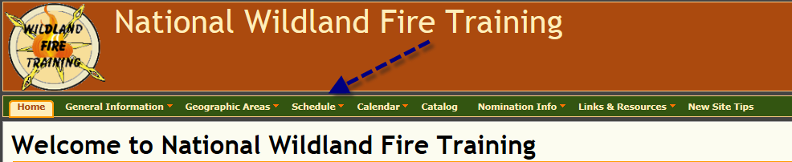
- Select “Schedule”

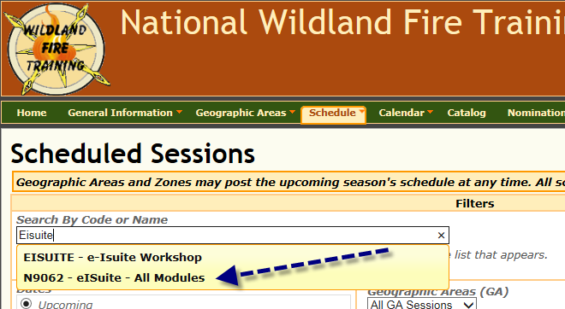
- In the search box type “Eisuite” and select “N9062 – eIsuite – All Modules”.

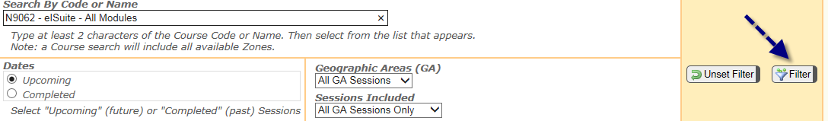
- Select “Filter”. All course offering will be displayed.

