System Requirements
- Intel (or compatible) Processor I3 or better
- 4 GB of memory or better
- Wired or Wireless Network (802.11 g/n or NIC 10/100/1000)
- 256 MB Video Card or better
- Hard Drive: 5 GB of Free Space for ROSS install and 100 MB of free space for Internet Explorer Caching
- Operating System
  - Windows 7 (minimum 32 bit; 64 bit preferred)
  - Compatible with Windows XP
- Browser – Internet Explorer Version 8 or 9
  - NAP will not work with earlier Versions.
  - Cognos (Reports) will not work with other Browsers and unexpected errors will occur with FireFox and Google Chrome.

- If using Internet Explorer Version 9, set the compatibility flag so that it will work with the NAP application.
Problem:
NAP users may experience display problems when using Internet Explorer 9. Users may see a portion of the NAP screen missing or cut off.
Solution:
Use compatibility mode in IE to overcome this issue or run IE9 in IE8 mode.
Detailed information from Microsoft regarding compatibility mode can be found here: http://windows.microsoft.com/en-US/internet-explorer/products/ie-9/features/compatibility-view
To run IE9 in IE8 mode
Open IE9 and hit the F12 key. Click Browser Mode and select IE8.
- NAP requires Adobe Flash Player (Version 11.3.300.257 or Greater). If Flash is not already installed, it will need to be.

  - To determine if Flash is installed, go to http://www.adobe.com/software/flash/about/
If it is installed, a Version Information Box is displayed with the installed version.

Non-FS Citrix Software Requirements
  - URL https://ross.fs.fed.us/XenApp/auth/login.aspx

Ensure that the computer has the latest version of the Citrix Client loaded. There is a link on the website above just below the log on box which will load the proper version of the Citrix Client for Explorer.

Renting Computers/Networks for Expanded
- If ordering rental computers, ask for an administrator’s account to be set up for each computer if your agency would allow this. Have the contractor provide you with the administrator account’s user name and password. Note: Elevated privileges are not need to download the ROSS client, but, they will be essential for troubleshooting if there are network issues.
- While ROSS itself does not use that much bandwidth, things like GIS applications do
- The number of Bounces/Stops that are made over the network can be detrimental to ROSS performance.
- Often Hotel Networks lease network time with varying bandwidth by the hour, with smaller bandwidths available during the daytime hours. Additionally, hotel occupancy rates will really affect the amount of bandwidth being used.
- Consider using carrier wireless network cards. These are often difficult to order at the last minute.
- If not using one of the major carriers ( Verizon, T-Mobile, Cricket, etc.), and there are connectivity issues, you may need provide the helpdesk with the contact information of the provider. The helpdesk will open a ticket and escalate it to system/network experts when needed.
- Be sure to open the ROSS ports on the network. Also make sure that the ROSS IP addresses (including the Non-FS Citrix IP if using this) are not blocked by a firewall. (Call the helpdesk for a list of addresses and ports that ROSS uses)
- Ensure the PC Keep Alive Network Card Timeouts settings are set to at least 2 hours.
Add http://*.nwcg.gov to the Trusted Sites List on each computer.
1 Start your Internet browser.
2 On the Tools menu, click to select Internet Options.
3 On the Internet Options dialog box, click the Security tab.
4 On the Security tab, click to select the Trusted Sites icon,
5. Click on the Sites button
5 On the Trusted Sites dialog box under
“Add this website to the zone”, type http://*.nwcg.gov,
6. Click Add
7. Close the Internet Options Dialog
8. Click the small “x” on the top right of the box to close the dialog box
- Ensure that the power options do not cause the PC to go into standby mode.
Go to the Control Panel and select “Power Options”, then “Power Schemes” and make sure that “Never” is selected for “System Standby” and “System Hibernates.” Click Okay to save the settings.

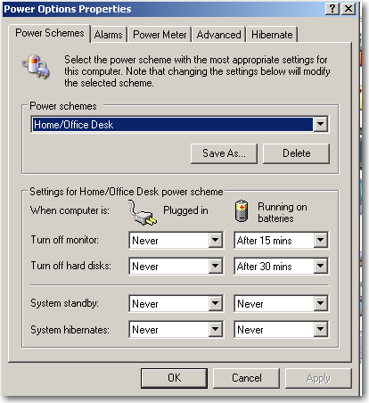

Interagency Helpdesk
Hours: 24 hours a day / 7 Days a Week
Phone: (866) 224-7677 / (360) 326-6002
Email: help@interagencyhelpdesk.com
Computer technical specialist may request a copy of the list of the ROSS IPs from the IIA Helpdesk.
Last updated: 1/ 31/2013

