ITSS 2018 – UniFi AC MESH

What you will need to complete these training exercises:

1 – UniFi 802.11 AC MESH Access Point (AP) with POE Injector (power supply)
1 - Linksys Router
4 - Cat 5 patch cables
1 - Paperclip or small tool (to reset the MESH unit)
1 - Laptop computer
1 – Unmanaged switch
UniFi Controller Software v5.7 or newer

Exercise #1: Router – One to Many Connection
- Plug your Laptop into the router.
- Download and install and run the latest Unifi Controller software for Windows
  - https://www.ubnt.com/download/unifi.
- In the UniFI Controller popup window click on Launch a Browser to Manage Network.
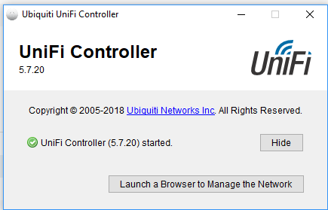

- You may get a website security certificate notice. Disregard and continue to the website.
- Make sure your Country and Time zone are set correctly and click NEXT.
- Do not select any devices. Click NEXT on the Configure devices page.
- Setup SSID as ITSS_Group[group#] and Security Key as ITSS_Group[group#]. Do not Enable Guest Access. Click NEXT.
- Set Admin Name as admin, Email as your email address and Password as ITSS_Group[group#]. Also setup Device Authentication name as admin and Password as Group[group#]. Click NEXT
- Review settings and click FINISH to confirm.
- Skip the Cloud Login Credentials.
- Sign in using the Admin name and Password. You should see the UniFi dashboard open in front of you.
- Now attach an Ethernet cable to the POE (Power Over Ethernet) port on the Injector and attach the other end to the AP.
- Attach another Ethernet cable to the LAN (Local Area Network) port on the Injector and attach the other end to the router.
- Plug in the Injector power cord. Wait until the indicator light on the AP is on.
- Reset the AC MESH AP to clear any existing configuration.
  - Use the end of a paper clip or small tool to depress the reset button, which is located to the right of the RJ45 port on the AP.
  - Hold the reset button (5 - 15 seconds) until Status light on the side of the AP turns off.
- Once it restarts fully you should see the AP listed under Devices. Be patient as this may take a few minutes.

- At the left side of your screen select DEVICES.
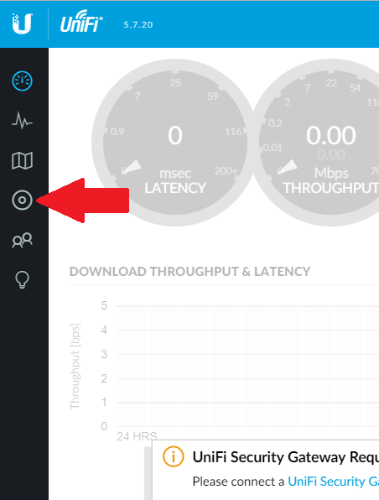

- The AP will be listed on the Devices page. Click ADOPT on the AP to connect.

- Once Adoption is complete the status will change to Connected. Click on the device and a window will open on the right.

- The device name is defaulted to its MAC address, which is located on the AP below the Ethernet port. Go to Config > General. Change the Alias to whatever is labeled on the AP.
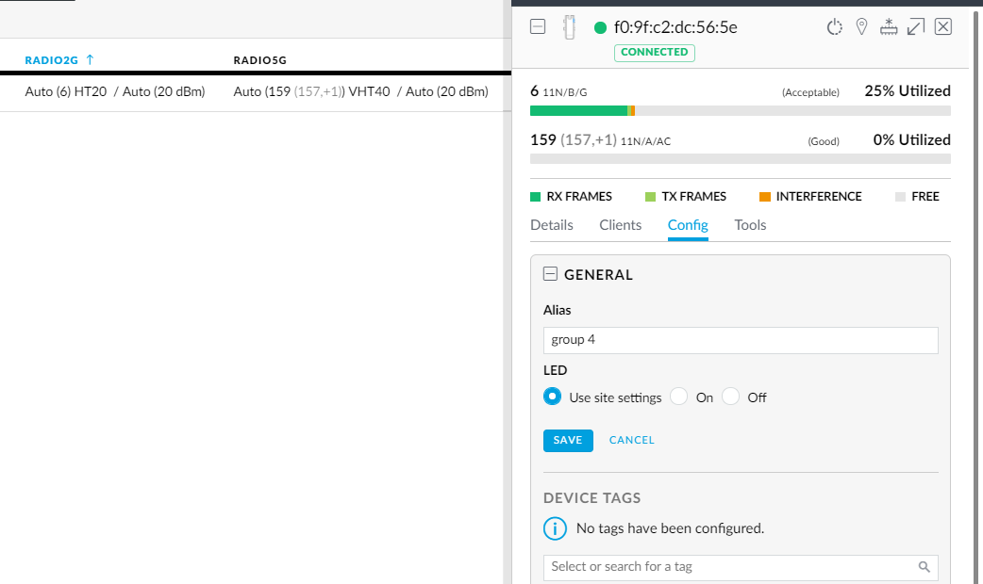
- Go to Network. Change the IP settings from DHCP to STATIC:
  - IP = 10.5.[GROUP#].20
  - Subnet = 255.255.255.0
  - Gateway 10.5.[GROUP#].1

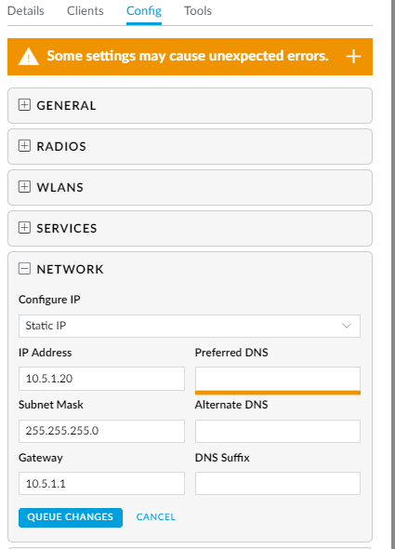

- Unplug the Ethernet cable connected to your laptop and connect it to the router.
- Test your Settings.
  - Enable the laptop wireless adapter.
  - Connect to the wireless network using the SSID Security Key you set up earlier.
  - Verify you can connect to the internet.

Exercise #2: Bridge
Find another Team to partner up with. One will be BASE CAMP and other will be REMOTE CAMP.
- The Base Camp team will need to plug their laptop into the router.
- The Remote Camp team needs to move their AP’s LAN cable from the router to the un-managed switch and reset the AP to clear its configuration.
- Once the Remote Camp AP is booted up, you will see it populate on list of devices on the Base Camp laptop. Any other AP that is trying to connect wirelessly will be listed here as well. Verify your Remote Camp device by the MAC address and click ADOPT.
- Once the Remote Camp AP is connected it will show the STATUS Connected (Wireless). Be patient as this may take a few minutes.
- Test your Settings. You should now be supplying connectivity to any computer you plug into the un-managed switch.
  - Disable the laptop wireless adapter and connect it to the un-managed switch.
  - Verify you can connect to the internet.

If time allows, reverse rolls and try the Bridge exercise again.

