
Yolo RX 2025

Total Acres: 419
10/28-30/2025
FS FAM RX (OT, IRPP, TRAVEL) - WISX325 (1825)
FS NON-FIRE OT - NISXR326 (1825)
(Please Use CTRs For Overtime Hours Only!)
All Resources Use QR Code for all Time
Scan for Yolo RX OT Tracker Scan for Yolo RX Map


ORGANIZATION ASSIGNMENT LIST (ICS 203)
Prescribed Fire Organizer |  |  |  |  |  |  |  |  |  |  | 9. Rx Assignment List
 |  |  |  |  |  |  |  |  |  |  | Rx Burn Boss | Jason Heffner
1. Project Name: YOLO RX |  |  |  |  |  |  |  |  |  |  | Burn Boss (T) | Mark Timber
 |  |  |  |  |  |  |  |  |  |  | a. Firing |  |  | Channel: Tac 2
2. Date: 10/28-30/2025 |  |  |  |  |  |  | 3. Time: 0900 |  |  |  | Firing Boss | Mike Williams
 |  |  |  |  |  |  |  |  |  |  | Firing Boss (t) | Eric Jelinek
5. Spot Weather Forecast |  |  |  |  |  |  |  |  |  |  | Aerial Firing | UR-31 (Drone) |  |  | Aaron Farmer
Discussion: Provided in daily briefing |  |  |  |  |  |  |  |  |  |  | Rx Resource | Crew 1 |  |  | Morgan Nelson
 |  |  |  |  |  |  |  |  |  |  | Rx Resource | Crew 2 |  |  | Jake Clawson
 |  |  |  |  |  |  |  |  |  |  | Rx Resource
 |  |  |  |  |  |  |  |  |  |  | Rx Resource
 |  |  |  |  |  |  |  |  |  |  | Rx Resource
 |  |  |  |  |  |  |  |  |  |  | Rx Resource
 |  |  | Today |  | Tonight |  |  |  | Tomorrow |  | Rx Resource
Sky |  |  |  |  |  |  |  |  |  |  | b. Holding |  |  | Channel: Tac 2
Temp |  |  |  |  |  |  |  |  |  |  | Holding Boss | Austin Langham
RH |  |  |  |  |  |  |  |  |  |  | Rx Resource
Wind |  |  |  |  |  |  |  |  |  |  | Rx Resource | Engine 931 T3 |  |  | Julien Magallanez
Vent |  |  |  |  |  |  |  |  |  |  | Rx Resource | Engine 930 T3 |  |  | Tony Kontz
Clear |  |  |  |  |  |  |  |  |  |  | Rx Resource | Engine 611 T6 |  |  | Sam Long
6. Fuel Sticks  6. Fuel Sticks  6. Fuel Sticks  6. Fuel Sticks |  |  |  |  |  |  |  |  |  |  | Rx Resource
1 Hour |  |  |  | 10 Hour |  |  | 100 Hour |  |  | 1000 Hour | Rx Resource | Engine 612 T6 |  |  | Berkeley Krueger
 |  |  |  |  |  |  |  |  |  |  | Rx Resource
7. Briefing Checklist  7. Briefing Checklist  7. Briefing Checklist  7. Briefing Checklist |  |  |  |  |  |  |  |  |  |  | Rx Resource | T2 Crew |  |  | Superstition Crew
 | 1. Organization |  |  |  |  |  |  | 10. Medical Plan - EMT |  |  | Rx Resource
 | 2. Objectives |  |  |  |  |  |  | 11. Safety - PPE |  |  | c. EMT |  |  | Channel: Tac 2
 | 3. Fire Weather |  |  |  |  |  |  | 12. Communications |  |  | Click here to enter text.
 | 4. Fire Behavior |  |  |  |  |  |  | 13. Contingency Resource
 | 6. Smoke Management |  |  |  |  |  |  | 15. I.A. Resource |  |  | Rx Resource
 | 7. Archeological Sites |  |  |  |  |  |  | 16. Firing Plan |  |  | Rx Resource
 | 8. Other Special Resource |  |  |  |  |  |  | 17. Holding Plan |  |  | Rx Resource
 |  | 9. Public Information |  |  |  |  |  | 18. Logistics |  |  | Rx Resource
8. Daily Completion Narrative |  |  |  |  |  |  |  |  |  |  | Rx Resource
Record weather if different than forecast: |  |  |  |  |  |  |  |  |  |  | Rx Resource
 |  |  |  |  |  |  |  |  |  |  | Rx Resource
 |  |  |  |  |  |  |  |  |  |  | Rx Resource
 |  |  |  |  |  |  |  |  |  |  | d. Additional Personnel
Describe fire behavior: |  |  |  |  |  |  |  |  |  |  | Wx / FEMO | On-Site |  |  | Michael Hanson
 |  |  |  |  |  |  |  |  |  |  | Assigned EMT
 |  |  |  |  |  |  |  |  |  |  | Fuel Logistics | On-Site
 |  |  |  |  |  |  |  |  |  |  | I.A. Resource | On-Site
Describe how well objectives were met (fire effects): |  |  |  |  |  |  |  |  |  |  | Contingency | On-Site
10. Contingency Resources
10. Resources on Scene
10. Resources on Scene
 |  |  |  |  |  |  |  |  |  |  | Engine 611 T6 |  | Engine 612 T6
Visitors, comments, follow-up needed, site rehab needed or other issues:
 |  |  |  |  |  |  |  |  |  |  | Briefing by: Mark Timber

INCIDENT OBJECTIVES (ICS 202)

Purpose: Move project area towards desired vegetation structure and fire regime. Restore and maintain soil and watershed function. Move landscape toward desired conditions described in the land management plan for the Prescott National Forest.
Fuels: There are three different fuel types within in this burn unit. PJ evergreen shrub, ponderosa pine, and shrub.
Objectives:
Resource:
- Increase the frequency of fire disturbance to aid in the inhibition of woody species and certain types of nonnative invasive plant species.
- Maintain or improve soil stability, soil productivity and watershed condition.
- Improve native vegetation condition and distribution.
- Maintain or improve stream channels and drainage condition by improving and diversifying riparian dependent vegetation.
- Ensure timing restrictions for wildlife outlined in Chino Landscape Restoration Environmental Assessment are maintained.
- Protect historic and pre-historic sites.
- Increase quality of wildlife habitat
- Ensure no permanent roads will be constructed to implement vegetation management treatments.
Prescribed Fire:
- Allow for varying levels of fire intensity to accomplish resource objectives.
- Utilize fire to manage encroachment of juniper trees and allow for heathier grasslands.
- Decrease density of juniper trees and shrubs within the Pinion-Juniper Evergreen Shrub PNVT
- Reduce the risk of uncharacteristic fire behavior in Ponderosa Pine PNVTs
- Limit treatment of slopes greater than 40% to reduce the potential for soil movement.
- Limit fire intensity in SMZs.
Desired Fire Behavior:
- PJ Evergreen Shrub - The desired fire behavior within this fuel type is moderate to high intensity/severity.
- Ponderosa pine- The desired effects within this fuel type are low to moderate intensity.

On-Site Values:
- Property -Yolo Ranch to the East/ Private Property to the North/Private Property to the West
- Wildlife - Golden eagle 3 miles to the NE of the unit. Goshawk nest 1 mile NE of unit. No concerns if wind is predicted away from nest
- Arch Site - One fire sensitive site within the unit. Refer to map. (Will be prepped and flagged)

Prescription:

Temperature: Maximum- 110 degrees Minimum- 30 degrees
Relative Humidity: Maximum- N/A Minimum- 10%
Mid Flame Wind: Maximum- 25 mph Minimum- 0 mph
Live Woody Moisture: Maximum- 120% Minimum- 60%
Fine Dead FM: Maximum- 14% Minimum- 2%
10hr Fuel Moisture: Maximum- 15% Minimum- 3%
100hr Fuel Moisture: Maximum –16% Minimum- 4%

DIVISION GROUP ASSIGMENT LIST (ICS 204)

Group Assignment List |  |  |  |  |  | 1. Branch |  |  |  |  |  |  |  |  |  | 2. Group
 |  |  |  |  |  |  |  |  |  |  |  |  |  |  |  | Ignitions
3. Incident Name |  |  |  |  |  | 4. Operational Period Briefing
YOLO RX |  |  |  |  |  | Date: 10/28-30/2025 |  |  |  |  |  |  |  | Time: 0900
5. Operations Personnel
Prescribed Fire Burn Boss 2 |  |  |  | Jason Heffner |  |  |  | Ignitions Supervisor |  |  |  |  | Mike Williams
Prescribed Fire Burn Boss 2 (t) |  |  |  | Mark Timber |  |  |  | Firing (t) |  |  |  |  | Eric Jelinek
6. Resources Assigned this Period
Strike Team/Task Force/Resource Designator |  |  | Leader |  |  |  | Number Persons |  |  | Trans. Needed | Drop Off PT./Time |  |  |  |  |  | Pick Up PT./Time
Crew 1 |  |  | Morgan Nelson
Crew 2 |  |  | Jake Clawson
7. Operations:
Task: Implement appropriate Fire intensity to meet desired condition for fuel type.
Purpose: To improve forest health and reduce the risk of catastrophic wildfire.
End State: Majority of small woody debris is consumed along with larger dead and down fuels with limited scorch on standing Ponderosa Pine.

8. Special Instructions
- Establish LCES and Adhere to the 10 Standard Fire Orders and 18 Watch Out Situations.
- Minimize scorch to pine/pine stringers. (Low to Moderate Fire intensity in Pine)
- If needed, ignitions personnel will assist holding.
9. Division/Group Communications Summary
Function | Frequency | System |  |  | Channel |  |  |  | Function |  |  | Frequency |  |  | System |  |  |  | Channel
Command | Fire RPT  RX: 173.925  TX: 165.750  Tone: 146.2  (Hyde) | PNF West Zone  Group 3 |  |  | 2
Tactical Div/Group | Tac 2  168.6750 TX/RX | PNF West Zone  Group 3 |  |  | 10
Prepared By (Burn Boss) (T) |  |  |  |  |  |  |  |  |  |  |  | Date |  |  |  |  |  | Time
Mark Timber |  |  |  |  |  |  |  |  |  |  |  | 10/26/25 |  |  |  |  |  | 1800

DIVISION GROUP ASSIGMENT LIST (ICS 204)

Group Assignment List |  |  |  |  |  | 1. Branch |  |  |  |  |  |  |  |  |  | 2. Group
 |  |  |  |  |  |  |  |  |  |  |  |  |  |  |  | Holding
3. Incident Name |  |  |  |  |  | 4. Operational Period Briefing
YOLO RX |  |  |  |  |  |  |  |  |  |  |  |  |  | Time: 0900
5. Operations Personnel
Prescribed Fire Burn Boss 2 |  |  |  | Jason Heffner |  |  |  | Holding Supervisor |  |  |  |  | Austin Langham
Prescribed Fire Burn Boss 2 (t) |  |  |  | Mark Timber
6. Resources Assigned this Period
Strike Team/Task Force/Resource Designator |  |  | Leader |  |  |  | Number Persons |  |  | Trans. Needed | Drop Off PT./Time |  |  |  |  |  | Pick Up PT./Time
AZ-PNF-E930 |  |  | Kontz |  |  |  | 2
AZ-PNF-E931 |  |  | Julien Magallanez |  |  |  | 4
AZ-ASF-E612 |  |  | Berkeley Krueger |  |  |  | 4
AZ-CNF-E611 |  |  | Sam Long |  |  |  | 4
Superstition Crew |  |  | David McDowell |  |  |  | 18
7. Operations
Task: Hold fire within the prescribed fire boundaries.
Purpose: To keep spot fires from getting established that would require additional resources or impact natural resources - outside of burn unit boundaries.
End State: Boundaries are secure, and spot fires completely extinguished.

8. Special Instructions
- Establish LCES and Adhere to the 10 Standard Fire Orders and 18 Watch Out Situations
- If needed holding resources will assist ignitions.
9. Division/Group Communications Summary
Function | Frequency | System |  |  | Channel |  |  |  | Function |  |  | Frequency |  |  | System |  |  |  | Channel
Command | Fire RPT  RX: 173.925  TX: 165.750  Tone: 146.2  (Hyde) | PNF West Zone  Group 3 |  |  | 2
Tactical Div/Group | Tac 2  168.6750 TX/RX | PNF West Zone  Group 3 |  |  | 10
Prepared By (Burn Boss) (T) |  |  |  |  |  |  |  |  |  |  |  | Date |  |  |  |  |  | Time
Mark Timber |  |  |  |  |  |  |  |  |  |  |  | 10/26/25 |  |  |  |  |  | 1800

INCIDENT COMMUNICATION PLAN (ICS 205)
INCIDENT RADIO COMMUNICATIONS PLAN |  |  | 1. Incident Name Yolo RX  West Zone, Group 3 |  | 2. Date/Time Prepared  010/26/25 |  | 3. Operational Period Date/Time  10/28-10/30 0600-2200
4. Basic Radio Channel Utilization
Radio Type/Cache | Channel | Function |  | Frequency/Tone |  | Assignment |  | Remarks
King | 2 | PNF Fire RPT |  | RX 173.925  TX 165.750 |  | RX Command |  | Hyde 146.2 (tone 5)
King | 10 | FS Tac 2 |  | RX 168.675  TX 168.675 |  | RX Tac (Primary) |  | Ignitions/Holding
King | 9 | FS Tac 1 |  | RX 167.550  TX 167.550 |  | PNF IA Tac |  | Primary Tac for IA.
King | 11 | FS Tac 3 |  | RX 168.775  TX 168.775 |  | RX Tac (Back up) |  | Can be requested if needed
King | 12 | A/G 44 |  | RX 167.625  TX 167.625 |  | RX A/G |  | Primary A/G
King | 13 | A/G 34 |  | RX 167.175  TX 167.175 |  |  |  | Secondary A/G
King | 14 | VFire 21 |  | RX 154.280  TX 154.280 |  |  |  | Mutual Aid
Prepared by: Mark Timber

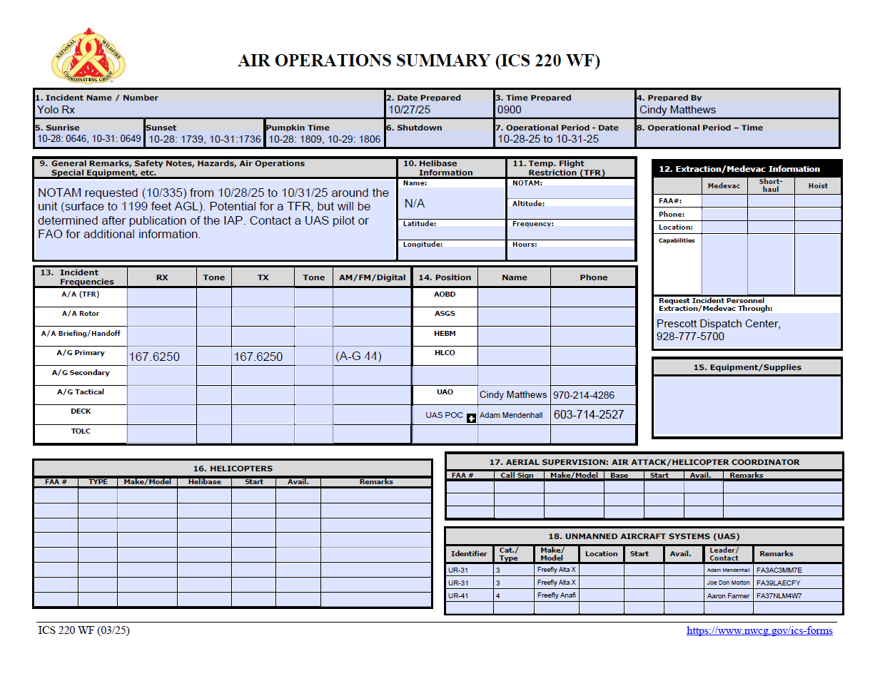
1. Incident Name:  Yolo RX |  | 2. Operational Period:  Date From:10/28/2025 Date To:10/30/2025  Time From: Time To: |  |  | 3. Sunrise:0645 Sunset:1741
12. Task/Mission/Assignment (category/kind/type and function includes: air tactical, reconnaissance, personnel transport, search and rescue, etc.):
Category/Kind/Type and Function | Name of Personnel or Cargo (if applicable) or Instructions for Tactical Aircraft |  |  | Mission Start | Fly From | Fly To
PSD Operations/IR | Joe Morton, Aaron Farmer, Adam Mendenhall |  |  | 10/28 | 0900
11. Prepared by: Name: Jason Heffner Position/Title: Burn Boss Signature:
ICS 220, Page 2 |  |  | Date/Time: 09/25/2025

Incident/Project Name |  |  |  |  |  | - Operational Period
Yolo RX |  |  |  |  |  | DATE 2025 TIME 0900
- Ambulance Services
Name |  | Complete Address |  |  |  |  |  |  |  | Phone  &  EMS Frequency |  | Advanced Life Support (ALS)  Yes No
Williamson Valley FD Station #91 |  | 15450 N. Williamson Valley Rd Prescott, AZ 86305 |  |  |  |  |  |  |  | (928) 717-2304 or 911  Mutual Aid |  | X
- Air Ambulance Services
Name |  |  |  | Phone |  |  | Type of Aircraft & Capability
Native 4  YRMC West, Prescott |  |  |  | (800) 642-7828 or 911 |  |  | A-Star, Nurse and Paramedic, Night vision capable, Contact on AZ Mutual Aid.
Native 14  YRMC East Prescott Valley |  |  |  | (800) 642-7828 or 911 |  |  | A-Star, Nurse and Paramedic, Night vision capable, Contact on AZ Mutual Aid.
Angel 3 Guardian Air Cottonwood (Dispatch) |  |  |  | (800) 523-9391 |  |  | Bell 407, Nurse and Paramedic, Night vision
DPS Ranger |  |  |  | (928) 773-3700 or 911 |  |  | Bell 407, Short Haul Day Time only (must inform them if short haul needed prior to launch), Night vision capable, ALS.
- Hospitals
Name  Complete Address | GPS Datum – WGS 84  Coordinate Standard  Degrees Decimal Minutes  DD° MM.MMM’ N - LatDD° MM.MMM’ W - Long |  |  |  | Travel Time from Porter Air / Ground |  |  |  | Phone |  | Helipad  Yes No |  |  | Level  of Care  Facility
YRMC West 1003 Willow Creek Prescott, Az. 86301 | Lat: |  | 34 33.60 N |  | 30 Min |  |  | 2hr | (928) 445-2700 |  | ☒ |  | ☐ | Level 4 Trauma center
YRMC West 1003 Willow Creek Prescott, Az. 86301 | Long: |  | 112 28.86 W
YRMC West 1003 Willow Creek Prescott, Az. 86301 | VHF: |  | Call by phone
Valleywise Health Medical Center 2601 Roosevelt, Phoenix, AZ | Lat: |  | 33 27.0 N |  | 1Hr |  |  | 3 Hrs | (602) 344-5011 Or  Burn Center (602) 344-572 |  | ☒ |  | ☐ | Level 1Trauma Center  And Burn Center
Valleywise Health Medical Center 2601 Roosevelt, Phoenix, AZ | Long: |  | 112 01.80 W
Valleywise Health Medical Center 2601 Roosevelt, Phoenix, AZ | VHF: |  | Call by phone
ST JOSEPHS 350 West Thomas, Phoenix, AZ | Lat: |  | 33.28.87 N |  | 1Hr |  |  | 3 Hrs | (602) 406-3000 |  | ☒ |  | ☐ | Level 1 Trauma Center
ST JOSEPHS 350 West Thomas, Phoenix, AZ | Long: |  | 112 04.77 W
ST JOSEPHS 350 West Thomas, Phoenix, AZ | VHF: |  | Call by phone
FMC 1200 N Beaver ST, Flagstaff, AZ, 86001 | Lat: |  | 35 12.511 N |  | 30 Min |  |  | 3 Hrs | ((928) 779-3366 |  | ☒ |  | ☐ | Level 1 Trauma Center
FMC 1200 N Beaver ST, Flagstaff, AZ, 86001 | Long: |  | 115 10.200 W
FMC 1200 N Beaver ST, Flagstaff, AZ, 86001 | VHF: |  | Call by phone

- Division | Branch | Group | Area Location Capability
Yolo RX Prep | EMS Responders & Capability: | TBD
Yolo RX Prep | Equipment Available on Scene: | BLS Kit
Yolo RX Prep | Medical Emergency Channel: | PNF Command Tone 5; 146.2 (Hyde)/ AZ Mutual Aid
Yolo RX Prep | ETA for Ambulance to Scene: | ALL TIMES APROXIMANT
Yolo RX Prep | Air: | ~20 min after launch
Yolo RX Prep | Ground: | ~ 40 Min
Yolo RX Prep | Approved Heli spot: | Yolo Air Strip Camp Wood HS WindMill HS
Yolo RX Prep | Lat: | 34 47.338’ N 34 48.322’N 34 48.678’N
Yolo RX Prep | Long: | 112 58.353’ W 112 52.677’W 112 46.645’W

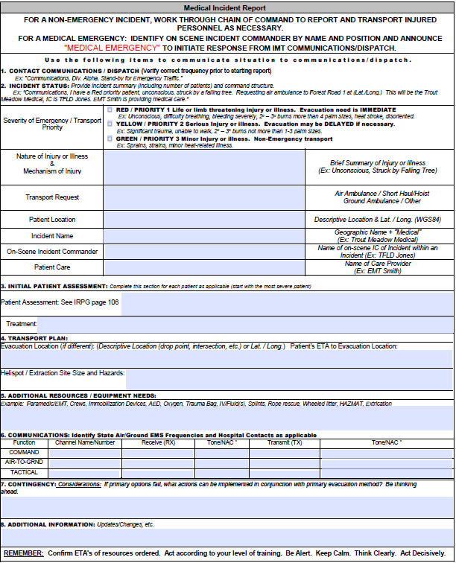

ACTIVITY LOG (ICS 214)

1. Incident Name:  YOLO RX |  | 2. Operational Period: Date From: Date To:  Time From: Time To:
3. Name: |  | 4. ICS Position: |  | 5. Home Agency (and Unit):  MSDH
6. Resources Assigned:
Name |  | ICS Position |  | Home Agency (and Unit)
7. Activity Log:
Date/Time | Notable Activities
8. Prepared by: Name: Employee Signature: Date:
ICS 214, Page 1 |  |  | Supervisor Signature: __________________ Date: __________________

