Harris Units 12, 13, 14 & 41
Prescribed Fire Report

October 12th, 2018
Shasta-McCloud Management unit, Shasta-Trinity NF

Prepared by:
Kevin J. Osborne

CONTENTS:
1 – General Information
2 – Prescription
3 – Project Implementation
Appendix A – Weather Observation Forms

- General Information

  - Site Description
Harris units 12, 13, 14 and 41 are contiguous to each other and combine for a total of 340 acres, all which were burned on 10/12/2018. All of the units were included in the Harris Vegetation Management Project. Overall the project area is mostly flat with some small concave features, sitting at an elevation of 4,650 ft.
Vegetation in the unit consists of an open overstory of mixed conifer, with Ponderosa Pine (Pinus ponderosa) as the most frequently occurring spices, followed by true firs (Abies sp.), Doug fir (Pseudotsuga menziesii) and Incense cedar (Calocedrus decurrens). The understory consists of pockets of brush, comprising 25-20%, grass and forbs comprising 25-30% and the remainder timber litter and slash. Large portions of the burn unit have been previously logged, resulting in the open stand condition and surface fuel accumulations. Overall, the stand is best characterized as fuel model TL3, moderate load conifer litter. Due to past activity in the stand, the areas dominated by brush average 2-3 ft. in height and are not the primary carriers of fire through the unit, though brush species such as Greenleaf manzanita (Arctostaphylos patula) and bitter brush (Purshia tridentata) still contribute to heat pulses into the crowns of overstory trees when they are available to burn.
At the time of implementation, fuel moisture samples had not been collected recently, but shortly after implementation (10-15-2018), live fuel moisture of Greenleaf Manzanita at the McCloud Flat site off of the Pilgrim Creek Road was 106%. At the same site, 1000 hr. dead fuel moisture on 10-15-2018 was 17%. In the 30 days prior to ignitions, the Ash Creek RAWS collected approximately 2.1 inches of rain, all between 9-30-2018 and 10-5-2018. This weather station is the closest and most representative station to the burn, sitting 17 miles SW of the burn unit on the same geographic feature, the McCloud Flats.

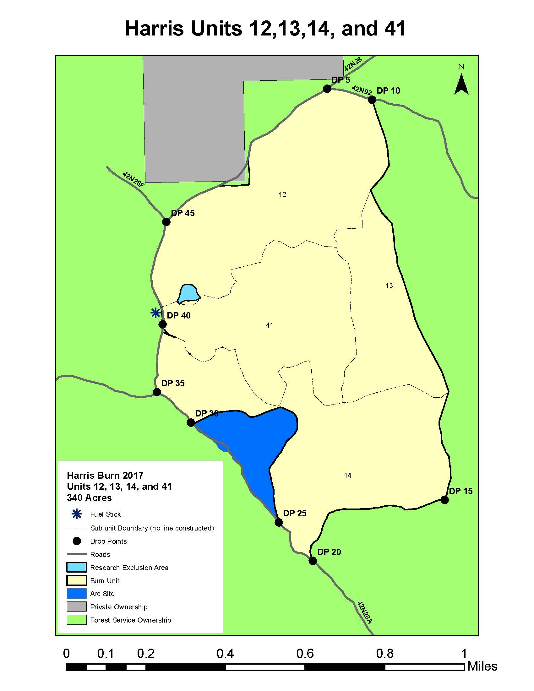
Figure 1 Map of Harris Units 12, 13, 14 and 41.

  - Project Objectives
1.2.1 Resource objectives:
- Reduce surface and ladder fuels to reduce future fire intensities
- Reduce activity fuels generated in harvest activities
- Restore fire to its natural role in the ecosystem.
- Manage vegetation to a level that results in healthy forest stands, productive wildlife habitat, and good scenic quality.

1.2.2 Prescribed Fire Objectives:
- Consume 20-50% of the duff layer
- Consume 40-100% of 1hr. and 10hr fuels
- Consume 40-85% of 100hr fuels
- Consume 30-70% of the brush component
- Reduce overall surface fuel loading by 1-15 tons per acre
- Induce mortality of 50-100% in trees less than 4 inches dbh.
- Induce mortality of 20-50% in trees 4-8 inches dbh.
- Induce mortality of less than 10% in trees 9-14 inches dbh.
- Limit mortality of trees over 14 inches dbh to 5%

- Prescription

  - Environmental Prescription
 | Prescription  Low Intensity | Prescription  High Intensity | Observed  Low Intensity | Observed  High Intensity
Mid Flame Wind Speed (mph) | 0 | 10 | 0 | 2
Dead Fuel Moisture 1hr. % | 12% | 4% | 10% | 4%
Relative humidity % | 50% | 15% | 44% | 16%
Dry bulb Air temp °F | 35°F | 85°F | 51 °F | 66°F

- Project Implementation

3.1 Organization
Burn Boss – Steve Clark RXB2 / Adam Zaharris (t)
Firing – Pat Bell FIRB
Aerial ignitions – Heather McRae
Firing East – Josh Hernandez/ Adam Koeller (t)
Firing west – Justin Regelin / Isaac Obst (t)
Holding – Mike carter
Ignition and Holding – approximately 50 additional personnel from units across the Shasta-Trinity NF and Modoc NF

3.2 Days Events – 10-12-2018
- 0800 - Briefing @ McCloud district office
- 1030– Initiate test fire
- 1115 - Test fire declared success, target 340 acres
- 115-1200 – small spots caught in archeology exclusion area
- 1215 – Helicopter 506 arrived at scene for recon of unit.
- 1225 – Started aerial ignition from PSD.
- 1320 – East ignition group arrives at DP 15, begins heading north along line
- 1400 – Helicopter 506 back to ash creek for fuel cycle
- ~1530 – Helicopter 506 returns after fixing PSD machine and fueling
- ~1610 – complete aerial ignitions
- 1630 – complete all ignitions
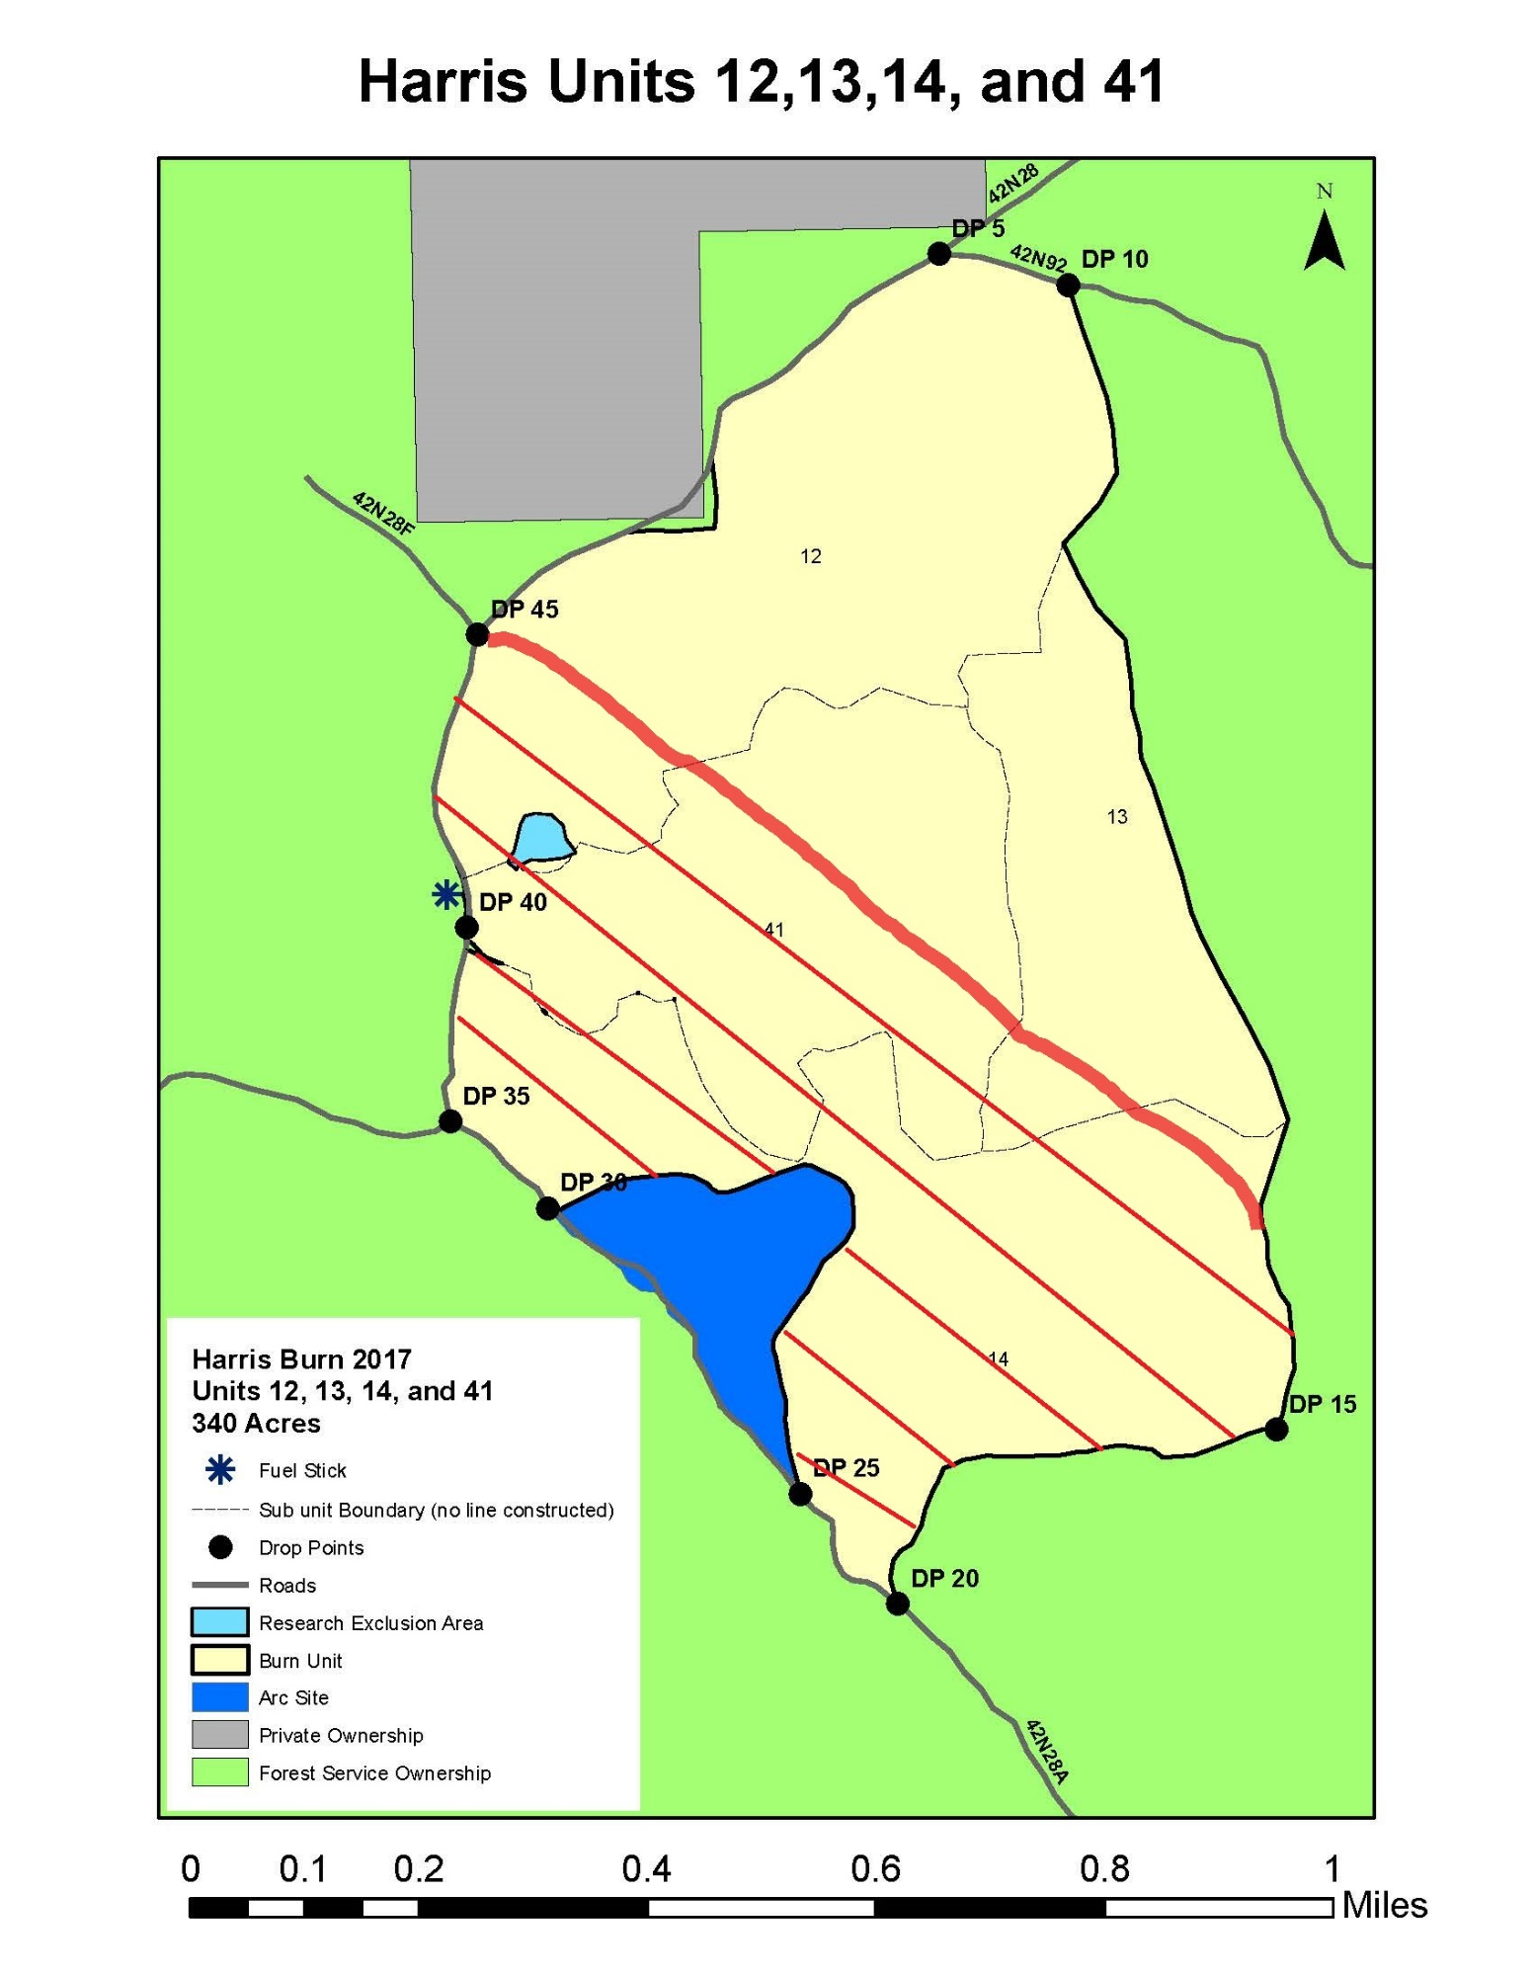
Figure 2 Approximate area completed by helicopter 506 on first fuel cycle.
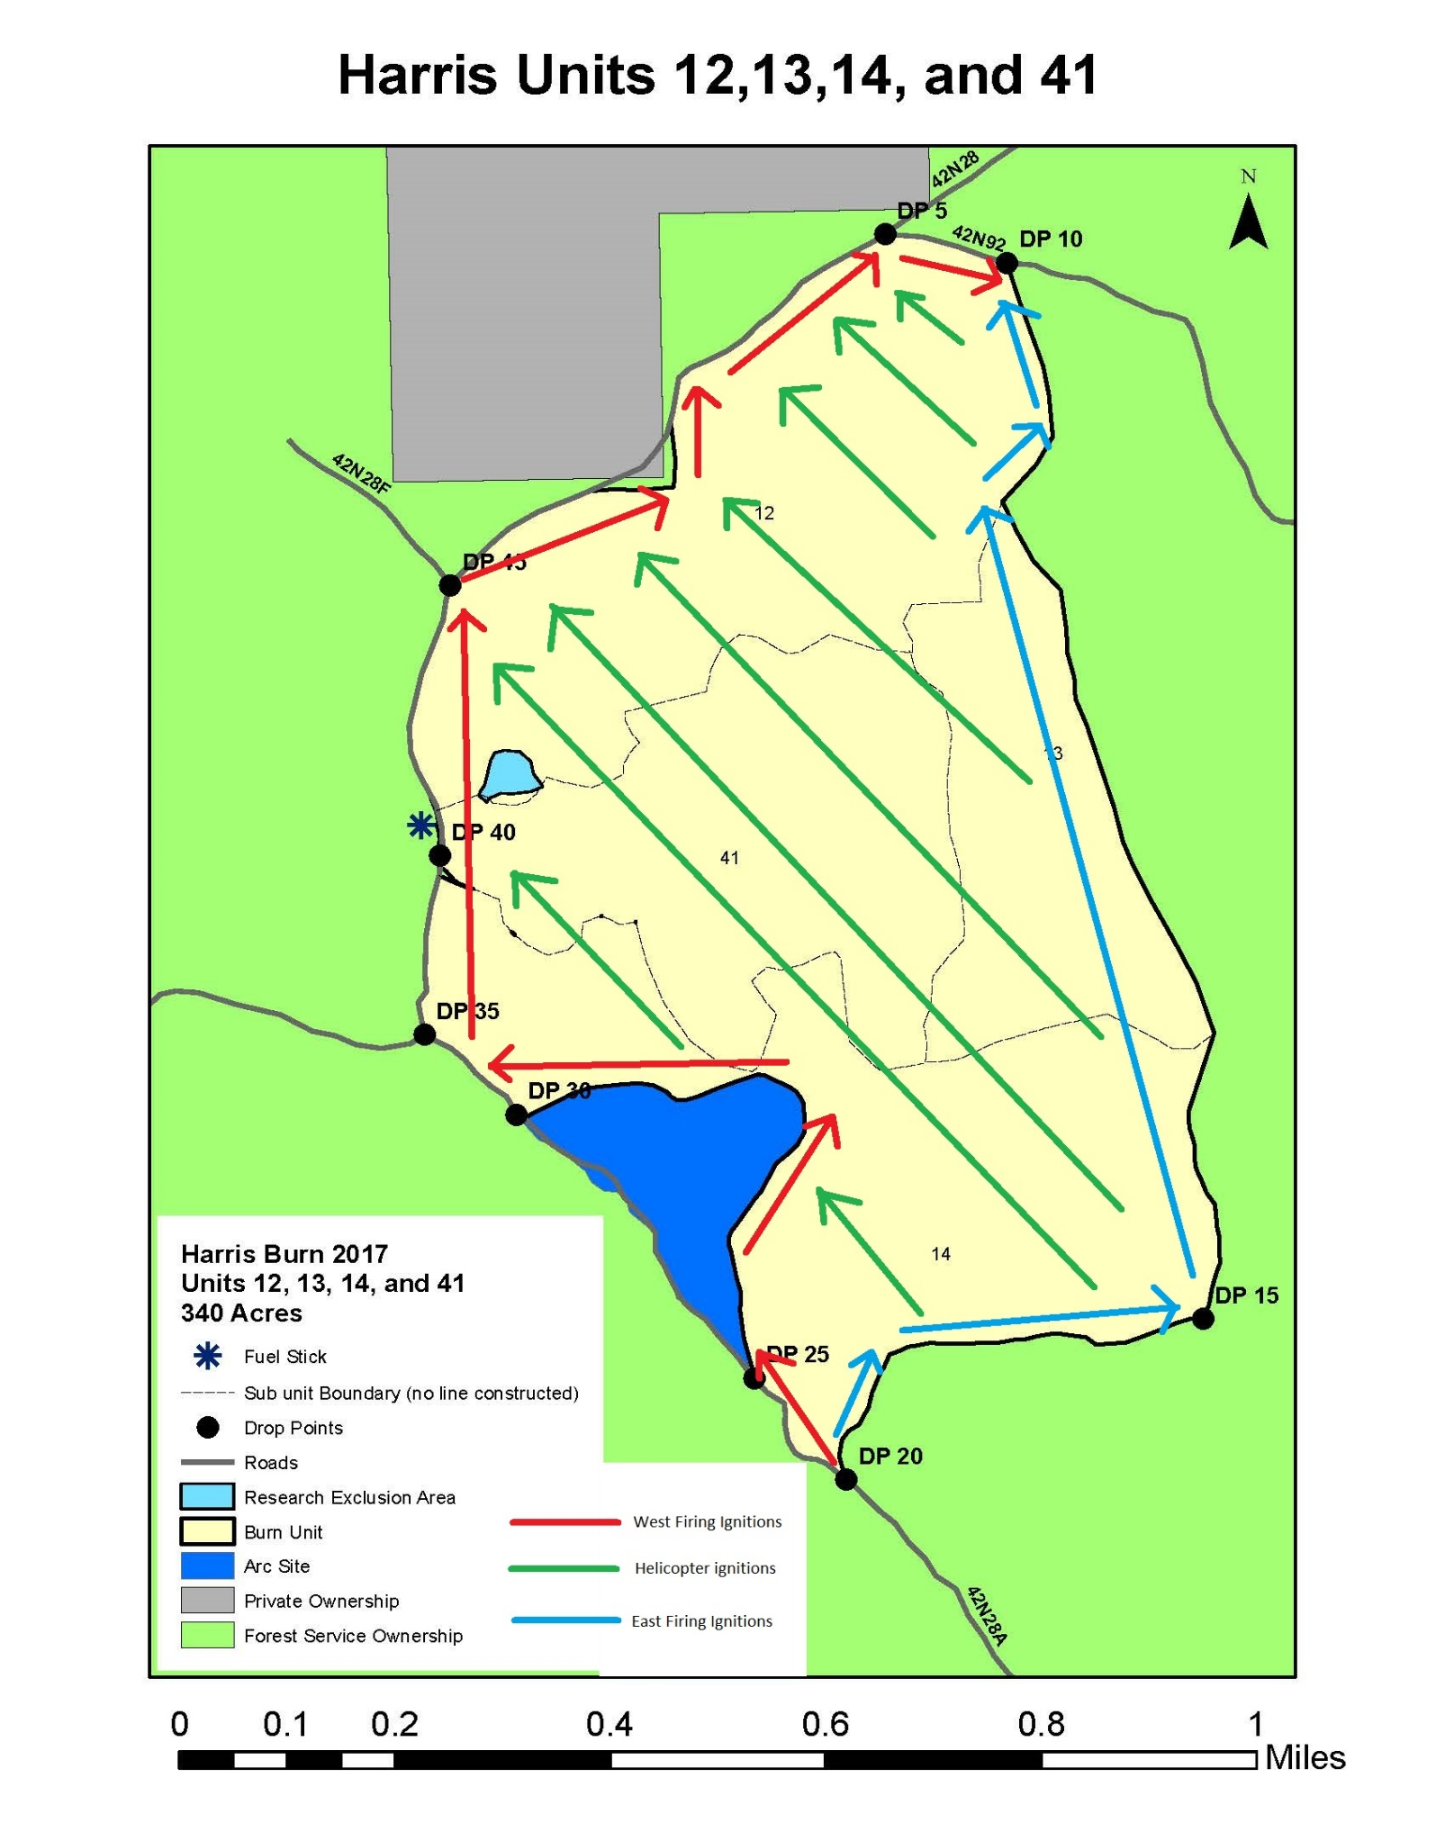
Figure 3 Map Showing the approximate pattern of ignitions. Helicopter worked southern area first, dropping PSD balls in the direction shown on the map. Ignitions were completed at the north end of the unit in the vicinity of DP10. Test fire was conducted at DP 20.

3.3. Fire Behavior Summary
Fire behavior was initially very moderate, with flame lengths of less than 1 foot in needle littler and light grass. Rates of spread were well below 1 chain per hour. As the test fire moved in areas of light brush, higher flame lengths approaching 2 ft. were observed with occasional max flame lengths of 3-4 ft. Smoke remained light gray in color and very light in volume during the test fire (see figure 4).
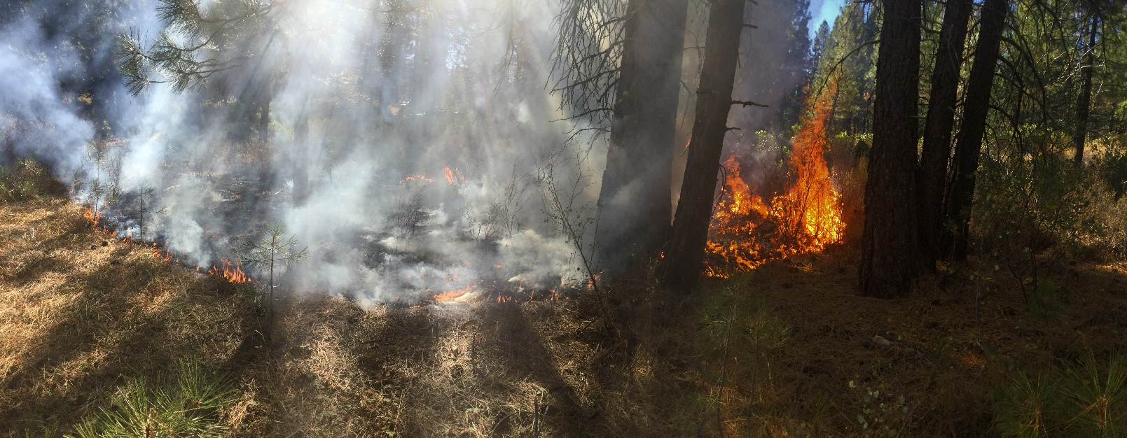
Figure 4 Test fire showing difference in fire behavior from litter and brush fuels. Photo taken at 10:37 hours.

Once the test fire was completed, ignitions moved up the western flank of the unit. Ignitions moved slowly to avoid putting smoke into the view of anticipated helicopter operations. Winds were very light at this time and were out of the S and SE, which differed from the predicted NE. As ignitions neared the archelogy exclusion rea, see figure 1, several small spots were extinguished, furthers lowing progress along the west edge of the unit (figure 5). Fire behavior in this area consisted of 2-3 ft. flame lengths in brush fuels with the rate of spread reaching approximately 1 chain per hour. Flame length and rate of spread were significantly lower in the timber litter fuel type.
As ignitions progressed along the southern boundary, the area SE of the archeology exclusion to become available for aerial ignitions, see figures 3 and 6. Fire behavior from initial aerial ignitions was in timber litter and resulted in low flame lengths and rates of spread well below 1 chain per hour. Once the spot fires were handled and west ignitions continued to the north, Helicopter 506 was able to also conduct ignition operations NW of the exclusion area and in the vicinity of the PSW research plot, light blue on map ion figure 1.
Helicopter 506 finished the small triangle SE of the exclusion area and the space between the research plots and the exclusion area at approximately the same time as east ignitions group brought fire to DP 15, which allowed for longer passes to be completed by the helicopter, moving diagonally across the entire unit from SE to NW.

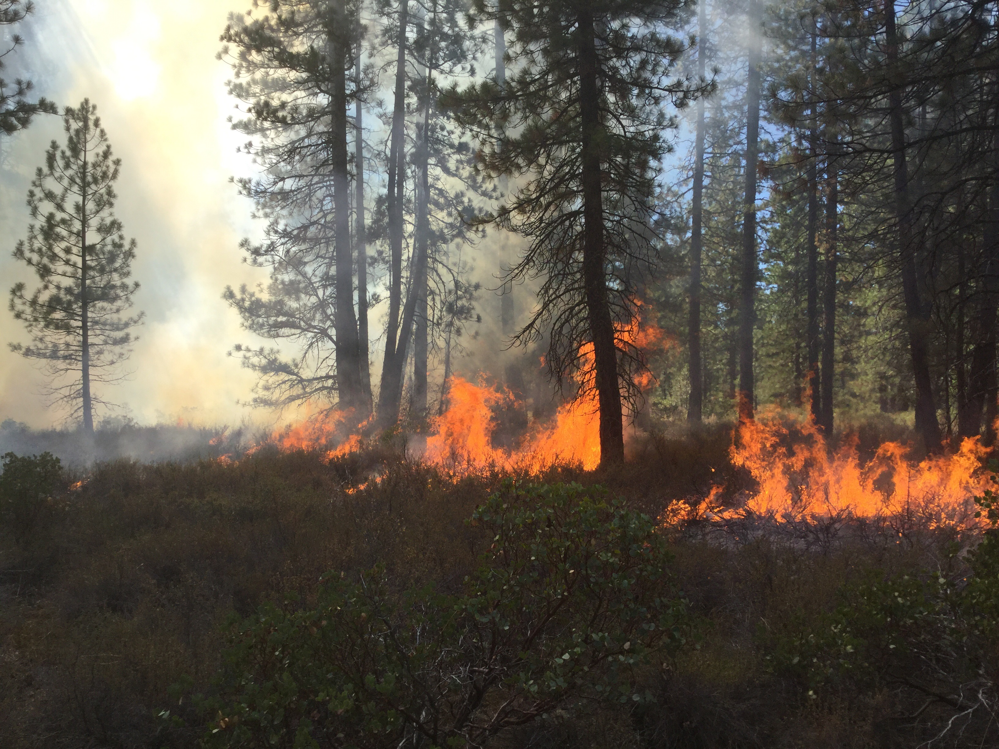
Figure 5 Fire behavior along west edge of unit in brush fuel component at the time small spots were extinguished with the archeology exclusion area (shaded blue in figure 1). Photo taken at 11:21 hrs.
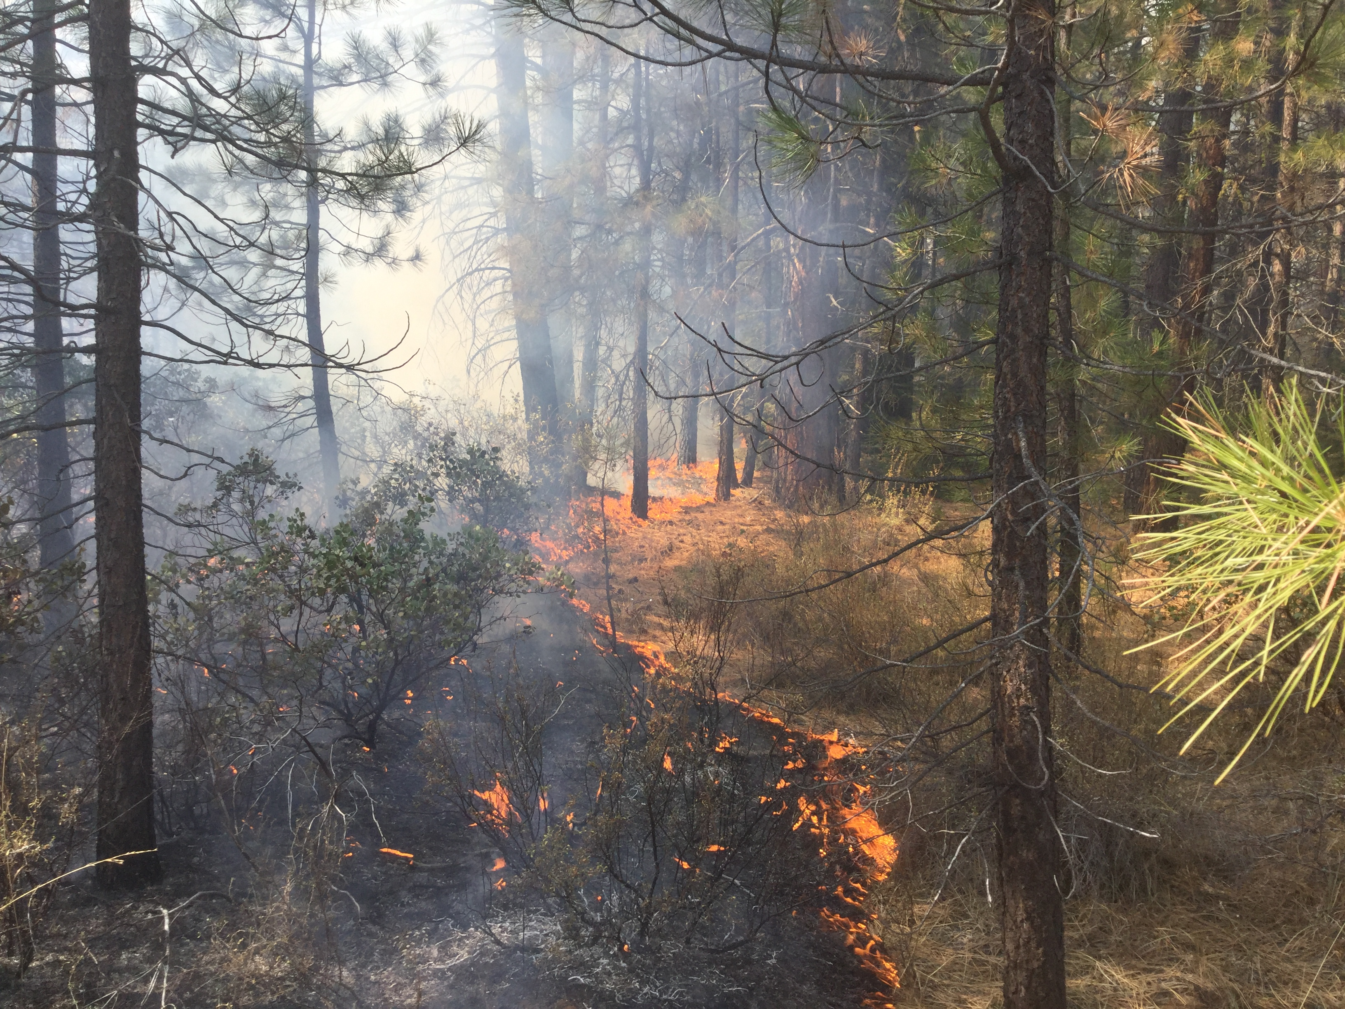
Figure 6 Fire behavior along southern boundary of the unit as helicopter 506 worked to fill in triangle SE of the archeology exclusion area. Photo taken at 1240 hours.
At approximately 1400 hrs. Helicopter 506 returned to ash creek for fuel, allowing an opportunity to assess interior fire behavior. The line of fire interior that was in place at this time is shown in figure 2, with approximately ½ of the unit being ignited. It was a very straight edge, the only bellies coming from PSD balls that did not ignite or that did not result in ignition of the fuels. Flame lengths were generally <2 ft. in the majority of the unit, which was dominated by timber litter from long needle and short needle conifers. Where ignition dots grew together, flame lengths increased to 4 ft. for brief periods, lasting less than 1 minute at each intersection. Figures 7 and 8 demonstrate the typical fire behavior observed on the interior of the unit between 1400 and 1430 while traversing from SE to NW along last line of ignitions from 506 before finishing first fuel cycle.

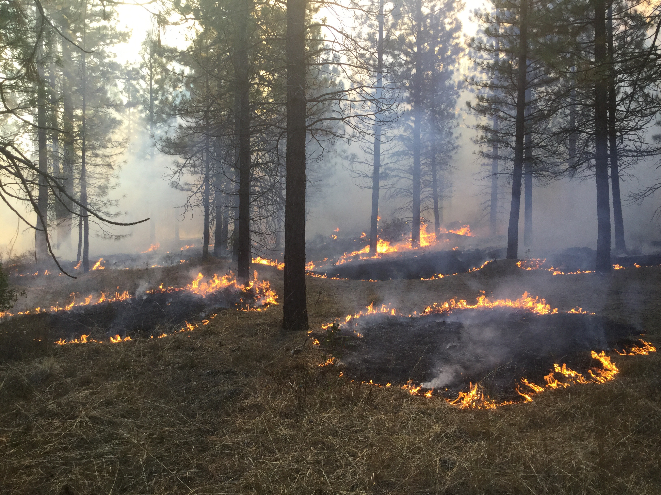
Figure 7 Initial fire behavior from firing dots created from PSD operations on interior of the unit. Photo taken at 1400 hours.
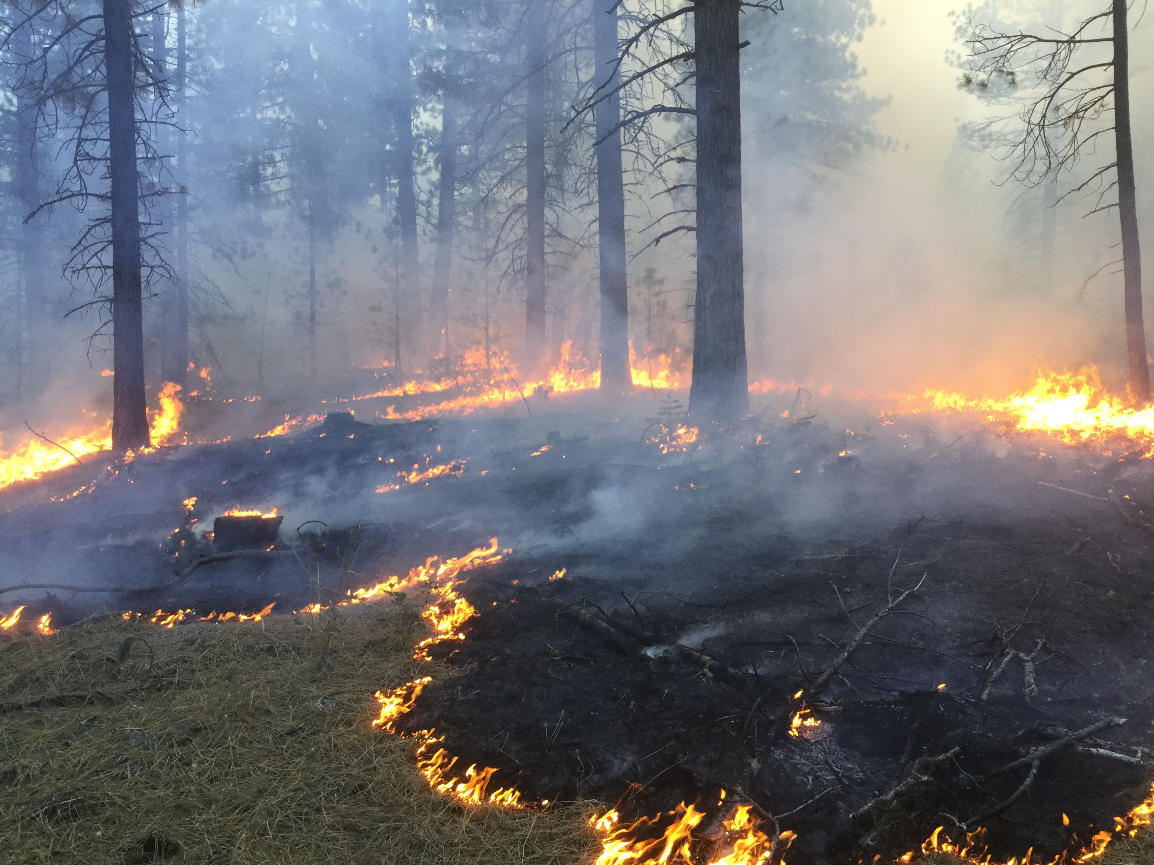
Figure 8 Increase in fire behavior exhibited when dots from PSD operations grow together. Photo taken at 1408 hours.

Upon return from fuel cycle, helicopter 506 completed the remainder of the unit and both ignitions groups worked towards DP 10. The 2 firing groups on the outside of the unit met just south of DP to complete ignition operations. Fire behavior was moderated while the helicopter was gone for its fuel cycle due to shading from the column and from the lack of heat generated by any addition ignitions. Upon return of the helicopter and resumption of interior ignitions, heat was generated sufficient to increase fire behavior and result in significant smoke development. Flame lengths of 2-3 ft. were observed, see figures 9-11. Shortly after aerial ignitions were complete, the heat from the last 2 lines of PSD ignitions came together, creating a small pocket of torching, resulting in the highest flame lengths and most severe fire effects observed over the course of the day.
Overall consumption of fuels was very good. Throughout the day, surface litter consumed at least 75%, in most locations close to 100% consumption litter and fine surface fuels was observed. Brush fuels did not consume fully in most areas, reaching 50-75% consumption in most areas. Coarse woody debris was still smoldering when the unit was completed for the day and a final assessment of their consumption will be available once post-burn fuel loading plots are recorded.
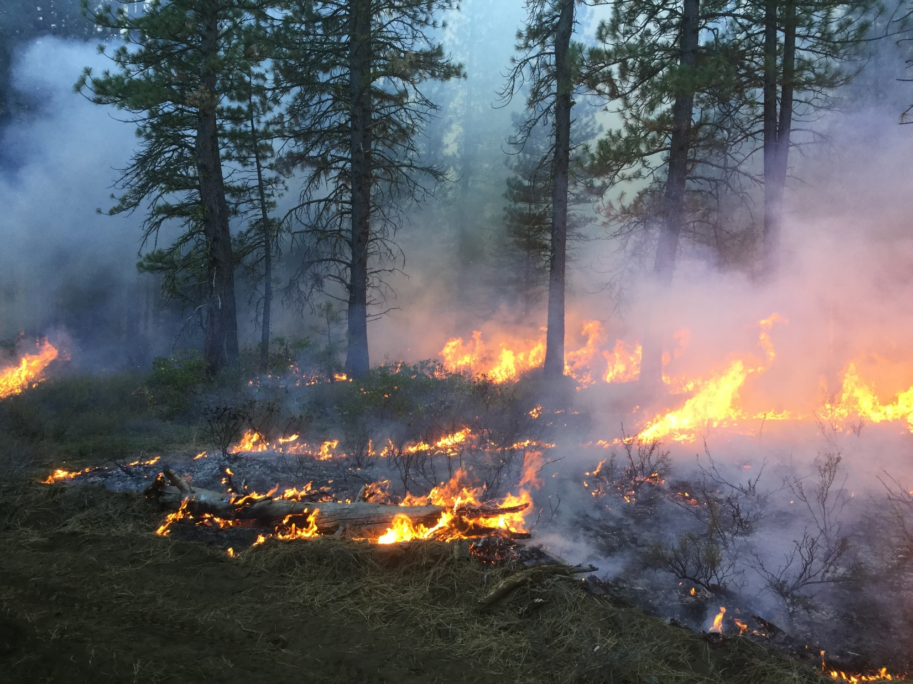
Figure 9 Increased fire behavior on north end of the unit as exterior ignitions groups neared the tie in point south of DP 10. Photo taken at 1619 hours.

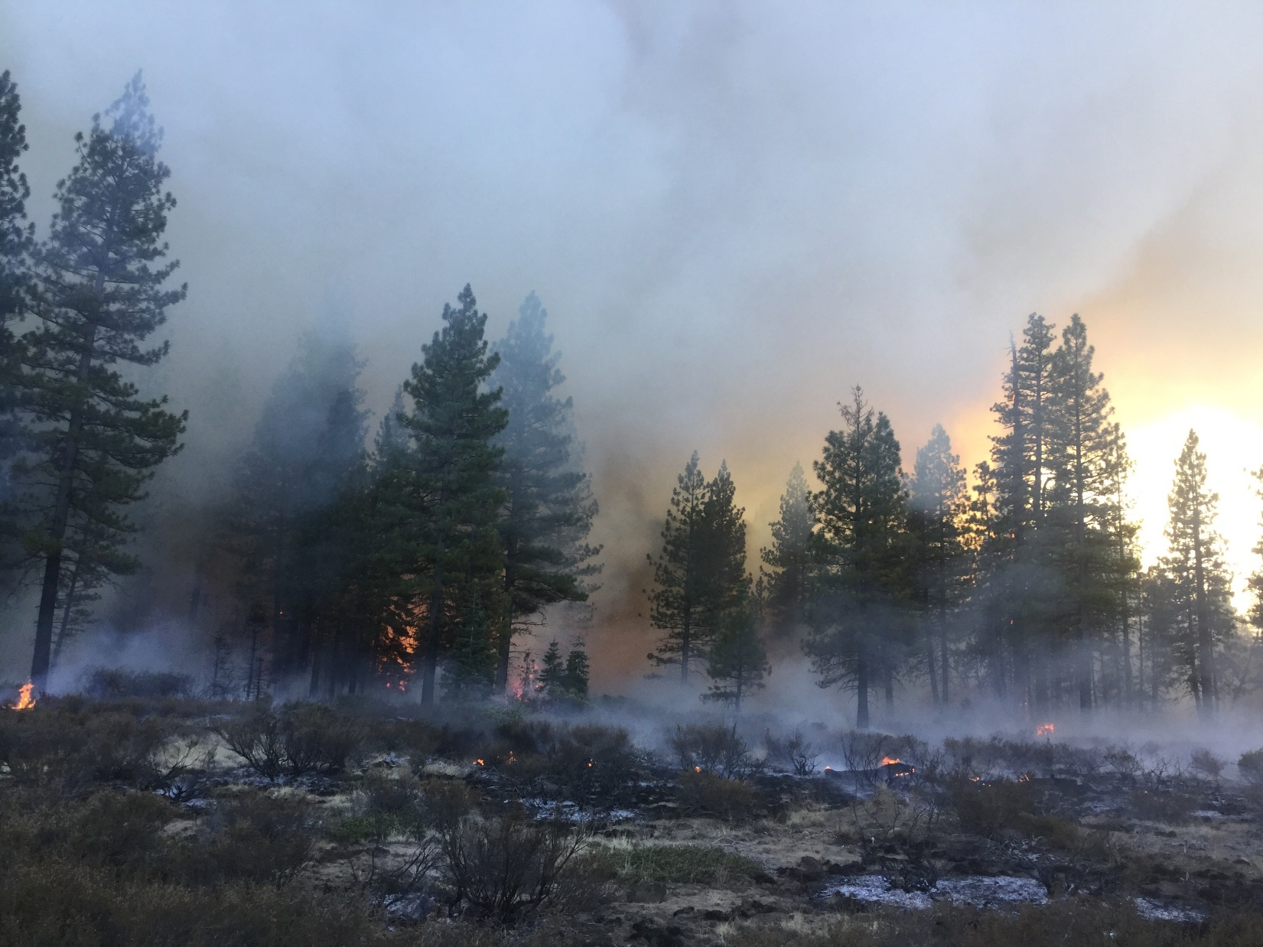
Figure 10 North end of the unit near DP showing moderate consumption of the brush with more complete surface fuel consumption. Photo also shows the patchy nature of surface fuels in the short brush patches. Photo was taken at 16:21 hours.

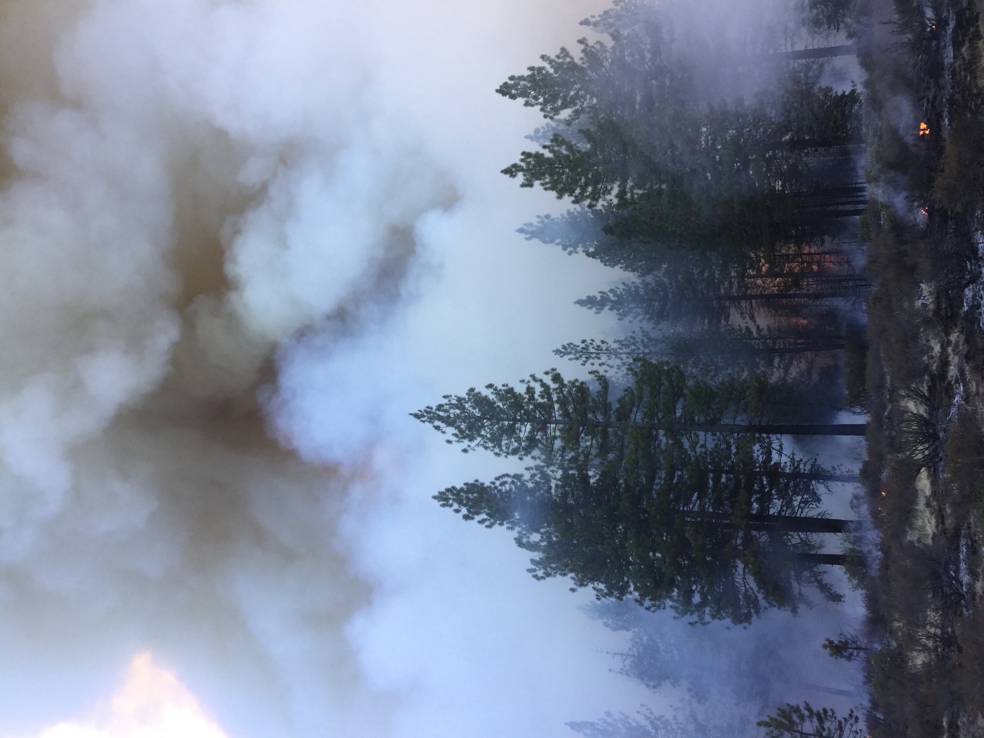
Figure 11 Smoke production at the north end of the unit shortly after completion of aerial ignitions. Photo taken at 16:26 hours.

10-12-18
Prepared By: Tim Aldridge

Observer: Tim Aldridge | Elevation 4,600ft | 42N28 Road

Time | Location | Wind Direction | Wind  Speed | Dry  Bulb | Wet  Bulb | RH% | FDFM | PIG

09:50 | Fuel Stick | N/A | 0 | 51 | 41 | 44 | 10 | 30
10:30 | Arc Site | N/A | 0 | 55 | 43 | 38 | 8 | 40
11:00 | Arc Site | W | 0-1 | 56 | 43 | 35 | 8 | 40
12:00 | Arc Site | N/A | 0 | 60 | 45 | 31 | 6 | 50
13:00 | Arc Site | W | 0-2 | 61 | 45 | 28 | 8 | 40
14:00 | Arc Site | W | 0-2 | 65 | 46 | 22 | 5 | 60
15:00 | Arc Site | N/A | 0 | 65 | 45 | 19 | 4 | 70
16:00 | Arc Site | N/A | 0 | 66 | 45 | 16 | 5 | 70
17:00 | Arc Site | N/A | 0 | 63 | 45 | 23 | 6 | 50

