Green Mountain
Prescribed Fire Report – C Block

February 25th 2018
Shasta Lake Ranger District, Shasta-Trinity NF

Prepared by:
Ryan Means
Kevin J. Osborne
R.J. Reierson

CONTENTS:
1 – General Information
2 – Prescription
3 – Project Implementation
Appendix A – Photo Plots
Appendix B – FEMO Observation Forms

- General Information

  - Site Description
The entire unit is within the Green Mountain project site on the Shasta-Trinity NF in Northern CA. The purpose was to burn areas of brush that previously didn’t burn in the spring of 2017 for approximately 400 acres. C Block is approximately 700 acres and lies in the Eastern portion of the project area and borders the Pitt River Arm of Shasta Lake. The bottom of the burn is at an elevation of 1,060 ft. at the high water line on the lake, and the top of the unit is on a ridge to the West of Green Mountain, at an elevation of 1,750 ft.
The vegetation in the project area consists of montane chaparral, mixed conifer and oak species (40% chaparral 20% conifer and 40% hardwoods). The unit was previously burned in 2017, resulting in a mosaic of size classes in the brush, ranging from dense stands with 10 ft. tall manzanita containing a significant component of dead material in areas that did not consume in previous entries, and shorter, less dense stands that contain a much lower percentage of dead material where consumption was higher in the previous entry.
There are also pockets of mixed conifers (Douglas Fir, Ponderosa Pine, and Knobcone Pine) mainly in draws and on northern exposures. There are large areas of decadent, closed stands of shrub species (Brewers Oak, Canyon Live Oak, Manzanita, and Chamise), most with a large dead component. Due to the condition of the montane chaparral (large Manzanita, 10 feet tall) and Brewers Oak during the planned project implementation, both within and adjacent to the area, FM TL9 represents the burning characteristics of the area and will be used to model all BEHAVE runs for the project.

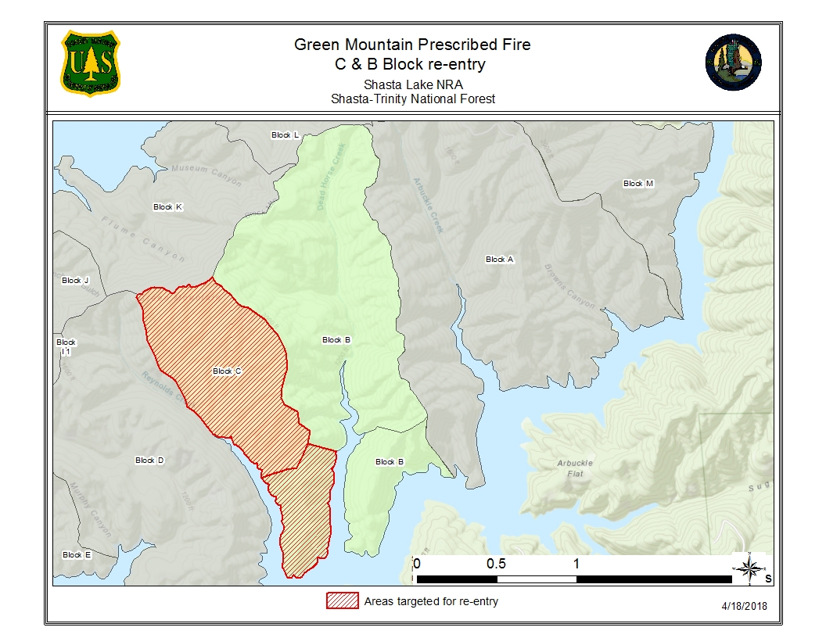

  - Project Objectives
1.2.1 Resource objectives:
- Manage selected chaparral lands to create a natural mosaic.
- Manage vegetation to a level that results in healthy forest stands, productive wildlife habitat, and good scenic quality.
- Reduce fuel loading in order to reduce likelihood of fire from lake recreation activities resulting in high severity wildfire.
- Improve stand health by reducing stand densities and using fire to mimic the historic role of fire in the ecosystem.

1.2.2 Prescribed Fire Objectives:
- Consume 30-50% of the duff layer
- Consume 60-80% of 1hr. and 10hr fuels
- Consume 30-70% of 100hr fuels
- Consume 30-50% of the brush component
- Induce mortality of 50% of Knobcone Pine & Gray Pine, with an acceptable range of 25-75%
- Limit mortality of mature Black Oak, Ponderosa Pine, and Douglas Fir to 5%, with up to 20% mortality acceptable.

- Prescription

  - Environmental Prescription
 | Prescription  Low Intensity | Prescription  High Intensity | Observed  Min. | Observed  Max.
Mid Flame Wind Speed (mph) | 0 | 10 | 0 | 8
Dead Fuel Moisture 1hr. | 13% | 5% | 1% | 12%
Dead Fuel Moisture 10hr. | 15% | 6% | 8% | 9%

  - Prescribed fire Prescription
 | Prescription  Low Intensity | Prescription  High Intensity | Observed  Min. | Observed  Max.
Flame Length (ft.) | 0 | 6’ | <1 ft’ | 3’*
Spread Rate (ch/hr) | 0 | 25’ | < 1 | 6
Scorch Height** | 0 | 20’ | 0 | 15’
*Observed flame lengths were along black line operations, higher flame lengths were likely observed interior during aerial operations, but due to location and views it was not possible to determine them accurately
** Observed scorch height minimum occurred outside Knobcone Pine, where group torching occurred. Higher scorch heights are permissible in gray pine and knobcone pine.

- Project Implementation

3.1 Organization
Burn Boss – Pat Bell RXB2
Firing – Jeff Michels FIRB
Aerial ignitions – Alex McBath, Engelkes, Eiszele
Holding – Alex Malson (t), Charles Barber
Ignition and Holding – approximately 20 additional personnel from units across the Shasta-Trinity NF.

3.2 Days Events - 02-25-2018
- 0730 - Briefing @ JV boat ramp
- 0900 – Initial check of fuel stick at 9%
- 0930 – Initiate weather observations
- 0950 – GO/NO GO COMPLETED
- 1000 – Wind change noticed, changing from NE to S
- 1005 – Test fire initiated near DP 40.
- 1022 – Test fire called successful continuing for 400 acres.
- 1045 – Helicopter 6PJ arrived at scene for recon of unit.
- 1100 – Started aerial ignition from PSD, dropping east to west 50 feet off the line.
- 1113 – 6PJ going to drop spheres down adjacent spur ridges due to delay in spheres taking in previous passes off line.
- 1122 – 6PJ Heads to Unit B to finish burning a green island, while giving spheres in Unit C time to burn.
- 1150 – Decision made to take wider passes in Unit C.
- 1158 – Increase in upslope winds out of the south observed.
- 1210 – Increase lift of smoke towards the NE observed.
- 1310 – Holding started to get “duffers” along main road near DP 40.
- 1520 – FEMO location changed to C/D line and weather observation are done from this point.
- 1540 – 50’x10’ spot upslope from DP 40 in near Green Mt. proper.
- 1550 - Cloud cover over burn area increasing
- 1553 – Ariel firing completed.
- 1626 – Ignitions completed for 400 acres.
- 1640 – Weighed fuel stick at 8%.

3.3. Fire Behavior Summary – 02-25-2018
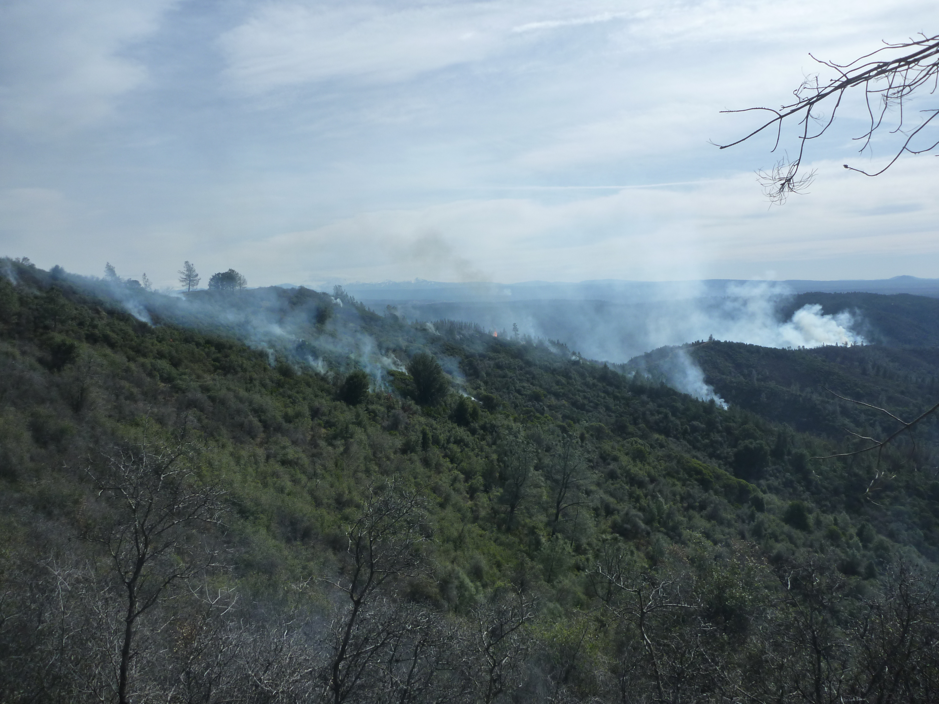Fire Behavior was primarily driven by litter in Timber/Oak stands, and decadent brush on southerly facing slopes. Burn intensity was highest in Knobcone stringers with needle draped brush where group torching and higher rates of spread were observed. As the burn continued through the day consumption in the brush increased. As the fire backed down on the southern aspect there was incidents of single brush pocket torching, and 50 % fuel consumption in the oak litter. As 6PJ progressed down the B/C line with the PSD’s fire behavior increased with short sustained uphill runs in brush patches with single and group torching in patches of knobcone pine.

Figure 1. Shows south facing slope near test fire location and DP 40 while 6PJ ignites island in Unit B allowing time for PSD passes to ignite and come together. Compare to Figure 2 as a before and after when fire behavior picks up in bowl.
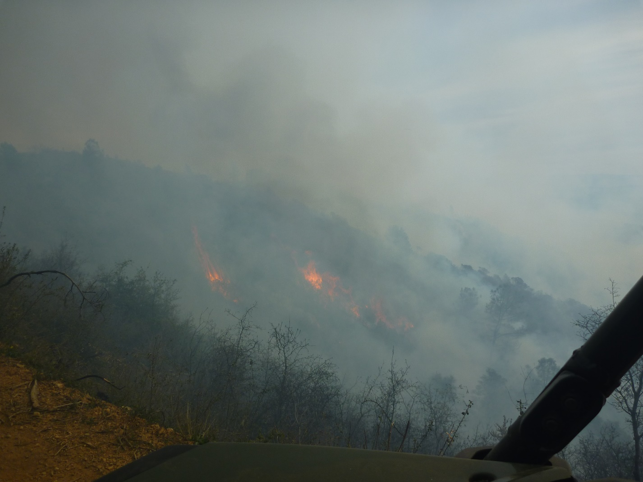
Figure 2 shows fire behavior making up hill runs with pockets of torching brush in same area as Figure 1. Also shows the increase of behavior as the heat of the day approached.

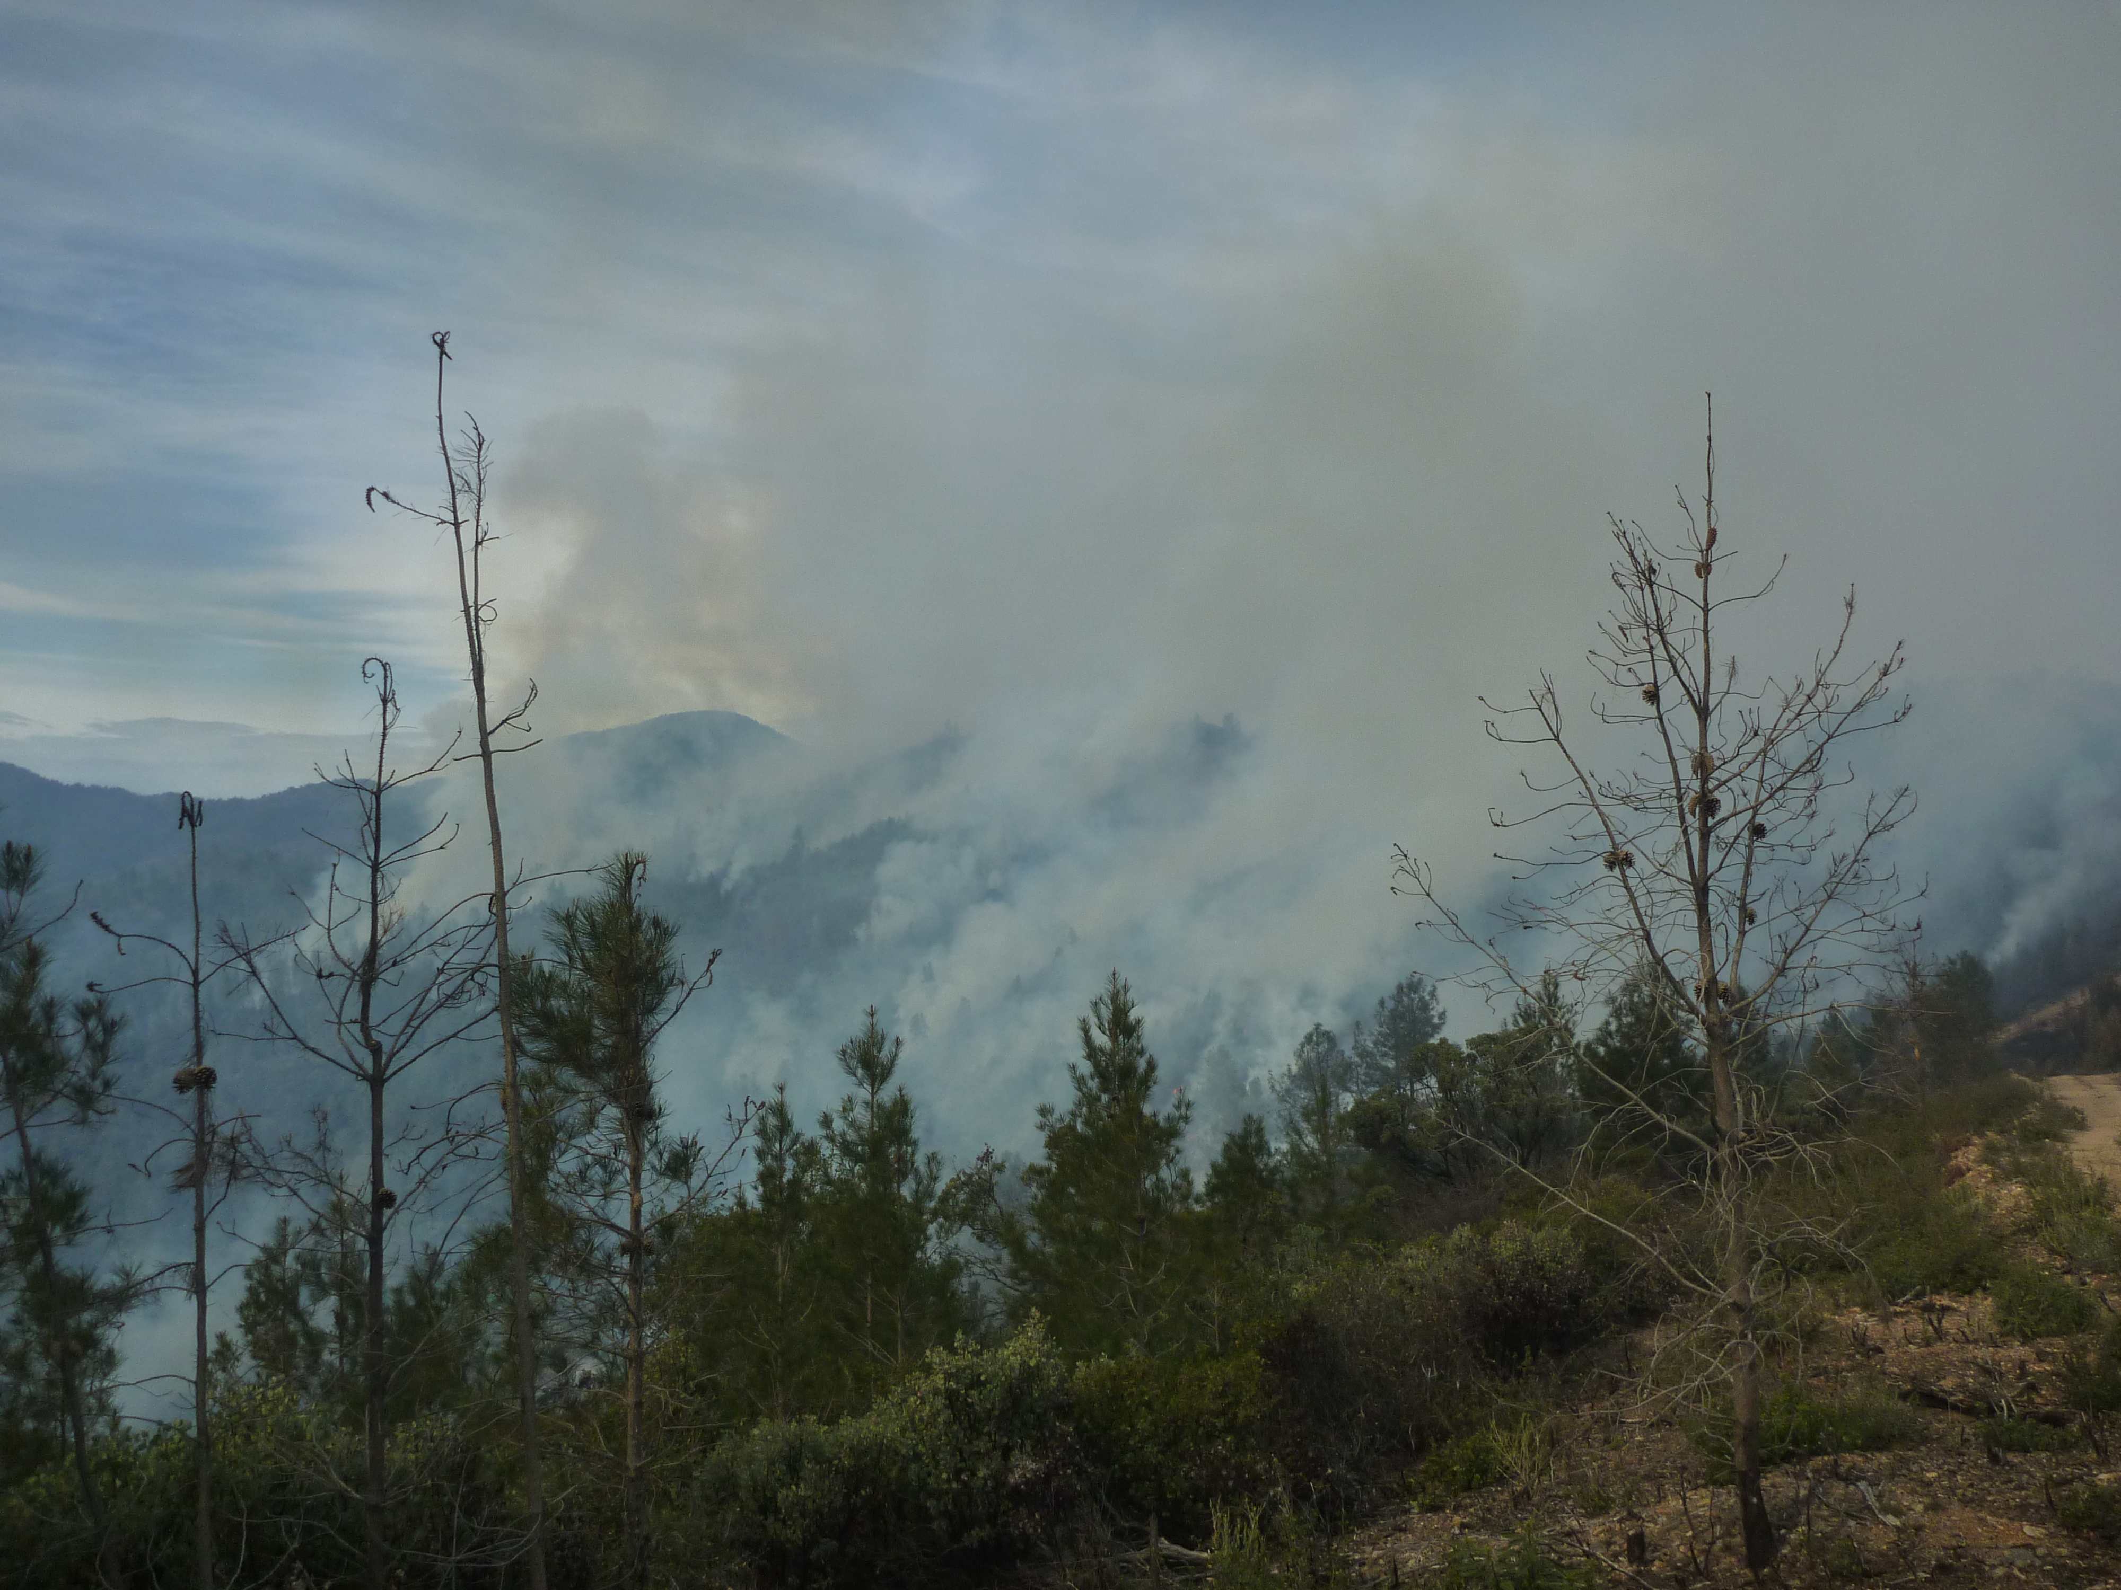
Figure 3 shows fire behavior and smoke production SE of DP 40 in brush patches on southerly facing slopes. Refer to Figure 4 for a post burn effects photo for the same area.

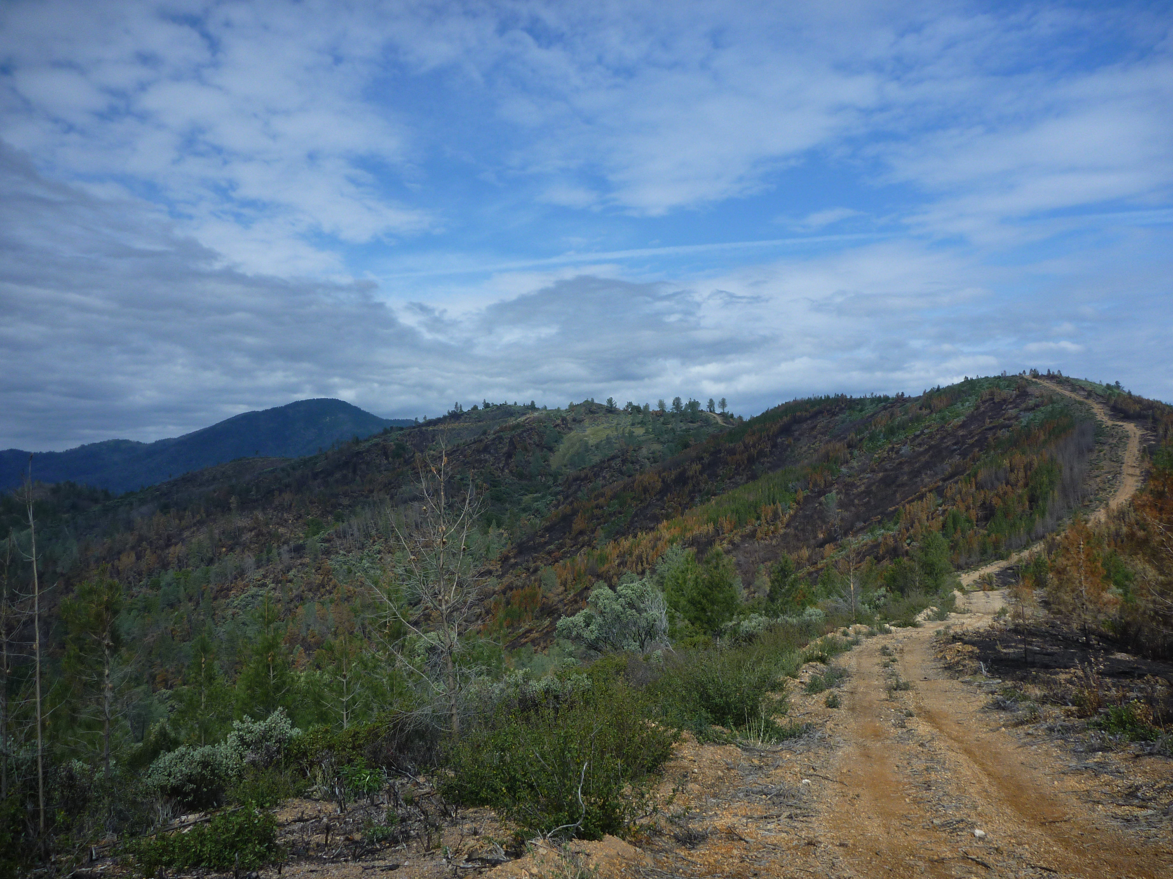

Figure 4 shows post burn effects in brush patches on southerly facing slopes with some mortality of Knobcone patches along spur ridges. Photo taken from same location as Figure 3.

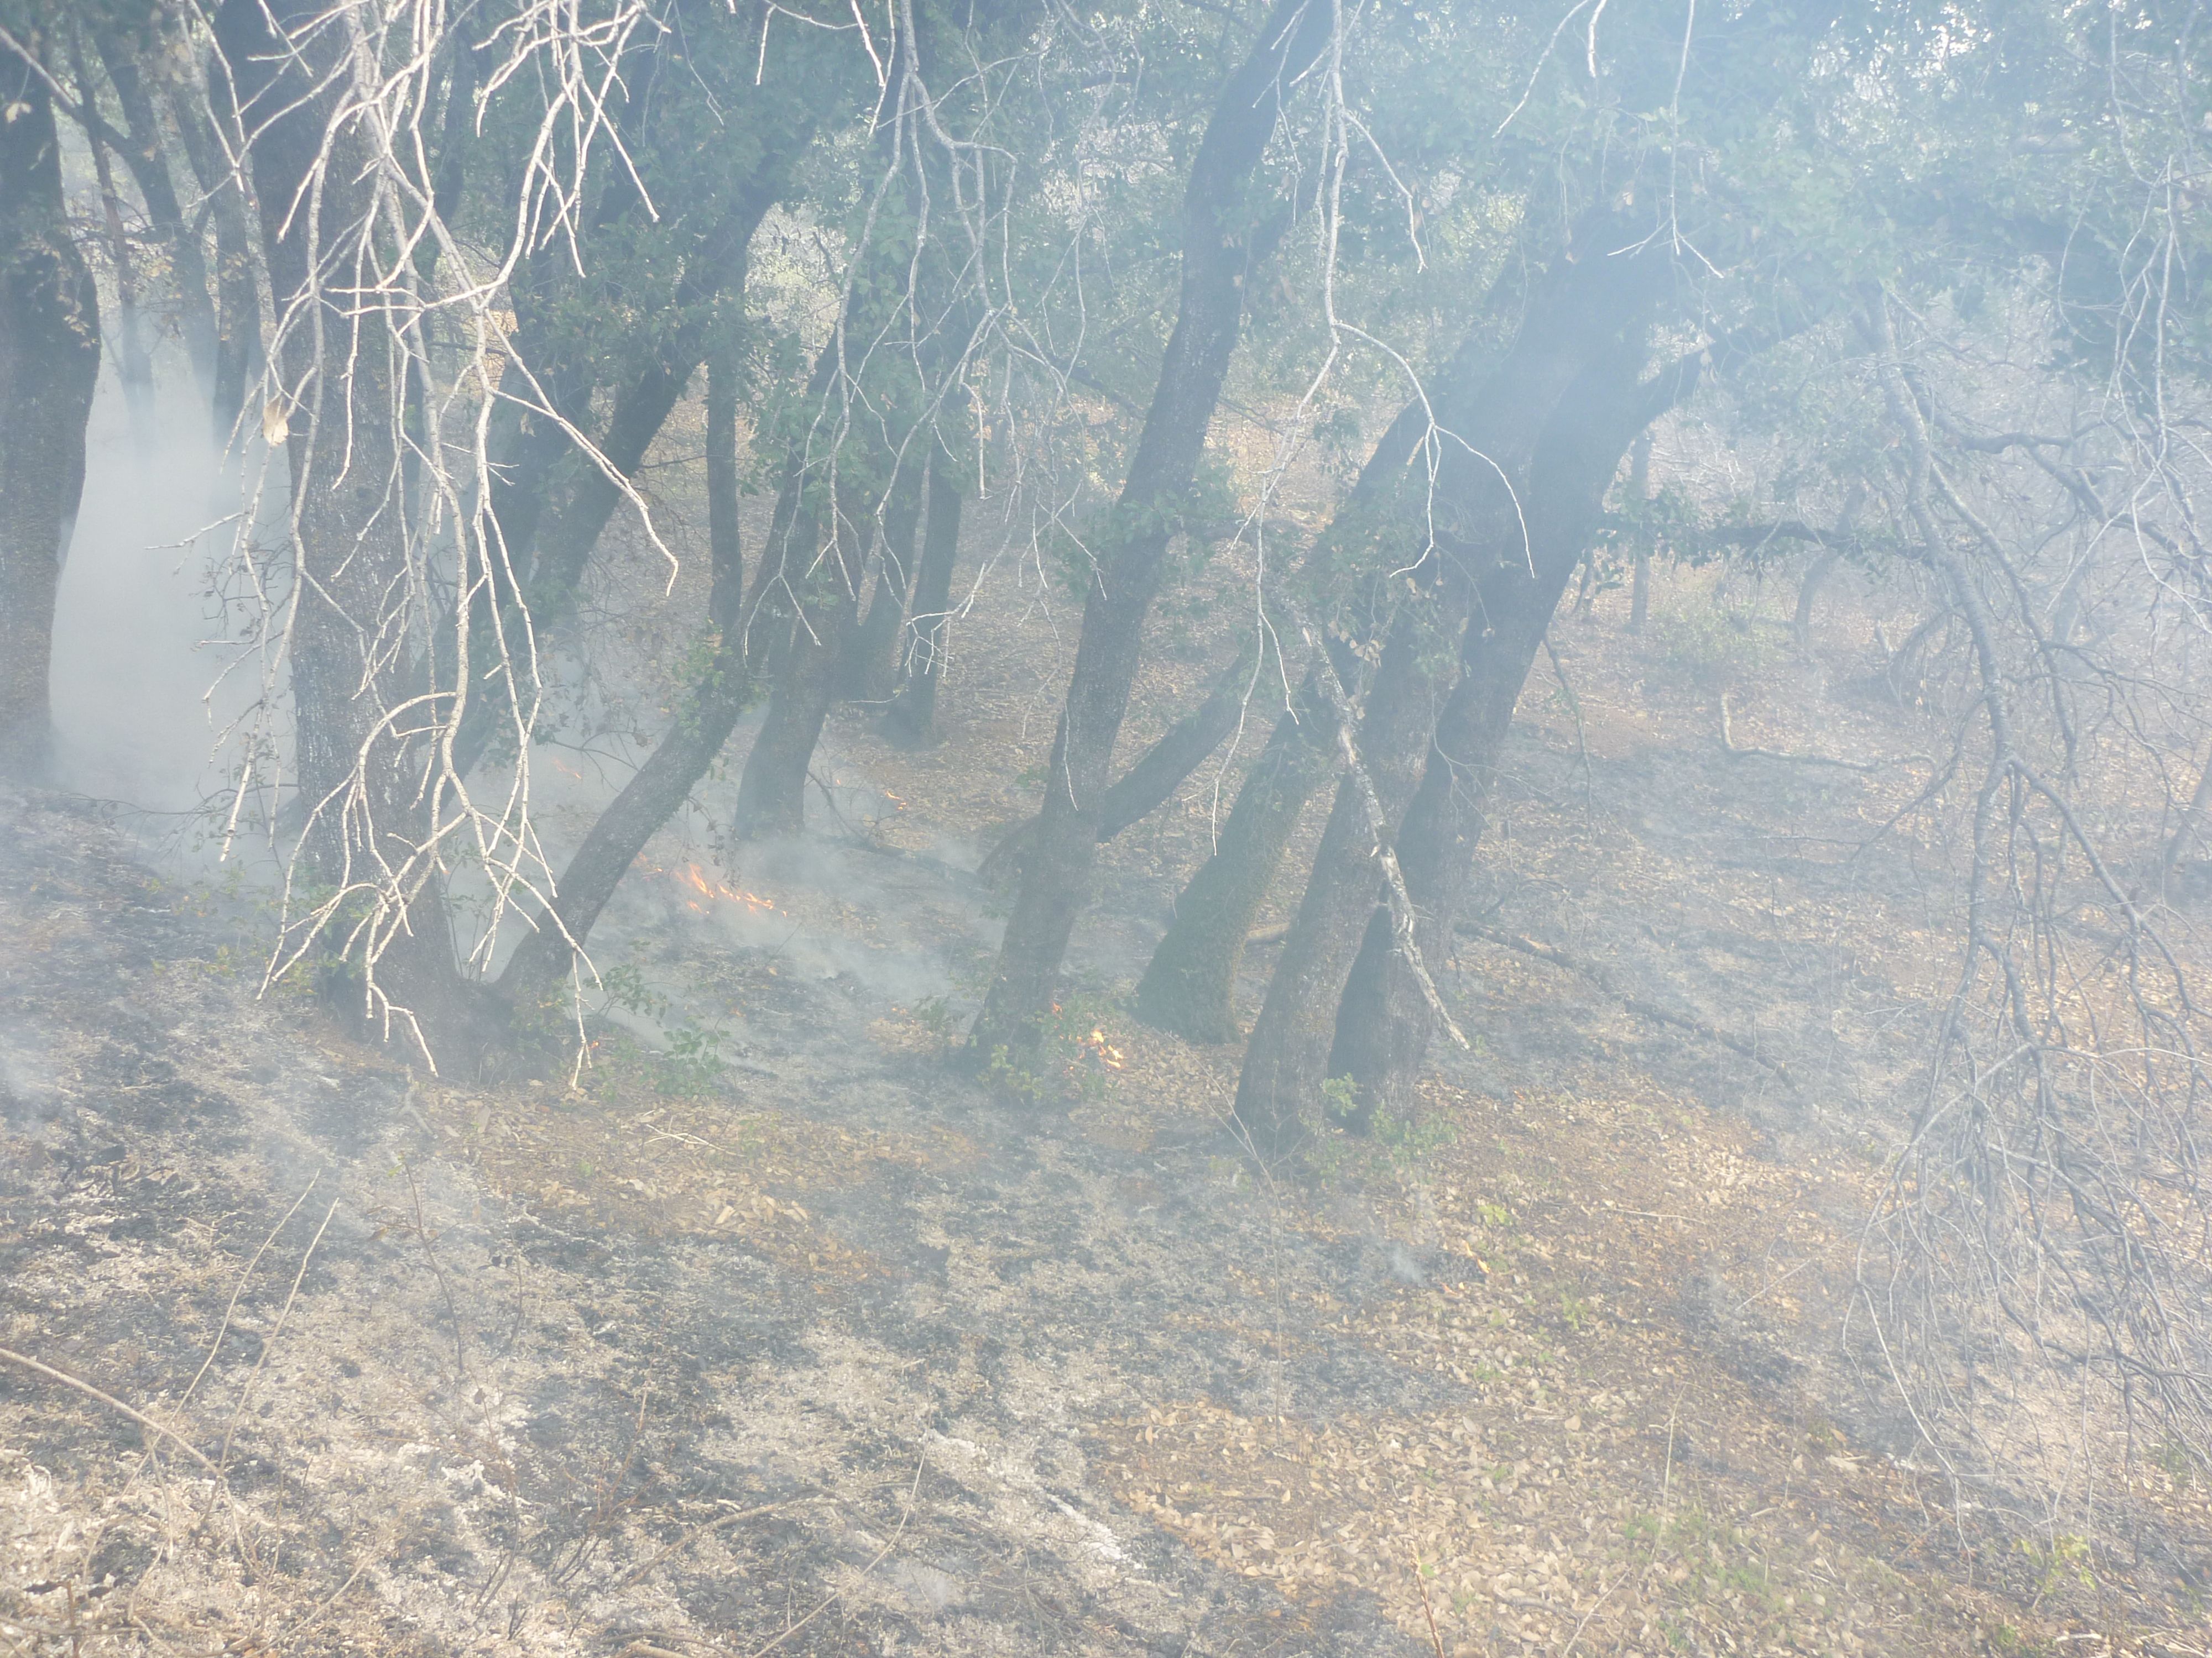
Figure 5 shows backing fire and flanking fire with consumption near 50 % in Oak litter.
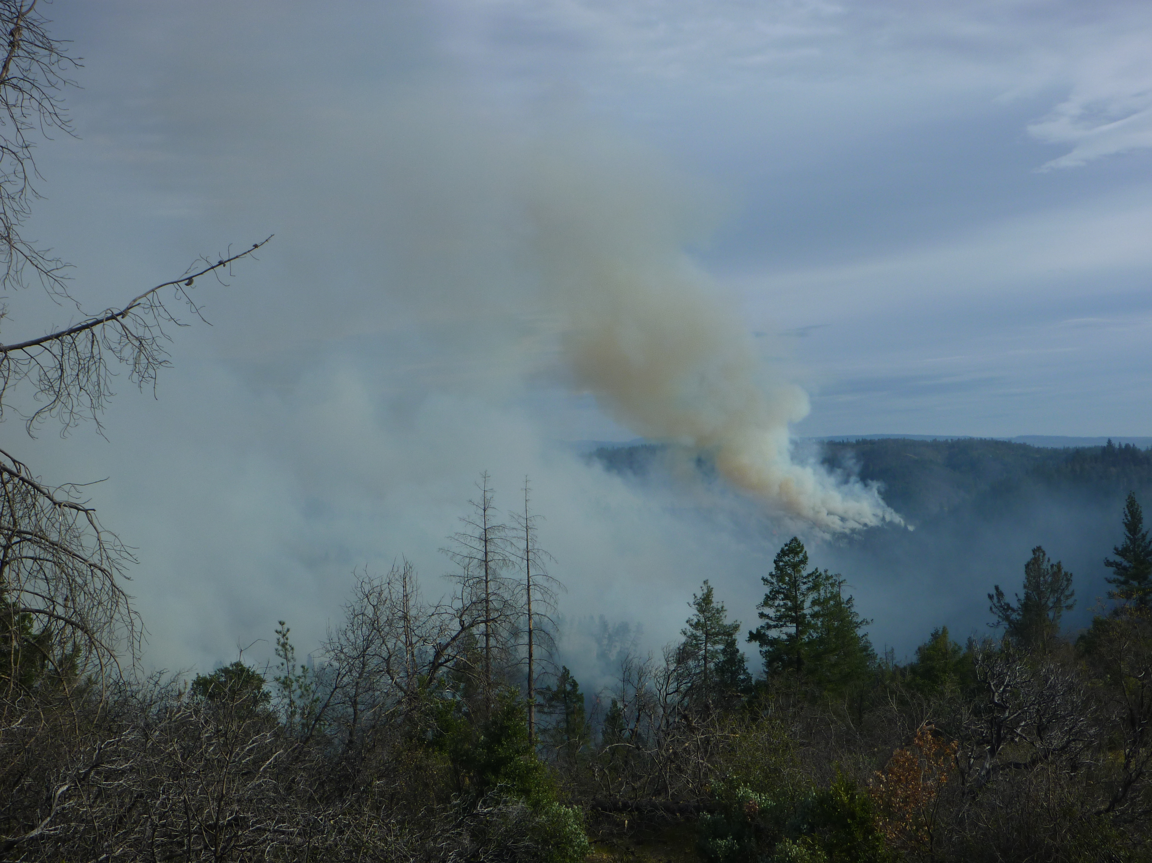
Figure 6 shows good column lift above Reynolds creek area. Also observable is single tree torching in timber on lower slopes near Pit Arm. Photo taken close to when 6PJ stopped ignitions at the completion of burn.
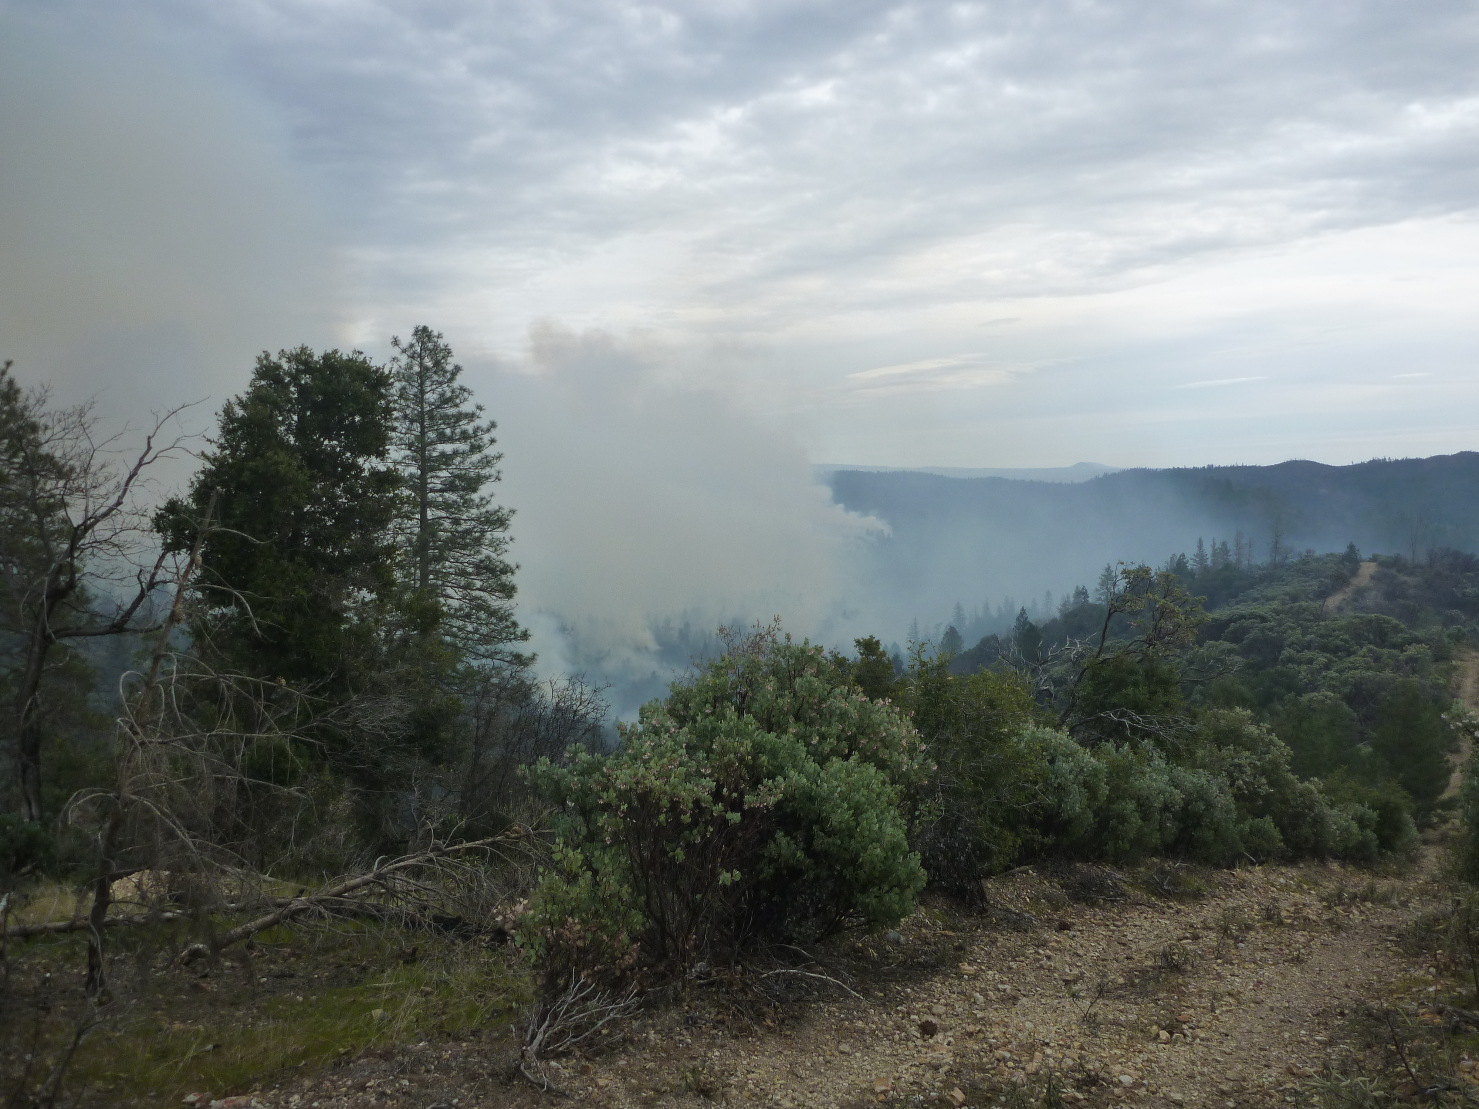
Figure 7 shows smoke beginning to settle into the Reynolds Creek drainage.
Initial ignition struggled to meet consumption objectives with the exception of knobcone stringers along intermediate ridges (Figure 1). As solar heating occurred into early afternoon and PSD operation progressed down slope, fire behavior and consumption of brush on south facing slopes increased to desirable levels (Figure 2, 3). Fire behavior was significantly affected by the aerial ignitions needing the heat created by 6PJ to consume fuel. After 6PJ completed aerial ignitions for the day fire activity began to decrease. Holding concerns were insignificant due to the western boundary being black lined in the spring of 2017, and the entire eastern ridge separating B and C Blocks having been 11 days prior. Only a few small spots where suppressed throughout the day, the largest being 30’ x 50’, on the north end of the block. The photo plots for this unit were all within the area burned by aerial ignition, none fell into areas burned with hand ignition. Based on the photos in appendix A, it appears that the consumption of surface fuels and brush is at or above the levels stated for project goals. The Photo Point 2 showed the best consumption, see appendix A.

Appendix A – Photo Plots
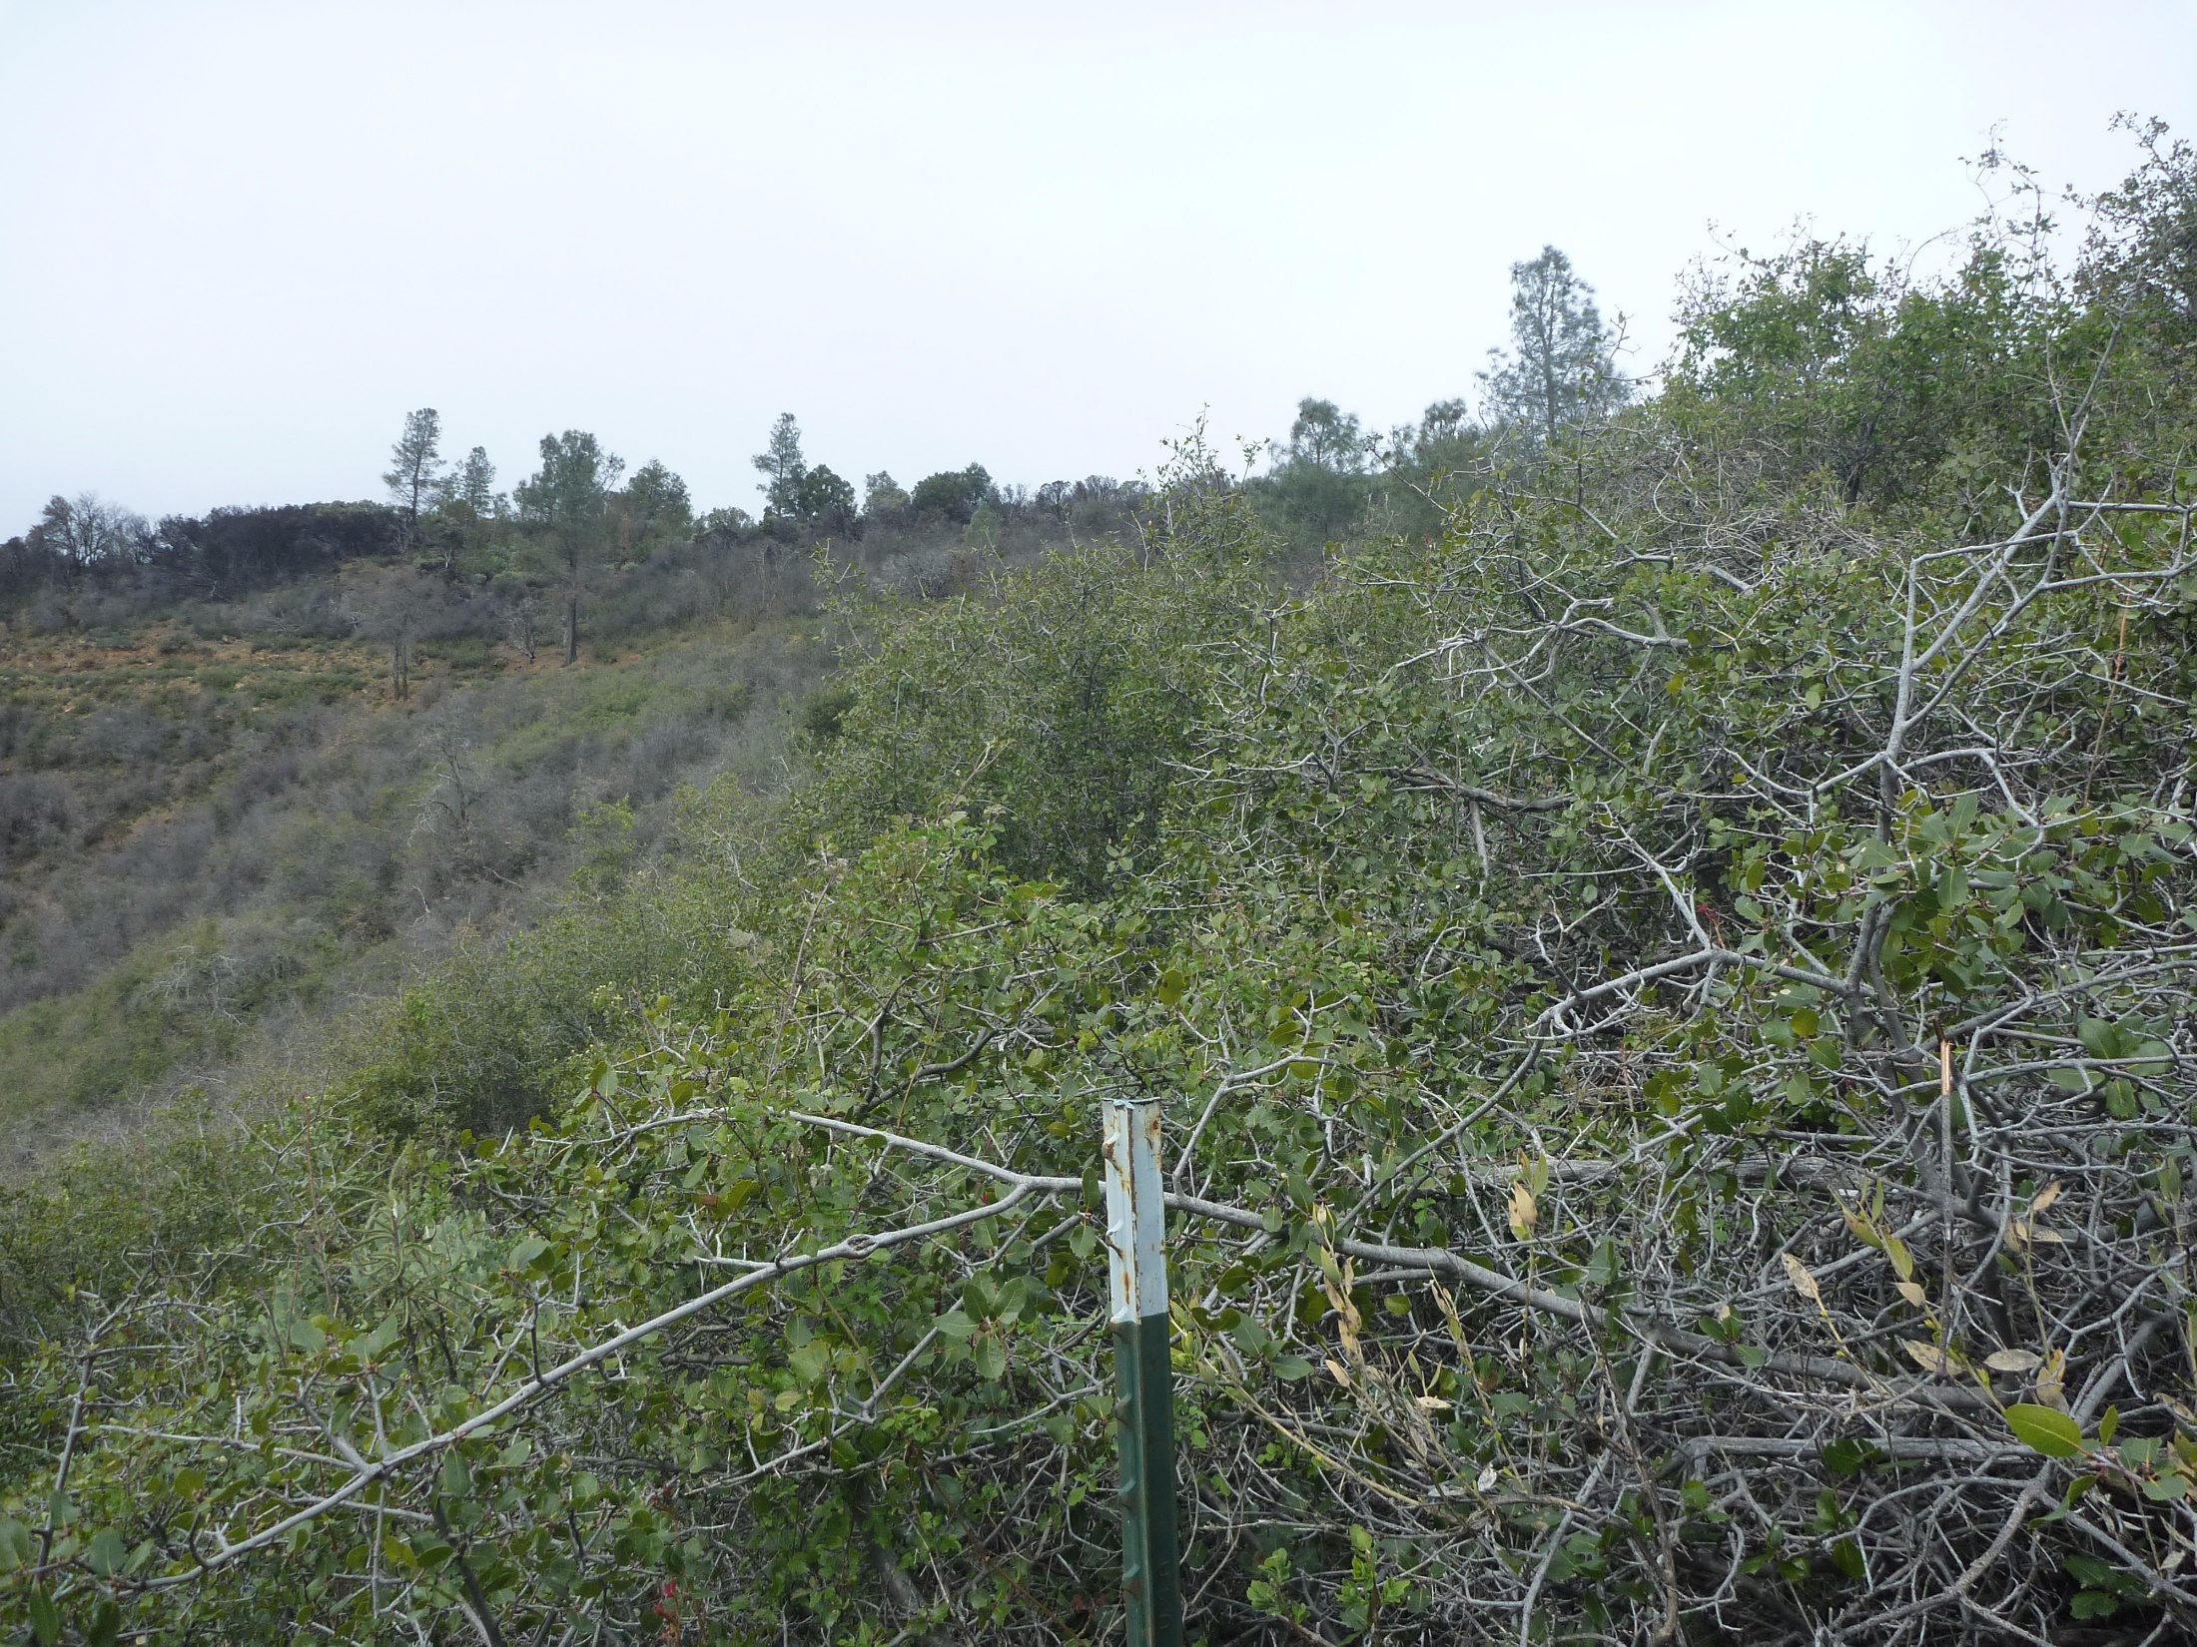
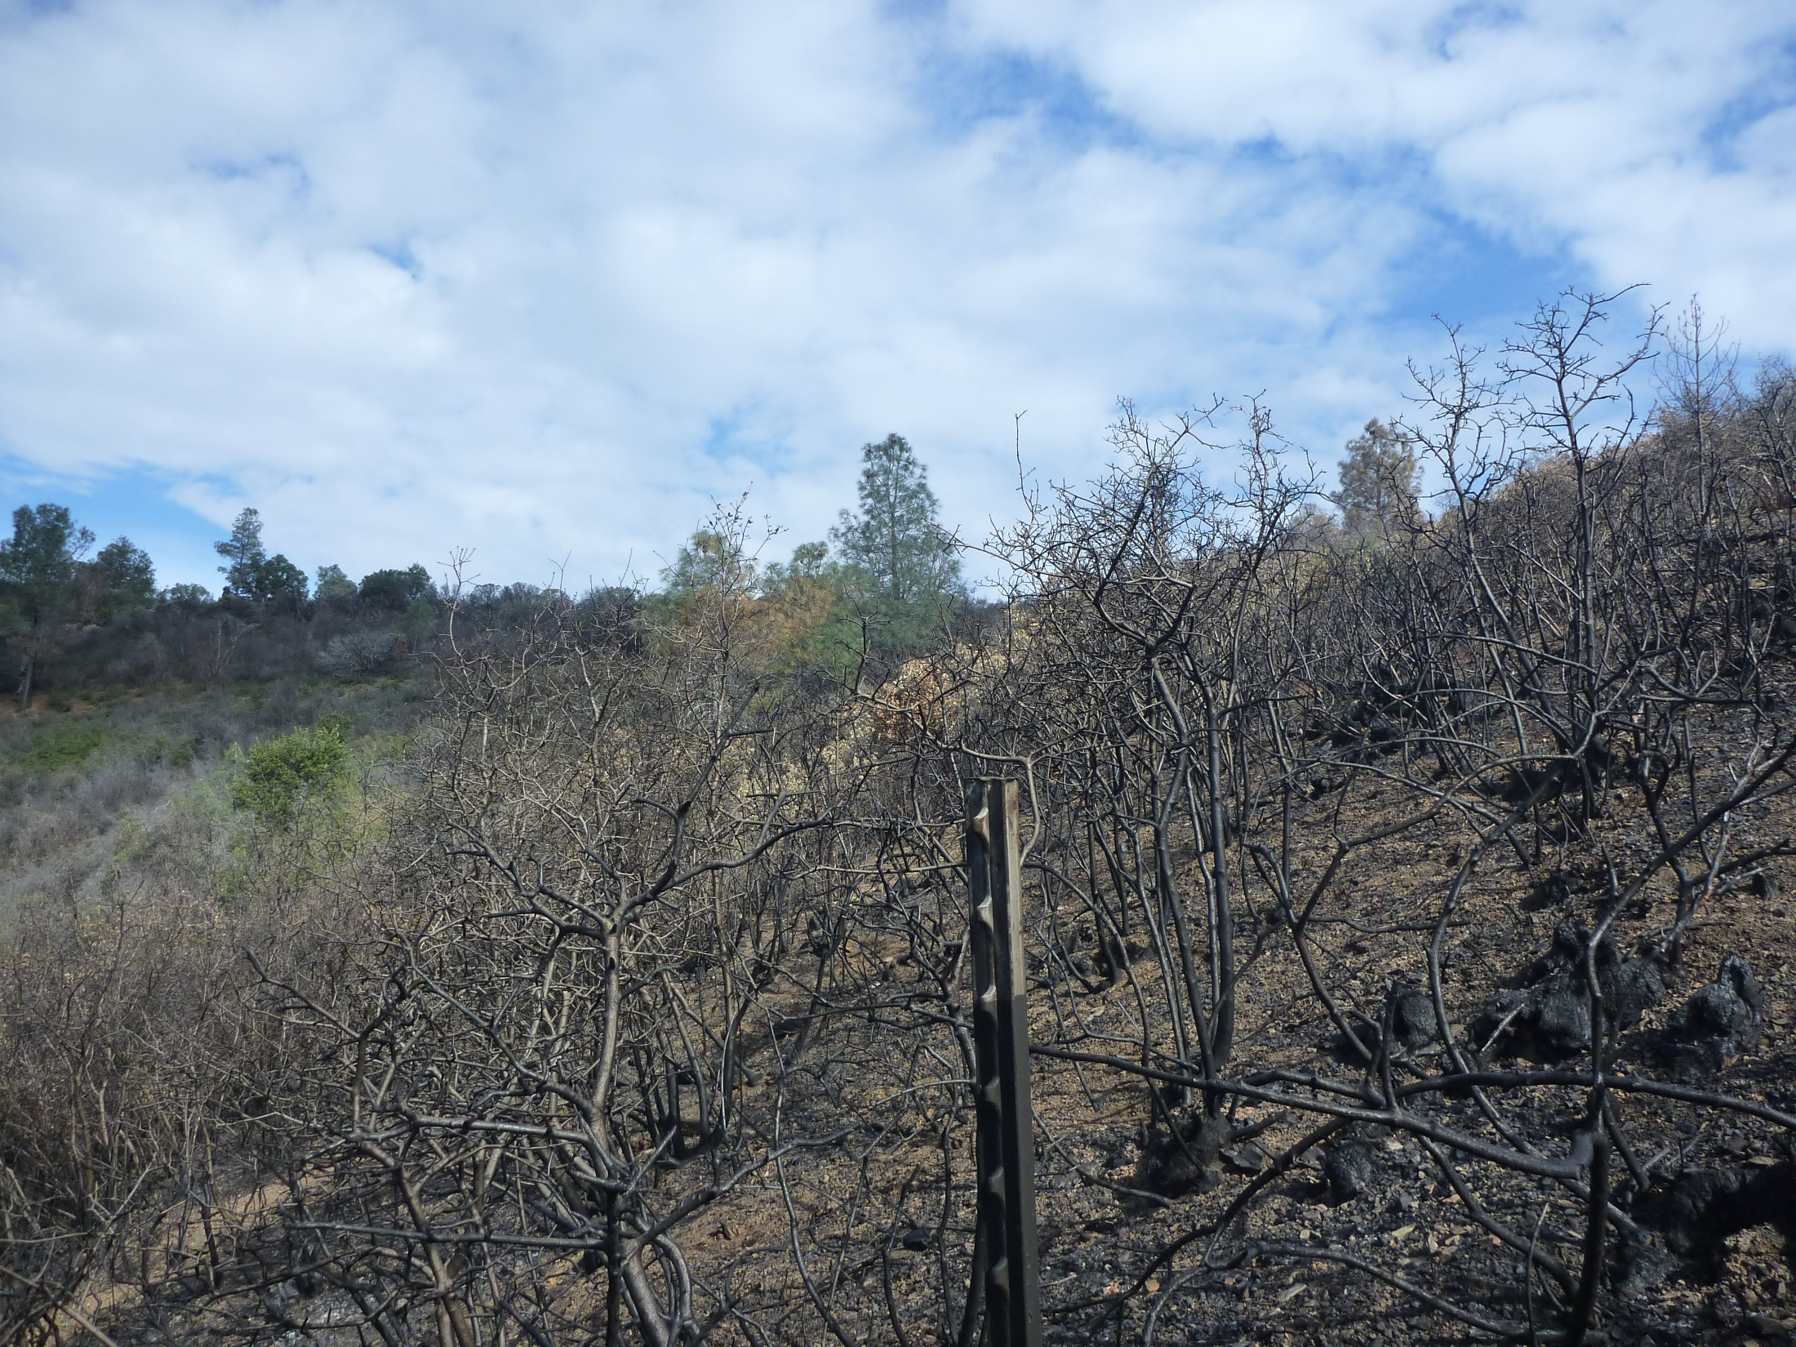

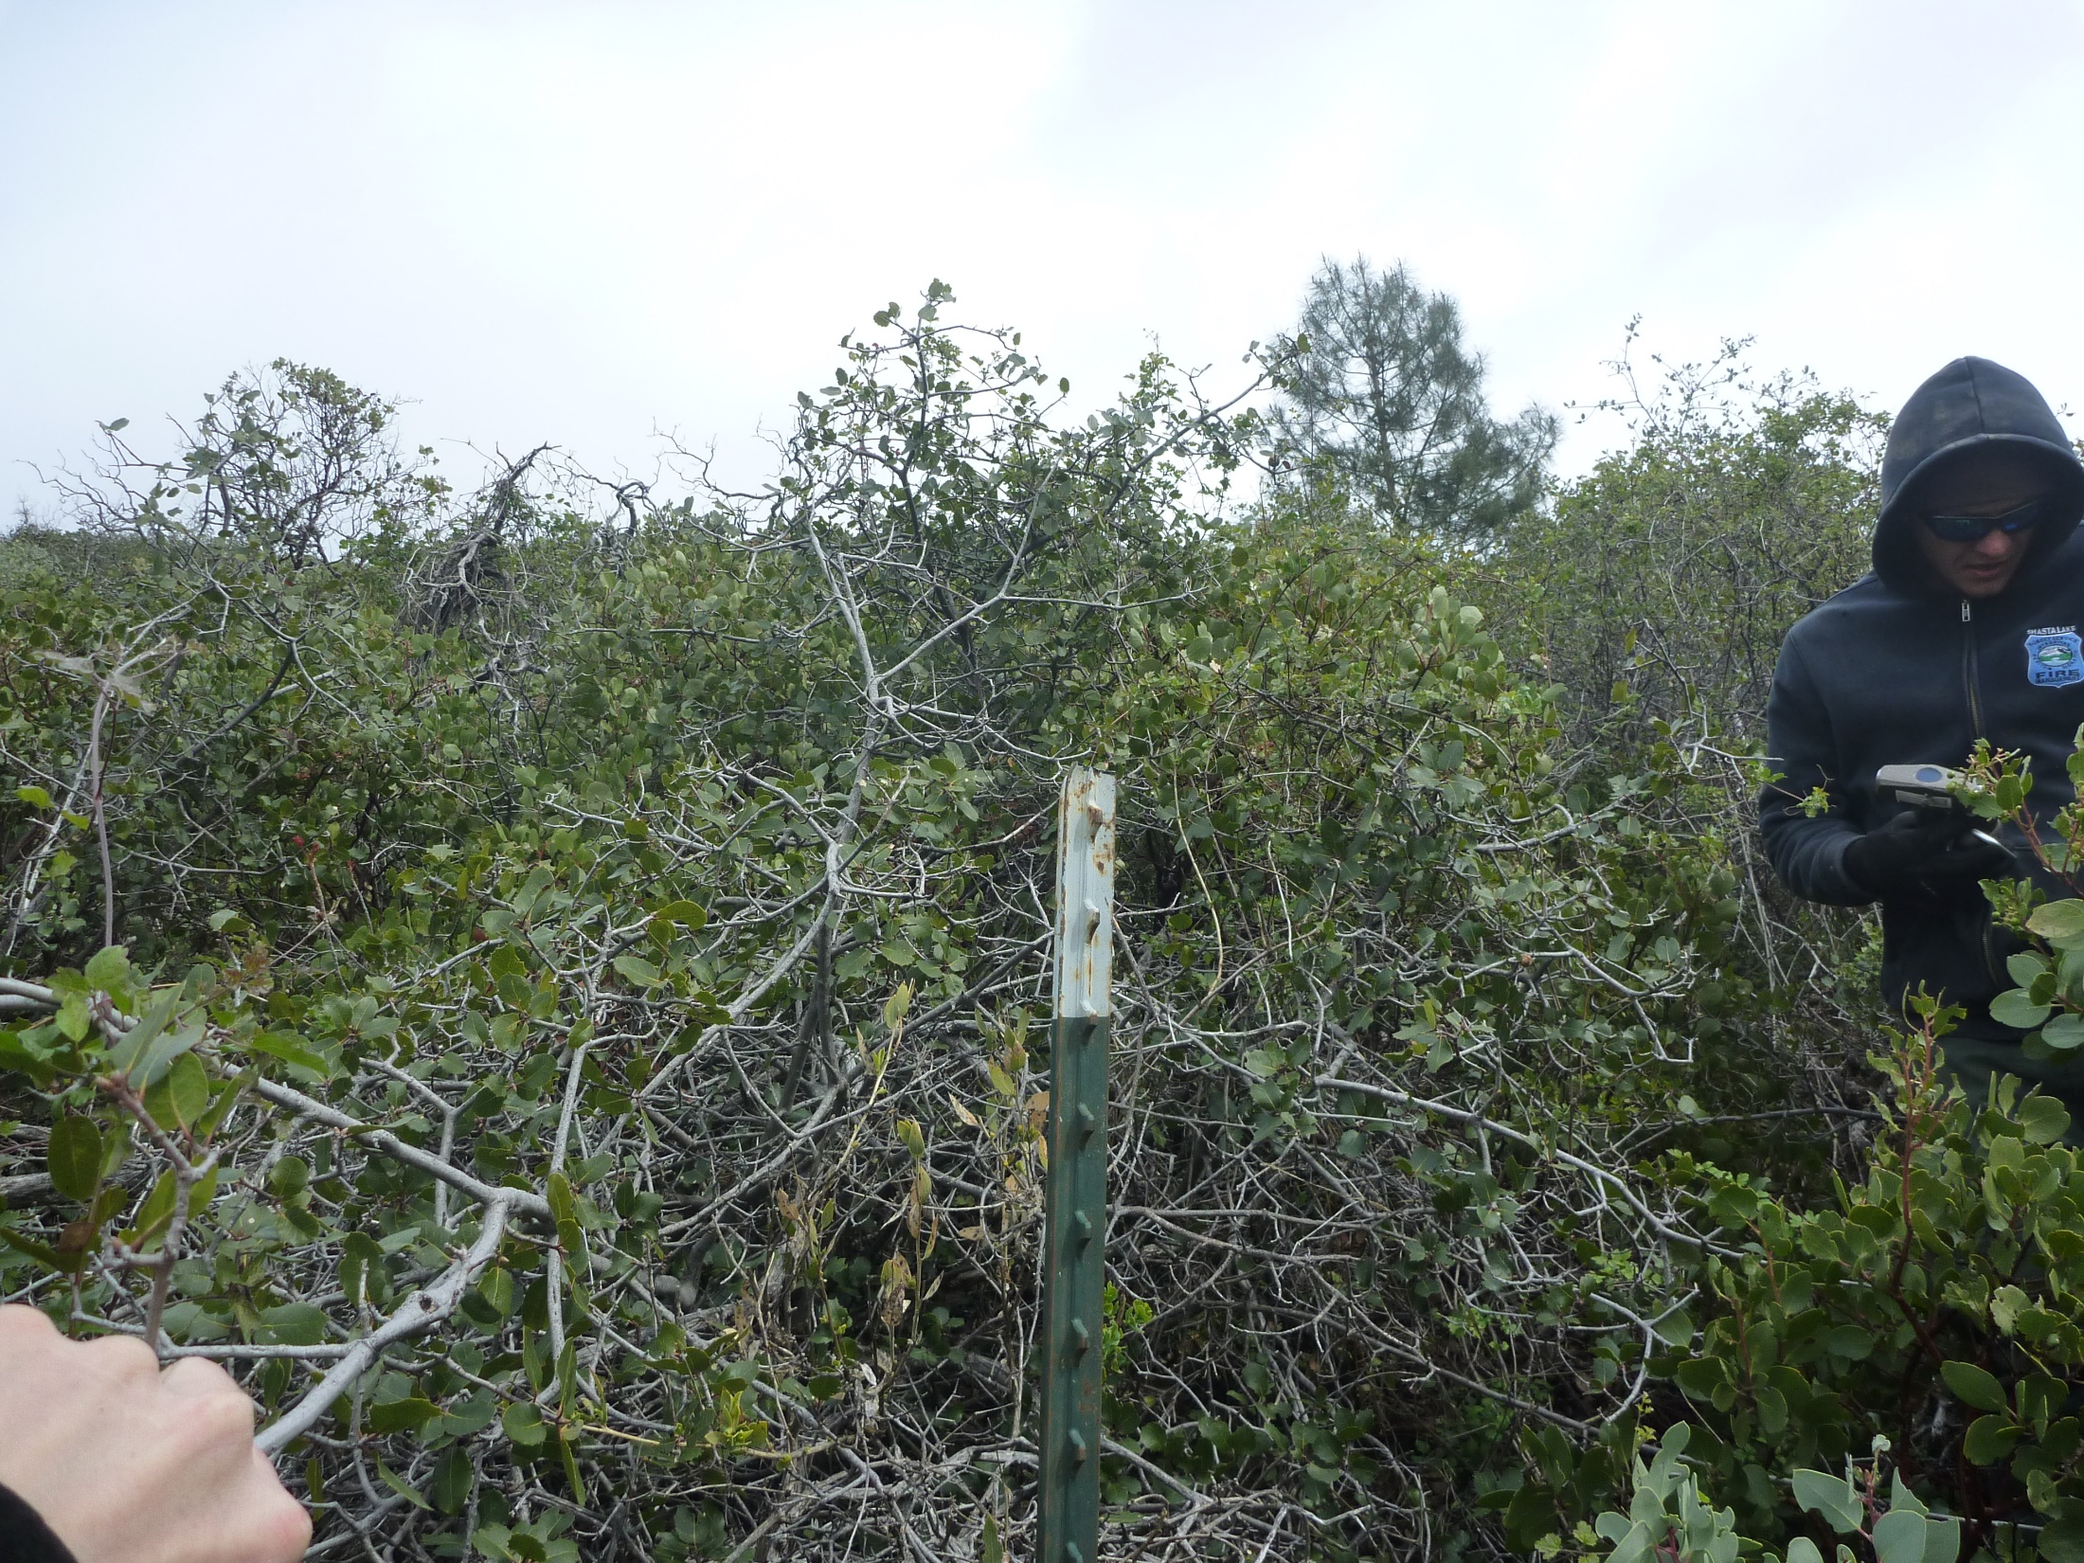
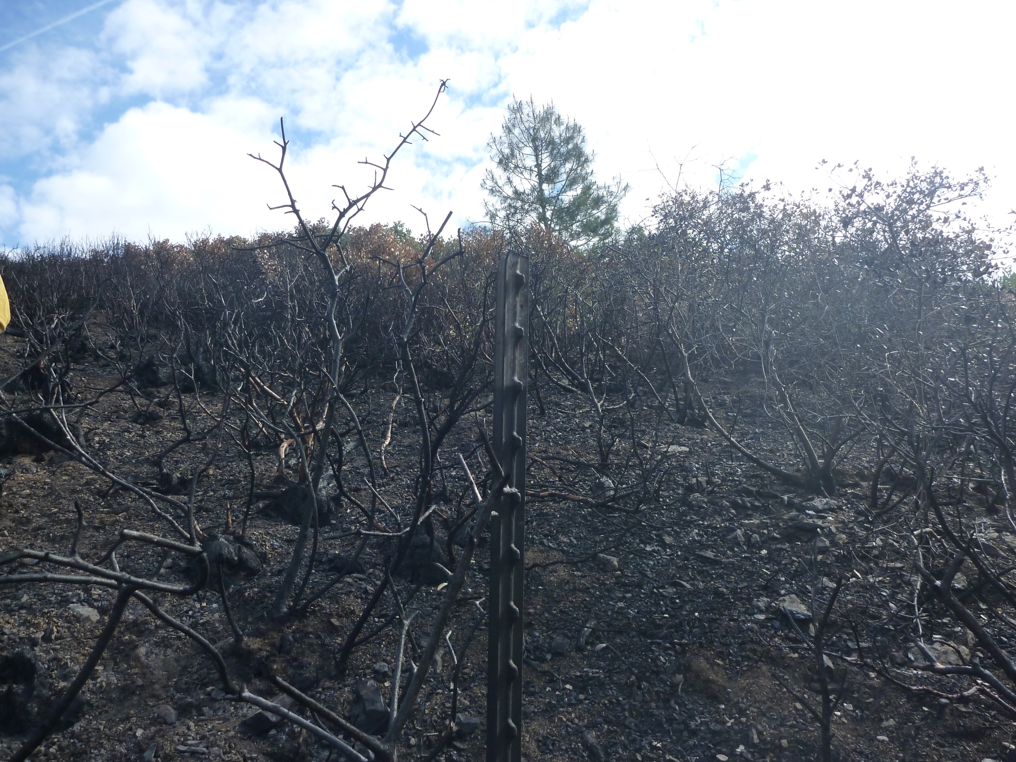
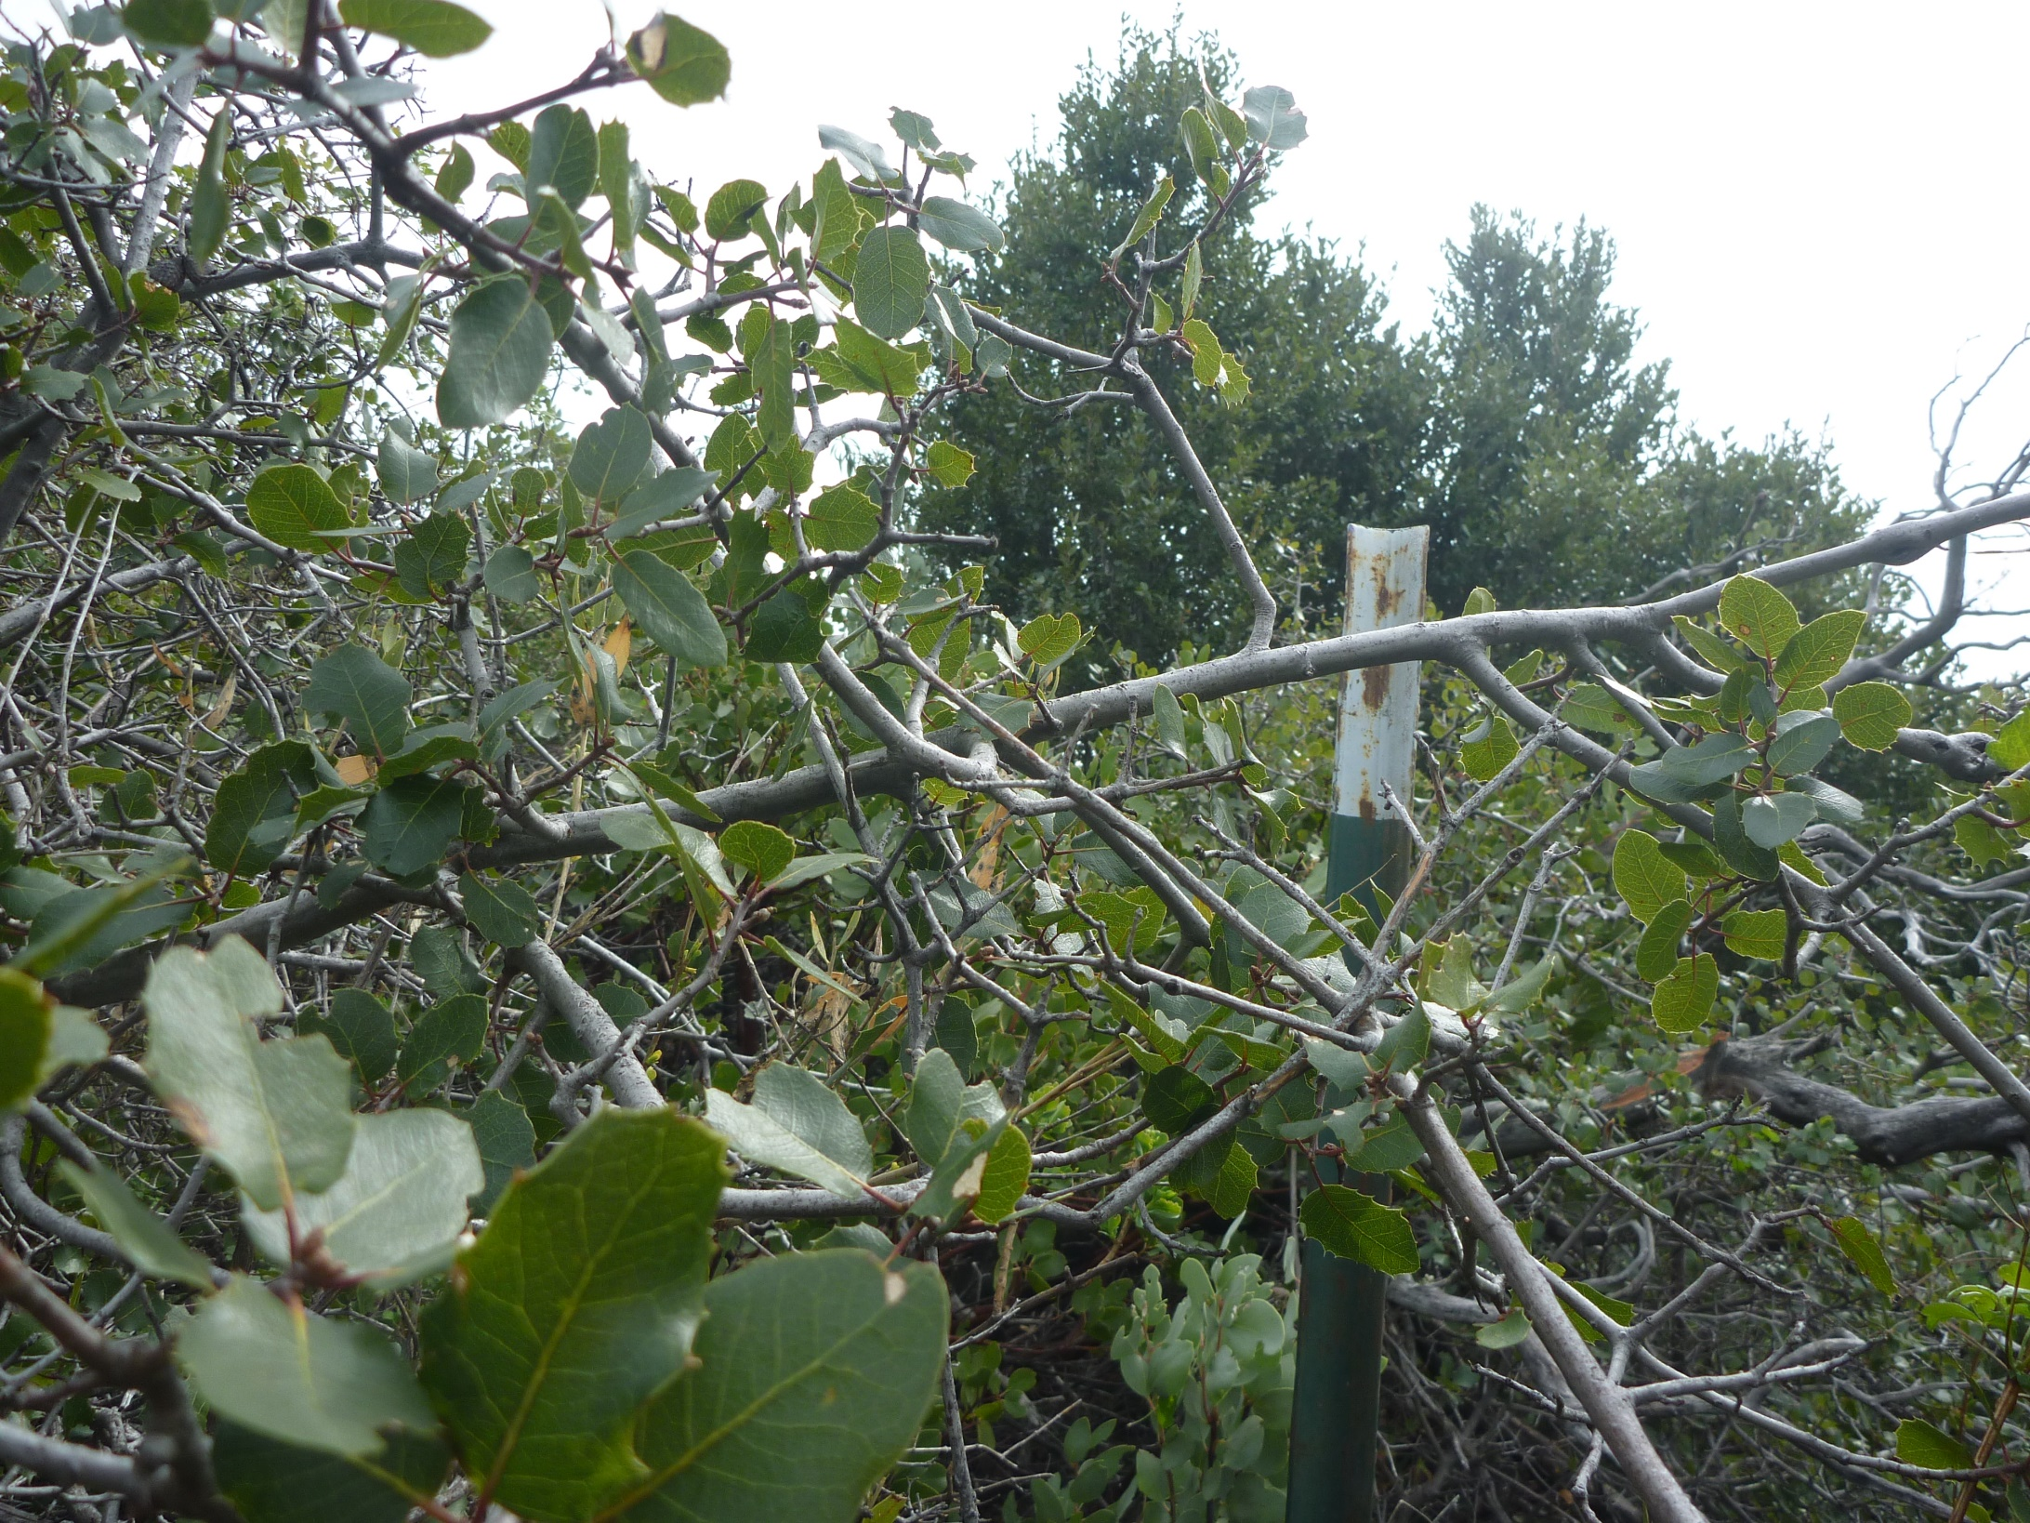
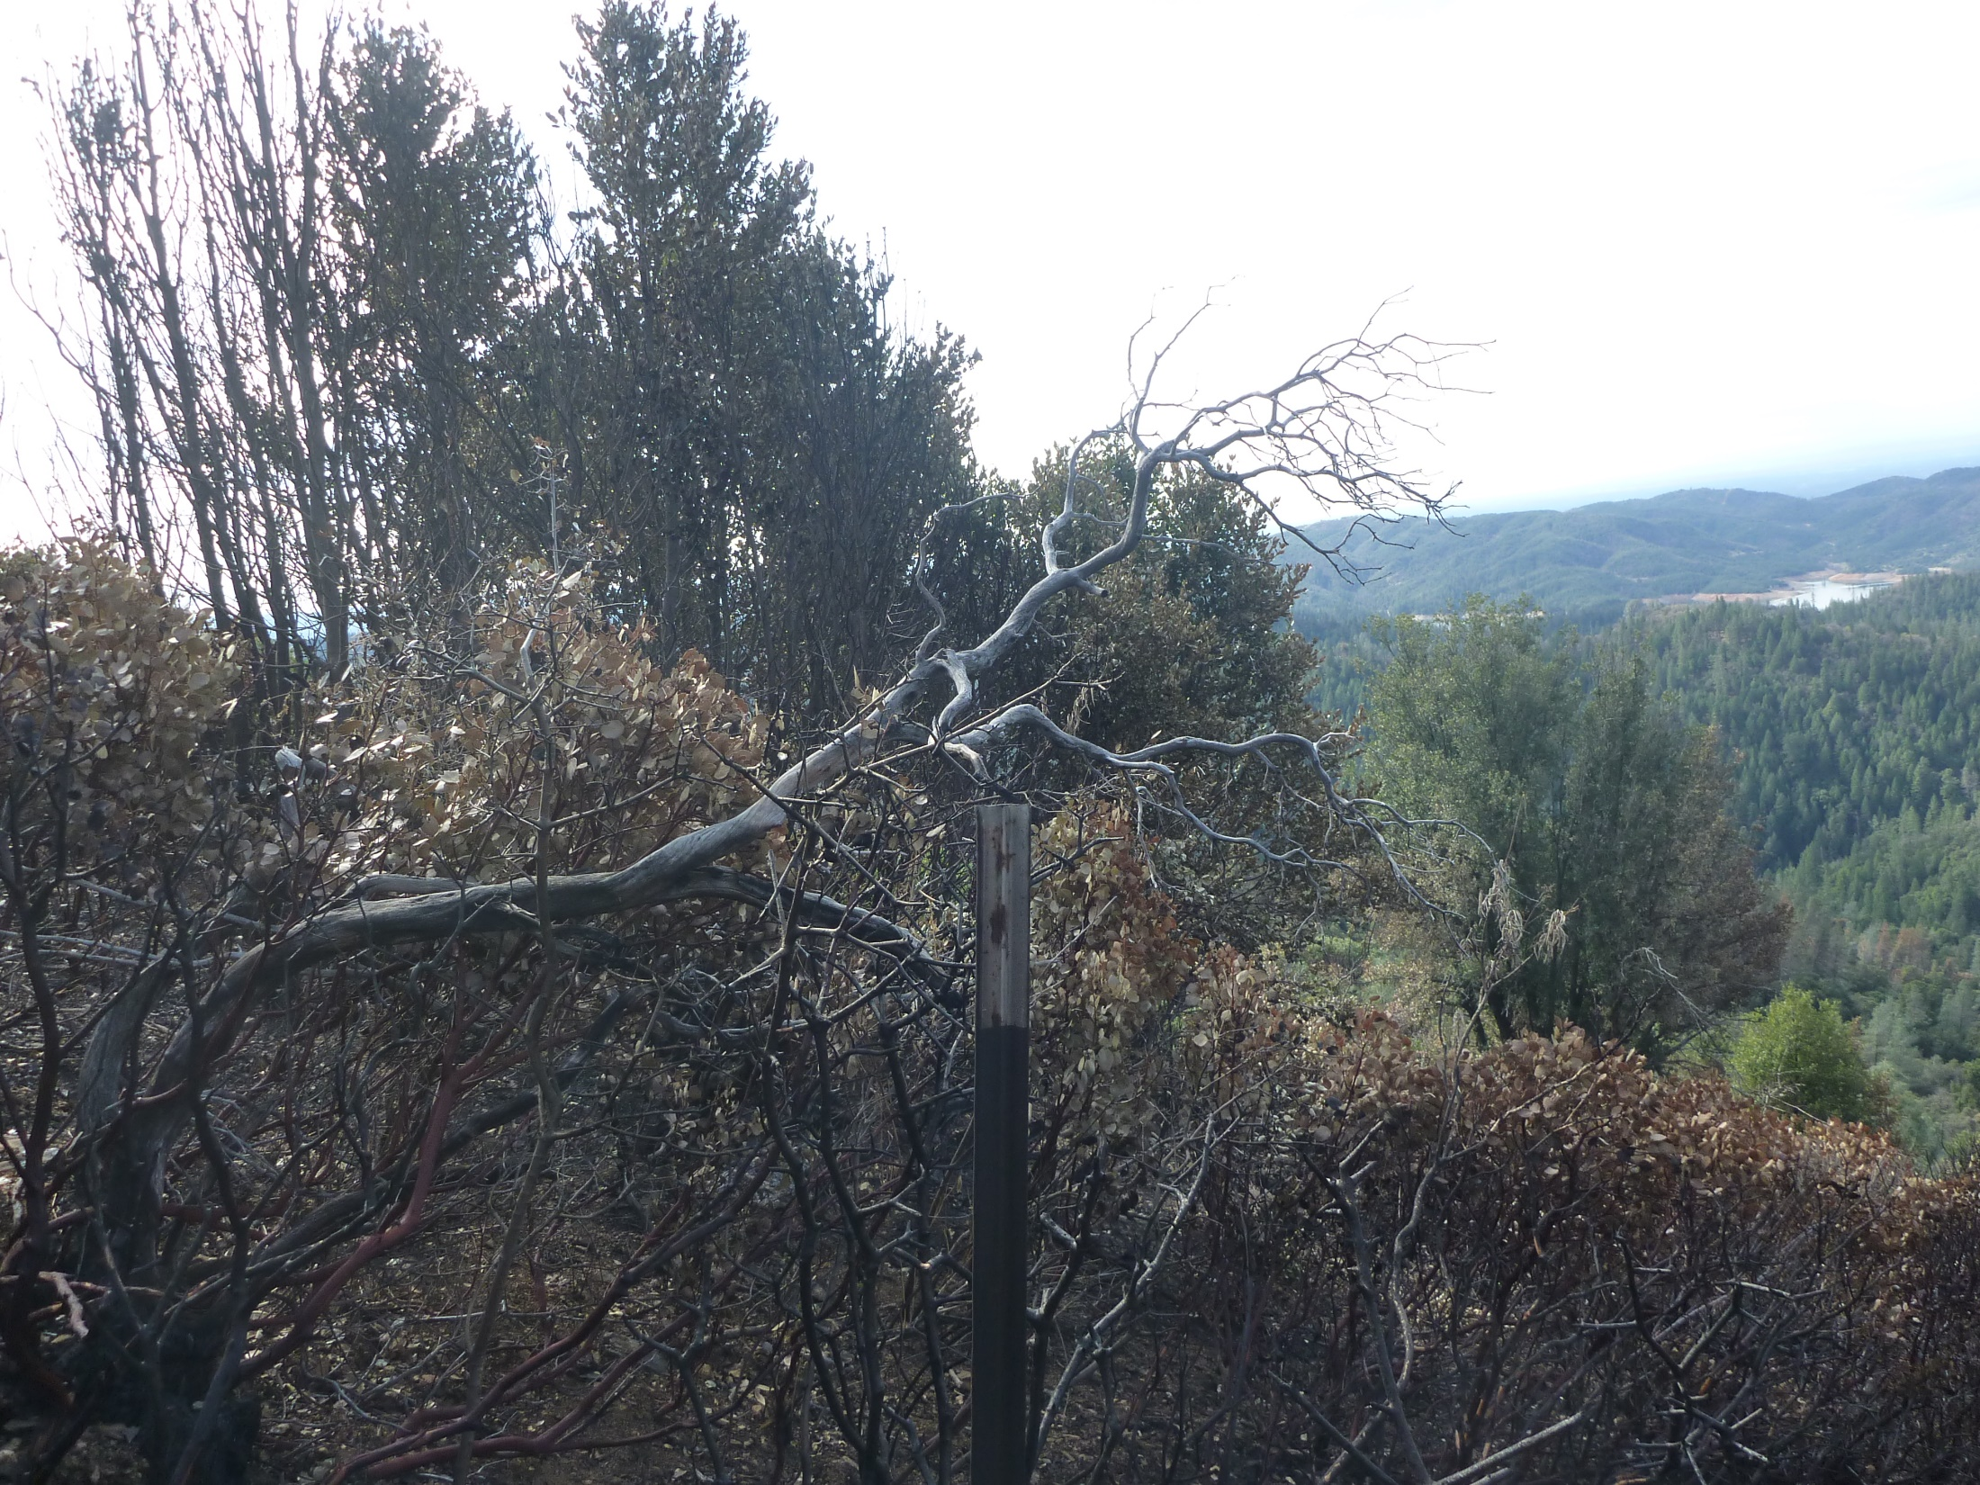
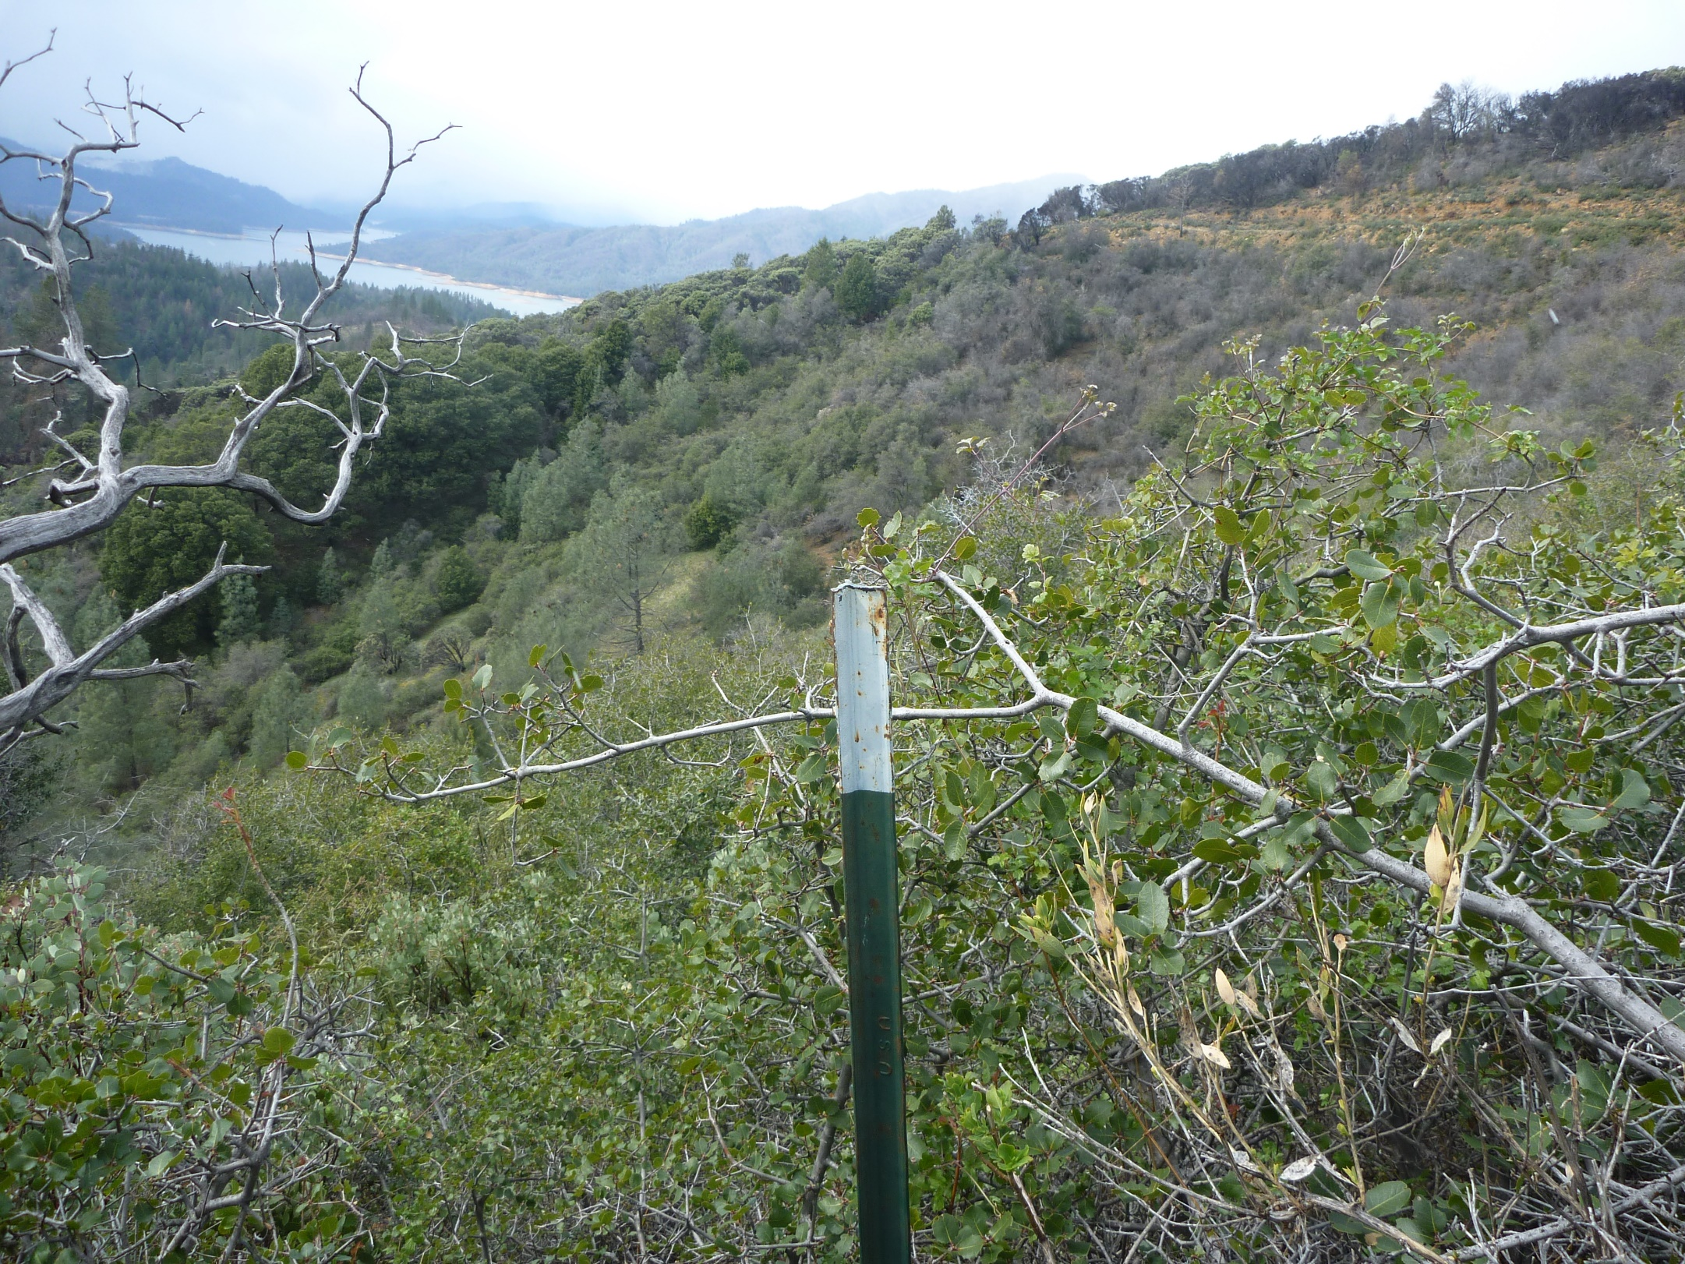
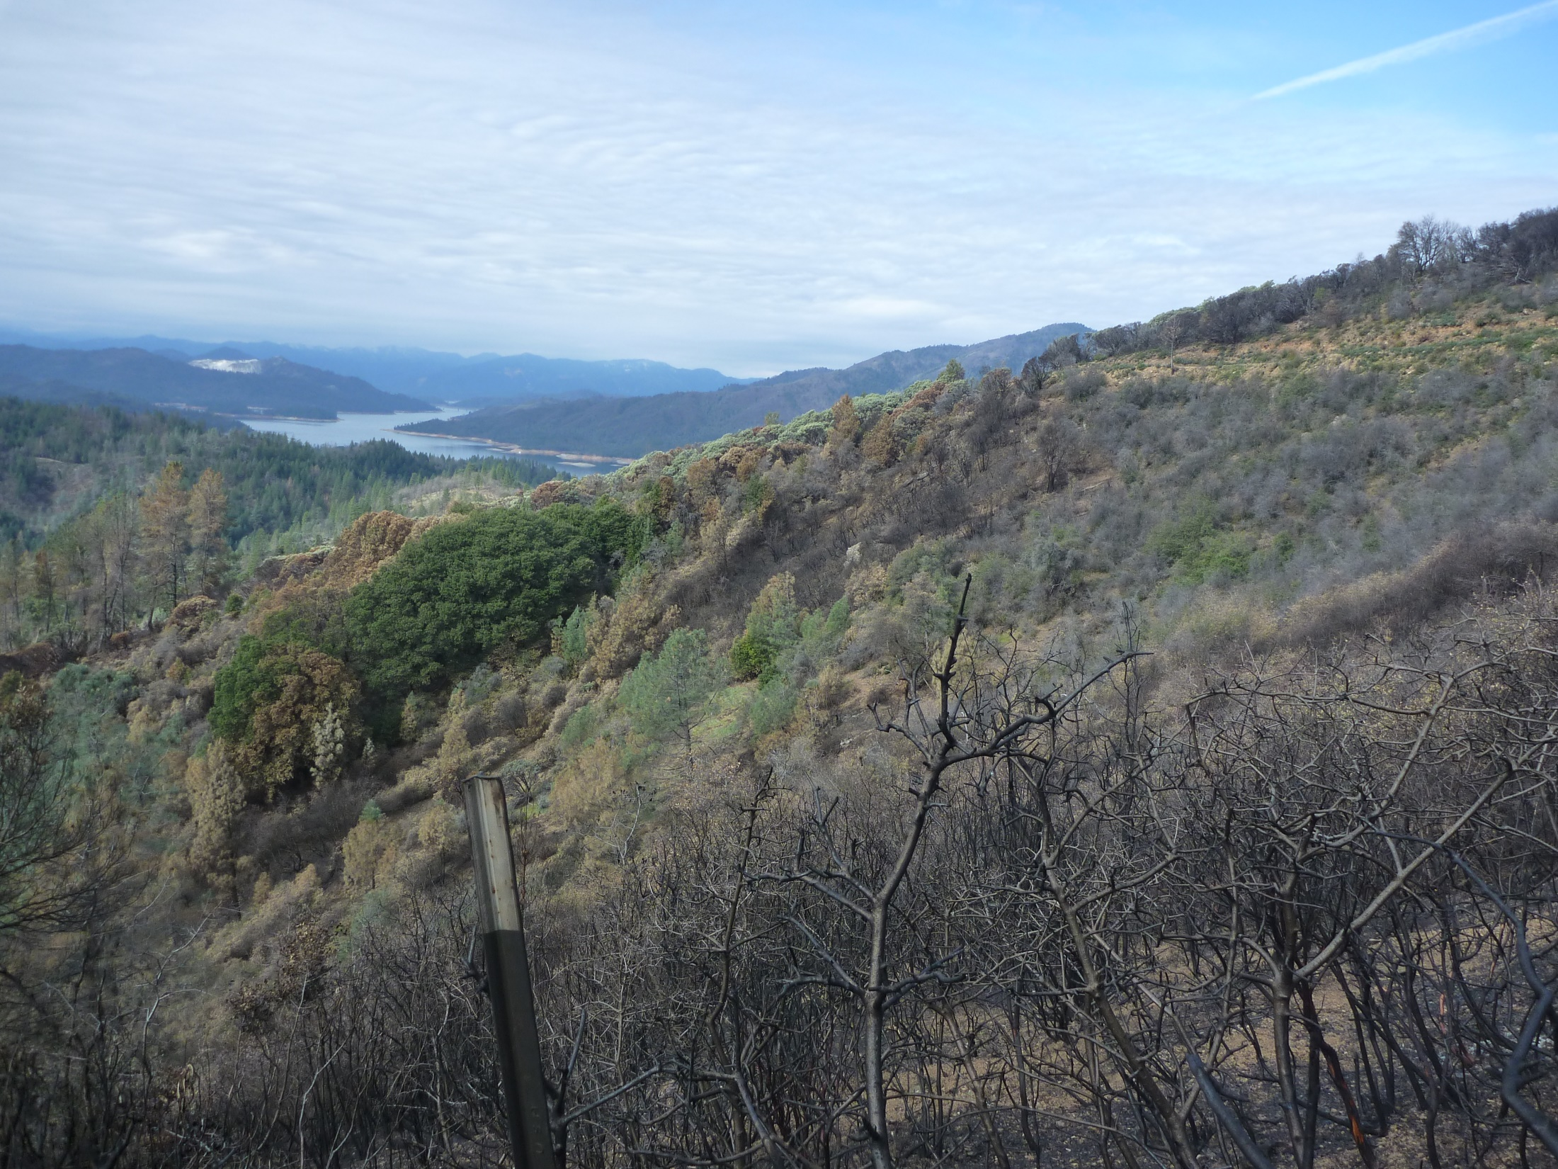
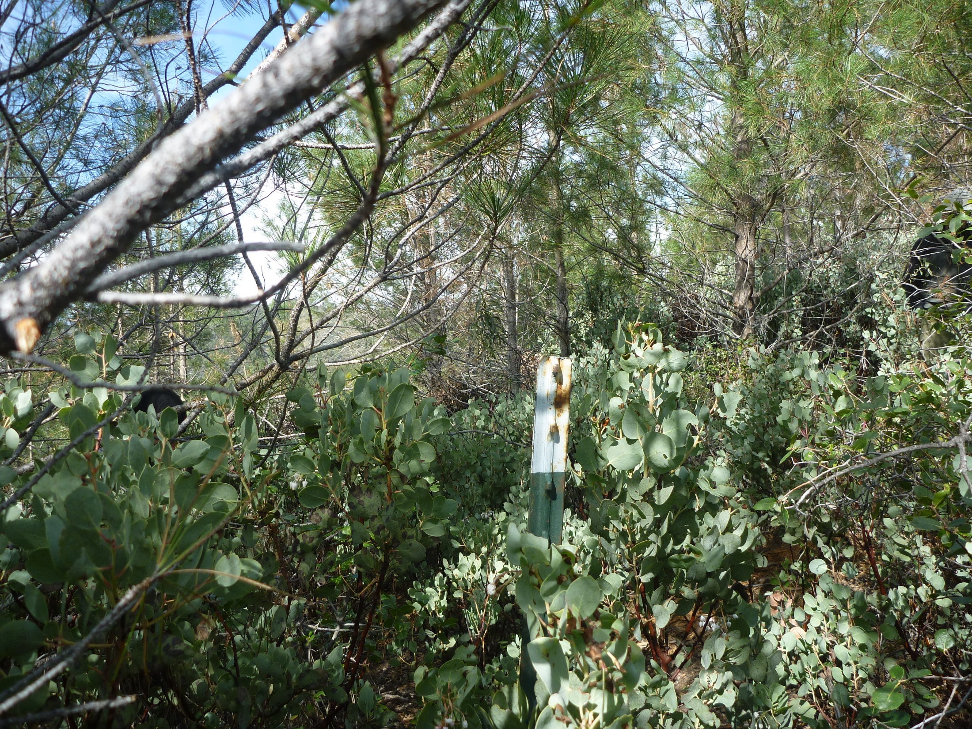
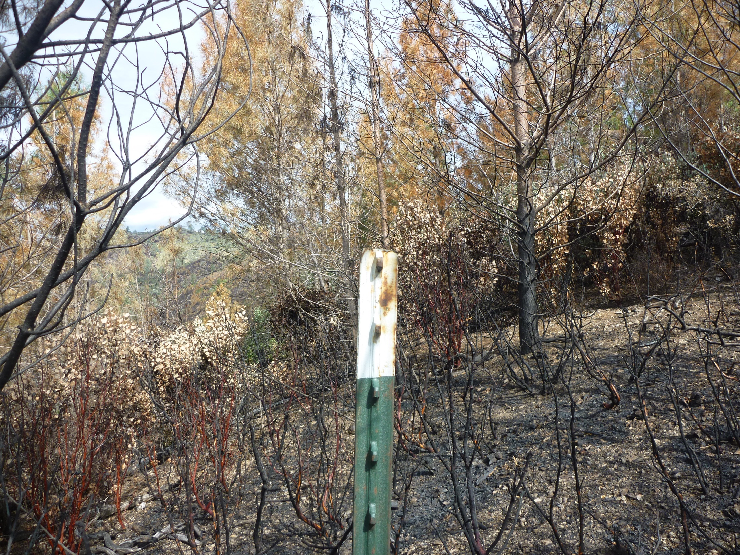
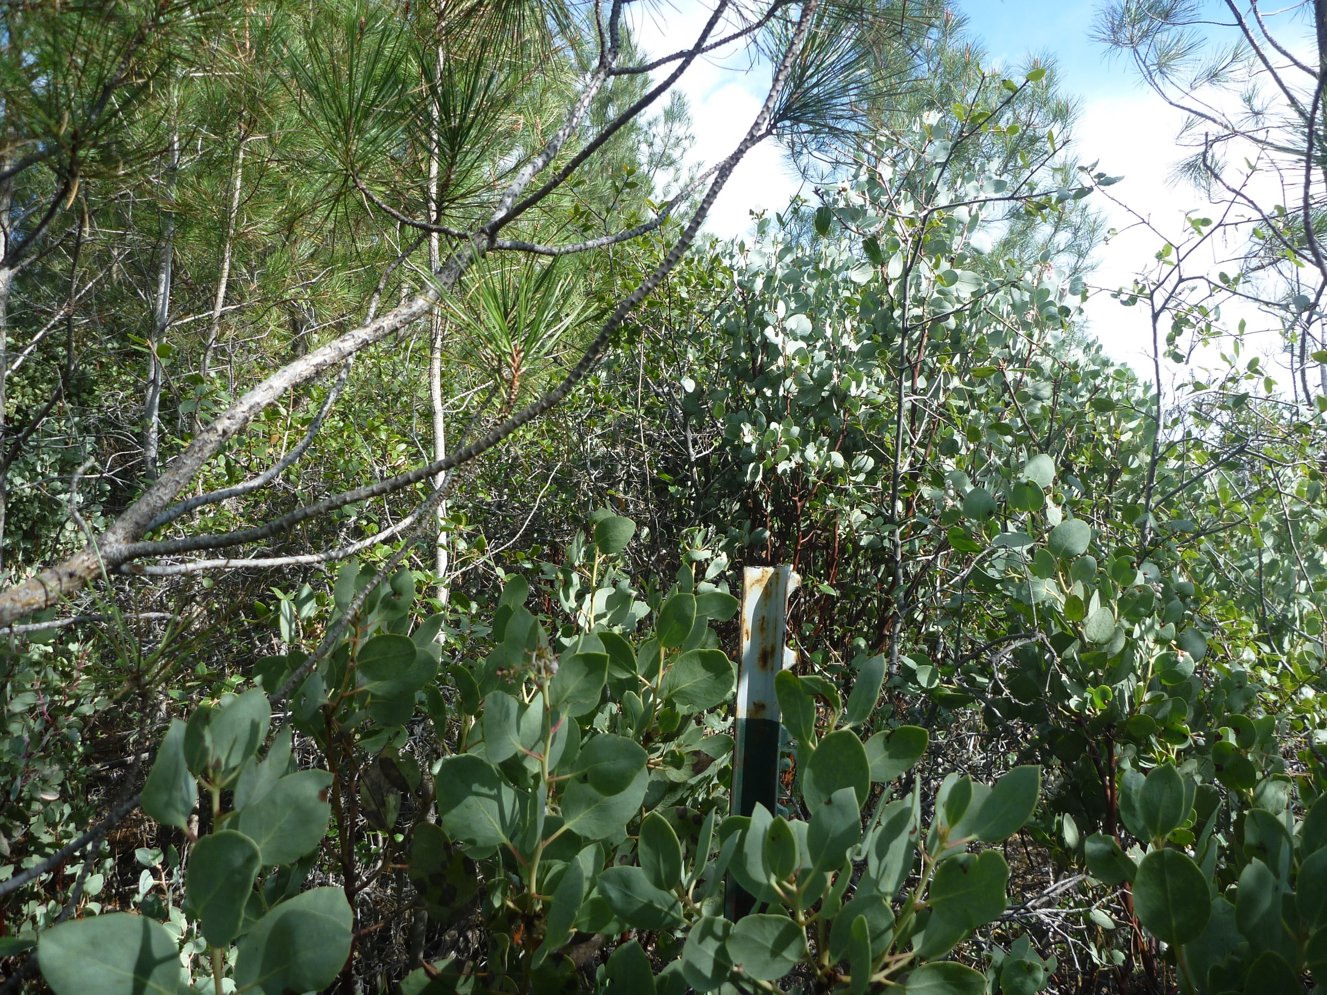
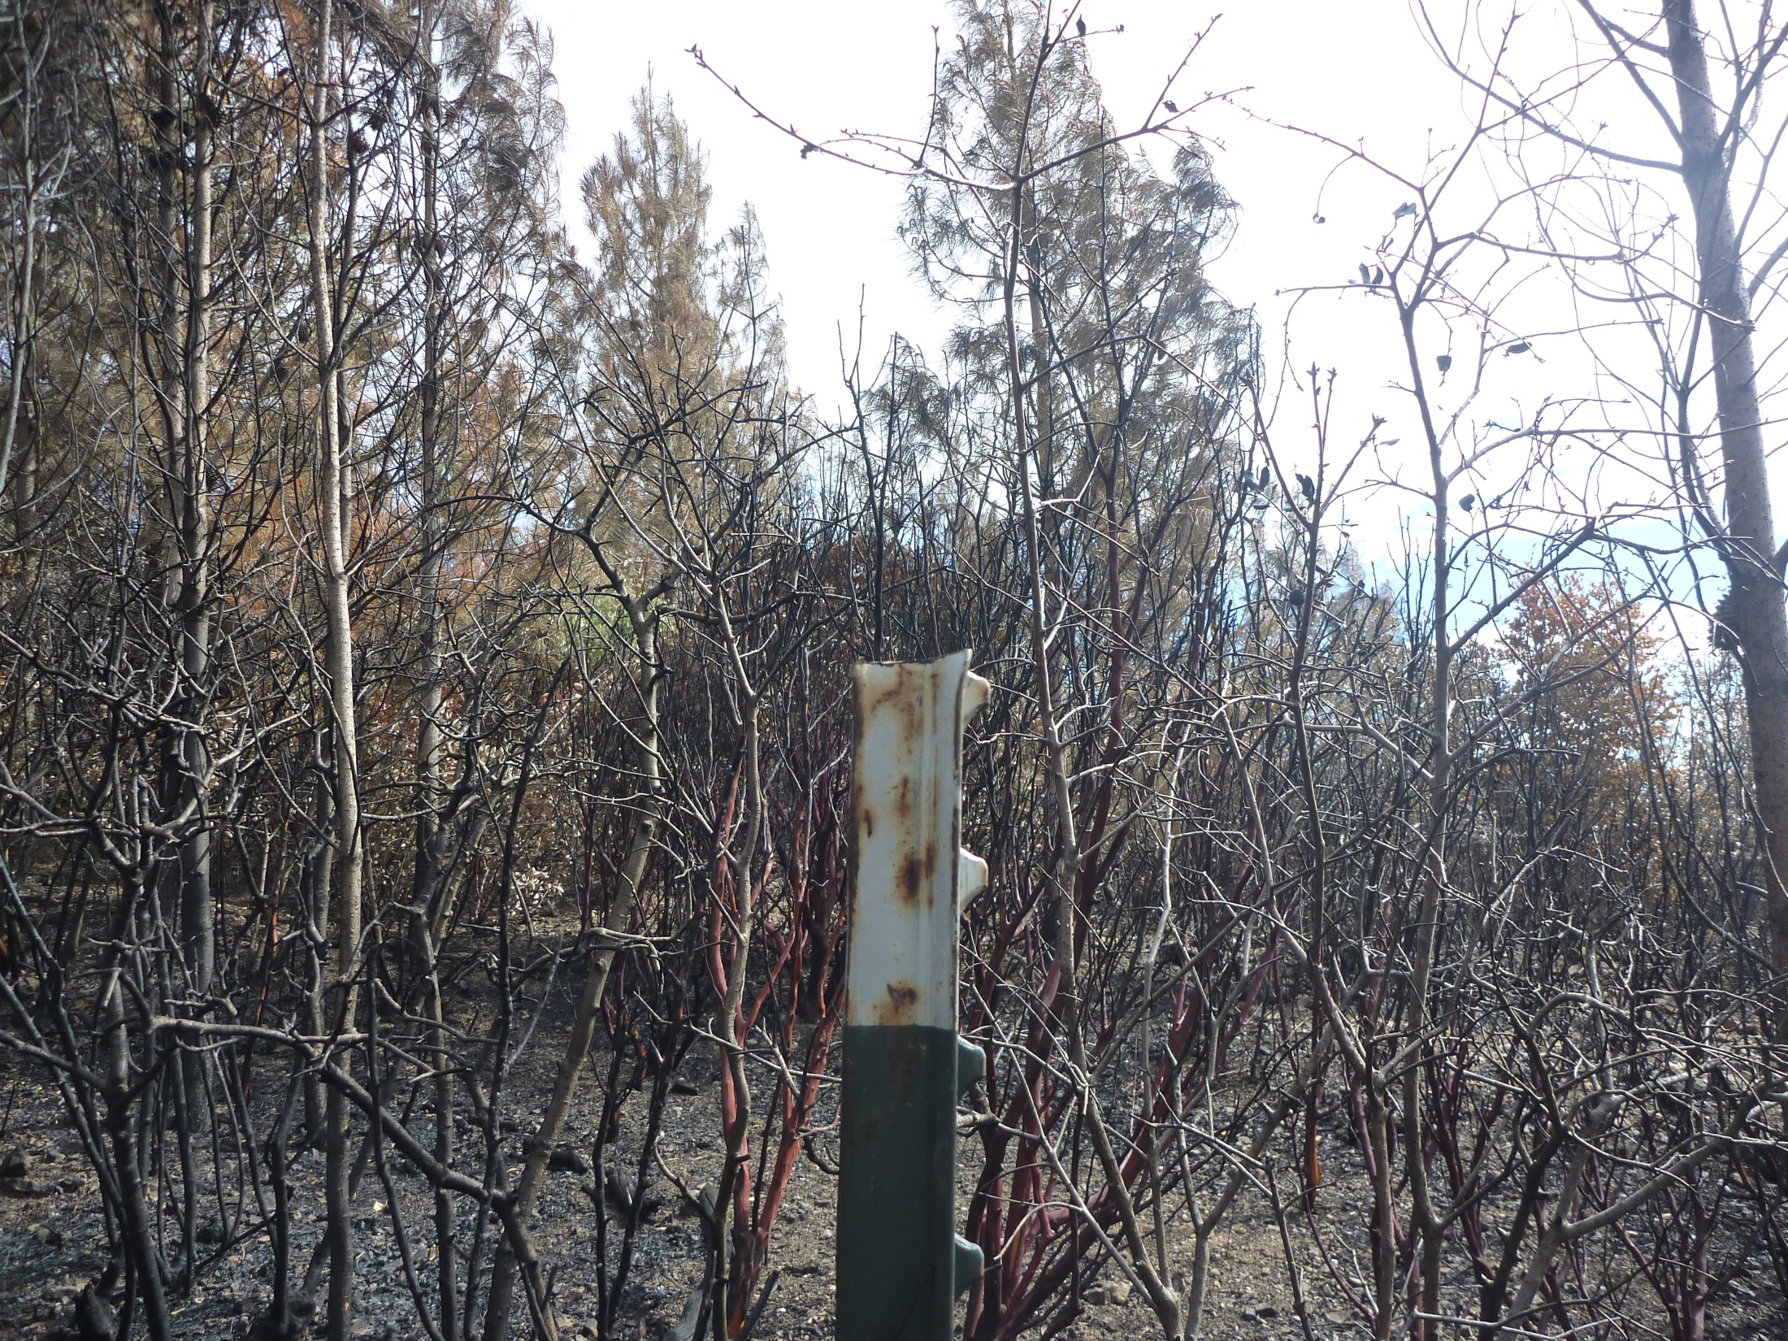
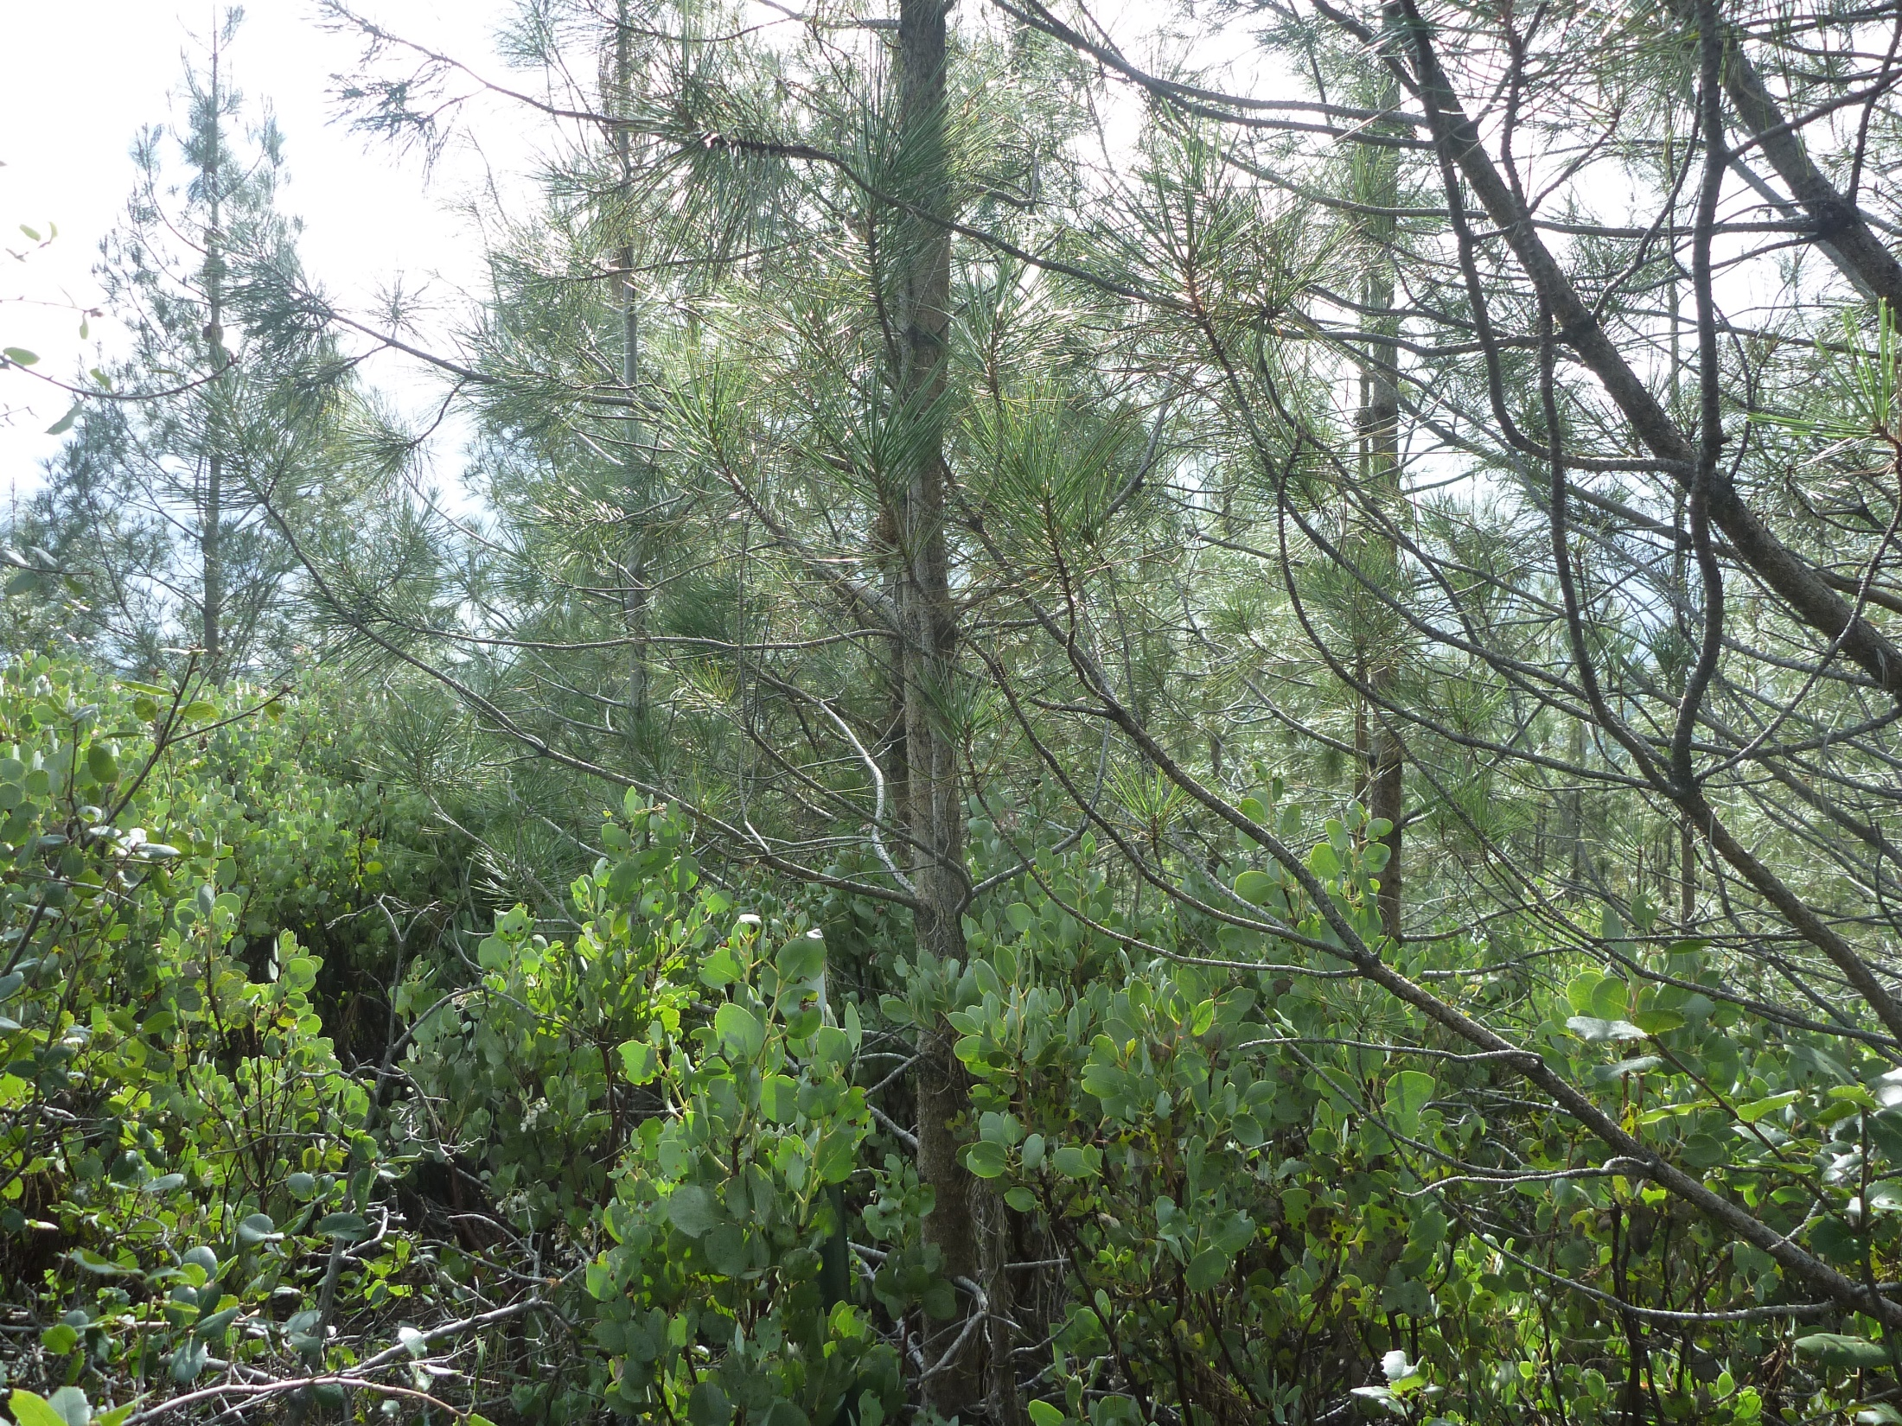
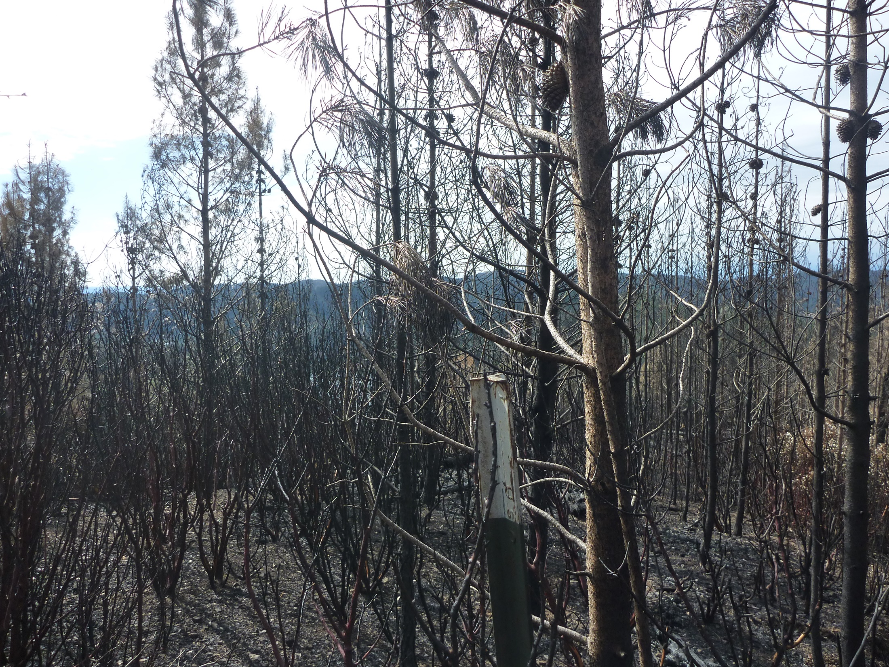
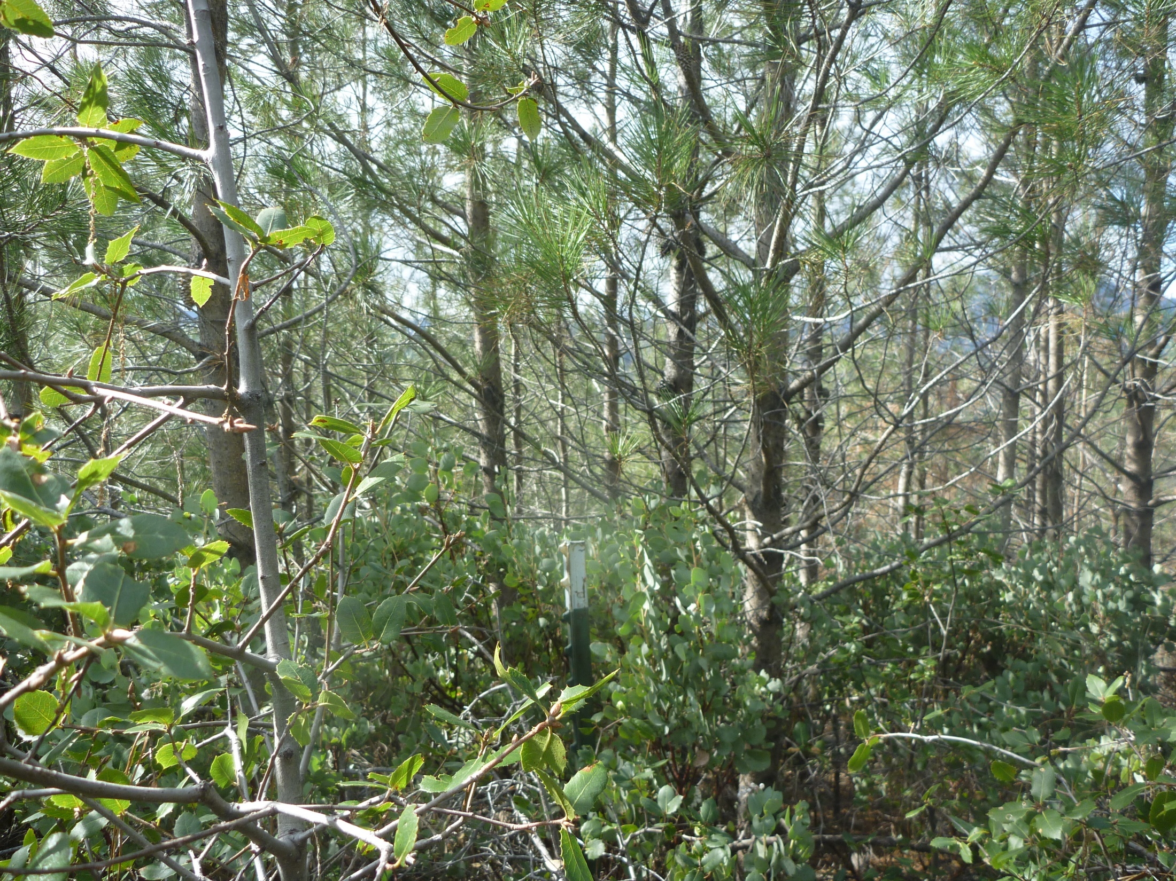
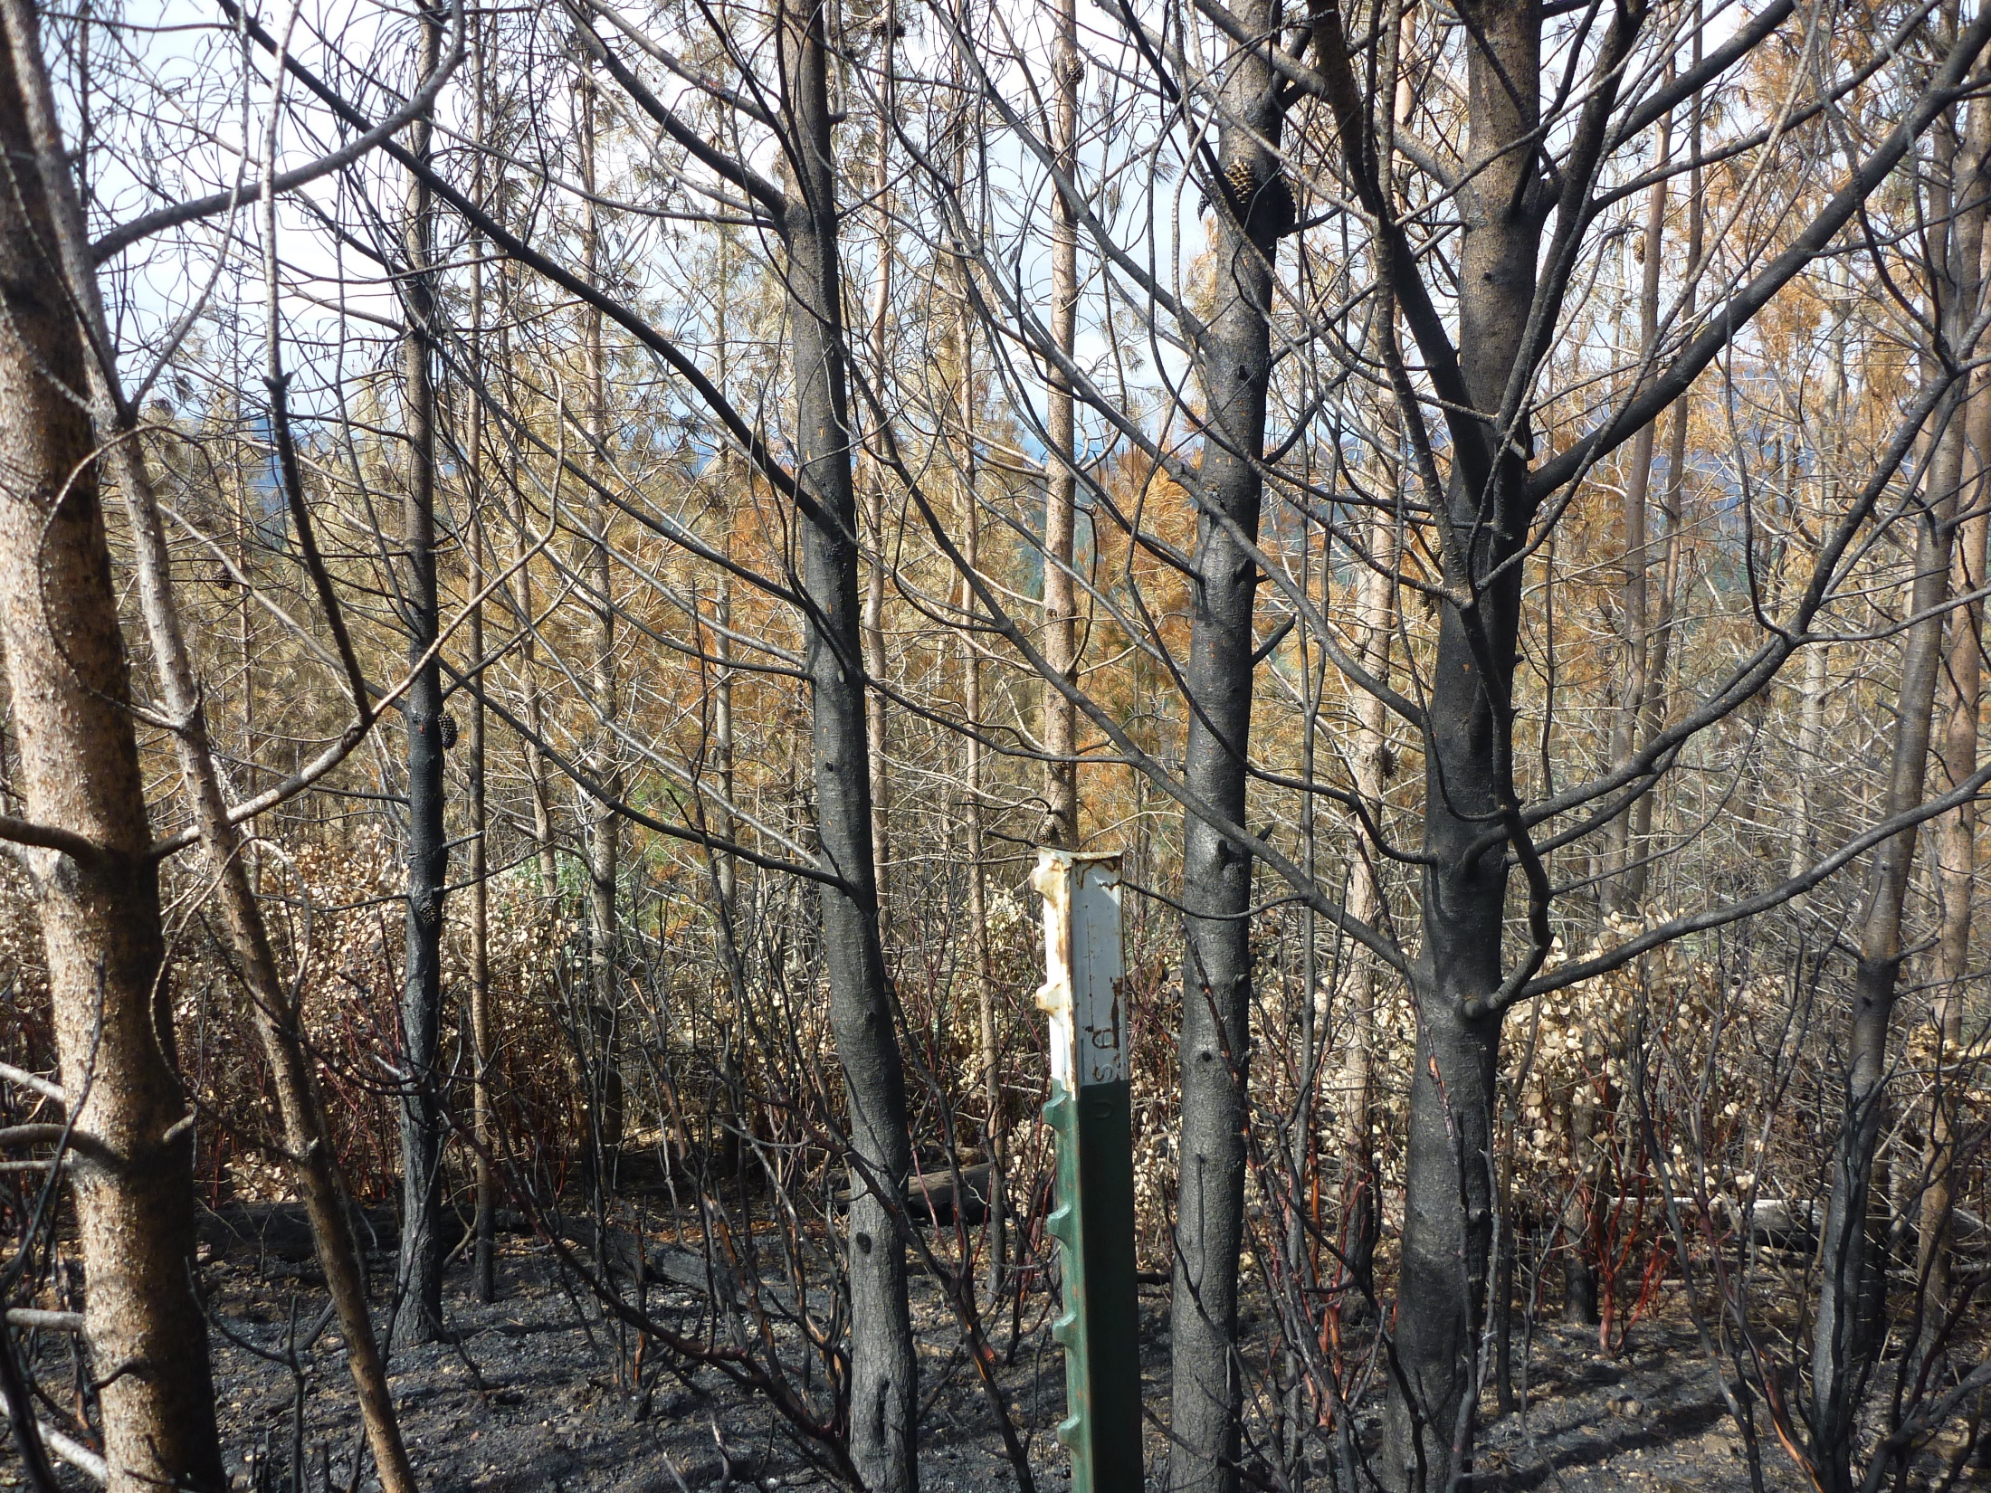
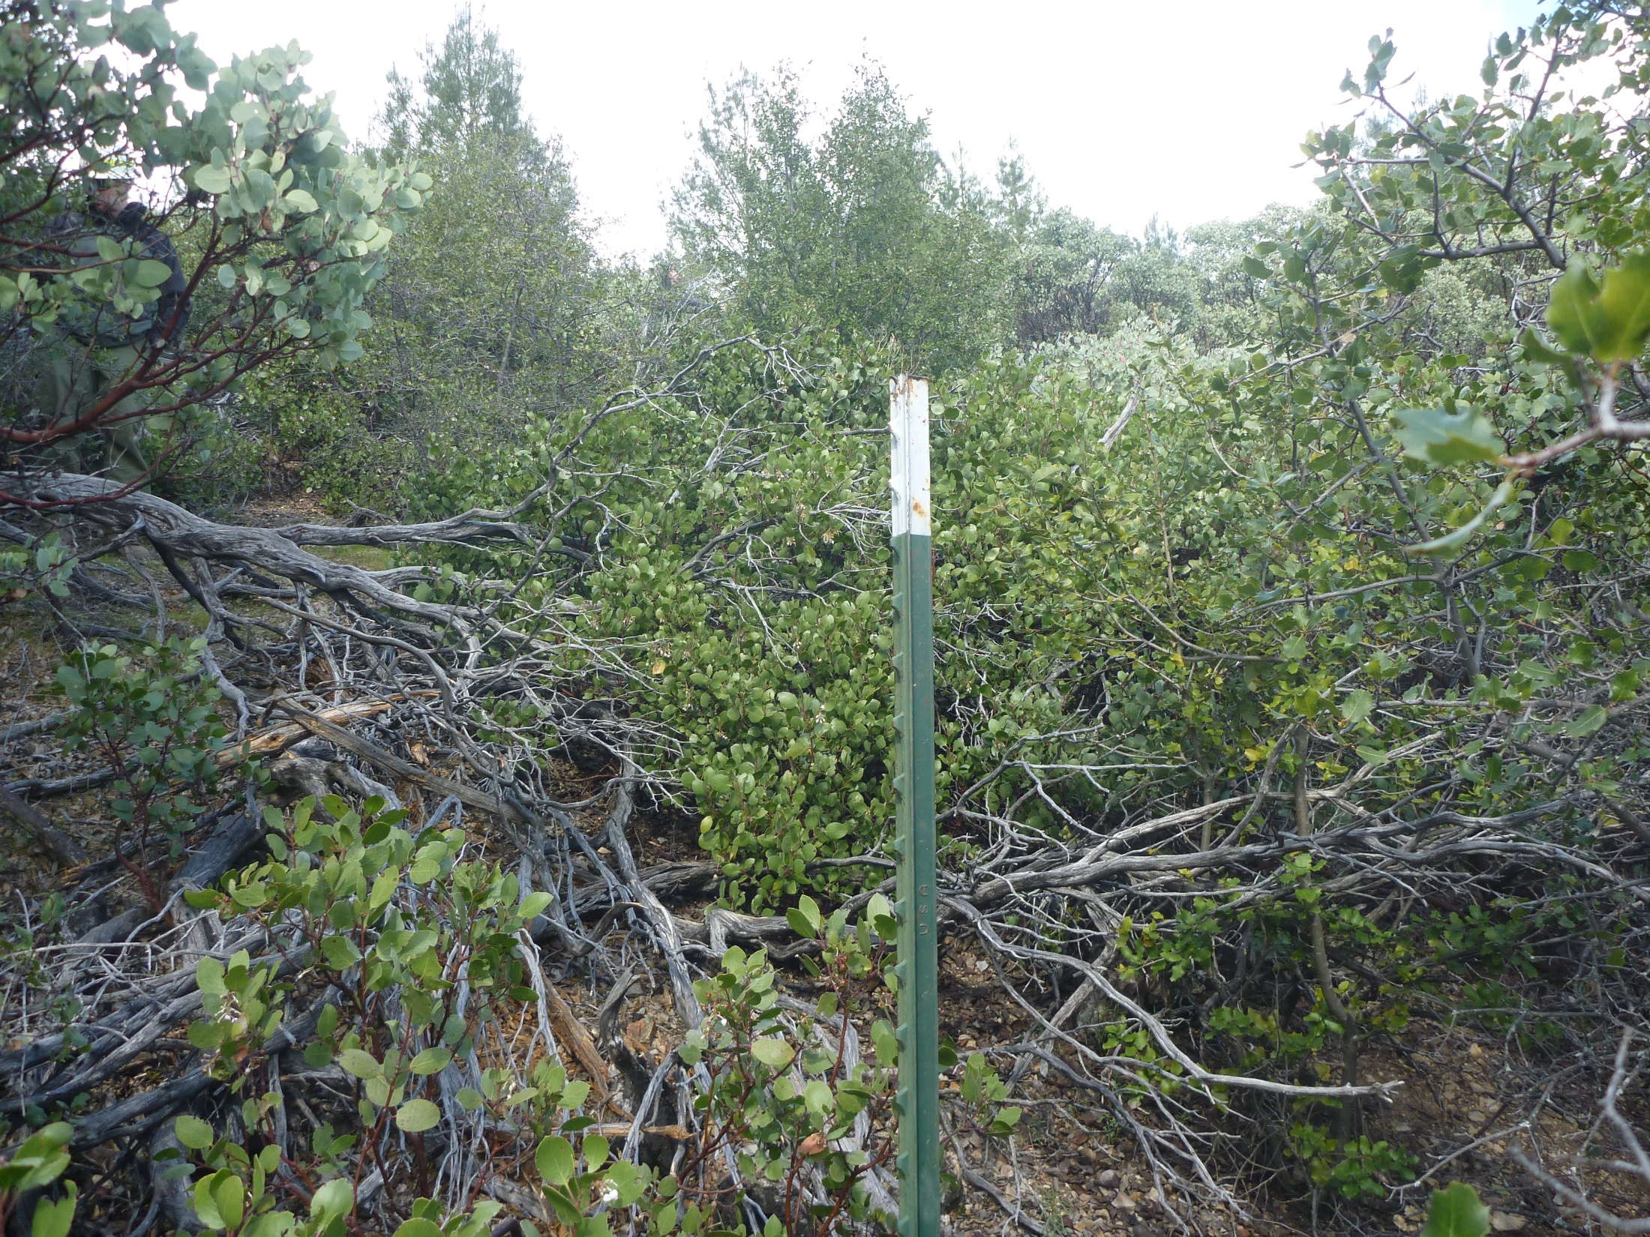
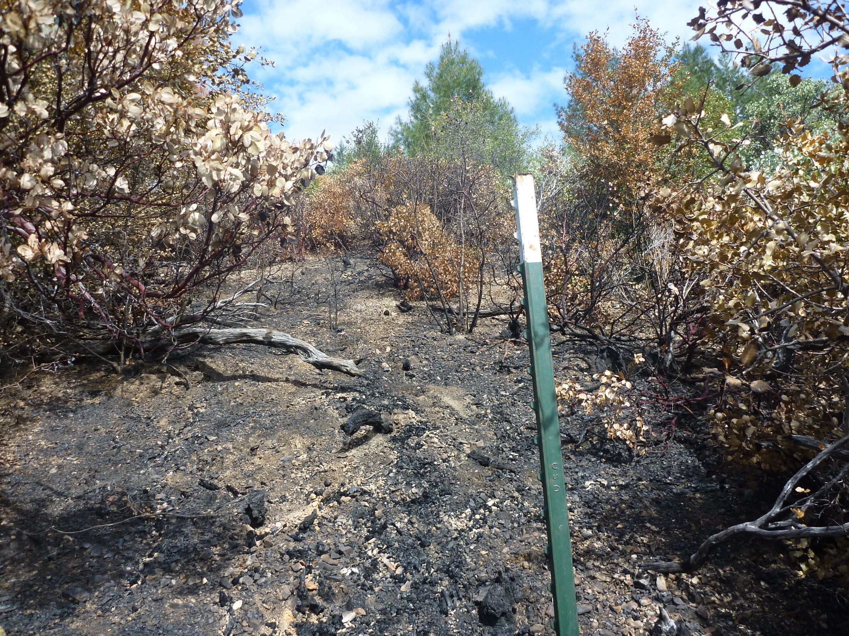
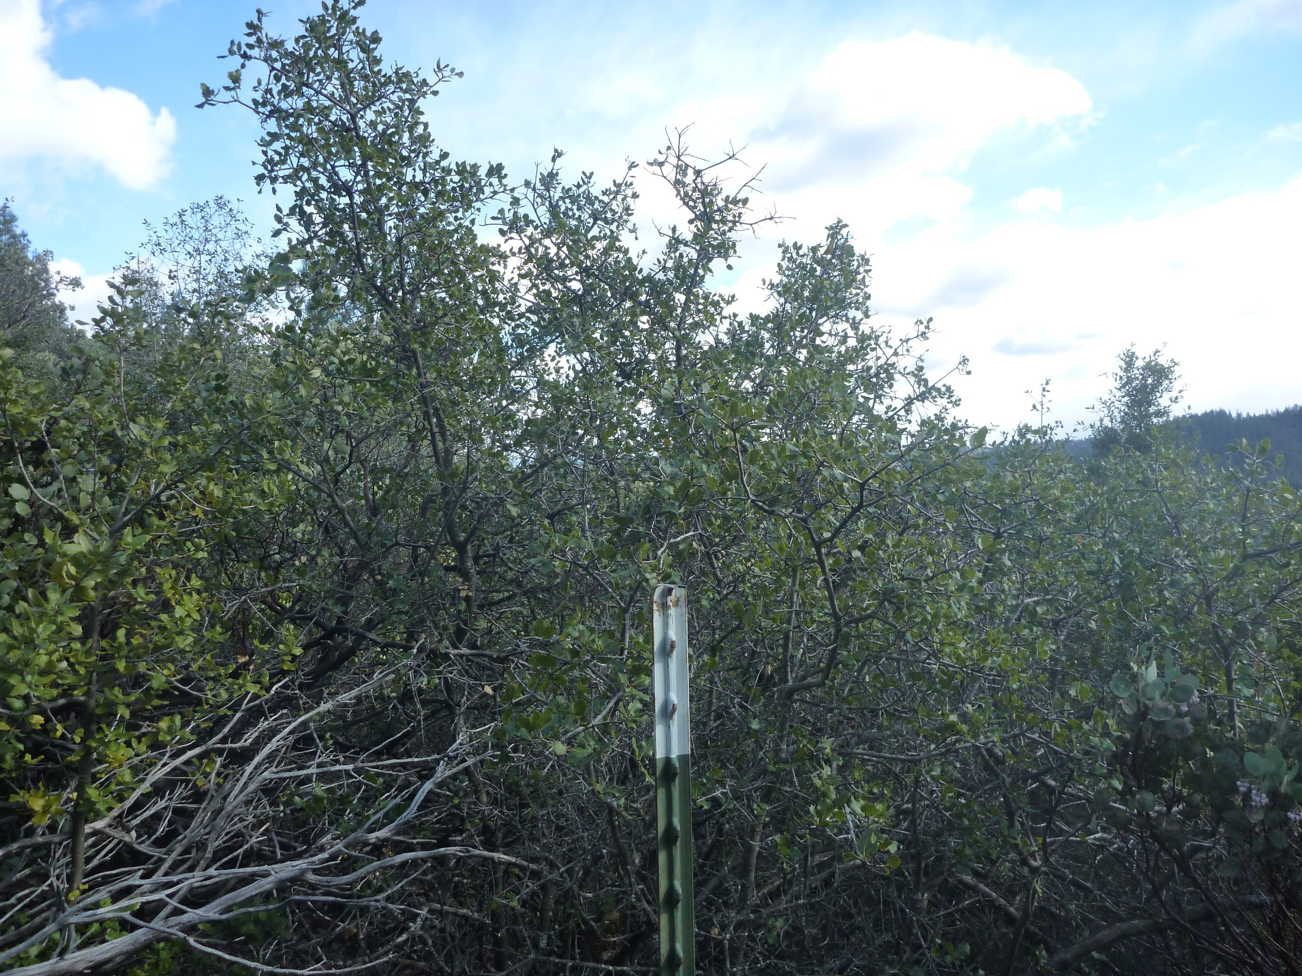
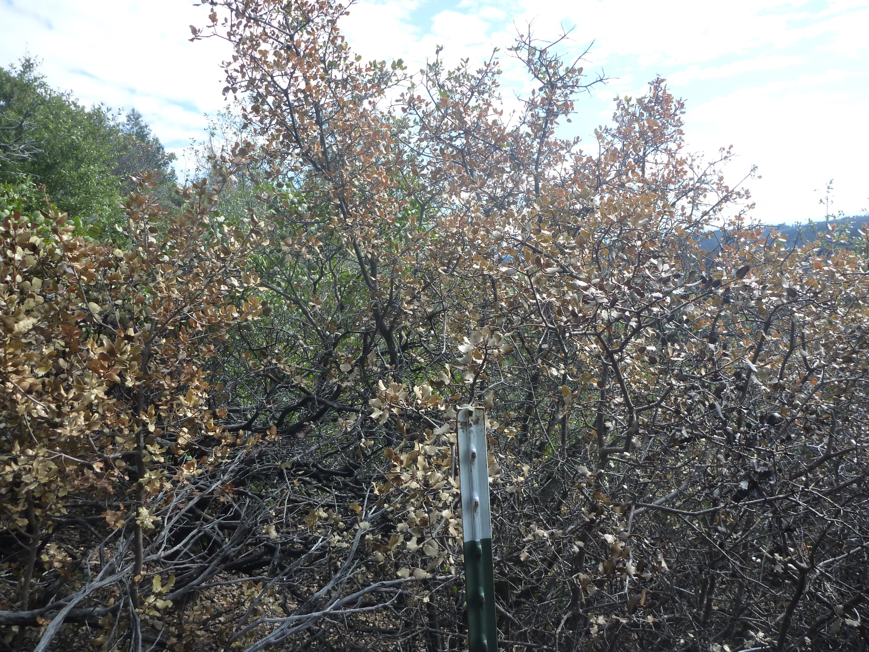
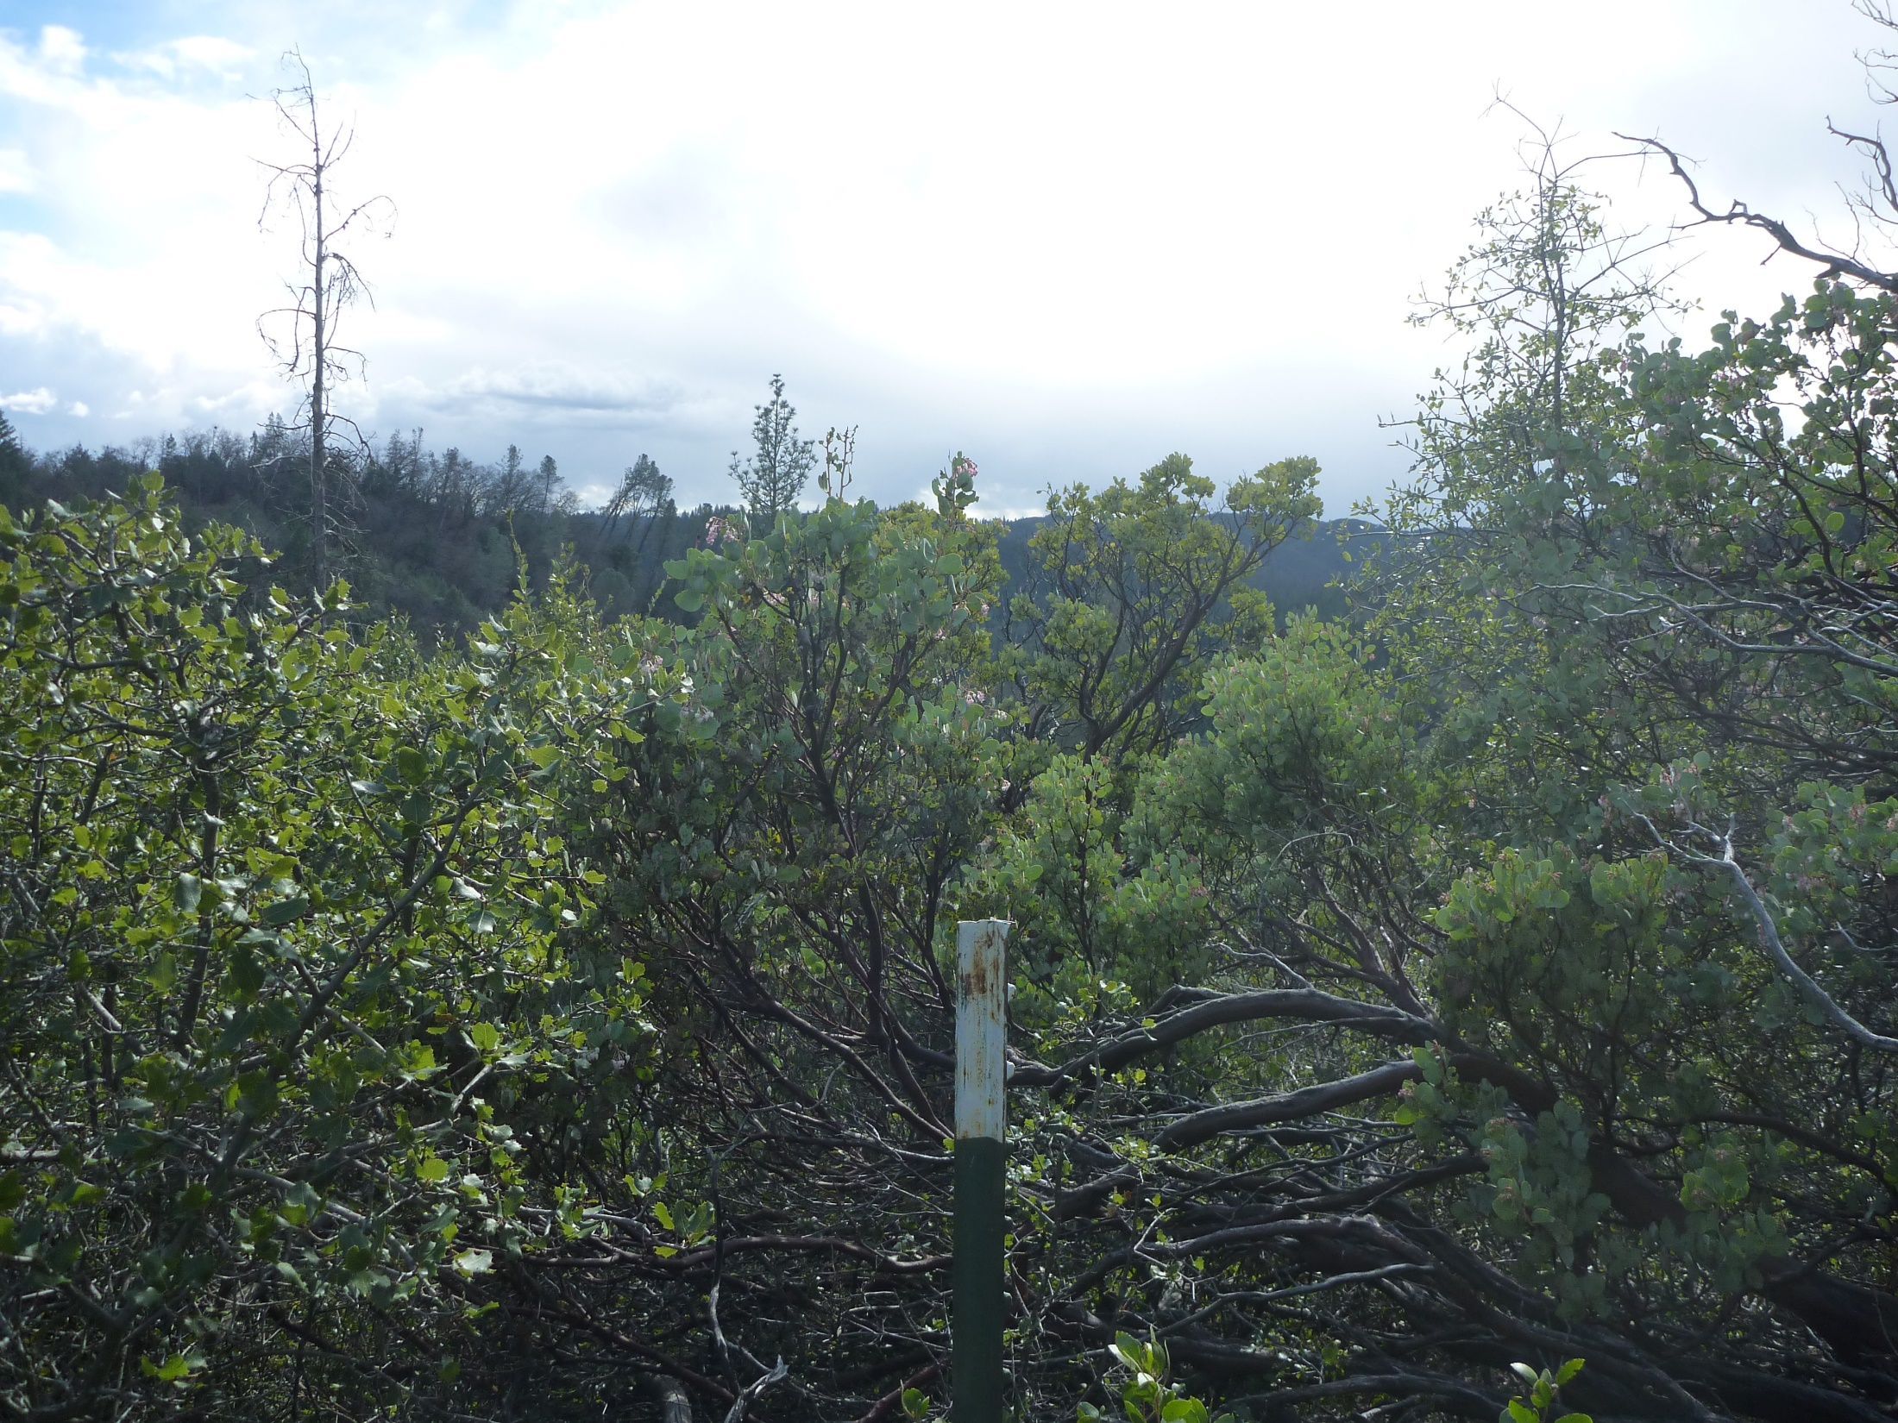
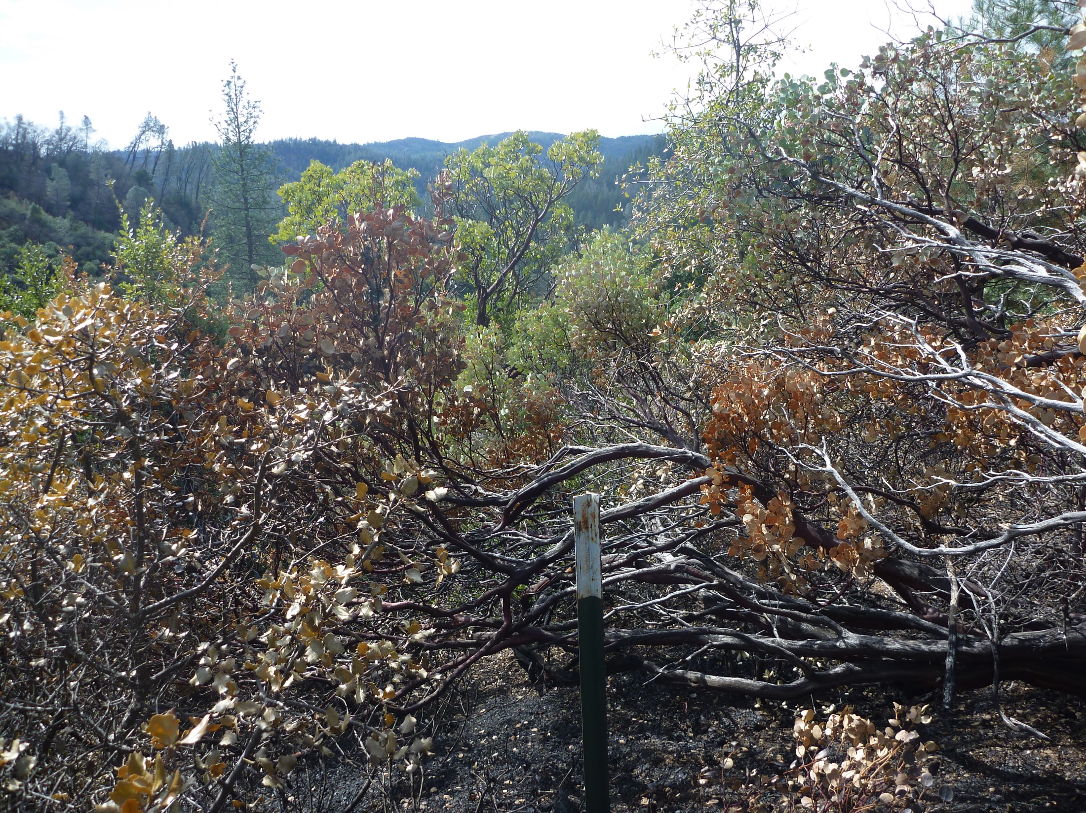
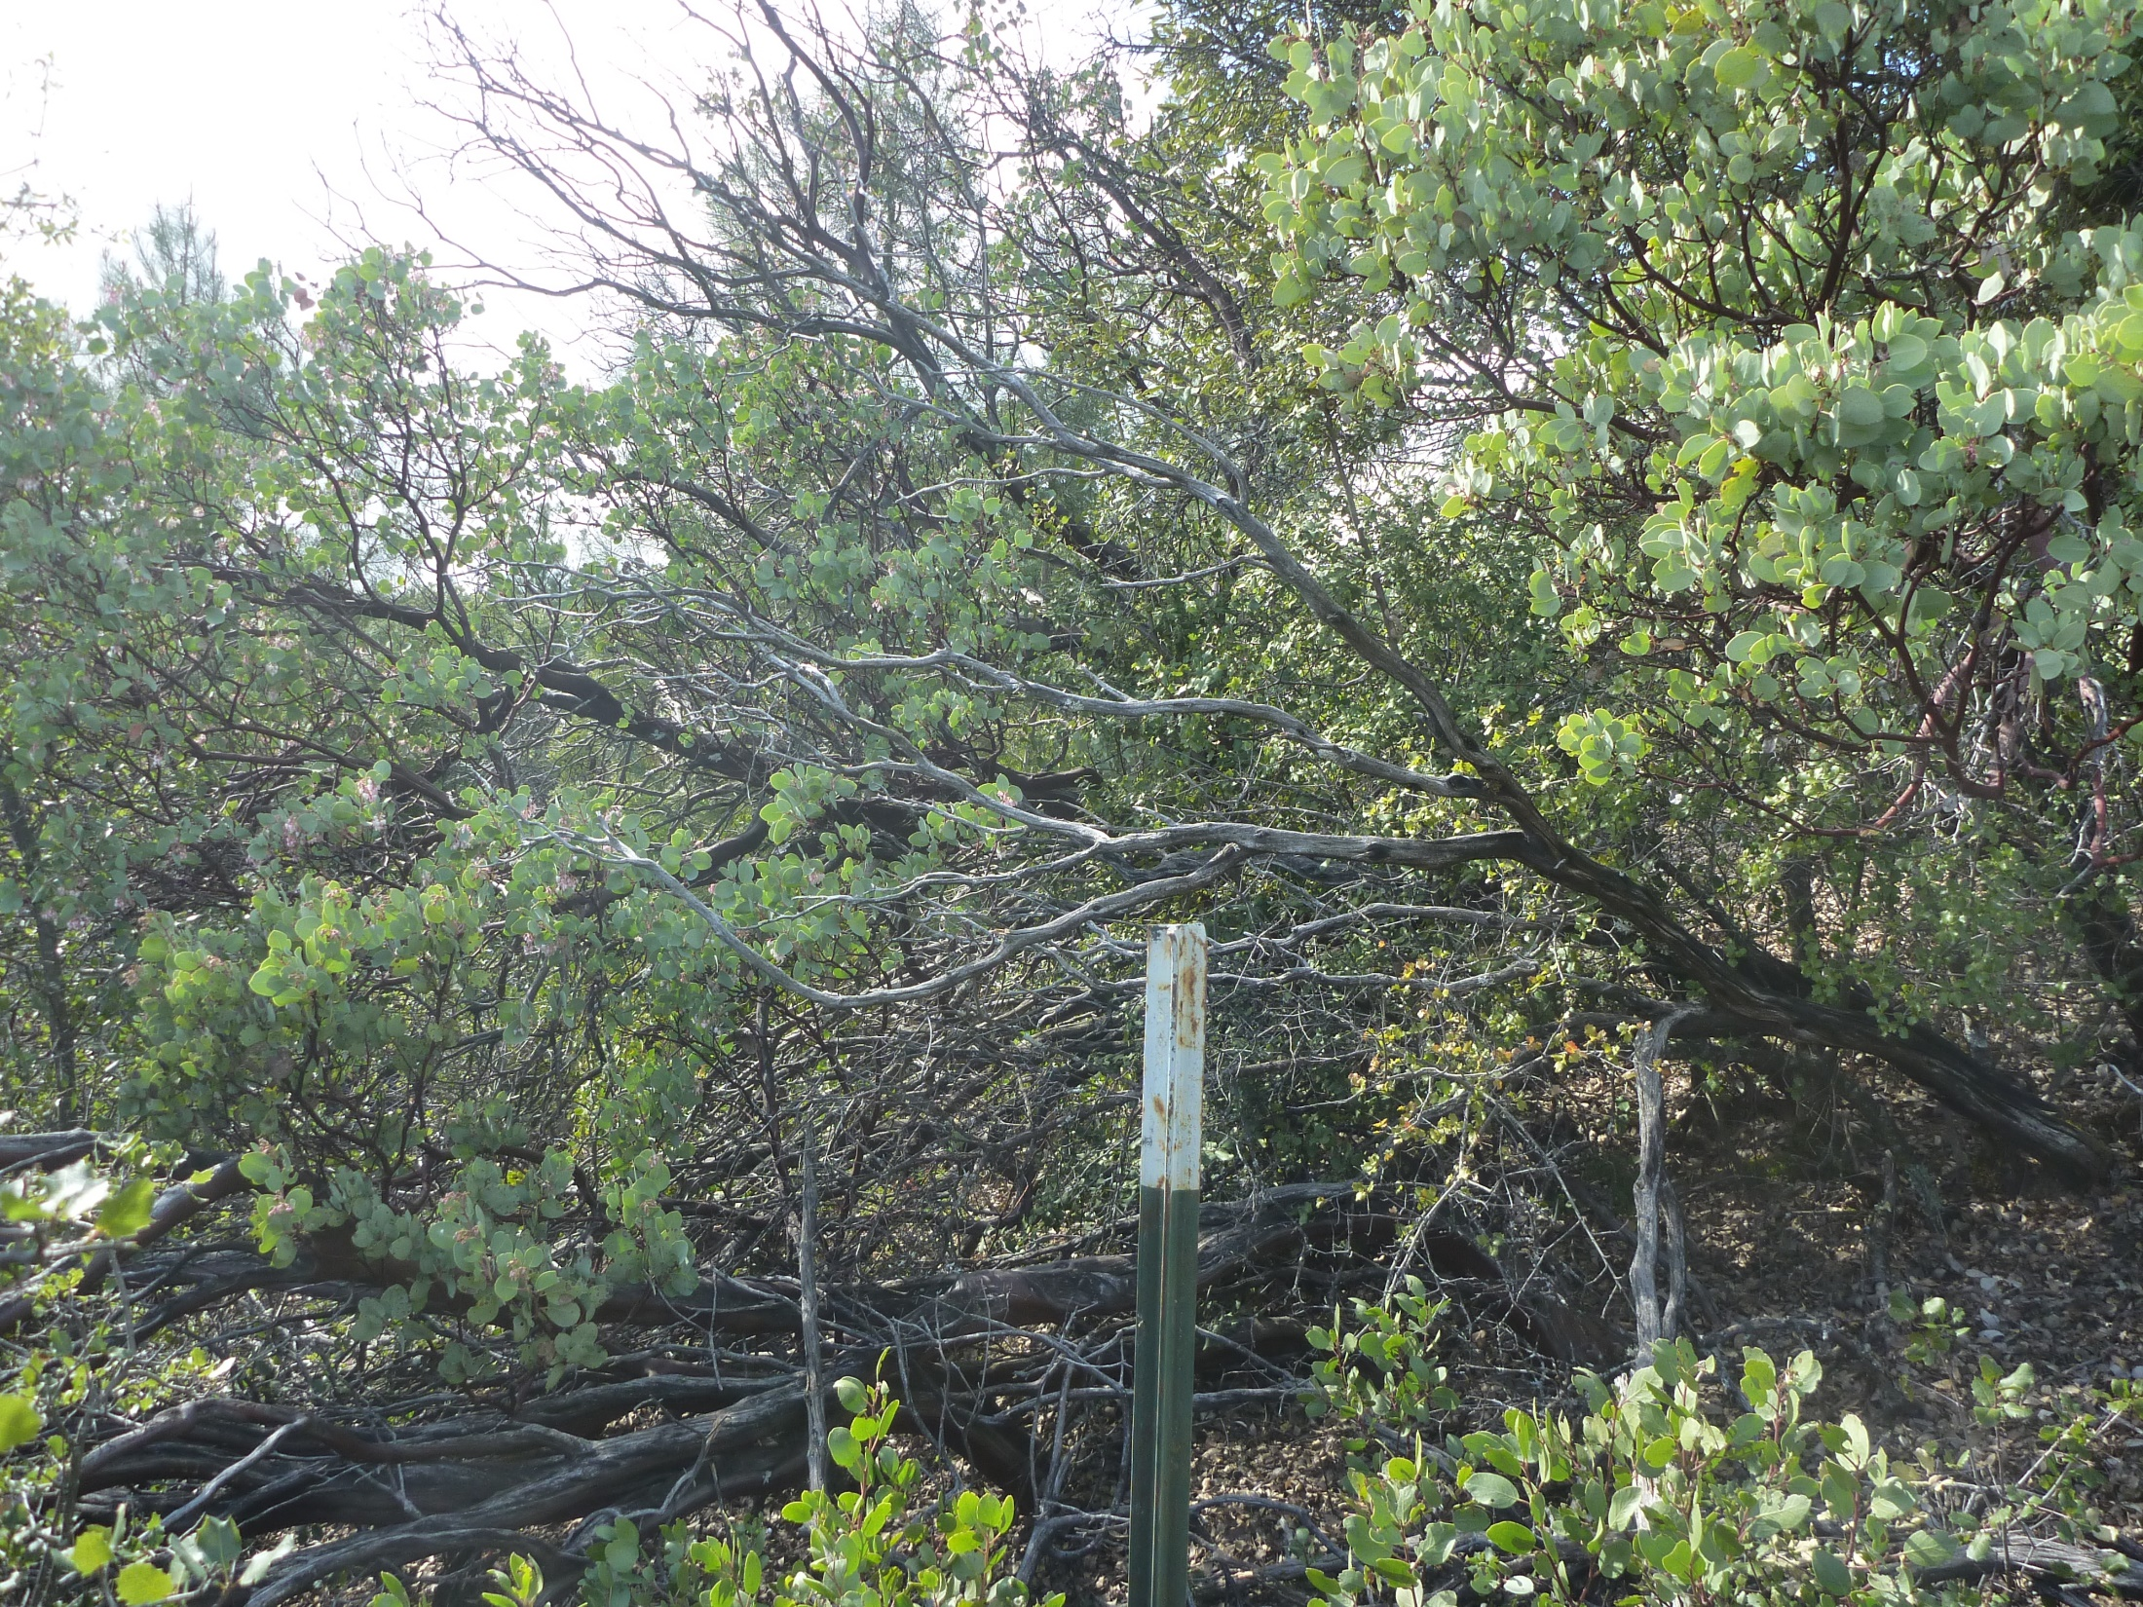
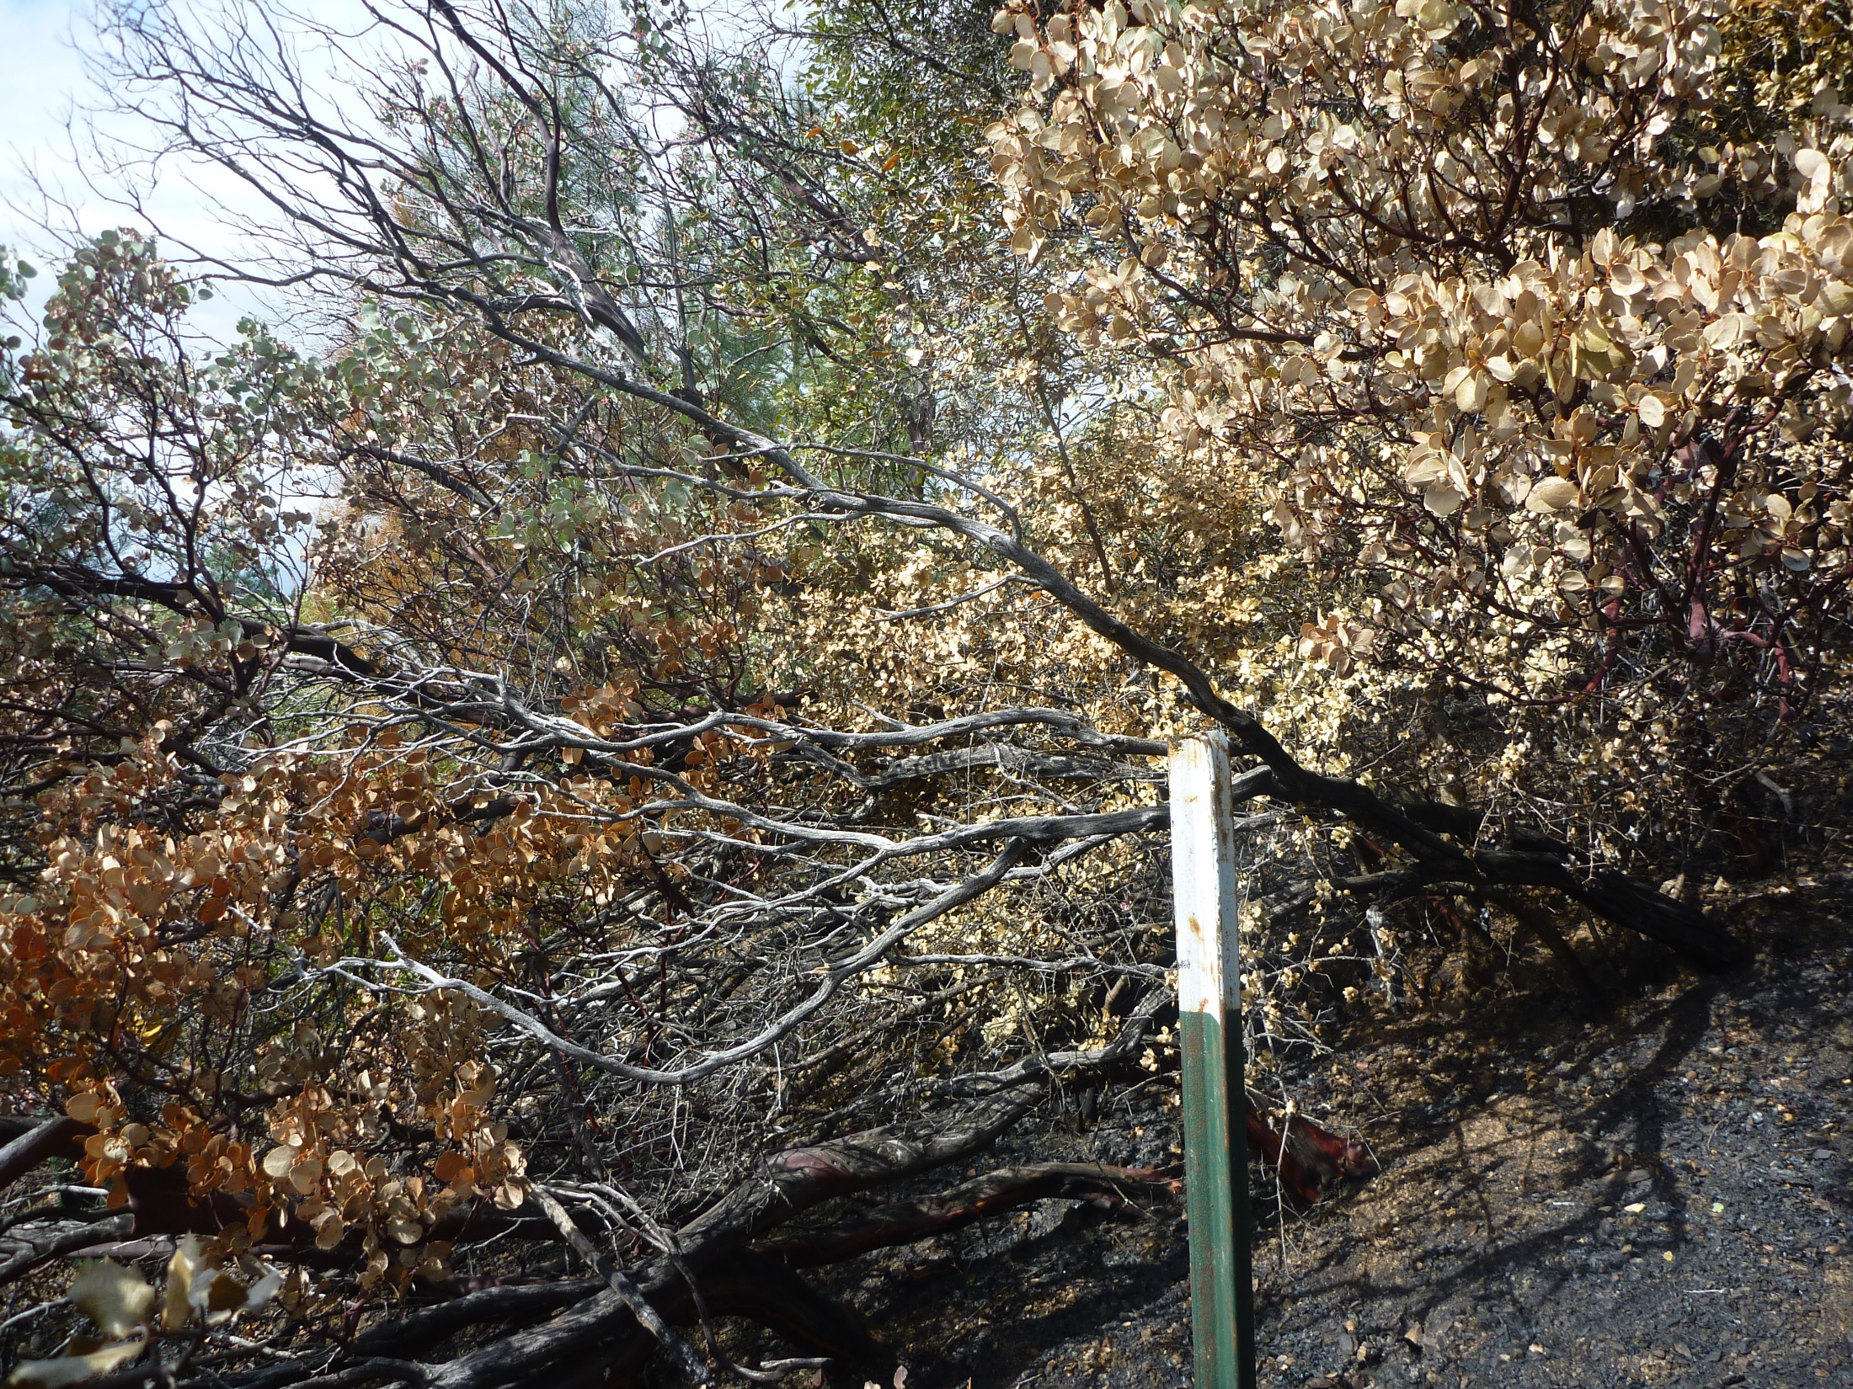
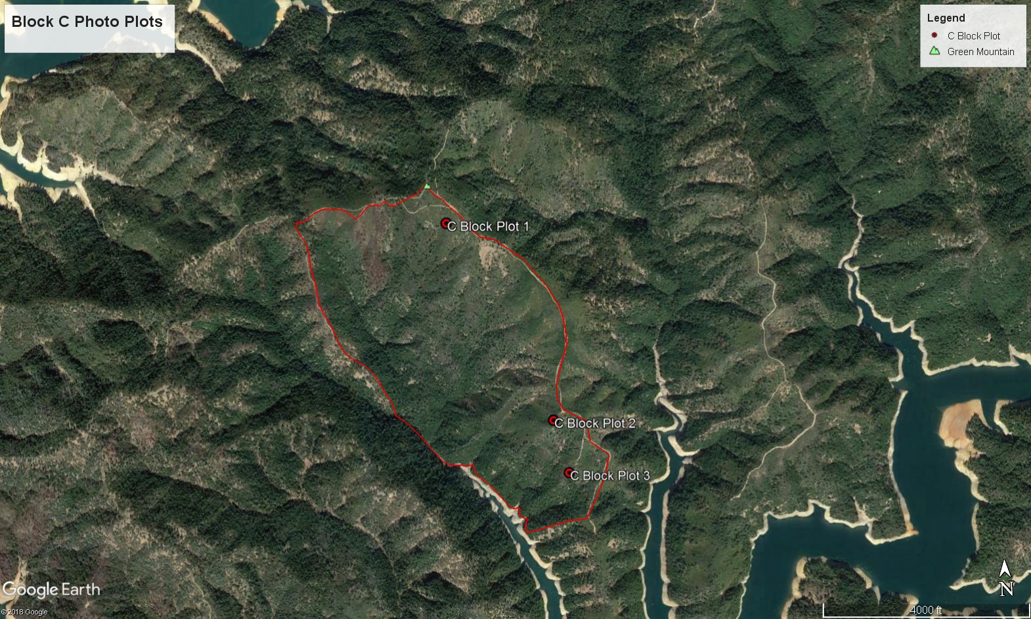

 | WEATHER OBSERVATIONS
 |  |  |  |  |  |  |  |  |  |  |  |  |  |  |  |  |  |  |  |  |  |  |  |  |  |  |  |  |  |  |  |  |  |  |  |  |  |  |  |  |  |  |  |  |  |  |  |  |  |  |  |  |  |  |  | Page ___ of ___
DATE:  2-25-2018 |  | FIRE NAME: |  | Green Mtn Rx Block C |  |  |  |  |  |  |  |  |  |  |  |  |  |  |  | OBSERVERS:  Kevin Osborne, Ryan Means, RJ Reirson
TIME | LOCATION | ELEVATION |  | WIND SPEED (GUSTS) |  | WIND DIRECTION |  |  | DRY BULB |  | WET BULB |  |  |  | RH |  |  |  |  | DP |  | ASPECT |  |  |  |  | SLOPE (%) |  |  |  |  |  | % CLOUD COVER |  |  |  | % SHADING |  |  |  | Ref Fuel Moisture |  |  |  | Exposed/ Shaded |  |  |  |  | FINE DEAD FUEL MOISTURE | PROB. OF IGNITION |  | COMMENTS (PRECIP, FIRE BEHAVIOR, SMOKE, ETC.)
Prescription
0900 | RAWS Location |  |  |  |  |  |  |  |  |  |  |  |  |  |  |  |  |  |  |  |  |  |  |  |  |  |  |  |  |  |  |  |  |  |  |  |  |  |  |  |  |  |  |  |  |  |  |  |  |  |  |  | 10 hr fuel stick – 9%  RAWS 10 hr fuel moisture 9 %
0925 | DP 40 TEST FIRE | 2100 |  | Light |  | NE |  |  | 42 |  | 36 |  |  |  | 57 |  |  |  |  | 28 |  | S |  |  |  |  | 50 |  |  |  |  |  | 50 |  |  |  | 0 |  |  |  | 8 |  |  |  | 4/5 |  |  |  |  | 12/13 | 20/20 |  | HIGH THIN CLOUDS
1030 | DP 40 | 2100 |  | 1-2 |  | S |  |  | 46 |  | 38 |  |  |  | 48 |  |  |  |  | 27 |  | S |  |  |  |  | 50 |  |  |  |  |  | 50 |  |  |  | 0 |  |  |  | 7 |  |  |  | 2/4 |  |  |  |  | 9/11 | 30/30 |  | HIGH THIN CLOUDS
1130 | DP 40 | 2100 |  | 2-4 |  | S |  |  | 50 |  | 41 |  |  |  | 46 |  |  |  |  | 30 |  | S |  |  |  |  | 50 |  |  |  |  |  | 40 |  |  |  | 0 |  |  |  | 7 |  |  |  | 2/4 |  |  |  |  | 9/11 | 30/30 |  | HIGH THIN CLOUDS
1230 | 400 YDS WEST DP 40 | 2000 |  | 3-5 G8 |  | S |  |  | 51 |  | 40 |  |  |  | 37 |  |  |  |  | 26 |  | S |  |  |  |  | 50 |  |  |  |  |  | 50 |  |  |  | 0 |  |  |  | 6 |  |  |  | 1/4 |  |  |  |  | 7/10 | 40/30 |  | HIGH THIN CLOUDS
1330 | HALFWAY DOWN B/C LINE | 1600 |  | 2-4 |  | SE |  |  | 53 |  | 42 |  |  |  | 37 |  |  |  |  | 27 |  | S |  |  |  |  | 50 |  |  |  |  |  | 60 |  |  |  | 0 |  |  |  | 6 |  |  |  | 1/4 |  |  |  |  | 7/10 | 40/30 |  | HIGH THIN CLOUDS (INCREASING)
1430 | HALFWAY DOWN B/C LINE | 1600 |  | Light |  | S |  |  | 53 |  | 42 |  |  |  | 37 |  |  |  |  | 27 |  | S |  |  |  |  | 50 |  |  |  |  |  | 50 |  |  |  | 0 |  |  |  | 6 |  |  |  | 1/5 |  |  |  |  | 7/11 | 40/20 |  | HIGH THIN CLOUDS
1530 | C/D Line above Reynolds Creek | 1600 |  | 1-3 G6 |  | SW |  |  | 56 |  | 44 |  |  |  | 36 |  |  |  |  | 29 |  | S |  |  |  |  | 30 |  |  |  |  |  | 50 |  |  |  | 0 |  |  |  | 6 |  |  |  | 1/4 |  |  |  |  | 7/10 | 40/30 |  | HIGH THIN CLOUDS (INCREASING)
1630 | C/D/ Line above Reynolds Creek | 1600 |  | 1-2 G4 |  | SW |  |  | 52 |  | 41 |  |  |  | 36 |  |  |  |  | 26 |  | S |  |  |  |  | 30 |  |  |  |  |  | 70 |  |  |  | 0 |  |  |  | 6 |  |  |  | 3/5 |  |  |  |  | 9/11 | 30/20 |  | High thin clouds thickening and increasing.
 | FIRE BEHAVIOR OBSERVATIONS
 |  |  |  |  |  |  |  |  |  |  |  |  |  |  |  |  |  |  |  |  |  |  |  |  |  |  |  |  |  |  |  |  |  |  |  |  |  |  |  |  |  |  |  |  |  |  |  |  | Page ___ of ___
DATE: | 02-25-2018 | FIRE NAME: |  |  | Green Mtn. Rx C Block |  |  |  |  |  |  |  |  |  |  |  |  |  |  |  |  |  |  |  | OBSERVERS:  Kevin Osborne, Ryan Means, RJ Reierson
TIME | LOCATION | ELEV. |  |  | ASPECT |  | SLOPE (%) |  |  | FIRE TYPE* (B/H/F) Circle one |  |  |  |  |  |  |  |  |  | FLAME LENGTH* |  |  |  |  | FLAME ZONE DEPTH* |  |  |  |  |  |  | ROS*  X_Ch/hr  ___ft/min  ___Other |  |  |  |  |  |  | PRIMARY CARRIER* |  |  |  |  |  |  | FUEL MODEL |  |  |  | COMMENTS*
PRESCRIPTION:
1050 | Green Mt at DP 40 | 2100 |  |  | S |  | 40 |  |  | B F H |  |  |  |  |  |  |  |  |  | .5’ |  |  |  |  | 1’ |  |  |  |  |  |  | <1 |  |  |  |  |  |  | Brush Litter |  |  |  |  |  |  | BR |  |  |  | Single brush pocket torching near test fire location.
1145 | 200 YDS West of DP 40 | 2100 |  |  | SE |  | 30 |  |  | B F H |  |  |  |  |  |  |  |  |  | 3’ |  |  |  |  | 10’ |  |  |  |  |  |  | 2-3 |  |  |  |  |  |  | Brush/Timber litter |  |  |  |  |  |  | T/B |  |  |  | Observed group torching and good consumption of Knobcone and brush along spur ridge.
1250 | Drainage East of Reynolds Creek | 200 |  |  | S |  | 25 |  |  | B F H |  |  |  |  |  |  |  |  |  | 10 inch |  |  |  |  | 10 inch |  |  |  |  |  |  | <1 |  |  |  |  |  |  | Oak litter |  |  |  |  |  |  | T |  |  |  | Approximately 50% consumption in Oak litter observed with backing and flanking low intensity fire.
1345 | Halfway down B/C line south of DP 40 | 1600 |  |  | S |  | 30 |  |  | B F H |  |  |  |  |  |  |  |  |  | 10-15’ |  |  |  |  | UO |  |  |  |  |  |  | 1-2 |  |  |  |  |  |  | Timber litter |  |  |  |  |  |  | T/B |  |  |  | Group Torching in Knobcone thicket with needle draped brush along a spur ridge.
1400 | Halfway down B/C line south of DP 40 | 1600 |  |  | S |  | 40 |  |  | B F H |  |  |  |  |  |  |  |  |  | 6’ |  |  |  |  | UO |  |  |  |  |  |  | 5-6 |  |  |  |  |  |  | Timber litter |  |  |  |  |  |  | T/B |  |  |  | Good uphill runs with single tree torching in Oak and Knobcone litter.
 |  |  |  |  |  |  |  |  |  | B F H
 |  |  |  |  |  |  |  |  |  | B F H
 |  |  |  |  |  |  |  |  |  | B F H
*Fire Type: B (backing), H (heading), or F (flanking) |  |  |  |  |  |  |  |  |  |  |  |  |  |  |  |  |  |  |  |  |  |  |  |  |  |  |  |  |  |  |  |  |  |  |  |  |  |  |  |  |  |  |  |  |  |  |  |  |  | *Comments: % Consumption, scorch height, spotting dist.,
*Flame Length (FL): nearest inch (0-23"); 0.5 foot (2-4'); 1.0 foot (4-15'); 5.0 feet (>15') |  |  |  |  |  |  |  |  |  |  |  |  |  |  |  |  |  |  |  |  |  |  |  |  |  |  |  |  |  |  |  |  |  |  |  |  |  |  |  |  |  |  |  |  |  |  |  |  |  | ~% shading of fuels, fuel continuity
*Flame Zone Depth (FZD): nearest inch (0-23"); 0.5 foot (2-4'): 1.0 foot (>4') |  |  |  |  |  |  |  |  |  |  |  |  |  |  |  |  |  |  |  |  |  |  |  |  |  |  |  |  |  |  |  |  |  |  |  |  |  |  |  |  |  |  |  |  |  |  |  |  |  | ~unusual fire behavior
*Rate of Spread (ROS): ft/min or chains/hr |  |  |  |  |  |  |  |  |  |  |  |  |  |  |  |  |  |  |  |  |  |  |  |  |  |  |  |  |  |  |  |  |  |  |  |  |  |  |  |  |  |  |  |  |  |  |  |  |  | ~photo reference #
*Primary Carrier: litter, duff, pine cones, 1hrs, 10 hrs, 100hrs, 1000hrs, grass/forbs, shrubs, trees, etc. |  |  |  |  |  |  |  |  |  |  |  |  |  |  |  |  |  |  |  |  |  |  |  |  |  |  |  |  |  |  |  |  |  |  |  |  |  |  |  |  |  |  |  |  |  |  |  |  | ~etc.
 | SMOKE OBSERVATIONS
 |  |  |  |  |  |  |  |  |  |  |  |  |  |  |  |  |  |  |  |  |  |  |  |  |  |  |  |  |  |  |  |  |  |  |  |  |  |  |  |  |  |  |  |  |  |  |  | Page ___ of ___
DATE: | 02-25-2018 |  | FIRE NAME: Green Mtn. Rx C Block |  |  |  |  |  |  |  |  |  |  |  |  |  |  |  |  |  |  |  |  | OBSERVERS: Kevin Osborne, Ryan Means, RJ Reierson
HAINES INDEX: |  |  | FORECASTED TRANSPORT WINDS:  NE 5 Becoming S-SE 8-15 in the Afternoon |  |  |  |  |  |  |  |  |  |  |  |  |  |  |  |  |  |  |  |  | SMOKE SENSITIVE AREAS:  Redding, Jones Valley, Bella Vista
TIME | LOCATION & ELEVATION |  | WIND SPEED & DIRECTION |  | SMOKE COLUMN OR INVERSION ELEVATION ABOVE GROUND LEVEL |  |  |  |  |  |  |  |  |  |  |  | SMOKE COLUMN DIRECTION |  |  |  |  |  |  | PLUME TYPE 1-5 (BELOW) |  |  |  |  |  |  |  |  |  |  | COLOR |  |  |  |  | VOLUME |  |  |  |  |  |  |  |  | OTHER OBSERVATIONS*
1030 | DP 40 2100 |  | S 1-2 |  | Weak lift <100 |  |  |  |  |  |  |  |  |  |  |  | N |  |  |  |  |  |  | 4 |  |  |  |  |  |  |  |  |  |  | LT Grey |  |  |  |  | Light
1130 | DP 40 2100 |  | S 2-4 |  | 200’ lift |  |  |  |  |  |  |  |  |  |  |  | N |  |  |  |  |  |  | 3 |  |  |  |  |  |  |  |  |  |  | LT Grey |  |  |  |  | Light
1200 | Between DP 40 & Reynolds Creek |  | S 4-6 |  | 300’ |  |  |  |  |  |  |  |  |  |  |  | N |  |  |  |  |  |  | 3 |  |  |  |  |  |  |  |  |  |  | LT Brown |  |  |  |  | MOD |  |  |  |  |  |  |  |  | Smoke blowing off to the North. Smoke thickening with the increased consumption in brush and timber litter. Smoke starting to have more lift.
1230 |  |  | SE 4-6 |  | 500’ |  |  |  |  |  |  |  |  |  |  |  | NW |  |  |  |  |  |  | 3 |  |  |  |  |  |  |  |  |  |  | Dark Grey |  |  |  |  | MOD |  |  |  |  |  |  |  |  | Smoke drifting up to the NW and beginning to settle in upper Squaw Creek Arm.
1330 | N 40’46.035  W 122’8.977 |  | S 2-4 |  | 1000’ |  |  |  |  |  |  |  |  |  |  |  | N |  |  |  |  |  |  | 3 |  |  |  |  |  |  |  |  |  |  | Thick White |  |  |  |  | MOD |  |  |  |  |  |  |  |  | Smoke continues settling in Squaw Creek Arm.
1420 | N40’45.968  W122’8.888 |  | S 2-4 |  | 1000’ |  |  |  |  |  |  |  |  |  |  |  | N |  |  |  |  |  |  | 3 |  |  |  |  |  |  |  |  |  |  | Thick White |  |  |  |  | MOD |  |  |  |  |  |  |  |  | Smoke is darker and heavier than previously observed.
1505 | N40’46.535  W122’9.987 |  | S Light |  | 1000’ |  |  |  |  |  |  |  |  |  |  |  | N |  |  |  |  |  |  | 3 |  |  |  |  |  |  |  |  |  |  | Thick White |  |  |  |  | MOD |  |  |  |  |  |  |  |  | Dark/Heavy smoke drifting into Squaw Creek Arm.
1600 | C/D line above Reynolds Creek. |  | S 2-4 |  | 800 |  |  |  |  |  |  |  |  |  |  |  | N |  |  |  |  |  |  | 3 |  |  |  |  |  |  |  |  |  |  | Grey |  |  |  |  | MOD |  |  |  |  |  |  |  |  | Smoke continues to move into the Squaw arm, but beginning to settle into drainages/low areas in Reynolds Creek. Refer to picture in Figure 6.
 |  |  |  |  | PLUME TYPES
 | 1 |  | 2 |  | 3 |  |  |  |  |  |  |  |  |  |  |  | 4 |  |  |  |  |  |  | 5
 | RISING STRAIGHT UP, MAY HAVE CUMULUS TOP |  | RISING HIGH, THEN SHEARED BY WIND |  | RISING LOW, WIND INFLUENCED |  |  |  |  |  |  |  |  |  |  |  | NOT RISING; LITTLE WIND OR INVERSION |  |  |  |  |  |  | FLOWING OVER STEEP CLIFF OR EDGE; OR COLLAPSED COLUMN |  |  |  |  |  |  |  |  |  |  |  |  |  |  |  |  |  |  |  |  |  |  |  |  | *Observations include visibiliy, inversion status, visibility to sighted distance, impacts to smoke sensitive areas/resources, forward & back scatter, complaints, etc.

