Oak Knoll Woodland Restoration Project
Prescribed Fire Report

February 4th 2013
Oak Knoll Work Center, Klamath NF

Prepared by: Kevin J. Osborne
Feb 7th 2013

1. General Information

1.1 Site Description
The entire unit is within the Oak Knoll Work Center administrative site, on the Klamath NF in Northern CA. The 47 acre project area occupies a south aspect with slopes ranging in steepness from nearly flat to 50%. The lower portion of the project area contains the buildings and infrastructure of the work center. Private land is also adjacent to the administrative site on east and west sides.

The vegetation in the area, both within the unit boundaries and on adjacent lands, is dominated by two main fuel types; an open grass-shrub type and a woodland/timber type. In the grass-shrub combination Buckbrush (Ceanothus cuneatus) is the dominant species, with lesser amounts of mountain mahogany (Cercocarpus sp.) and Manzanita (Arctostaphylous sp.). This fuel is best represented by fuel model GS2 (122); moderate load, dry climate grass-shrub from Scott and Burgan (2005). The timber/woodland fuel type is a hardwood /conifer mix, with an overall crown closure of < 20%. Predominant overstory consists of white oak (Quercus garryana) and ponderosa pine (Pinus ponderosa) with scattered incense cedar (Calocedrus decurrens). The timber/woodland fuel is best represented by fuel model TU1 (161); low load dry-climate timber-grass-shrub from Scott and Burgan (2005).

Geographically, 2 units were included in the project on Feb. 4th 2013. The largest area, approximately 40 acres, occupies the hillside above the work center complex. The second piece was the grass field below the work center that includes approximately 7 acres.

1.2 Project Objectives

1.2.1 Resource Objectives:
- Retain 50% total soil cover on slopes <35% where it exists.
- Retain 60% total soil cover on slopes 36-60% where it exists.
- Limit mortality of mature pine (>6”dbh) and Oak to 5%.
- Maintain Coarse Woody Debris (CWD) where it exists, if possible.(90% retention in riparian reserves). *Coarse Woody debris includes pieces 3 inches or greater in diameter and at least 3 feet in length, also called 1000-hour and greater fire fuels.
- Increase forage and browse by at least 50% by killing mature brush with fire in order to encourage new growth (via seed scarification).

1.2.2. Prescribed Fire Objectives:
- Kill by fire up to 90% of mature shrub cover.
- Reduce 1 and 10 hour fuels by 60-100%.
- Reduce 100 hour fuels by 50%.

2. Prescription

2.1 Environmental Prescription
 | Prescription Low Intensity | Prescription High Intensity | Observed Min.* | Observed Max.*
Relative Humidity % | 60 | 20 | 36% | 57%
Wind Speed (MFWS) | 0 | 5 | 1-2 mph | 2-3 mph
Wind Direction | Any | Any | N/A | N/A
Temperature (Dry Bulb degrees) | 30 | 80 | 50 | 59
Dead Fuel Moisture % 1hr. ** | 13 | 5 | 7 | 9
Dead Fuel Moisture % 10hr. *** | 16 | 6 | 10 | 15
* Observed during ignition of burn, observations outside of prescription may have been observed before or after ignition.
** Fine dead fuel moisture as calculated from weather observations for exposed fuels.
*** As recorded by the KNF 91 portable RAWS at the top of the unit.

2.2 Fire Behavior Prescription
 | Minimum Intensity | Maximum Intensity | Observed Min. | Observed Max.
Flame Length (ft) | .5 | 7 | 1 | 8*
Forward Spread Rate (chains/hour) | .6 | 24 | < 1 | 2
Backing Spread Rate (chains/hour) | .1 | 1 | < 1 | <1
Spotting Distance (miles) | n/a | .4 | None | None
Probability of Ignition (%) | 15 | 65 | 20 | 40
*8ft flame lengths were observed for short period in the grass field below the compound and did not pose a threat to successful completion of the burn.

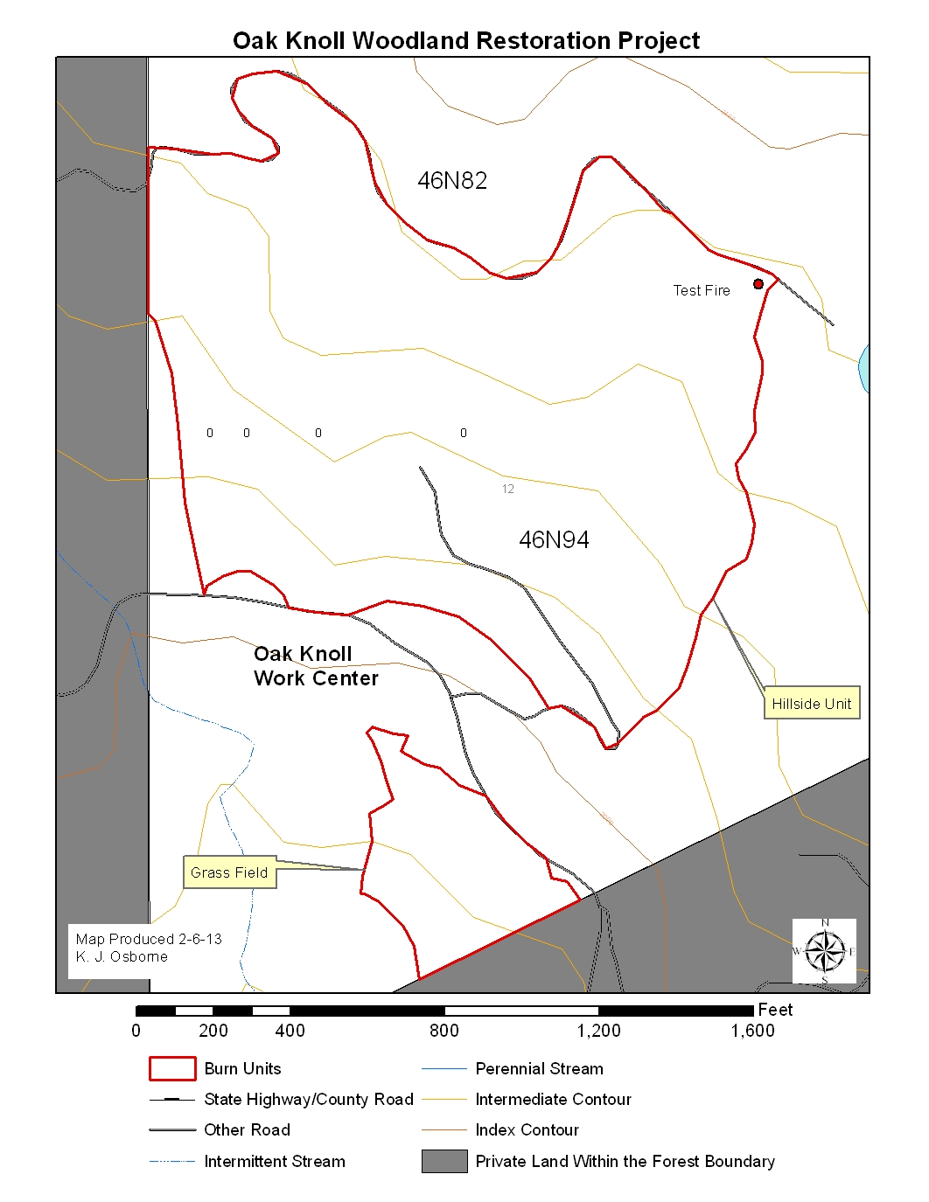

3. Project Implementation

3.1 Organization
Burn Boss – Devin Parks RXB2(t), Matt Watson RXB2
Firing – Brian Janes FIRB(t), Damon McCartney FIRB
Holding – Mike Huff
Ignition and Holding – approximately 25 additional personnel from Oak Knoll and Happy Camp

3.2 Days Events – 02-04-2013
- 0800 – Began collecting weather observations.
- 0900 – Briefing at Oak Knoll work Center given by Devin Parks, burn boss trainee.
- 0930-1100 – Resources staged waiting for prescription window, weather collected every 30 minutes.
- 1100 – Weather approached prescription parameters, resources moved to NE corner of the unit to prepare for test fire.
- 1200 – Prescription parameters met, test fire initiated shortly thereafter (approx. 1205).
- 1210 – Test fire declared successful, ignitions continued. Weather now recorded on the hour.
- 1250 – Ignition halted to assess fire effects and burn objectives.
- 1300 – Burn boss, firing boss and trainees met to discuss conditions. It was noted that the burn may not meet all objectives due to lower than desired fire behavior. Due to limited windows and past experiences, the burn boss decided to continue ignition and accept the fact that some objectives will not be met.
- 1315 – Ignition resumed with pattern altered to increase fire activity by keeping a larger group of lighters working together instead of using two separate groups.
- 1400 – As the ignition moved below the brush in the upper portion of the unit into oak woodland areas, fire behavior increased slightly and consumption of surface fuels improved.
- 1530 – Ignition on the main portion of the hillside unit and the grass field completed, all Happy Camp resources released.

3.3 Fire Behavior Summary
Fire behavior was fuel driven with some impact from topography and less from wind. In the upper 1/3 of the hillside unit, comprised mainly of buckbrush, grass and fine fuels carried fire but did not consume completely. The brush did not carry fire well, and the result was very short flame lengths (<1 ft.) and very short duration burning, with areas cool enough for foot travel within minutes (see Plot 1 photos). The most intense fire behavior in the upper portion of the unit occurred on the steepest slopes in areas with pine needle cast. In these areas, flame lengths up to 6 ft. were observed, however, the average flame lengths were 2-4 ft. In the pine needle fuels, consumption increased compared to the brush, but was still not 100%. At no point in the upper portion of the unit did consumption of mature brush reach the goal of 50-90%. Consumption of mature brush is best estimated between 1% and 5%.
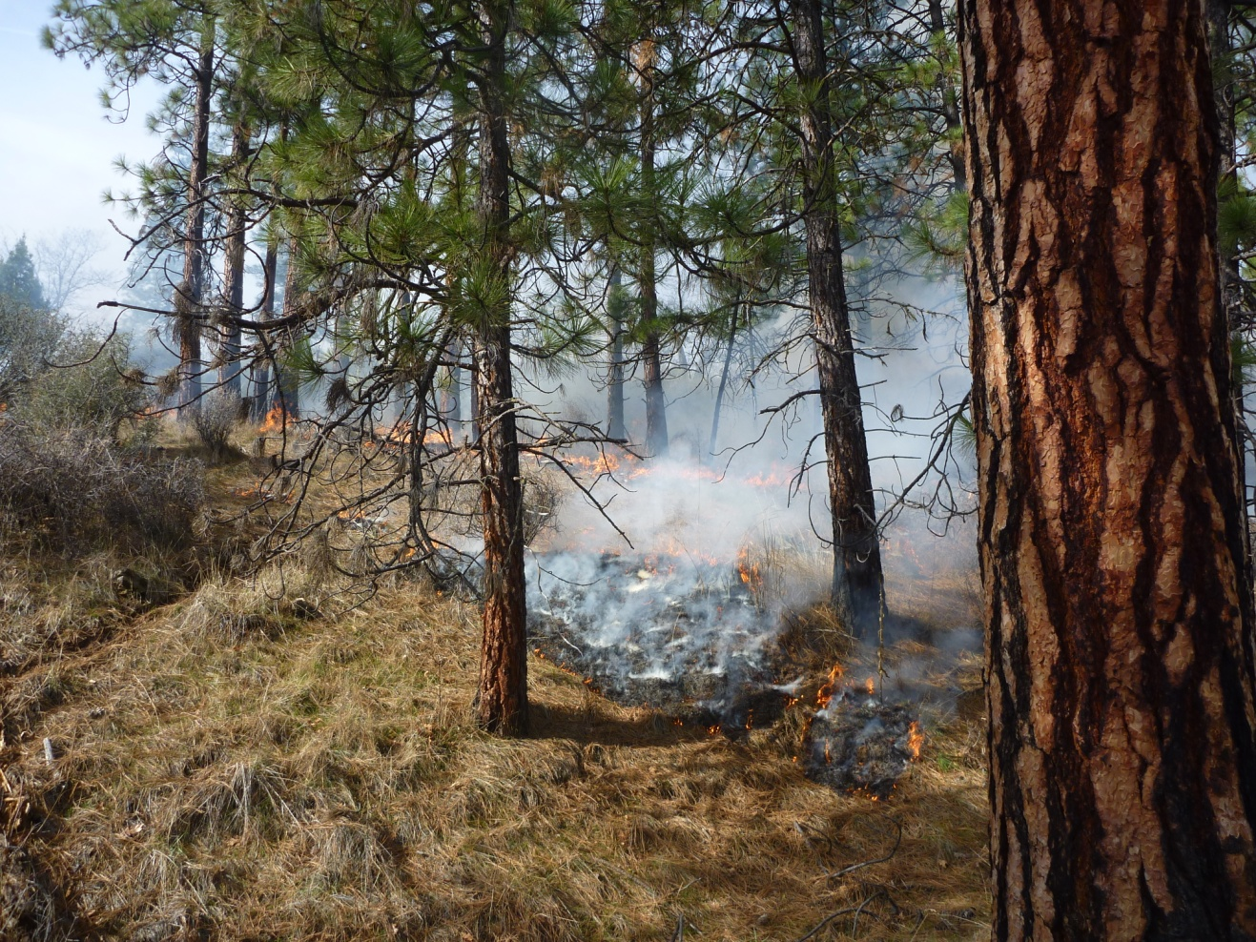
Fire behavior in pine needles on moderate slope, upper portion of hillside unit

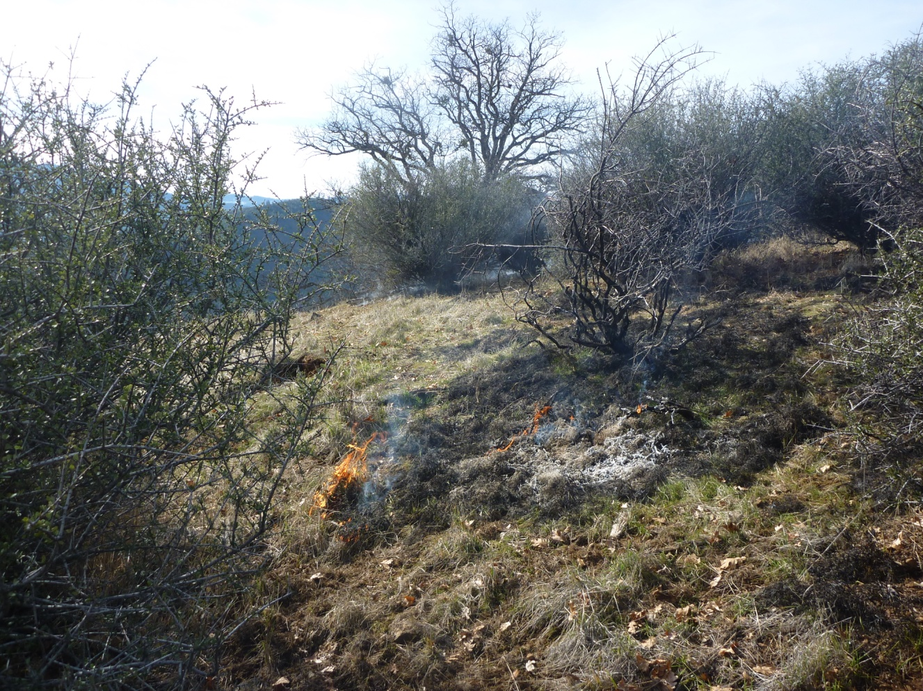
Fire behavior in grass and brush, upper portion of hillside unit
The lower 2/3 of the hillside unit is more open, with oak and pine woodland. Consumption was limited to the fine fuels with very little consumption of fuels larger than the 1 hr. fuel class. Topography also influenced fire behavior, with steeper slopes (>20%) having flame lengths of 2-3 ft. and slopes less than 20% having flame lengths of 1 to 2 ft., often less. Unfortunately, the increased flame lengths on steeper ground did not translate into increased consumption of larger fuels. In the more open fuel type, lighters were able to move more quickly and generate more heat, resulting in better consumption of fine surface fuels and slightly increased flame lengths (see Plot 2 photos), but this did not translate to increased consumption of larger size classes. Throughout the ignition, the ROS remained near 1 chain per hour: a stronger wind would have been needed to create faster rates of spread given the fuel moisture and humidity present during ignition.

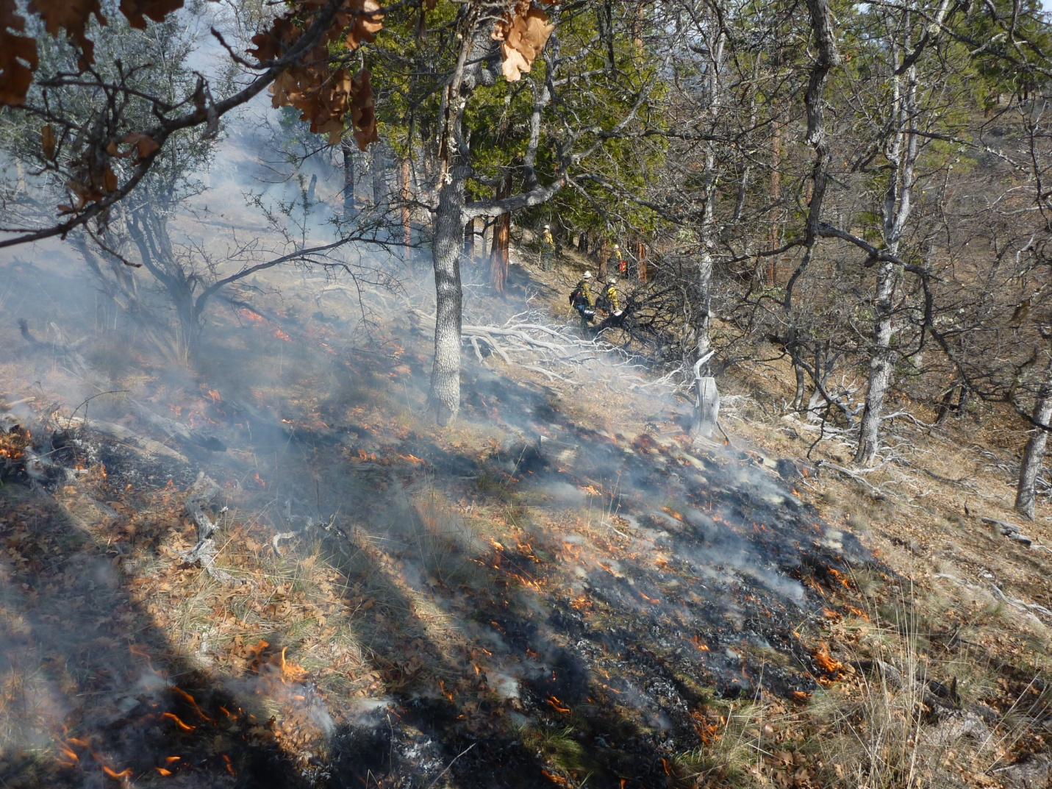
Average fire behavior in open, oak woodland fuel type in lower portion of the hillside unit

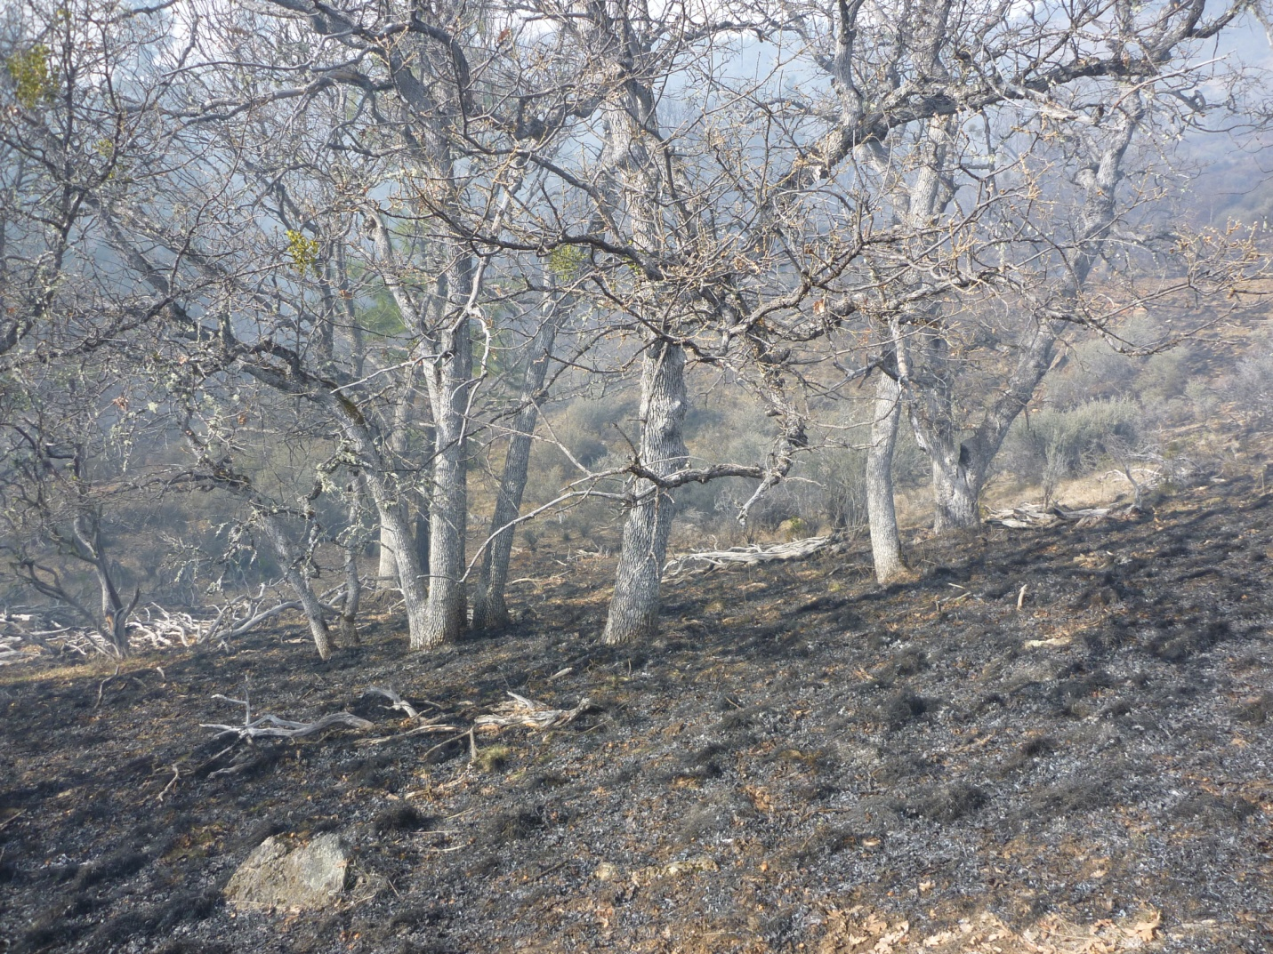
Fire effects in open, oak woodland fuel type in lower portion of the hillside unit

Due to the low ROS and small flame lengths, no torching of tree canopies was observed during ignition. Some ponderosa pines did receive sufficient heat to have char 6 to 8 ft. along the bole of the tree but this is not expected to have a significant impact on the health of these trees.

In the grass field below the compound, fire behavior was fuel driven, with 3 ft. grass producing 6 to 8ft. flame lengths for short periods, before cooling rapidly. The grass had some green-up at the base and the wind was very low, 1-2 mph, resulting in relative low rates of spread given the observed flame lengths.
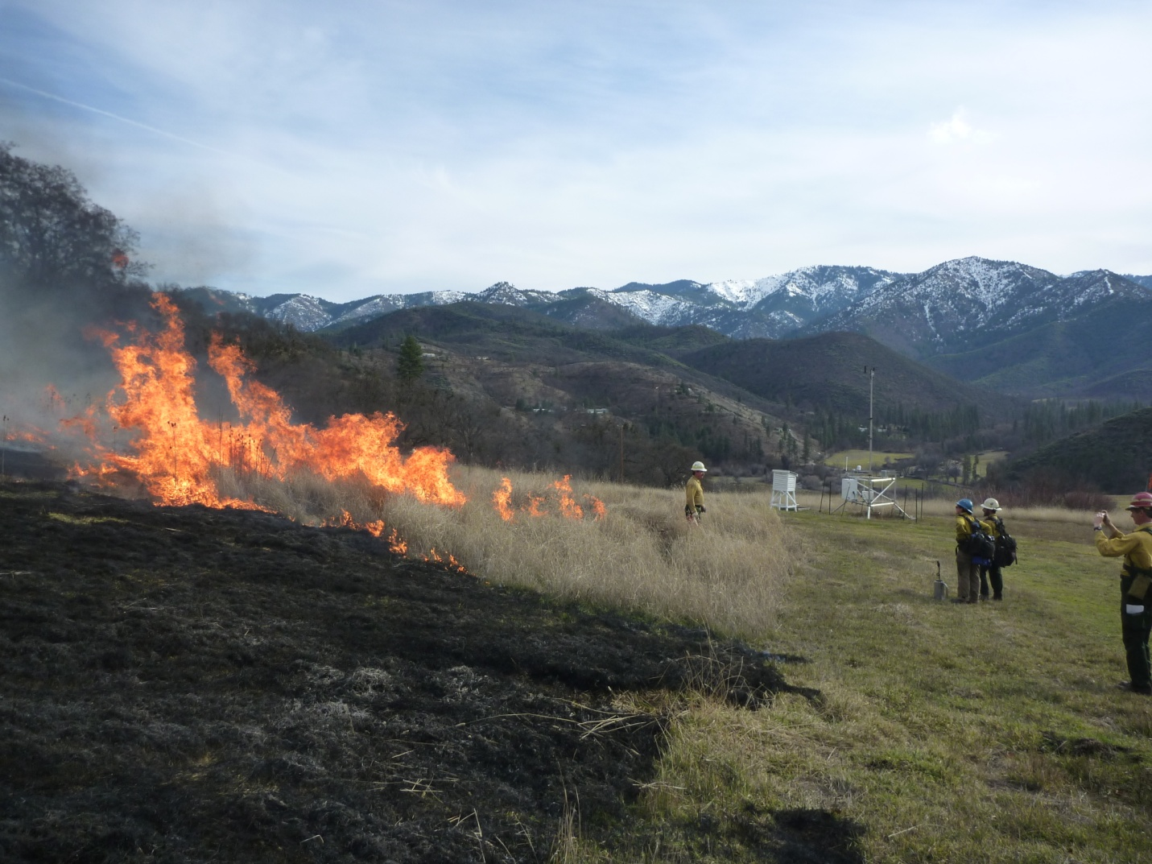
Grass in the lower field demonstrating typical fire behavior from 2-4-2013

3.4 Smoke Summary
The smoke from the upper portions of the hillside was very thin and light in color, likely due to the poor consumption and short residence time observed in the brush fuel type. As ignition progressed down the hill to the south, smoke production increased but remained relatively light in color. Throughout the burn, the smoke moved uphill to the north and northeast, away from the smoke sensitive community of Klamath River and State Highway 96. The smoke column rose to between 500 and 1000 ft. above ground level and was carried to the north in the same direction as smoke at the surface. Mixing was initially predicted to be 500 ft. and rise to between 700-1000 ft., and this was confirmed based on the level of rise and dispersion seen during the burn. While in place, the observer did not see any significant settling of smoke down into the Klamath River drainage or side drainages.

3.5 Summary of Objectives
Objective | Met? | Comments
Retain 50% total soil cover on slopes <35% where it exists | Yes | Consumption and heat production were low, soils undisturbed
Retain 60% total soil cover on slopes 36-60% where it exists | Yes | Consumption and heat production were low, soils undisturbed
Limit mortality of mature pine (>6”dbh) and oak to 5% | Yes | Some scorch on bole of trees up to 6 ft., no torching observed
Maintain Coarse Woody Debris where it exists | Yes | Consumption of 1000 hr. fuels limited
Increase forage & browse at least 50% by killing up to 90% mature brush with fire | No | Brush consumption very low, estimated to be no more than 5% of mature brush removed by fire
Reduce 1 and 10 hour fuels by 60-100% | No | Fine fuels were the primary carrier and consumed well, consumption of 10hr fuels was very low, below 50%
Reduce 100 hour fuels by 50% | No | Humidity and fuel moisture prevented larger fuels from consuming enough to reach objective

4. Photo Plots

Plot 1 after ignition showing poor shrub consumption (before ignition shows no change and is omitted for space reduction)
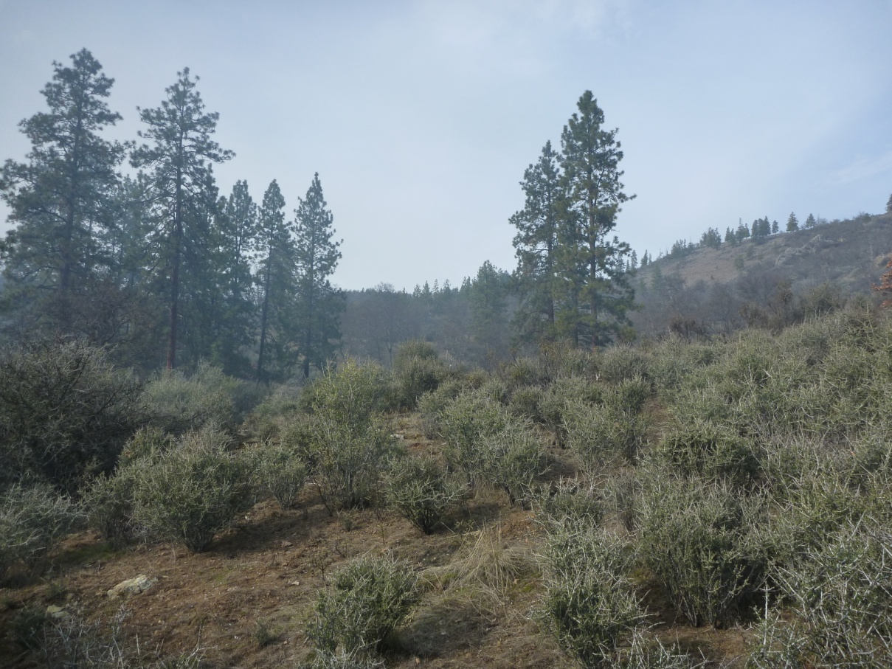
View looking north

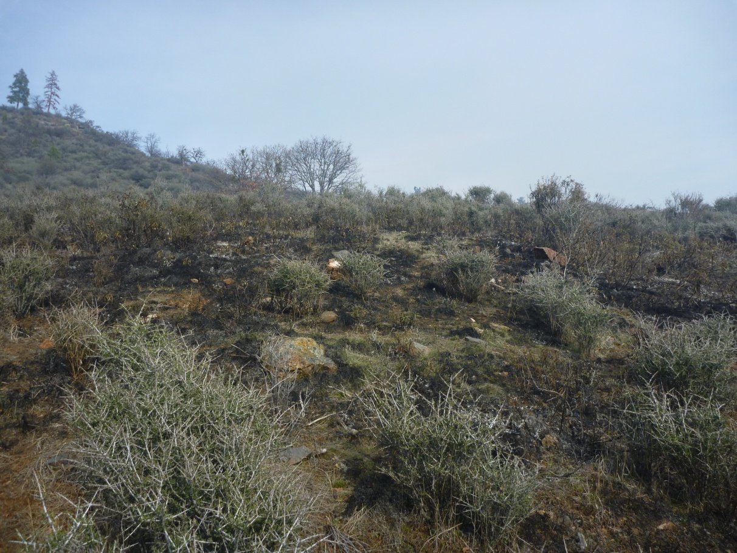
View looking east
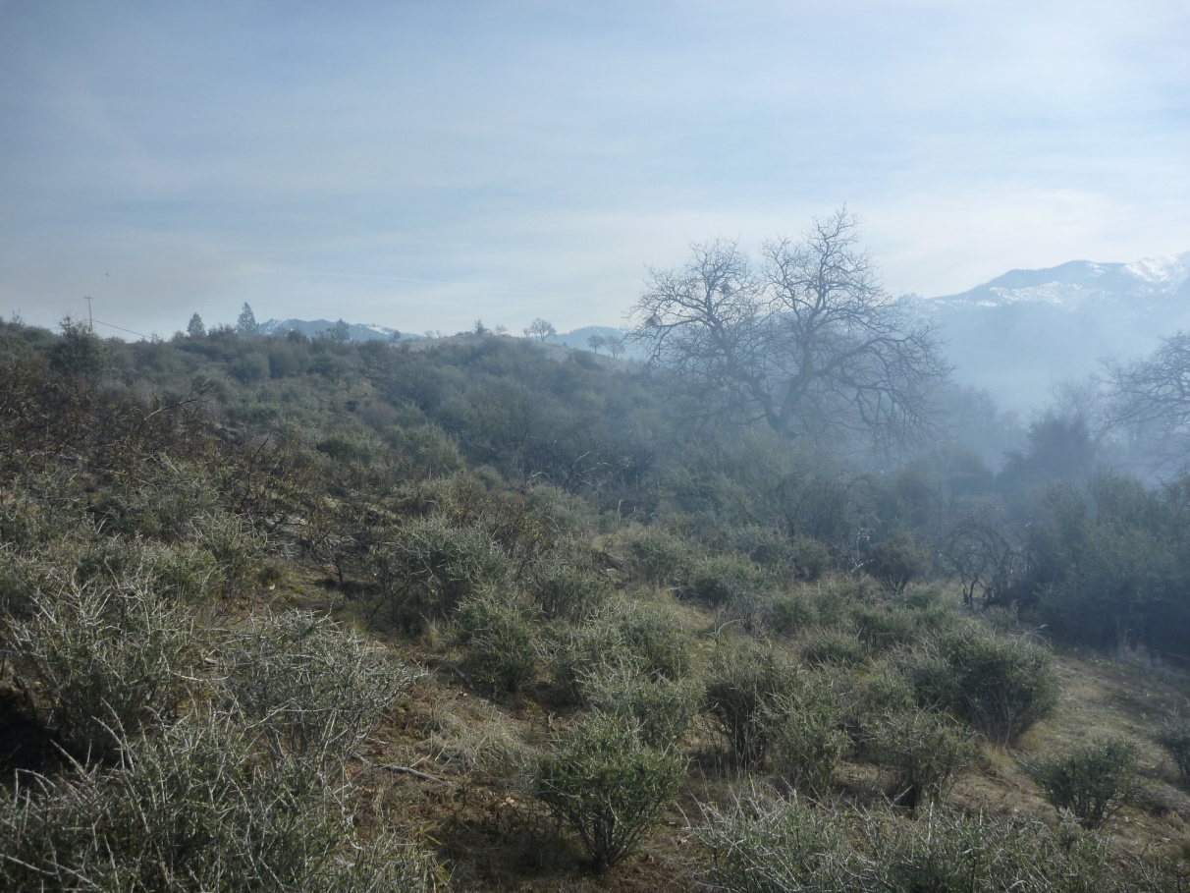
View looking south

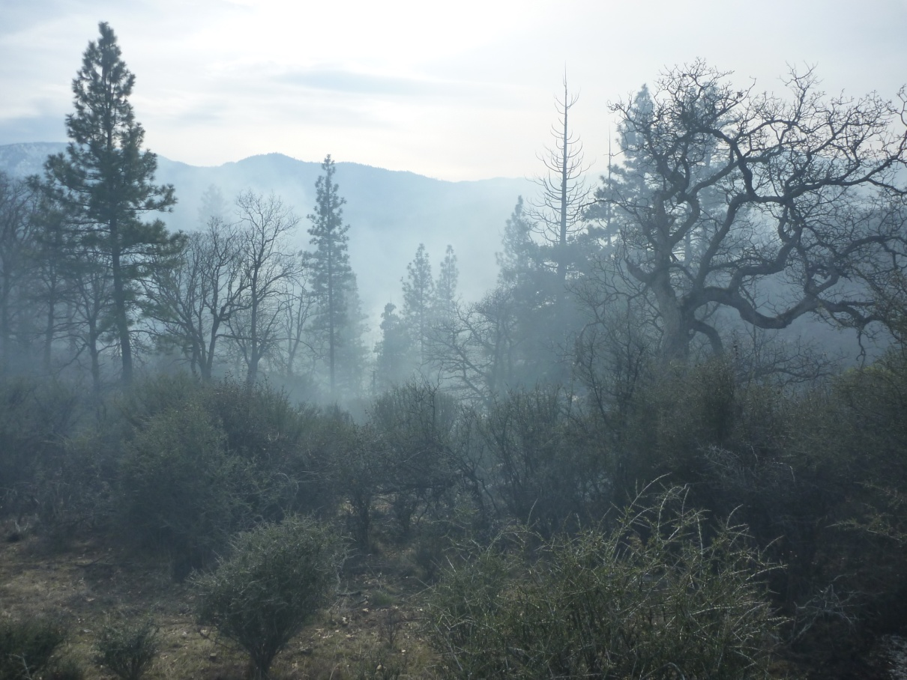
View looking west

Plot 2 before Ignition
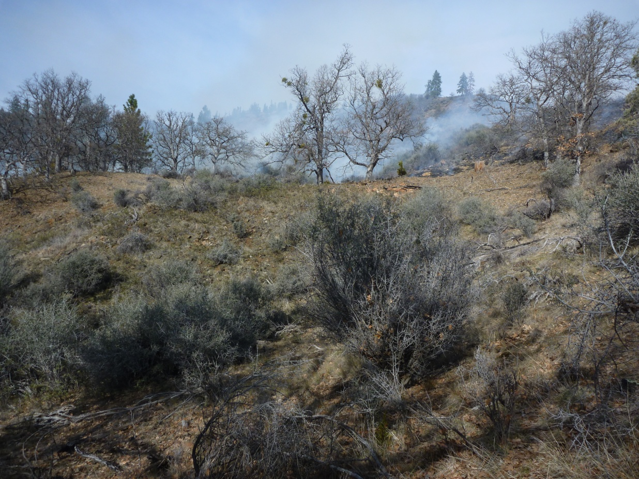
View looking north

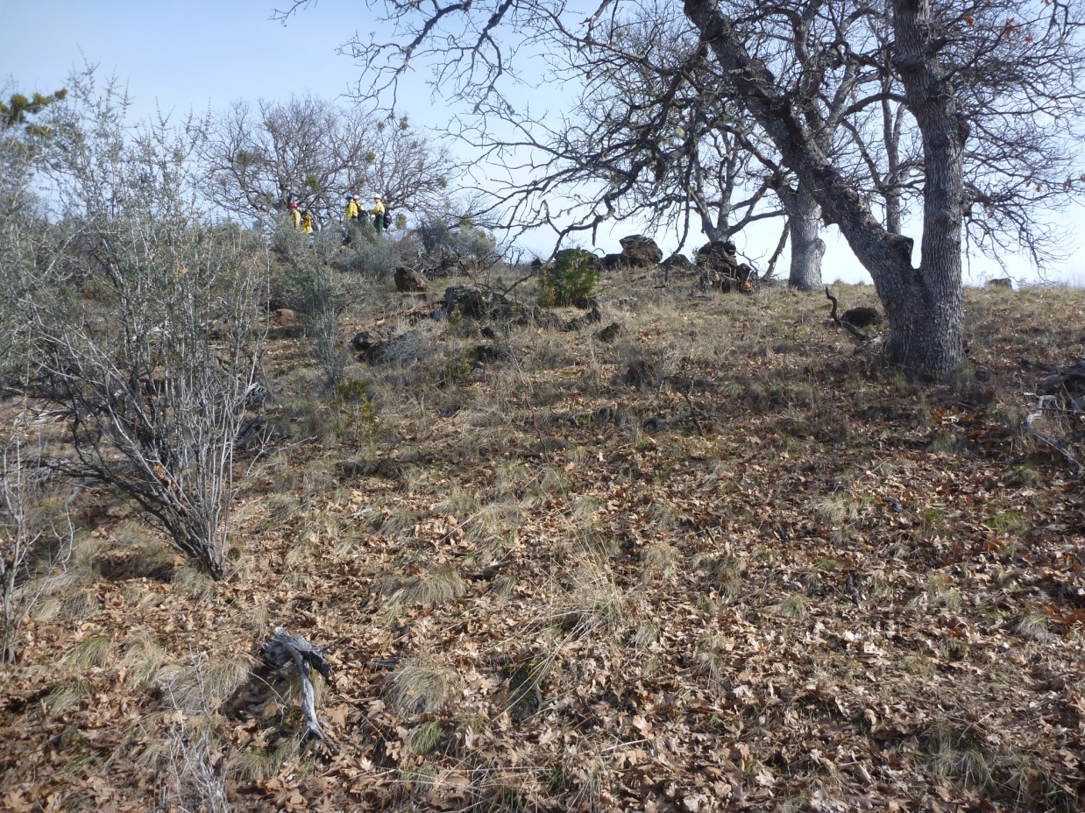
View looking east

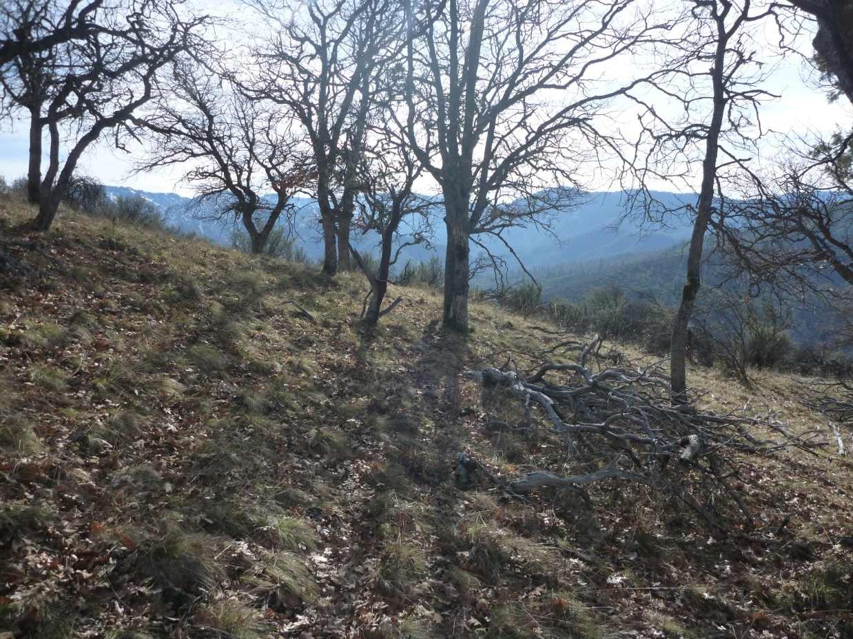
View looking south

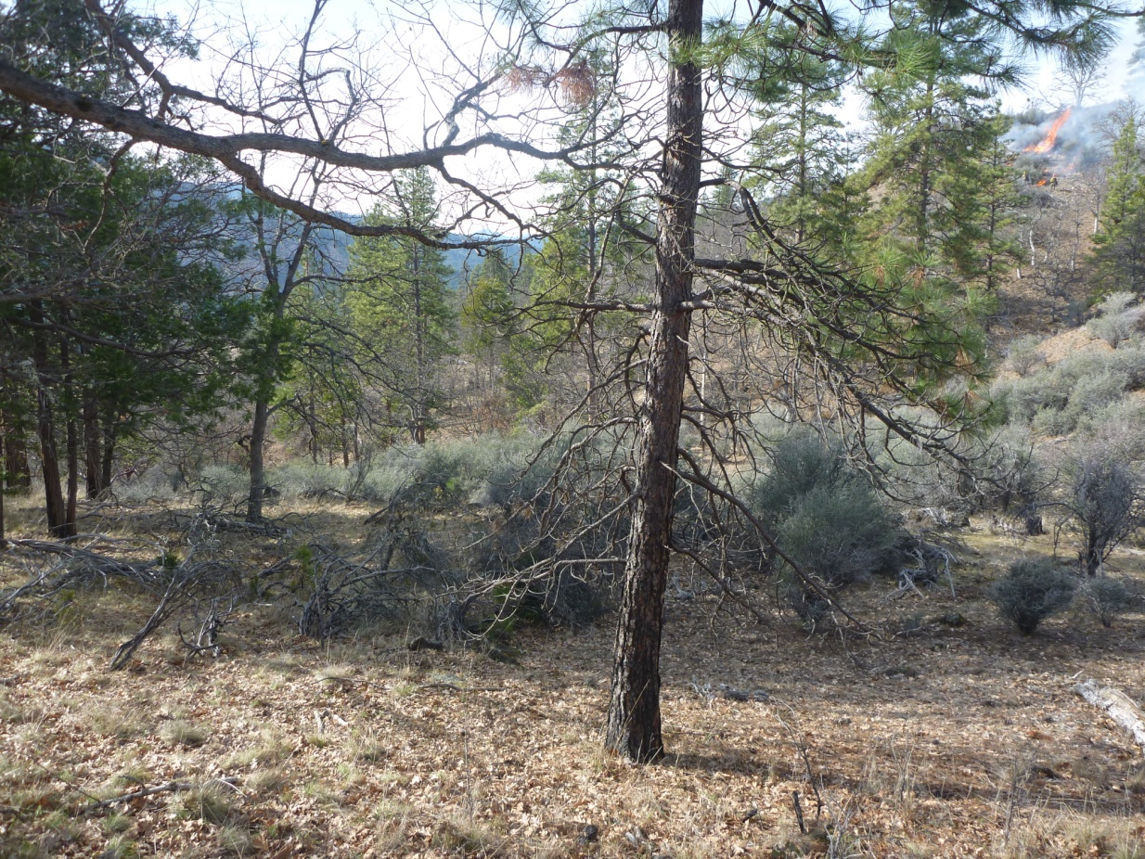
View looking west

Plot 2 after ignition, showing oak/pine litter consumption and poor shrub consumption
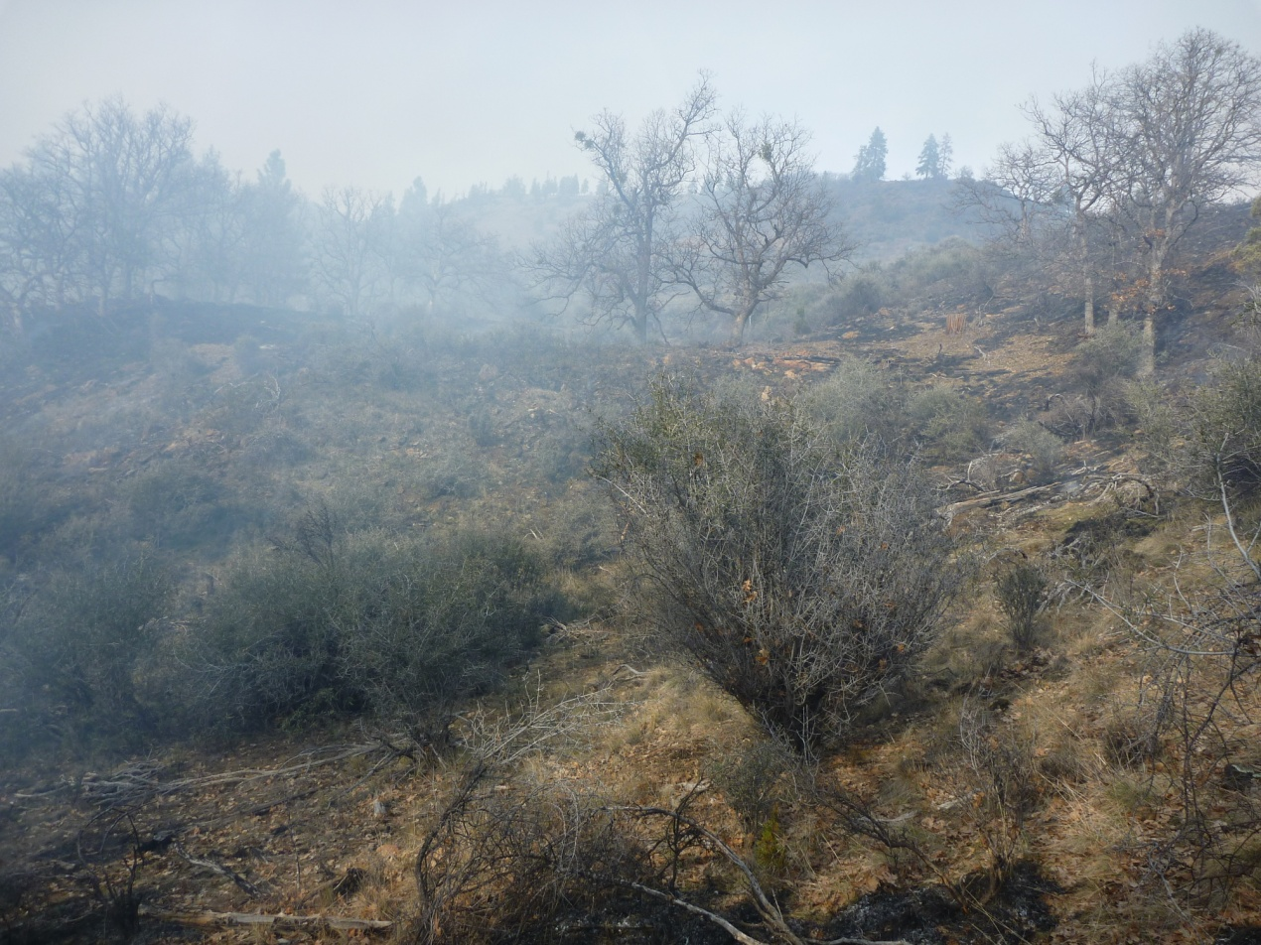
View looking north

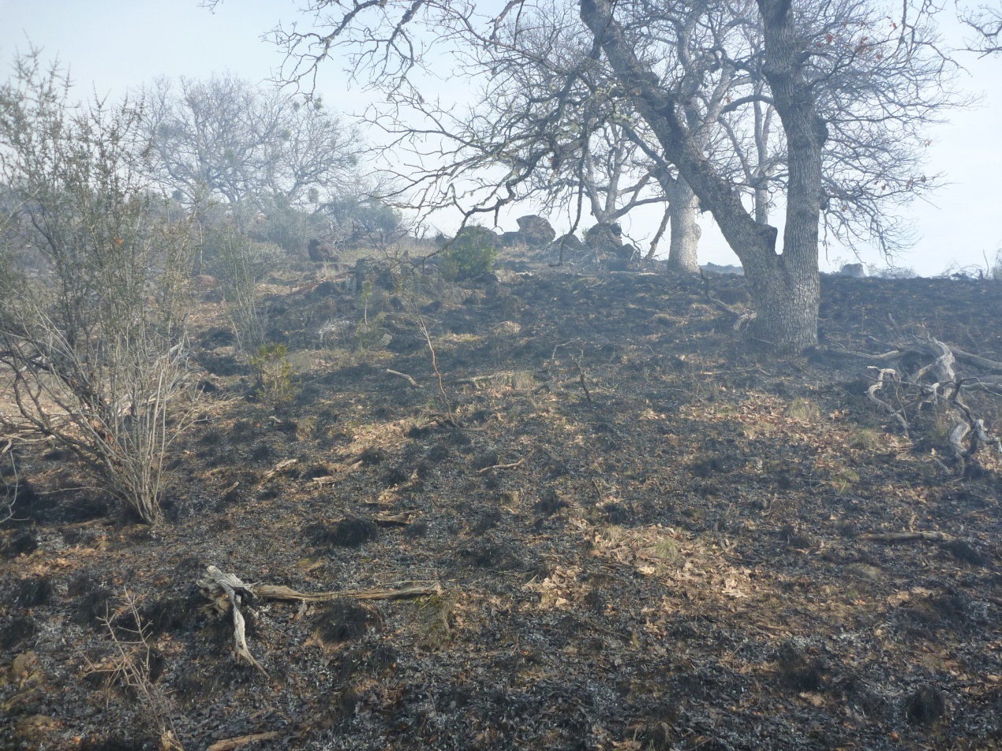
View looking east

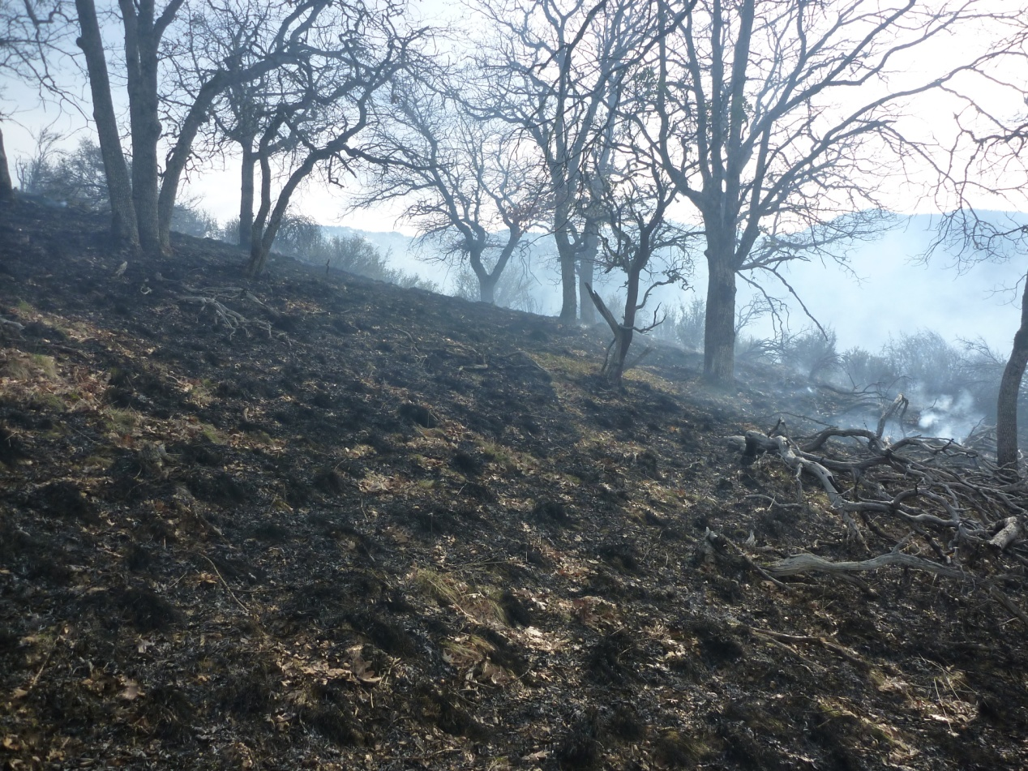
View looking south

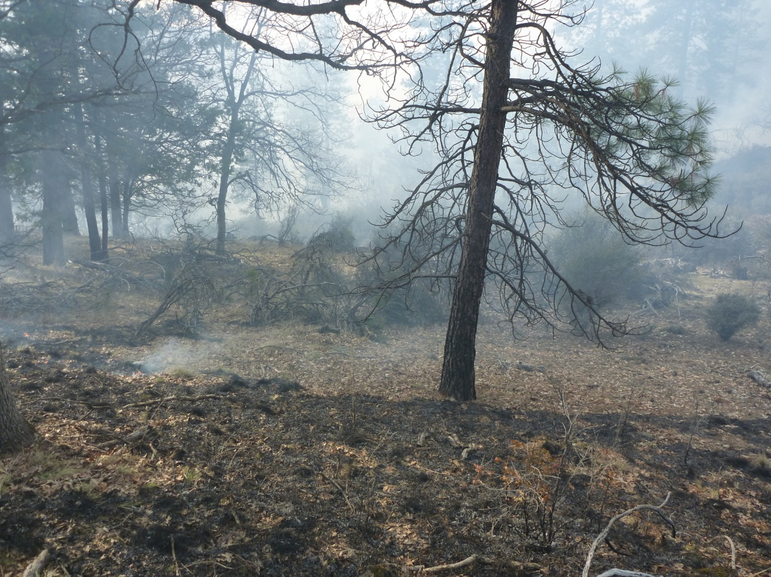
View looking west

