Underburn G

Happy Camp Ranger District
Klamath National Forest

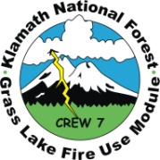

Prepared by: Jason Green
Map by: Andy Tompkins
May 21, 2012

GENERAL DESCRIPTION
The prescribed burn area is a 521 acre unit that is directly adjacent to the community of Happy Camp, CA. Aspects burned are south and west with slopes between 35-50 degrees.
Elevation ranges from 1800-3300ft
The burn area is composed of mixed conifer and oak components with heavy dead and down on the north end. Fuel models 9 and 10 represent the burn area.

Burn Management Objectives
Resource Objectives within the project area include:
- To reduce fuels adjacent to the Happy Camp community to lessen the impact of potential wildfire
- Maintain 5 to 20 pieces per acre of *CWD, >20 inches in diameter, where they exist.
*Coarse Woody debris includes pieces 3 inches or greater in diameter and at least 3 feet in length, also called 1000-hour and greater fire fuels
- Maintain soil cover to 50%-70% and 80% for coarser soils
- Retain 60% total soil cover on slopes 36%-60% where it exists
- Retain 70% total soil cover on slopes above 60%

Prescribed Fire Objectives within the project area include:
- Reduce 1-hour fuels by 80-100%
- Reduce 10-hour fuels by 70-100%
- Reduce 100-hour fuels by 60-90%
- Reduce 1000-hour fuels by 50-70%

Prescription Parameters
ENVIRONMENTAL CONDITIONS | Lower Limits | Upper Limits
Temperature (F deg) | 40 | 75
Relative Humidity (RH %) | 25 | 50
Average Mid-Flame Wind Speed* (MPH) | 0.0 | 7.0
1 hr fuel moisture % | 8 | 12
10 hr fuel moisture % | 10 | 14

PREDICTED FIRE BEHAVIOR | LOWER INTENSITY | HIGHER INTENSITY | Observed in Fuel Model 9 during the burn
Flame Length (ft.) | 1.2 | 3.7 | .5 - 2
Effective Wind Speed (mph) | 0 | 5 | 0 - 3
Scorch Height (ft.) | 5.8 | 11 | 3 - 20
Forward Spread Rate (ch/hr.) | 3 | 6 | 1.5 - 9
Backing (ch/hr.) | 0 | 3 | .1 - .6
Spotting distance (miles) | 0.0 | 0.1 | Spotting of .01 due to roll-out

Incident Resources
Burn Boss: Mario Gomez, Scott Bovey (T)
Holding: Damon McCartney
Firing: Tom Fielden, Matt Williams, William Johnson, Jesse Parry (T) Ken Cooper (T)
FEMO: Christina Barba, Aspen Franklin-Owens, Jason Green (T), Rich Wilson (T)
Additional Resources: Approximately 100 personnel from KNF districts

May 15, 2012
Daily Events
 | Time | Location
Briefing | 0930 | Drop point 3
Test ignition | 11:11 | Klamath Line and ridgetop Line
Start ignition | 1130 | Klamath Line and ridgetop Line
End ignition | 1930 | Drop point 3

Weather Summary
 | Predicted on spot forecast | Actual observed conditions
Eye Level Winds / Direction | W-NW 2-4 G 7 | Upslope 1-3 G 7
Maximum Temperature (F) | 80-85 | 87
Minimum Relative Humidity | 20-25 | 17

Summary
Ignitions began at the Klamath line and proceeded to drop point 3 stripping from the top down. Most of the day was spent out of prescription but ignitions continued due to rollout and the concern for firefighter safety.
Weather observations were taken between 1100 and 2000 with temperatures ranging between 64-87 degrees and relative humidity between 17-62%.
The biggest influence on the fire, this day, was the topography. The high temperatures and low humidity were big factors influencing the rate of spread (ROS) and intensity causing both to be slightly higher than normal in these fuel types. Types of observed fire behavior included: individual torching and flanking, but overall the fire backed down the slope meeting fire behavior parameters most of the day with an observed ROS of .25 ch/hr. (backing) in FM 9. Consumption was good in the 1 hour fuels that sat on top of the duff layer. The fuel loading varied from north to south with the south having more of an oak component and the north having more fir and pine components with heavier dead and down. Orographic wind influenced the north end of the fire as ignitions dropped down, causing flanking. Numerous rollout areas produced ROS of 9 ch/hr. when the fire would make short runs up the slope to the existing fire.
May 16, 2012
Daily Events
 | Time | Location
Briefing | 0830 | Drop point 3
Test ignition | 1125 | West Line East Line intersection
Start ignition | 1018 | West Line and East Line
End ignition | 2030 | Lower 1/3 of slope on each line

Weather Summary
 | Predicted on spot forecast | Actual observed conditions
Eye Level Winds / Direction | AM var. 0-2 PM N 2-5 | Upslope 1-3
Maximum Temperature (F) | 77-81 | 79
Minimum Relative Humidity | 20-25 | 28

Ignitions began at the intersection of the westline and the eastline on top of the ridge. The plan for the day was to lay down strips of fire up to 300 feet interior off of each control line and proceed down the slope, to the intersection of the east and west lines with Doolittle Rd.
Weather observations were taken from 1100 to 2000 with temperatures ranging between 67-79 degrees and relative humidity between 28-59%.
Topography played a major role in influencing overall fire behavior. As ignitions progressed down the slope, the steep drop offs into the drainages allowed the fire to make small runs upslope into the existing fire with good consumption in the 10 hour fuels and ladder fuels and ROS of 6 ch/hr. The backing ROS and intensity were also influenced by the high temperatures and low humidity with the high ROS being .5 ch/hr. in FM 9. Both were consistent throughout the evening allowing ignitions to continue until 2030 with the fire backing very nicely down the slope. Winds were light and upslope most of the day at 0-2 mph. Throughout the day, the smoke was drawn into the middle of the burn unit before rising and transporting to the northeast. In the late afternoon smoke began settling into the lower elevations.

May 17, 2012
Daily Events
 | Time | Location
Briefing | 0800 | Happy Camp District Office
Start ignition | 1130 | West Line and East Line
Aerial ignition | 1206 | Middle of unit near the top
End ignition | 1850 | Lower 1/3 of slope

Weather Summary
 | Predicted on spot forecast | Actual observed conditions
Eye Level Winds / Direction | W/NW 2-5 G 9 | Var. 0-2 G 7
Maximum Temperature (F) | 65-70 | 72
Minimum Relative Humidity | 33-38 | 28

Ignitions crews resumed lighting strips to 300’ interior down the east and west lines of the burn area in preparation for aerial ignitions. Firing bosses altered strip distance to mitigate drainage and ladder fuel concerns. Hand ignition stopped when igniters on both lines reached Doolittle road.
Temperatures ranged from 69 – 77 degrees and relative humidity ranged from 33 – 64%.
Fire behavior continued to be influenced primarily by topography and shading, but was within prescription parameters. Observed ROS for fire backing in FM9 were between .1 and .6 ch/hr., depending on fuel bed depth. Head fire with wind-slope alignment produced a maximum ROS of 1.5 ch/hr.
Lower sections of the burn were influenced by proximity to Doolittle creek, rocky terrain, and increased shading resulting in reduced fire behavior and fuel consumption.
Consumption of litter and light fuels met objectives; however, in some areas consumption of heavy fuels (100 and 1000 hr. fuels) was less than 50%, primarily due to fuel moisture.

May 18, 2012

Weather Summary
 | Predicted on spot forecast | Actual observed conditions
Eye Level Winds / Direction | AM: E/NE 1-4 PM NW/W 3-6 G 9 | Var. 0-2
Maximum Temperature (F) | 70-75 | 70
Minimum Relative Humidity | 20-25 | 22

Ignitions resumed at 1130 with all of the ignitions being interior to clean up unburned pockets of fuel towards the bottom of the unit. Fire behavior was minimal with smoldering and creeping observed with numerous rollout in the drainages. The fire backed at a ROS of .25 ch/hr. in FM 9.
Smoke Column observations

Smoke was never an issue for holding or ignitions during the burn. There was enough convective heat produced in the middle of the unit to draw the smoke in at which point it lifted and was transported to the NE. Late in the afternoon of the 17th, the smoke began to settle into the lower elevations and continued to do so throughout the night and following day presented as a haze.
Special Events

There was numerous rollout which caused a spot below drop point 2 on the 15th. One engine responded to an initial attack incident on the 17th.
Overall Objectives Summary
Objective | Met? | Comments: See below
Conduct a safe burn operation | Y | No injuries occurred
Maintain 5 to 20 pieces per acre of *CWD>20 inches in diameter where they exist | Y | Fire did carry through the 10 and 100 hour fuels where consumption was 35-50 %.
Retain 60% total soil cover on slopes 36-60% where it exists | Y | Duff layer was compact and retained higher fuel moistures inhibiting ignition
Retain 70% total soil cover on slopes above 60% | Y | See above
Reduce 1 hour fuels by 80-100% | Y | Consumed well because of low fuel moisture and optimal burning conditions
Reduce 10 hour fuels by 70-100% | N | Our assessment was 40-70% of fuels consumed
Reduce 100 hour fuels by 60-90% | N | Our assessment was 35-50% of fuels consumed
Reduce 1000 hour fuels by 50-70% | N | Our assessment was 5-15% of fuels consumed

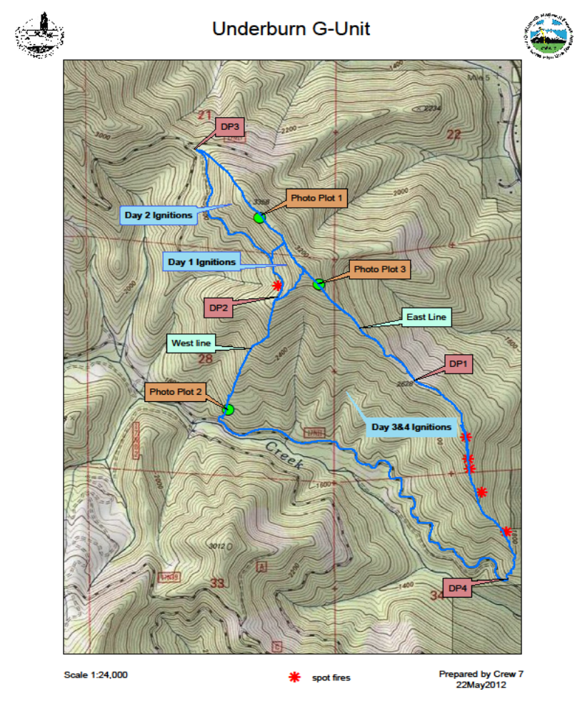

FIRE NAME: Understory G | INTERAGENCY FIRE USE MODULE  PHOTOGRAPH LOG SHEET | PHOTOGRAPHER(S): FEMO,FEMO (T)

PHOTO # | DATE | TIME | LOCATION | COMMENTS
1 | 5/15 | 1205 | Fire obs #1 | Obs#1 Test fire
2 | 5/15 | 1230 | #2 | Obs #2
3 | 5/15 | 1300 | #3 | Obs #3
4 | 5/15 | 1310 | #4 | 0bs#4
5 | 5/15 | 1320 | #5 | Obs#5 post fire obs
6 | 5/16 | 1430 | #6 | Obs#6
7 | 5/16 | 1445 | #7 | Obs#7
8 | 5/16 | 1550 | #8 | Obs#8
9 | 5/16 | 1600 | #9 | Obs#9
10 | 5/16 | 1610 | #10 | Post obs #10
11 | 5/16 | 1730 | #11 | obs#11
12 | 5/15 | 1740 | #12 | Pos obs#12
13 | 5/17 | 1300 | #13 | Obs#13
Misc pics |  |  |  | Misc pictures of understory G burn

FIRE NAME: Understory G | FIRE BEHAVIOR OBSERVATIONS | DATE: 5/152012

OBSERVER(S): Femo Femo (T)

TIME | LOCATION | ELEVATION | ASPECT | % SLOPE | FIRE TYPE (B/F/H) | FLAME LENGTH | FLAME ZONE DEPTH | ROS | PRIMARY CARRIER | FUEL MODEL | COMMENTS  (Scorch height, % consumption, spotting distance, fuel continuity and arrangement, etc.)
1205 | Top of ridge line | 3357 | S | 45 | B | 3” | N/A | .1 | TL | 9 | Test Fire Photo(1)
1230 | N 41.50.654  W 123.24.522 | 3345 | W | 45 | F | 1’ | 1’ | .25 | 10hr | 8,9 | Higher flame lengths in jackpot areas. Photo(2)
1300 | Top of ridge line | 3357 | S | 45 | B | 8” | N/A | .1 | TL | 9 | Slow backing fire in oak leaves and needle cast Photo(3)
1310 | N 41.50.557  W 123.24.414 | 3281 | W | 45 | B | 8” | 1’ | .5to1. | 1-10 hr. | 9 | Similar fire behavior more continuous 1 and 10 hr. fuels
1320 | Same as above |  |  |  |  |  |  |  |  |  | Post obs pic
------- | ---------------------- |  |  |  |  |  |  |  |  |  | End of day 5/15
1430 | N 41 50.623  W 123.24.531 | 3275 | S | 45 | B | 1’ | N/A | .25 | TL | 9 | Slow backing fire heavy good consumption rate on 1000 hr. fuels
1445 | Top of ride near K line | N/A | S | 45 | N/A | 20’ | N/A | N/A | TL | 9 | Individual tree torching
1550 | North end of fire | N/A | S | 45 | B | N | N/A | N/A | TL | 9 | Roll out more continues 1 and 10 hr. fuel continuity
1600 | N 41.50.638  W 123.24.655 | 3080 | W | 45 | H | 2-3’ | 10’ | 9 | TL | 9 | Roll out causing head fire up slope terrain and wind driven
1610 | Same as above |  |  |  |  |  |  |  |  |  | Post obs pic
1730 | N/A | N/A | W | 45 | B | 8” | 6” | .5 | TL | 9 | Backing fire good consumption heavy fuel loading
1740 | Same as above |  |  |  |  |  |  |  |  |  | Post obs pic
------ | ---------------------- | --- | -- |  |  |  |  |  |  |  | End of 5/16
1300 | N 41.50.395  W123.24.244 | 2800 | W | 40 | B | 3” | 2” | .1 | 1-10 hr. | 9 | Backing in oak litter slow rate of spread

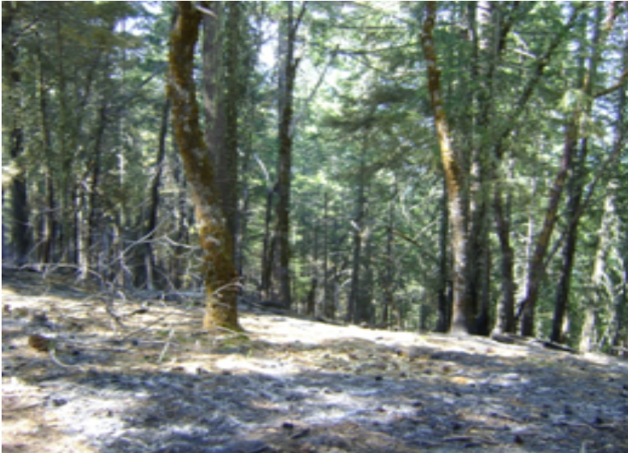

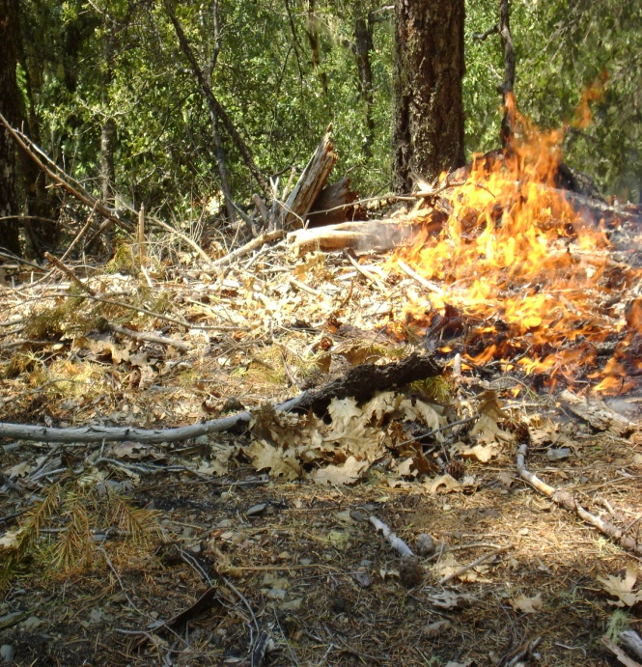

- 2
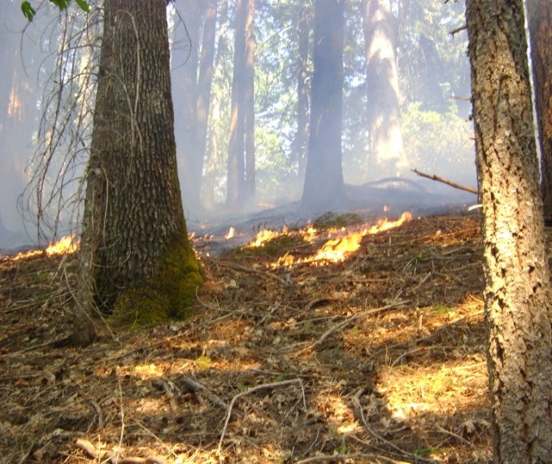

3
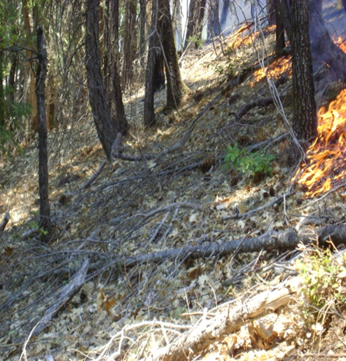
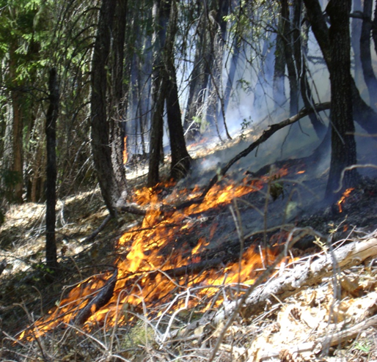

4 5
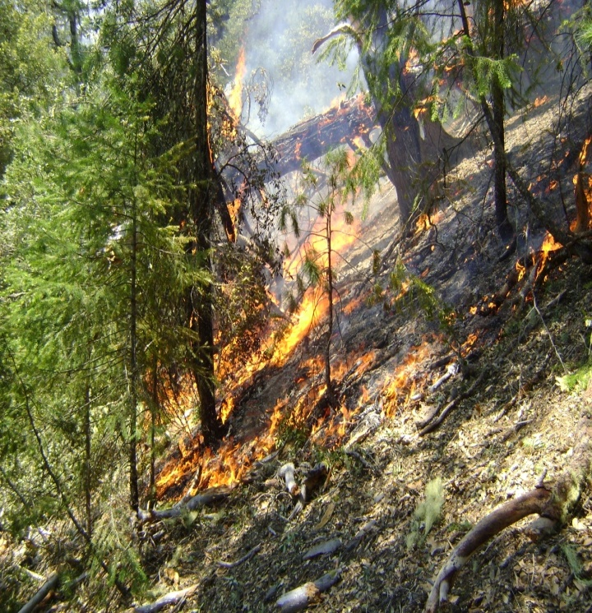
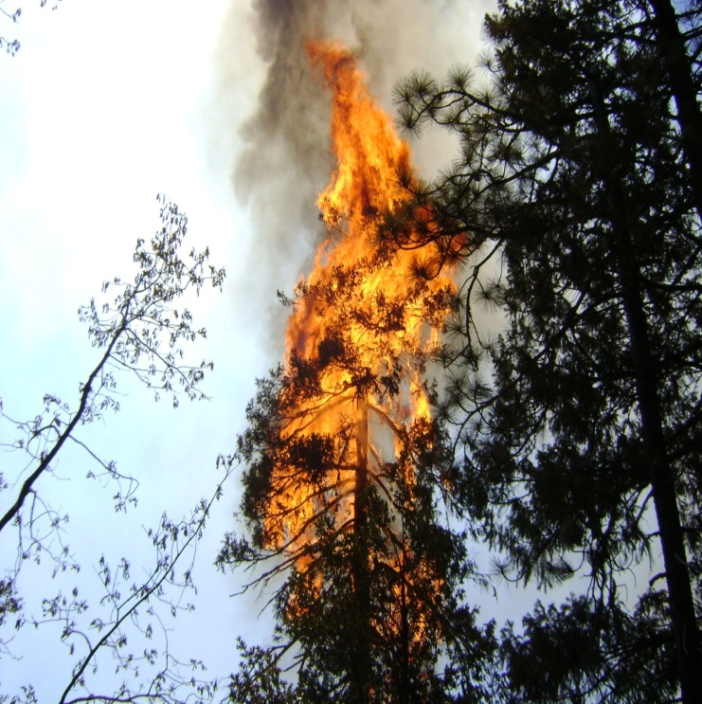

6 7
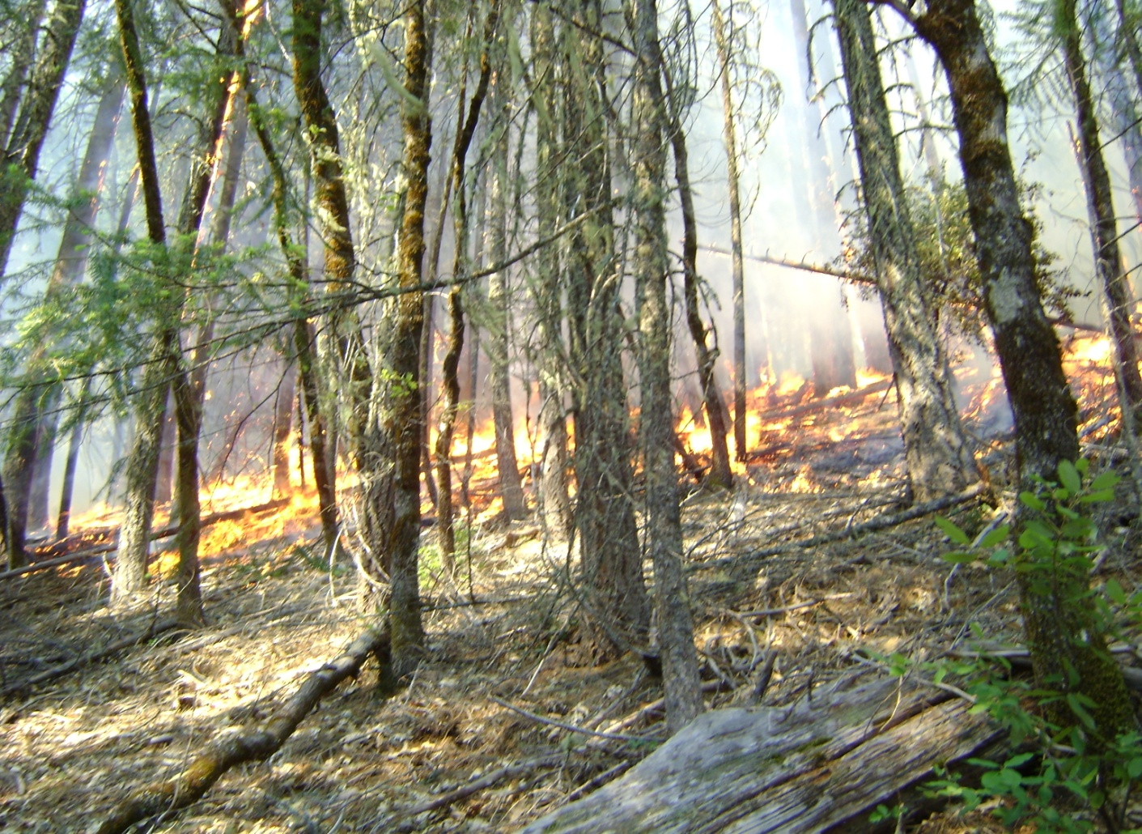

8
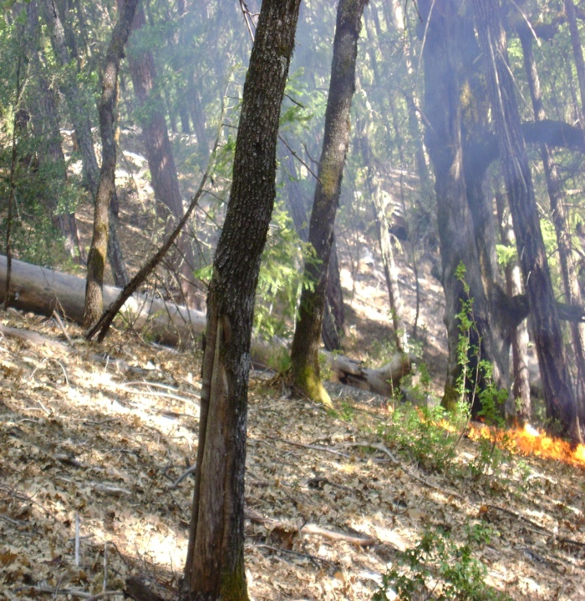
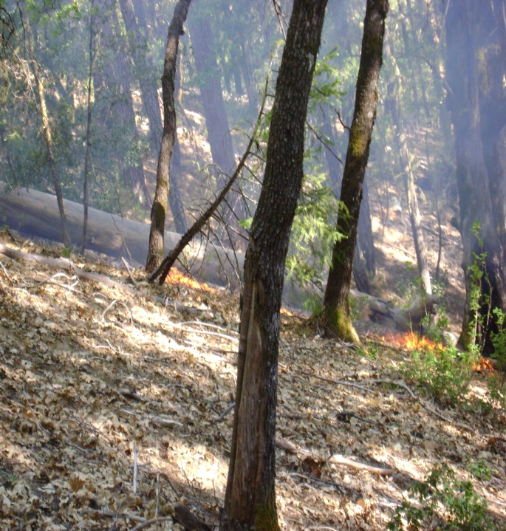

9 10
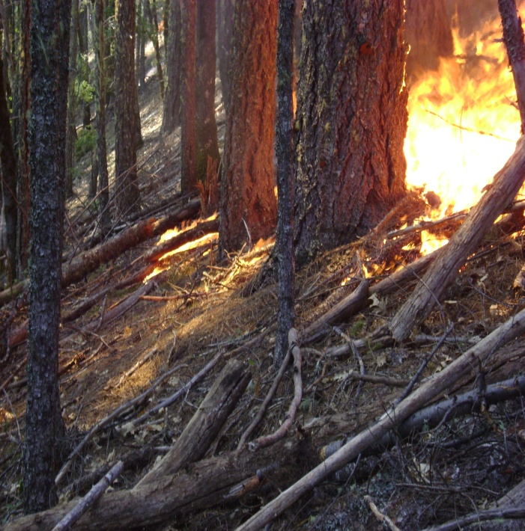
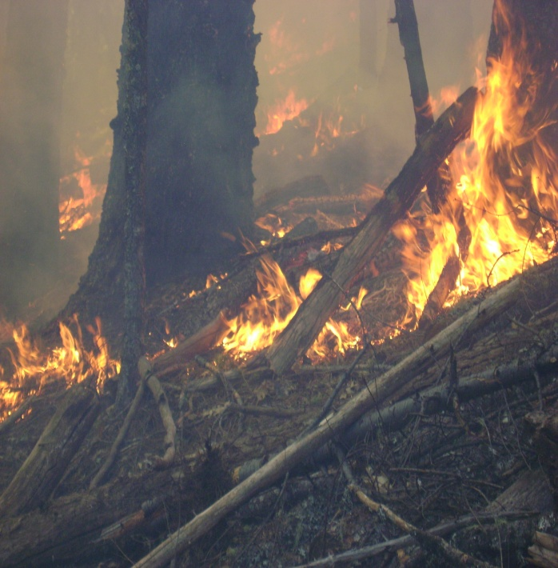

11 12
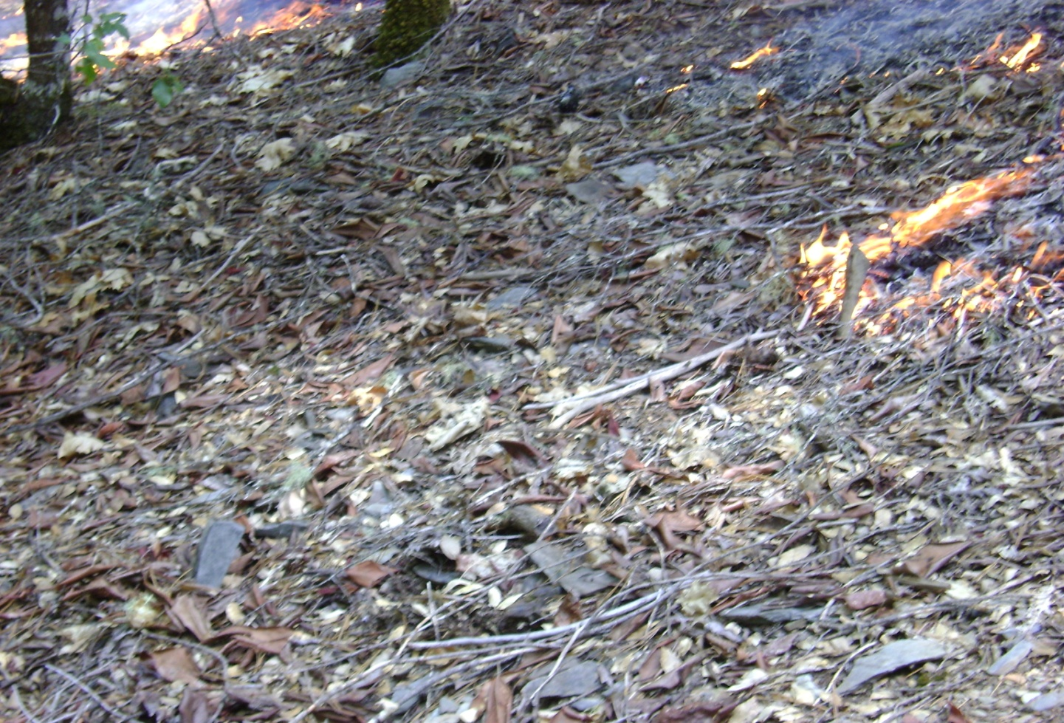

13
Pre Fire Photo Series
FIRE NAME: Understory G | INTERAGENCY FIRE USE MODULE  PHOTOGRAPH LOG SHEET | PHOTOGRAPHER(S): FEMO

Pre plot #1
PHOTO # | DATE | TIME | LOCATION | COMMENTS
 |  |  |  | Pre Photo series
1-4 | 5/16 | N/A | N 41.50.557  W 123.24.413 | Pre plot number 1
1-4 | 5/17 | N/A | N 41.50.395  W 123.24.244 | Pre Plot 2
1-4 | 5/18 | N/A | N 41.49.922  W 123.24.678 | Pre Plot 3
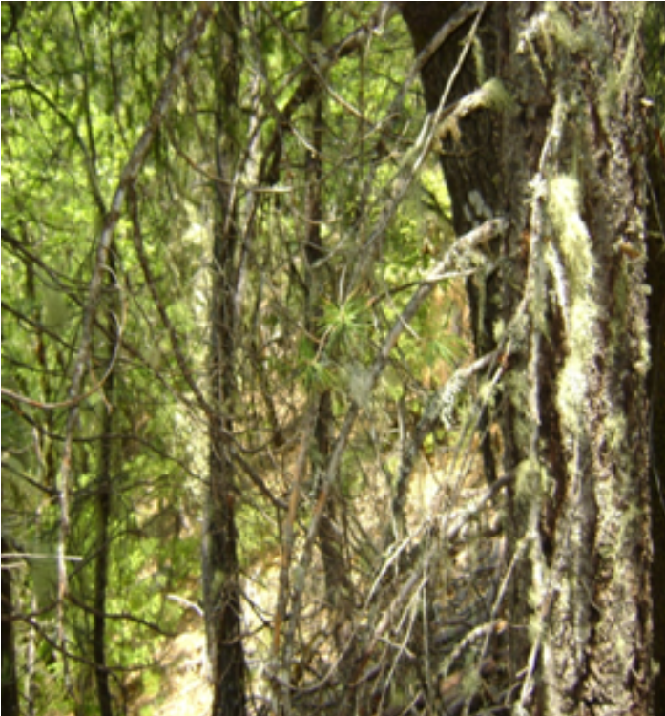
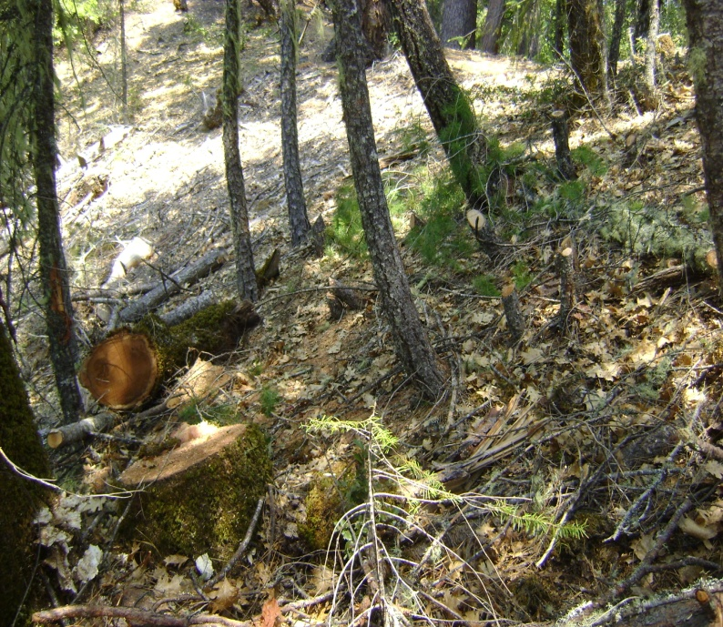

- 2

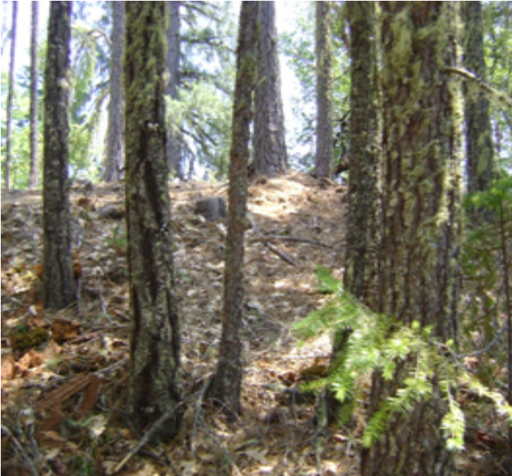
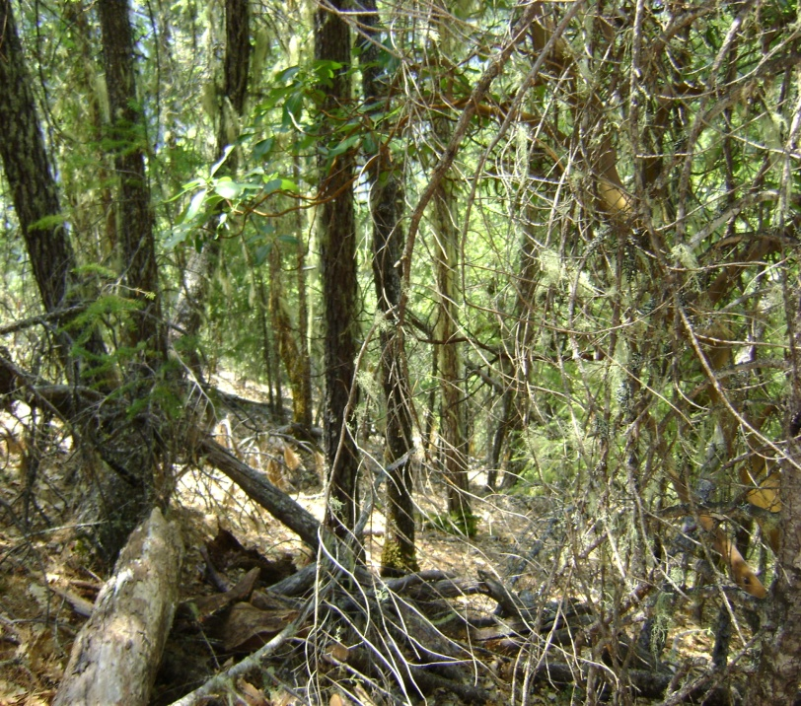

3 4

Plot#2
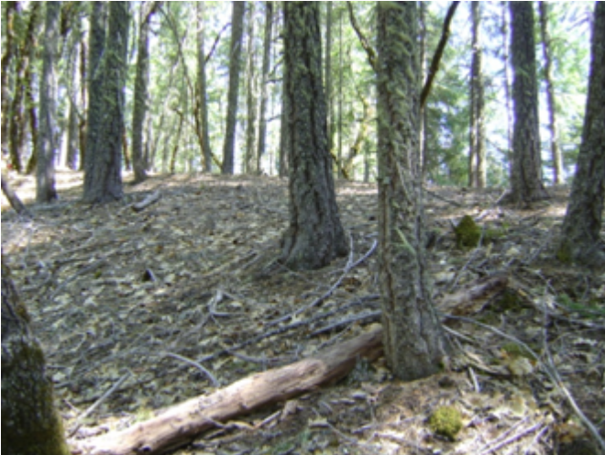
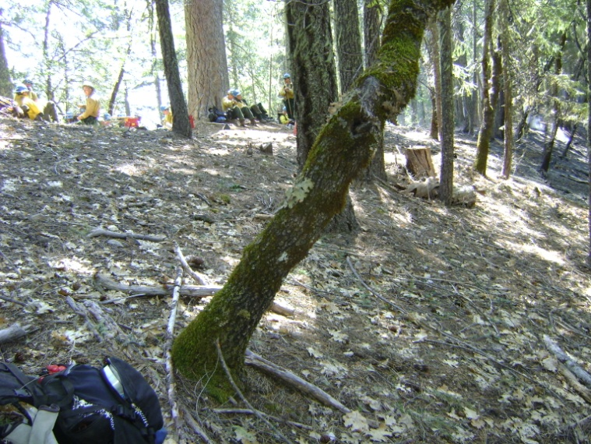

1 2
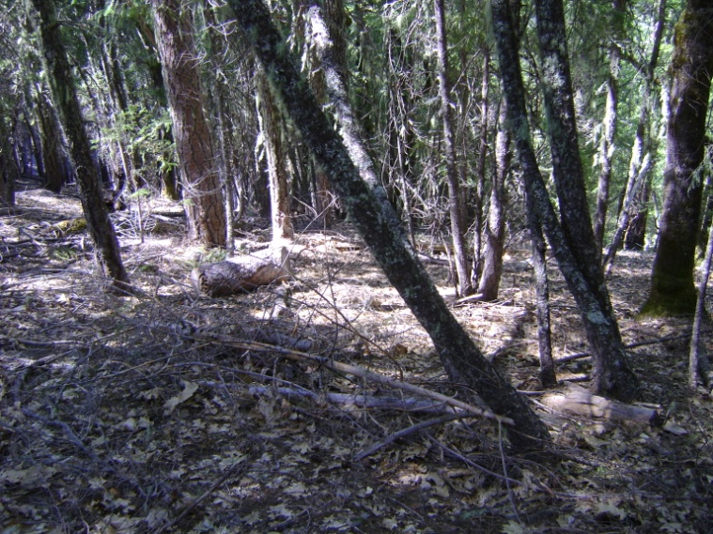
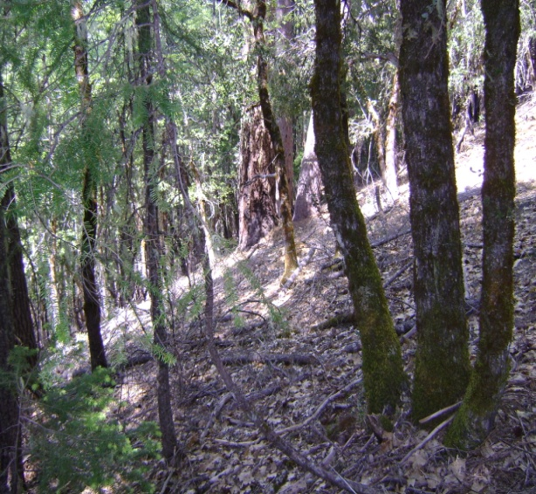

3 4
Plot#3

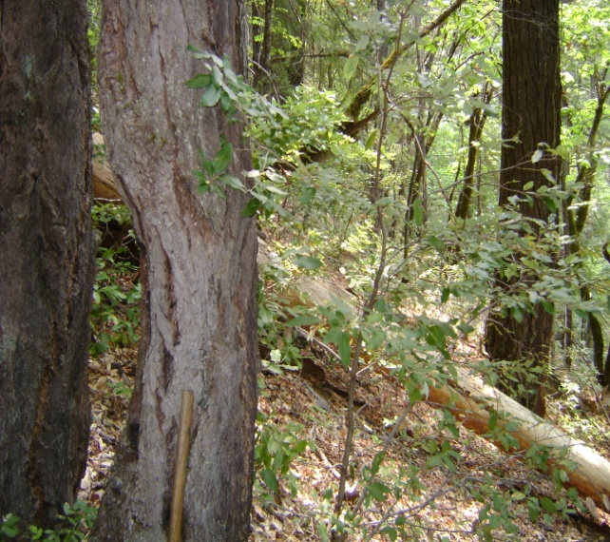
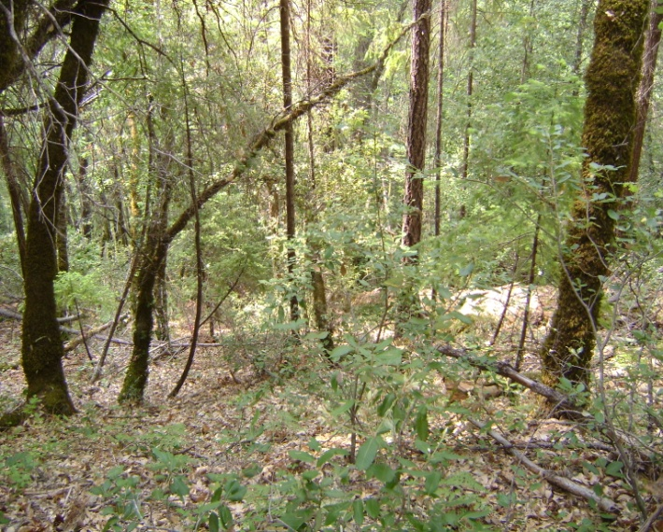

1 2

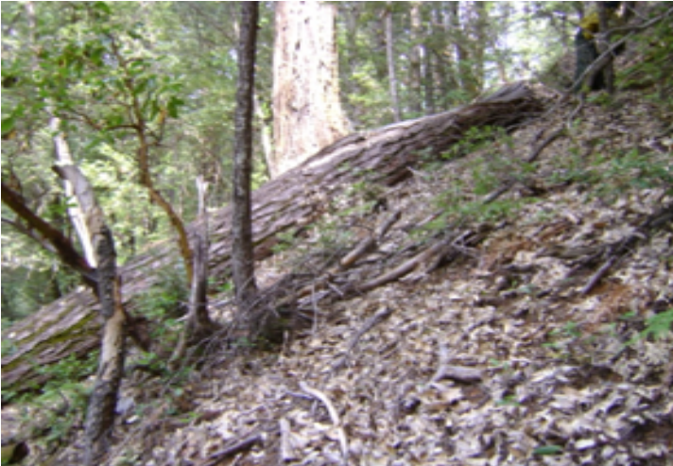
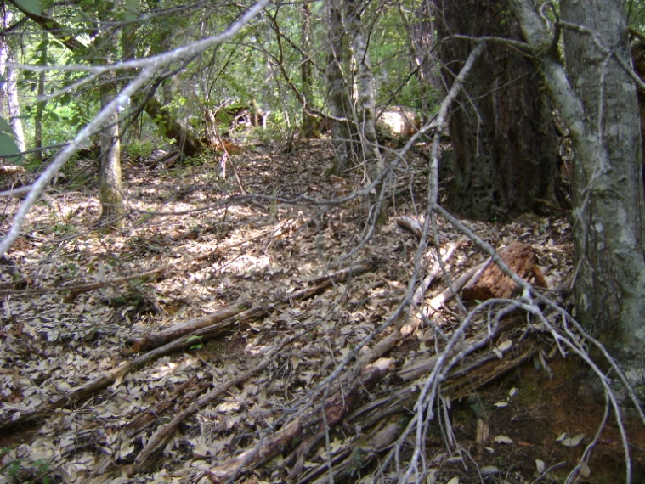

3 4

Random Pictures



