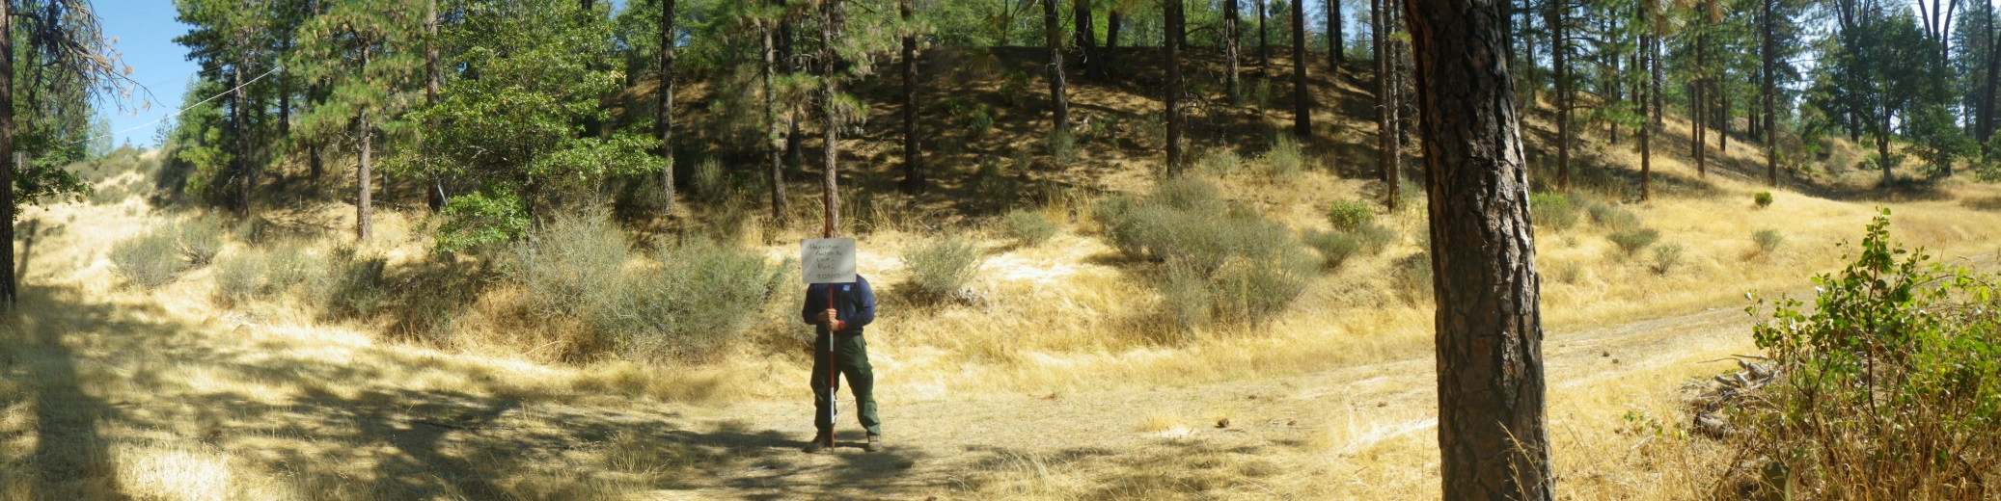
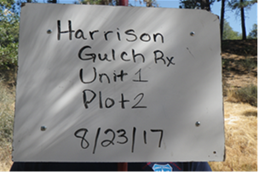

Date: 8/23/17
Lat/Long: N 40 21. 782 x W 122 57. 236
Azimuth: 0 N
Distance: 20 feet
Notes:
Author: K. Rohrs, J. Allan, L. Harney, L. Miranda.

