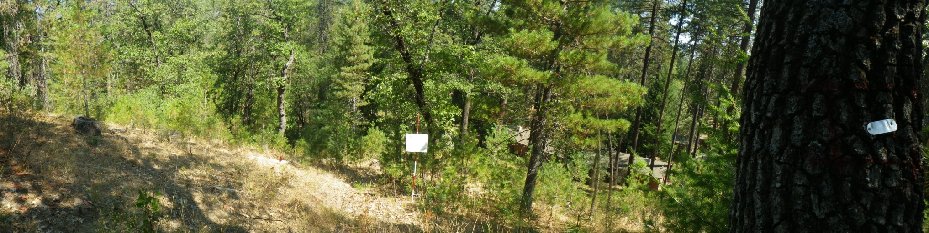
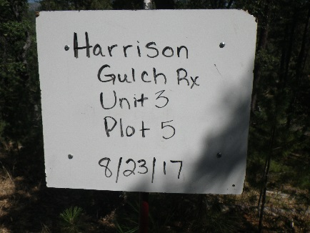
Date: 8/23/17
Lat/Long: N 40 21. 677 x W 122 57. 049
Azimuth: 200 N
Distance: 20 feet
Notes: Author: K. Rohrs, J. Allan, L. Harney, L. Miranda.

