INCIDENT/PROJECT
MEDICAL EMERGENCY
EVACUATION PLAN MEEP
BE SPECIFIC
This information will be prepared in advance and conveyed to Billings Dispatch to facilitate timely and appropriate response to medical emergencies in the field. All medical emergencies will be handled by Billings Dispatch Center (BDC).
Project Name: Horsethief Crew Leader/IC: TBD
Radio Frequency: BLM Bull Mountain Rpt; Frequency: RX: 171.1625 TX: 166.0875 NAC: 13 $585
Sat /Cell Phone ______ Yes ____X____No _________________Number
Project Location By: Latitude: N46° 27.170' Longitude: W108° 40.992'
Legal T8N R24E Sections 1-3, 10-15
Geographic Location: Between Horsethief Rd and Golf Course Rd 6 miles west of Roundup
Potential Helispots/Extraction Points
Helispot Name (H-1, Jones Meadows Etc.) | Legal Location | Lat x Long Location  (hddd°mm.mmm /WGS 84)
 |  | Latitude | Longitude
H7 | T8N R24E Section 16 NESW | N46° 26.680' | W108° 41.176'
H20 | T8N R24E Section 28 SWSW | N46° 28.611' | W108° 40.377'
H21 | T8N R24E Section 12 NENE | N46° 27.968' | W108° 39.206'
H22 | T8N R24E Section 12 NWSE | N46° 27.612' | W108° 39.518'
H23 | T8N R24E Section 12 SESW | N46° 27.317' | W108° 39.870'
H25 | T8N R24E Section 12 NWNW | N46° 28.101' | W108° 40.294'
H30 | T8N R24E Section 14 NWNE | N46° 27.170' | W108° 40.992'
H31 | T8N R24E Section 11 NWNW | N46° 28.108' | W108° 41.467'
H50 | T8N R24E Section 02 SESW | N46° 28.339' | W108° 41.125'
Road and Trail Numbers
Roads | Trails
Horsethief Rd | HT1008
Golf Course Rd | HT1006
Ground Extraction Points (Legal, lat long)
Location Name (Camp Ground Name, Road Name, Etc.) | Legal Location | Lat x Long Location (hddd°mm.mmm)
 |  | Latitude | Longitude
Horsethief Rd | T8N R24E Section 14 NESW | 46° 26.868' | -108° 41.195'
Golf Course Rd | T8N R24E Section 02 NESE | 46° 28.408' | -108° 40.693'

Medical Qualifications of Personnel
Name | Qualifications
Taig O’Donnell | EMT
Bobby Griffin | EMR
Duration of Project: FY24-FY30___________________________________________________________
Communications Plan

Incident/Project Radio Communications Plan |  |  |  | Incident/Project Name  Horsethief |  | Date/Time  FY24
Channel Name | Zone 1  Channel | Frequency | Tone |  | Channel Use
BLM Bull Mountain RPT | Ch 1 | RX:171.1625  TX:166.0875 | NAC:13 $585 |  | Command
SOA 2 | Ch 3 | RX:167.1750  TX:167.1750 | Tone:(none) |  | Primary TAC
SOA 1 | Ch 2 | RX:168.225  TX:168.225 | Tone: (none) |  | Secondary TAC
Tan | Ch 6 | RX: 155.3400  TX: 155.3400 | Tone: 156.7 |  | Primary Air to Ground EMS contact
White | Ch 18 | RX: 155.2800  TX: 155.2800 | Tone: 156.7 |  | EMS to Hospital and Local EMS Contact
Billings Dispatch - 1-406-896-2900
Line Officer or Point of Contact - _Nate Arave________ Phone _406-896-5349_______
Sheriffs Office - _911_______________ Sheriffs Office Phone - _406-323-1402________
Cell/Other numbers - _____________ _____________ ______________ ______________

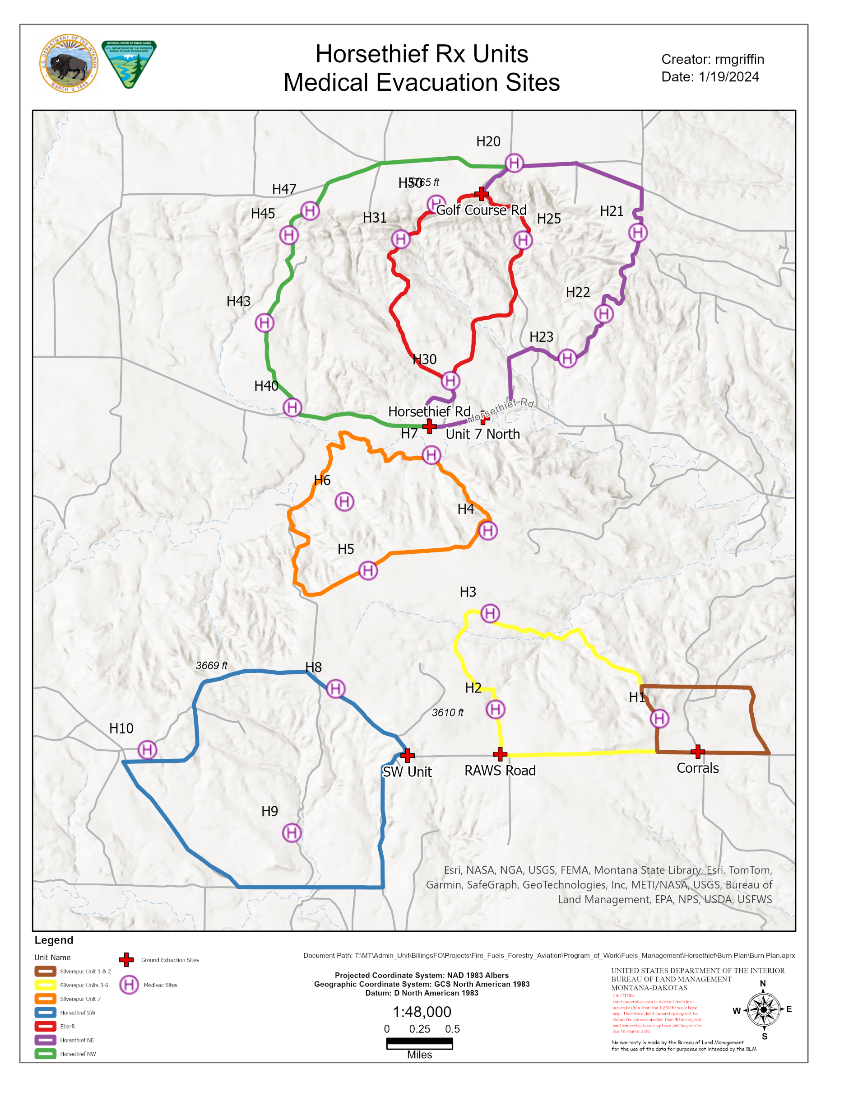

In the Event of a Medical Emergency
- FIRST, Ensure Responder Safety
- Call Billings Dispatch (BDC) with the following information:
  - Declare the nature of the Emergency
Is it an injury or illness?
If an injury or illness, is it Life Threatening, fatality?
  - Request that the frequency be cleared for emergency traffic.
  - Identify on scene point of contact (POC).
POC is in charge of managing on scene aspects of the medical emergency.
  - Identify on scene medical personnel.
This is the person in charge of patient care.
  - Type, Extent, and Mechanism of Injury/Illness.
Example: Airway, Breathing, Circulation? Massive bleeding? Spinal injury?
  - Identify type of Extraction Needed.
Example: Ground Ambulance, Air Ambulance, etc
  - Identify Extraction Point
Example: Helispot, Improved Road, Two Track, Forest Trail, etc.
  - Gather Information for General Patient Assessment – DO NOT announce names over the radio!!
Age________ Gender_______ Height______ Weight _______
Level of Consciousness: Alert – Responds to Verbal – Responds to Pain – Unresponsive
Breathing: Normal – Difficult/Labored – Not Breathing (Start Rescue Breathing) Pulse: Present – Absent (Start CPR)
Pupils: Equal and Reactive – Fixed – Unequal – Dilated – Constricted Pre-existing Medical Conditions:
Skin Condition
Color: Normal – Pale – Bluish – Flushed/Red
Moisture: Normal – Dry – Moist/Clammy – Profuse Sweating
Temperature: Normal – Hot – Cool – Cold

Documentation/Witness Contact Information

AVIATION
EXTRACTION
CONSTRUCT NEW
HELISPOT

SHORTHAUL
OR

HOIST

EXTRACT PATIENT

SHORTHAUL / HOIST

HELISPOT

EXTRACTION

TRANSFER TO
NEAREST MEDICAL
FACILITY

TRANSFER TO
NEAREST MEDICAL
FACILITY

NO

YES

NO
STABILIZE AND
PACKAGE PA
TIENT

INSERT PARAMEDIC

YES

YES

NO
TRANSFER TO
HELISPOT
-

LIFE
FLIGHT
–

NEAREST
MEDICAL FACILITY

EXTRACT PATIENT

SHORTHAUL / HOIST

TRANSFER TO
HELISPOT
-

LIFE
FLIGHT
–

NEAREST
M
EDICAL FACILITY

TRANSFER TO
WAITING
LIFE FLIGHT

TRANSFER TO
NEAREST MEDICAL
FACILITY

THIS FLOW CHART IS INTENDED TO GUIDE YOU THROUGHT THE DECISION PROCESS THAT FACILITATES
THE MOST EFFICIENT AND EFFECTIVE TREATMENT AND AVIATION EXTRACTION OF A MEDICAL PATIENT.

PRIMARY EXTRACTION

–

HELICOPTER

-

INCIDENT/LIFE FLIGHT/DEPT.
OF PUBLIC SAFETY HELICOPTER

SECONDARY EXTRACTION

–

GROUND

-

IMPLEMENT GROUND CARRY OUT TO DROP POINT AND
AMBULANCE TRANSPORT

ALTERNATIVE

EXTRACTION

–

ACTIVATE 305
TH

RESCUE SQUADRON
MPK June 24, 2011

