INCIDENT/PROJECT
MEDICAL EMERGENCY
EVACUATION PLAN MEEP

BE SPECIFIC
This information will be prepared in advance and conveyed to Billings Dispatch to facilitate timely and appropriate response to medical emergencies in the field. All medical emergencies will be handled by Billings Dispatch Center (BDC).
Project Name: Horsethief
Crew Leader/IC: TBD
Radio Frequency: BLM Bull Mountain Rpt; Frequency: RX: 171.1625 TX: 166.0875 NAC: 13 $585
Sat /Cell Phone ______ Yes ____X____No _________________Number
Project Location By: Latitude: 46° 24.714' Longitude: -108° 38.626'
Legal T8N R24E Sections 23-26; T8N R25E Section 30
Geographic Location: North of Johnson Rd, 6 miles west of Roundup
Potential Helispots/Extraction Points
Helispot Name (H-1, Jones Meadows Etc.) | Legal Location | Lat x Long Location  (hddd°mm.mmm /WGS 84)
 |  | Latitude | Longitude
H1 | T8N R25E Section 30 SESW | N46° 24.933' | W108° 38.993'
H2 | T8N R24E Section 26 NESE | N46° 24.996' | W108° 40.564'
H3 | T8N R24E Section 23 SESE | N46° 25.630' | W108° 40.615'
Road and Trail Numbers
Roads | Trails
Johnson Rd | HT1027, HT1029
Ground Extraction Points (Legal, lat long)
Location Name (Camp Ground Name, Road Name, Etc.) | Legal Location | Lat x Long Location (hddd°mm.mmm)
 |  | Latitude | Longitude
Corrals | T8N R25E Section 30 SESW | 46° 24.714' | -108° 38.626'
RAWS Road | T8N R24E Section 26 SESE | 46° 24.699' | -108° 40.522'

Medical Qualifications of Personnel
Name | Qualifications
Duration of Project: FY24 ___________________________________________________________

Communications Plan

Incident/Project Radio Communications Plan |  |  |  | Incident/Project Name  Horsethief |  | Date/Time  FY24
Channel Name | Zone 1  Channel | Frequency | Tone |  | Channel Use
BLM Bull Mountain RPT | Ch 1 | RX:171.1625  TX:166.0875 | NAC:13 $585 |  | Command
SOA 2 | Ch 3 | RX:167.1750  TX:167.1750 | Tone:(none) |  | Primary TAC
SOA 1 | Ch 2 | RX:168.225  TX:168.225 | Tone: (none) |  | Secondary TAC
Tan | Ch 6 | RX: 155.3400  TX: 155.3400 | Tone: 156.7 |  | Primary Air to Ground EMS contact
White | Ch 18 | RX: 155.2800  TX: 155.2800 | Tone: 156.7 |  | EMS to Hospital and Local EMS Contact
Billings Dispatch - 1-406-896-2900
Line Officer or Point of Contact – Nate Arave_________ Phone _406-896-5349_____
Sheriffs Office - _911_______________ Sheriffs Office Phone - _406-323-1402________
Cell/Other numbers - _____________ _____________ ______________ ______________
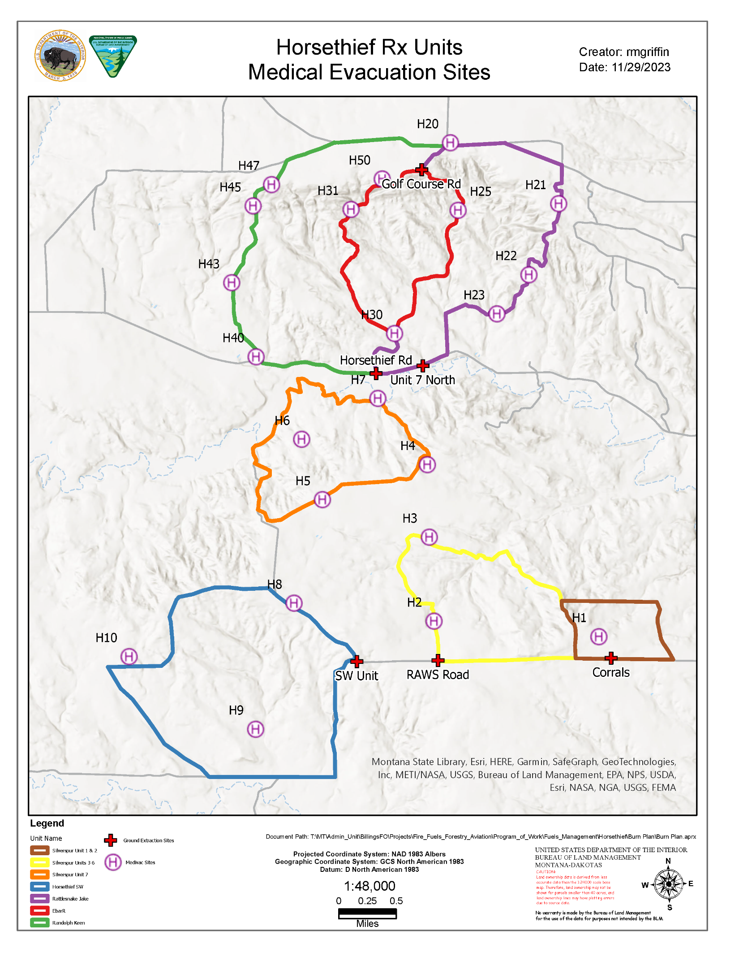

In the Event of a Medical Emergency
- FIRST, Ensure Responder Safety
- Call Billings Dispatch (BDC) with the following information:
  - Declare the nature of the Emergency
Is it an injury or illness?
If an injury or illness, is it Life Threatening, fatality?
  - Request that the frequency be cleared for emergency traffic.
  - Identify on scene point of contact (POC).
POC is in charge of managing on scene aspects of the medical emergency.
  - Identify on scene medical personnel.
This is the person in charge of patient care.
  - Type, Extent, and Mechanism of Injury/Illness.
Example: Airway, Breathing, Circulation? Massive bleeding? Spinal injury?
  - Identify type of Extraction Needed.
Example: Ground Ambulance, Air Ambulance, etc
  - Identify Extraction Point
Example: Helispot, Improved Road, Two Track, Forest Trail, etc.
  - Gather Information for General Patient Assessment – DO NOT announce names over the radio!!
Age________ Gender_______ Height______ Weight _______
Level of Consciousness: Alert – Responds to Verbal – Responds to Pain – Unresponsive
Breathing: Normal – Difficult/Labored – Not Breathing (Start Rescue Breathing) Pulse: Present – Absent (Start CPR)
Pupils: Equal and Reactive – Fixed – Unequal – Dilated – Constricted Pre-existing Medical Conditions:
Skin Condition
Color: Normal – Pale – Bluish – Flushed/Red
Moisture: Normal – Dry – Moist/Clammy – Profuse Sweating
Temperature: Normal – Hot – Cool – Cold

Documentation/Witness Contact Information

AVIATION
EXTRACTION
CONSTRUCT NEW
HELISPOT

SHORTHAUL
OR

HOIST

EXTRACT PATIENT

SHORTHAUL / HOIST

HELISPOT

EXTRACTION

TRANSFER TO
NEAREST MEDICAL
FACILITY

TRANSFER TO
NEAREST MEDICAL
FACILITY

NO

YES

NO
STABILIZE AND
PACKAGE PA
TIENT

INSERT PARAMEDIC

YES

YES

NO
TRANSFER TO
HELISPOT
-

LIFE
FLIGHT
–

NEAREST
MEDICAL FACILITY

EXTRACT PATIENT

SHORTHAUL / HOIST

TRANSFER TO
HELISPOT
-

LIFE
FLIGHT
–

NEAREST
M
EDICAL FACILITY

TRANSFER TO
WAITING
LIFE FLIGHT

TRANSFER TO
NEAREST MEDICAL
FACILITY

THIS FLOW CHART IS INTENDED TO GUIDE YOU THROUGHT THE DECISION PROCESS THAT FACILITATES
THE MOST EFFICIENT AND EFFECTIVE TREATMENT AND AVIATION EXTRACTION OF A MEDICAL PATIENT.

PRIMARY EXTRACTION

–

HELICOPTER

-

INCIDENT/LIFE FLIGHT/DEPT.
OF PUBLIC SAFETY HELICOPTER

SECONDARY EXTRACTION

–

GROUND

-

IMPLEMENT GROUND CARRY OUT TO DROP POINT AND
AMBULANCE TRANSPORT

ALTERNATIVE

EXTRACTION

–

ACTIVATE 305
TH

RESCUE SQUADRON
MPK June 24, 2011

