Billings BLM Prescribed Fire IAP
Unit Name or Number: Pompey’s Pillar RX Burn 2024
Date(s): January 4, 2024
Cost Codes
BLM OT/Travel: LLMTC00200/LLMTC00900 LF312D000 JW0000 LFHFHF260000 23X
FS OT/Travel: FY 23 0156 NFXFB223
Organizational Chart
Agency Administrator: Nate Arave
Burn Boss: Chad Cullum (Units 1, 2, 3)
Burn Boss Trainee: Dustin Sciacca
EMT/EMR(s): Jarid Clark (EMT) & Taig Odonnell (EMT)- Bobby Griffin (EMR)
FEMO/Weather Observer: Bobby Griffin
Public Relations: Chad Cullum
Firing- | Holding-
Firing Boss-  Dave Day  Jeff Stabio (FIRBt)  Firing Personnel-  Gibson  Johnson  Birch  Kornfield  Tucker  Schafer | Holding Boss-  ODonnell (Billings Red UTV)  Holding Personnel-  E2611 Ryg, Evans  E2612 Contingency  E2608 Perry, Keeran (ENGBt)  FS- E6821 Lee, Robinson  FS-E641 Carey, Foster  Fuel Truck- Craig  Billings UTV Camo- Griffin, Clark  Billings UTV Black- White  Miles City UTV- Harding, Boeder  Jordan UTV- Patten, Warwick

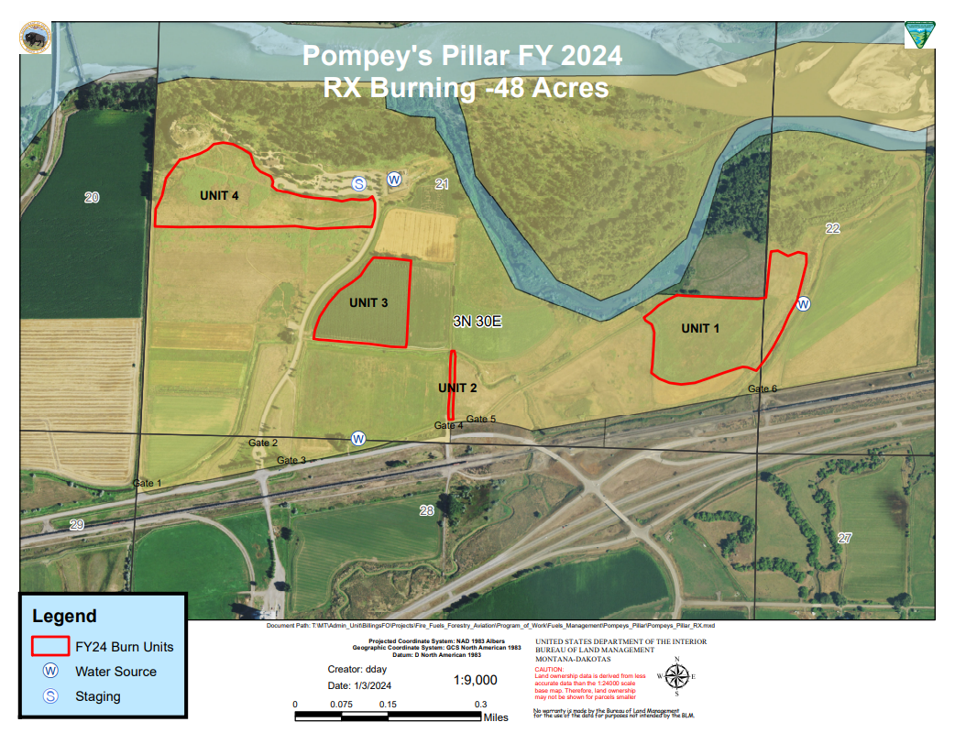
QR CODE FOR MAP
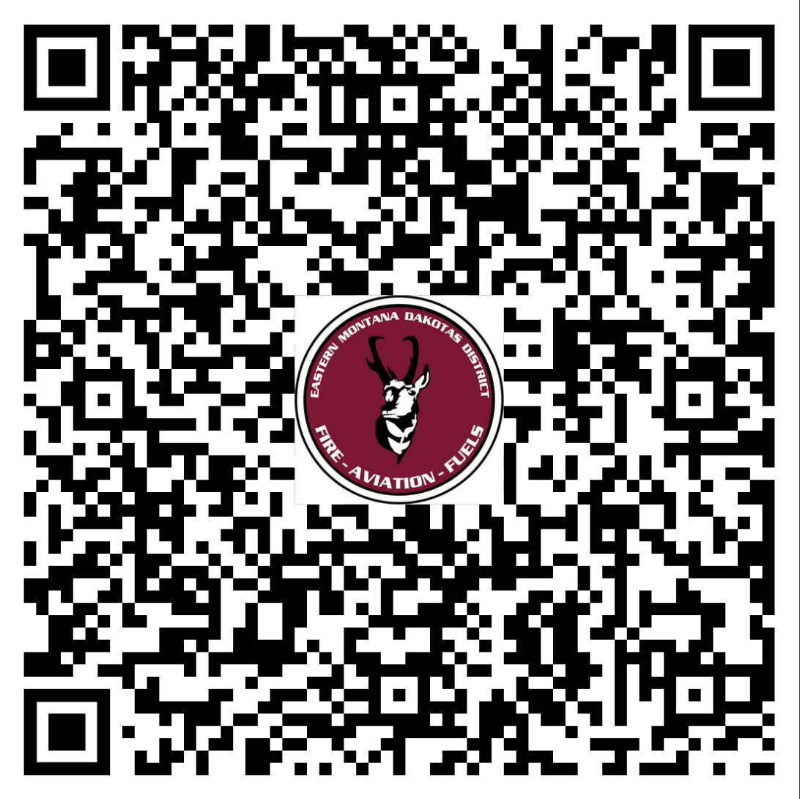
Communication Plan
Radio Frequencies
Name | Tx | Rx | CG | Use
DNRC S Pompey | 159.4050 | 151.2650 | 141.3 (tone 13) | Command RPT
SOA 2 | 167.1750 | 167.1750 |  | Primary Tac
SOA 1 | 168.2250 | 168.2250 |  | Secondary Tac
Red | 154.0700 | 154.0700 | 156.7 | Fire Mutual Aid
Life Flight and Emergency Radio Frequencies
Name | TX | RX | CG | Use
Tan (VMED28) | 155.3400 | 155.3400 |  | Air-to-Ground
White | 155.2800 | 155.2800 |  | Hospital-to-Ambulance
Gold | 153.9050 | 153.9050 |  | General Mutual Aid
Air Guard | 168.6250 | 168.6250 | 110.9 | Emergency Initial Aviation Contact

Objectives
Resource Objectives | Prescribed Fire Objectives
-Lower fire intensities throughout burn units as measured by the prescribed fire objectives.  -Enhance nutrient release and cycling. Increase quantity and quality of forage for range and wildlife. 10% or greater increase in species diversity post-fire. | -Reduce litter accumulation within unit 20%-90%.  -Reduce woody shrub layers within unit 10%-50%.  -Prepare farmland for seeding/tillage

Ignition Plan
Test Fire Location- TBD

Holding Plan- Generally holding resources will be paired up with ignition personal at the start of the fire following the black lining process around the unit. As the lines get bigger holding resources will be designated to hold and patrol a designated area, patrolling for spots, and controlling any slop-overs/spots.
Mop Up and Patrol- After main ignition is complete, the fuel will be given time to consume. Holding resources will patrol looking for slops and spot fires. Any immediate threat that could cause fire to cross the line (snags on fire close to line, fuel on ground throwing embers, etc.) will be taken care of immediately. After the main ignition/operational period, day two will have a minimum of one chain mop up.
Contingency Plan- Contingency engines are on scene. Worden VFD has an approximately 30 minute response time.
Wildfire Declaration
The Burn Boss will have the authority to declare a wildfire conversion after consultation with the Agency Administrator. In the event of a wildfire conversion, __Taig ODonnell____________ will assume command of the wildfire. The Burn Boss will retain control of the prescribed burn unit and resources will be realigned and/or ordered accordingly to meet the staffing needs of both organizational structures.
Safety
A Risk Management Assessment (RMA) will be discussed and signed by all personal prior to any prescribed fire activities.
Any other specific Safety needs.
Medical Plan
  - Pause or Cease Ignitions as necessary.
  - Utilize Medical Incident Report to Report to Dispatch
  - Best Qualified Individual Takes Over as Medical IC
  - Identified medically trained individuals (First Responder/EMT) utilized for patient care.
Emergency Evacuation Methods: A first responder or EMT may attend to minor injuries. Should the need for evacuation occur, Billings Dispatch will call for ambulance services and/or life flight following the Medivac/SAR/Fatality Procedures Plan if cell service is unavailable onsite or in the event of a green or yellow injury. In the event of a red (serious, life-threatening injury), the onsite resources may make direct contact with 911 and inform dispatch after initial contact. When an ambulance is used for transport, personnel will be sent to meet the ambulance, or the patient may be moved to a known location such as a highway junction or known landmark for ease of coordination.
In the event of Life Flight transport, the landing zone location is:
N 45° 59.334’ by W -108° 0.137’ (Just north of Pillar entry gate)
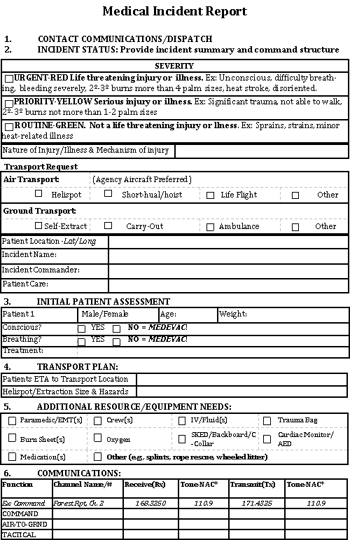
1. Incident Name: |  | 2. Operational Period: Date From: Date To:  Time From: Time To:
3. Name: |  | 4. ICS Position: |  | 5. Home Agency (and Unit):  MSDH
6. Resources Assigned:
Name |  | ICS Position |  | Home Agency (and Unit)
7. Activity Log:
Date/Time | Notable Activities
8. Prepared by: Name: Employee Signature: Date:
ICS 214, Page 1 |  |  | Supervisor Signature: __________________ Date: __________________

