HCRD North Fire Map 07072025  
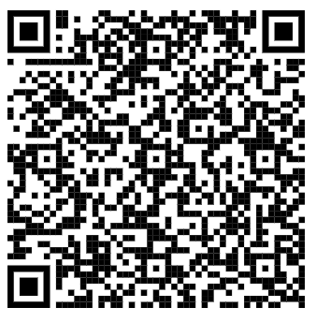

HCRD South Fire Map 07072025

