**Monte Cristo Creek West Management Action Point 1 established 7/6/25:**

* Start structure plan for values at risk West of the fire. Known values don’t show signs of occupancy.

**Values:**

1. 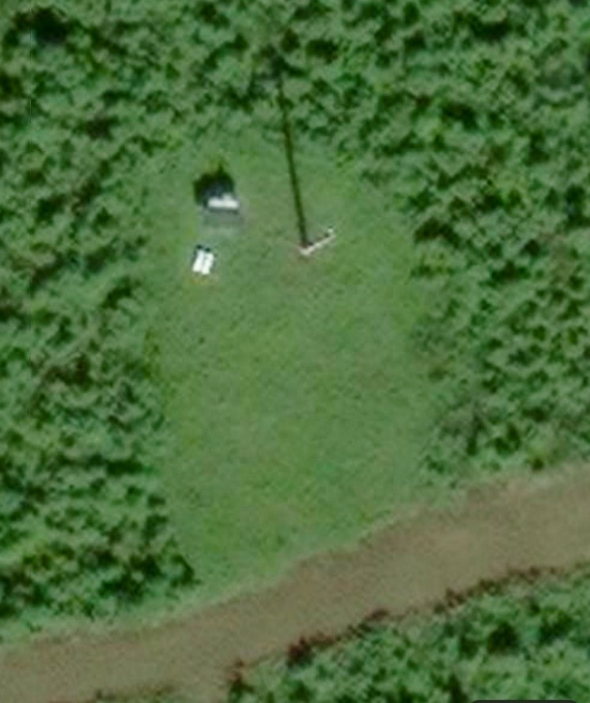Tower site is not identified on the map and was added to Field Maps on July 6, 2025. Labeled Tower Site #1 and is on Sam Mountain. The site consists of one tower approximately 30 feet tall, one larger tank containing an unknown substance, and what appears to be two smaller tanks with an unknown substance as well. The site was observed from the air, and there has been no ground verification. As of July 6, 2025, the fire is located over four miles from the site. The clearing area measures approximately 100 feet by 150 feet. Although it is not officially approved, the site appears to be suitable for a Type 3 helicopter. The recommended action is to protect the site with aviation resources, as there are no flammable items that need protection. An alternative action would involve sending a Helitack crew to conduct 1-2 hours of additional clearing around the tanks, preparing the site, and then leaving.
2. 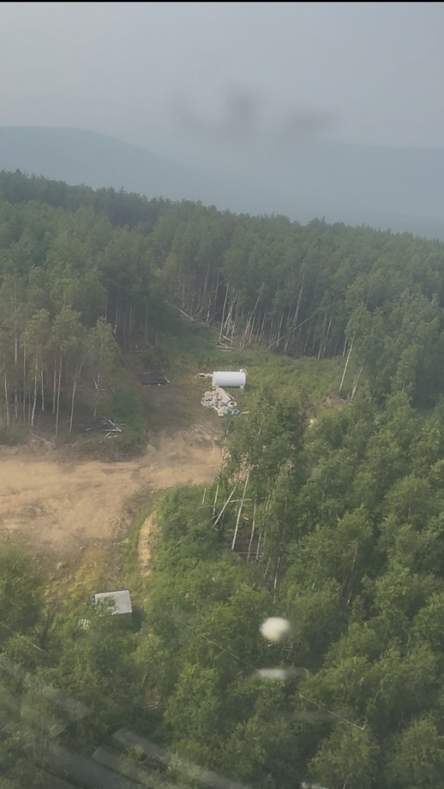**Mining Camp #1** Identified on the Alaska Known Sites database and shows type 2 helicopter access. The site contains a large tank with an unknown substance, a pile of hose/PVC pipe next to the tank, and a large wooden box structure. Please refer to the picture below. There is no water access. **Recommended Actions:** It is advised to protect the site using aviation resources. An alternative action would be to deploy a Helitack crew to conduct 2-3 hours of additional clearing around the tank and any flammable materials. Flammable items should be moved deeper inside the cleared area. After completing these tasks, prep the site and leave. Fire approximately 6 miles away on 7/6/25.
3. **Mining Site #2** The Alaska Mining APMA Points layer in Field Maps indicates that the permit expired in 2024, and there are no explosives on site. There is one large metal box and several older wooden box structures present. Potential access for a Type 3 helicopter exists, although it has not been approved. There is no water access available at the site. Recommended action includes protecting the area with aviation resources. An alternative action would involve deploying a Helitack crew for 2-3 hours to clear around the boxes and any other flammable materials. Flammable items should be moved deeper into the cleared area. Prep and leave. Fire approximately 4 miles away on 7/6/25.

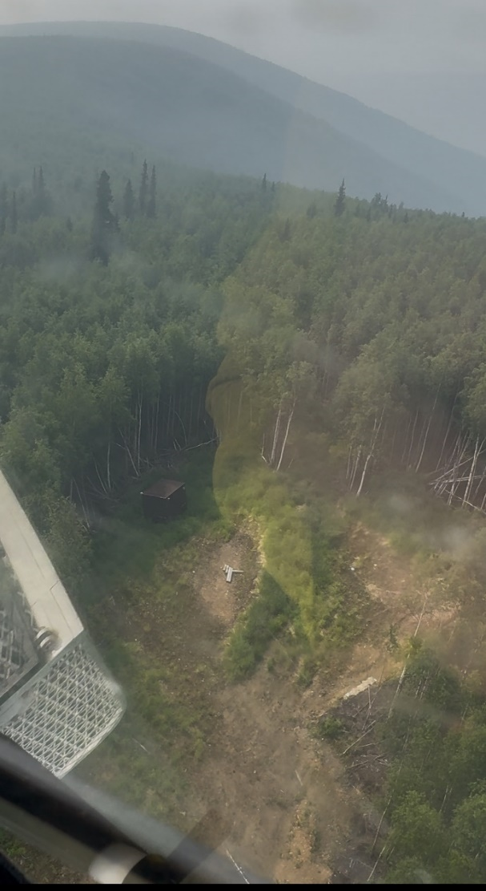

1. Unkown site labeld as LM_Private on the Operations map. This site was not identified from the air or ground. No information on this site.