Beaver Fire
CA-KNF-005497
Fire Behavior Analysis
For Strategic Operating Plan
08/09/14
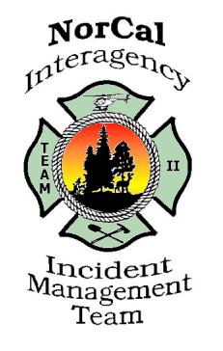

Fire Behavior Modeling Assumptions:
The Near-Term Fire Behavior model in WFDSS predicts fire spread using predicted weather values that change over the course of the modelling period (generally 3 days or less). It is subject to any errors or incorrect assumptions associated with forecasted weather values and live fuel moistures. The model assumes elliptical fire growth under uniform conditions, whereas the actual fire environment is much more complex, and no interaction between adjacent fire fronts. The spotting component of the model tends to under-predict spotting from active crown fire. The model does not account for suppression actions.
FSPro is a fire spread probability model designed to predict the probability of a given location burning during the modelling period (generally 5-14 days). Outputs do not represent fire progression, they represent the probability of each cell burning given a certain number of simulated fires (generally 1000+) under variable weather conditions. Weather inputs are based on 2 days of forecasted weather and 5 days of randomly selected historical weather values. The model assumes no suppression action, constant weather values set at peak burning conditions throughout each day, 100% foliar moisture content, and no variability of fuel moisture with wind speed, elevation or aspect. It is subject to any errors or incorrect assumptions associated with model inputs and representative weather station selection. Extremely rare weather events may not be represented by the simulation if those weather conditions are not part of the randomly selected set of values.

Beaver Fire Near Term:
A near term fire analysis was conducted on 08/07/14. The analysis utilized the most up to date infrared perimeter. The ignition file was based on the infrared perimeter with the open sections of perimeter used in the ignition file. The Klammath River Rd. on Div. W was used as barrier in order to reflect the control action taken.
The analysis represents a four day run based on seven hour burn periods (or 28 hours of burning). Oak Knoll RAWS was utilized and determined to be the best representative weather station. The model assumes no fire suppression action. Heavy smoke inversions, including smoke from other nearby fires, are not well represented within the model. See Beaver Fire Near Term Map at: ftp://ftp.nifc.gov/Incident_Specific_Data/CALIF_N/!2014_FEDERAL_Incidents/CA-KNF-005497_Beaver/WFDSS/NTFB/

Beaver Fire FSPRO:
The latest fire spread probability (FSPRO) is from 08/07/14. The FSPRO analysis represents a 7 day run with perimeters and ignition files from an infrared flight on August 7, 2014 at 0040 hours. Input adjustments were made due to extreme drought conditions; area is experiencing record ERC and BI trends, and current atmospheric instability. Significant smoke cover inversions may decrease fire behavior in the short term. The model assumes no fire suppression. Inputs also included three day of forecasted weather and four day of climatology based of Blue Ridge RAWS. See Beaver Fire FSPRO Map at: ftp://ftp.nifc.gov/Incident_Specific_Data/CALIF_N/!2014_FEDERAL_Incidents/CA-KNF-005497_Beaver/WFDSS/

Wind Rose
A wind rose is a tool to display historical wind observations. It is useful for highlighting winds that may be problematic for the Beaver Fire. The analysis below shows for the likely remaining duration of the Beaver Fire and how wind typically shifts as autumn progresses.

Directions for reading a wind rose follow.
- The wind rose shows directional origin of wind for the period of historical data it displays. North is up, south down, etc...
- Wind observation data is binned into directional angles. For each direction, the portion of time the winds come from that direction is shown by the total length of the bar shown.
- Within each directional bar color coding indicates the distribution of wind speeds. Both the relative proportion of time when each wind speed category occurred, and the absolute percentage of observations for each wind speed and directional bin can be determined.

Wind Analysis:

Two RAWS stations were selected to display predominant winds and identify possible problematic conditions for the August and September time periods. Oak Knoll RAWS is located along the river corridor and represents the lower portions of the fire area well. Collins Baldy RAWS is situated adjacent to the fire area at 5800ft. and is exposed to general flow winds. This is a good representation of upper elevations of the fire.

Wind patterns at the upper and lower elevations of the fire area are noticeably different.

Oak Knoll RAWS has a strong influence from the river drainage and up valley affects. Areas in the proximity commonly experience wind shifts from the S, SW, and W.

Collins Baldy RAWS is exposed to the general flow winds. These winds are most prevalent from the NW and W.

Both locations have potential to receive a strong north wind (45mph) during the months of August and September. This wind occurrence is a fairly rare event, however could have a significant effect on fire behavior.
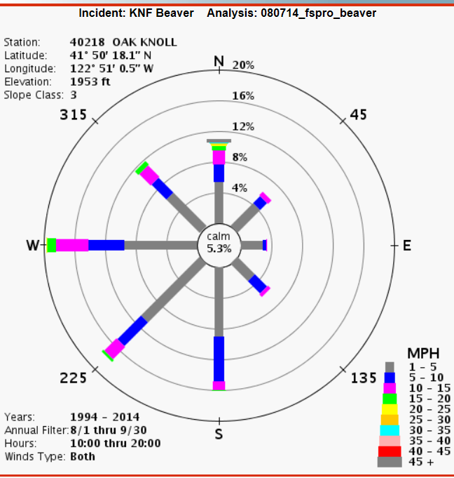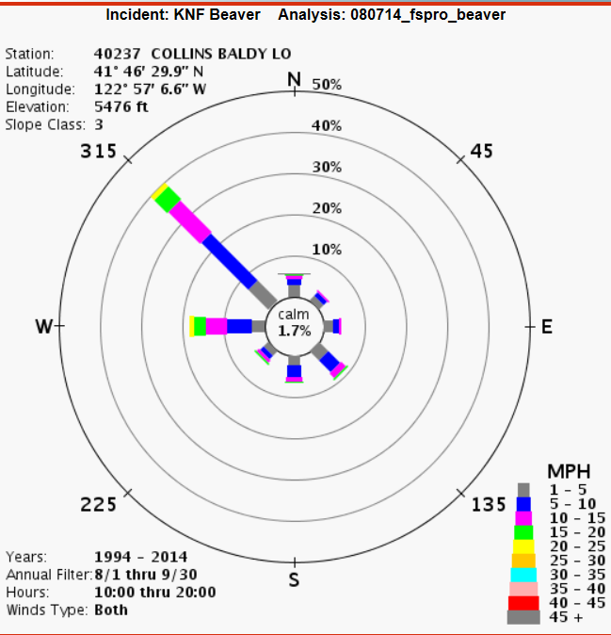

Season End Weather Event

Fire season commonly ends with a large scale rain event in the Klamath Mountains, but they can also end with the onset of shorter days and cooler/moister conditions. Often, a fire season fades away due to a combination of scattered, smaller precipitation events and changing day length and sun angle which, in turn, translates into lower maximum temperature, higher relative humidity, and a shorter burn period. Energy release component (ERC) can serve as an integrator of all these factors.
We developed criteria for estimating the end of fire season by talking with fire managers at the Klamath National Forest. The criteria selected included ½ inch of rain over a five day period, throughout which the ERC never climbed above 50. Using the dates from this analysis we developed a Term file for the probability of season-ending dates displayed in the graphic below.
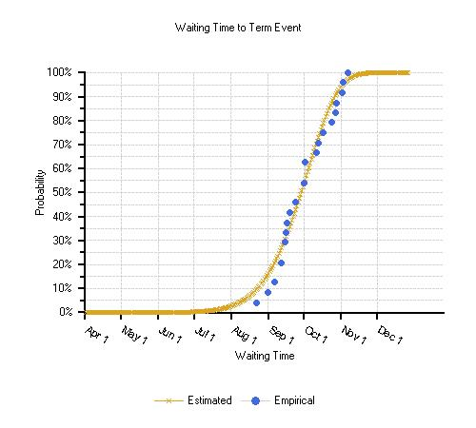
Fire Slowing Event
Along with season ending events, there is a possibility of fire-slowing precipitation events prior to the end of the fire season. Precipitation of at least 0.25 inches in a day might be expected to at least slow fire spread for two or three days, while greater amounts of rain (over 0.5 inches) could slow or check fire spread for several days. The probability of receiving greater than 0.25 inches of rain in one day was derived using the Blue Ridge RAWS. The likelihood of such events increases significantly in the latter part of September with the return of frontal systems moving in off the Pacific Ocean.

Time Period | Total Number of Days Recieiving >0.25 inches of Rain 1961-1979 & 1999-2010 Blue Ridge RAWS | Probability of Having at Least One Fire Slowing Event During this Time Period
Late August | 12 | 39%
Early September | 6 | 19%
Late September | 23 | 74%
Early October | 24 | 77%

Derived from http://plone.airfire.org/wfdss-aq/help/raws-wind-roses.
Energy release component (ERC) is a National Fire Danger Rating System (NFDRS) index related to how hot a fire could burn. It is derived from daily weather records and is associated with the worst case 24-hour potential energy at the flaming front of a given fire. This index tracks well with warming and drying as the season progresses and with the eventual cooling and lower fire potential as the season winds down. As the fuels dry through the season and become available to burn, adding to the potential energy, the ERC rises. As the days get shorter, temperatures fall, and nighttime humidity rises, the ERC falls.

