July Complex
CA-KNF-005561
Fire Behavior Analysis
For Strategic Operating Plan
as of 08/07/14
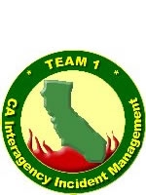

Executive Summary:
- The Near-Term Fire Behavior model indicates that the Log Fire will spread primarily to the south and east over the next several days.
- The Near-Term Fire Behavior model indicates that the Whites Fire will spread primarily to the northwest and the southeast.
- The FSPro burn probability model indicates that the Log Fire has the greatest probability of spread to the east over the next week, with a low probability for a significant spread event to the northeast and southeast.
- The FSPro burn probability model indicates that the Whites Fire has the highest probability of spreading to the east, with a low probability for significant spread events to the northwest and the south.
- The wind rose for the Quartz Hill RAWS (most applicable to the Log Fire) indicates that the strongest winds in August and September will be out of the west, with a moderately strong southeasterly component added in October.
- The wind rose for the Blue Ridge RAWS (most applicable to the Whites Fire) indicates that the strongest winds in August and September will be out of the west and northwest, and stronger from all directions in October with a distinct southerly component.
- WindNinja was used to model wind patterns in the complex terrain of the fire areas for use as fire behavior model inputs. Gradient wind directions modeled included southwest, west and northwest because they are potentially the most problematic from a structure protection standpoint.
- There is a 50% chance of a season-ending weather event (1/2 inch of rain over a 5 day period, ERCs below 50) by the end of September.
- There is a 74% chance of a fire-slowing event (1/4 inch of rain in one day) during late September.

Fire Behavior Modeling Assumptions:
The Near-Term Fire Behavior model in WFDSS predicts fire spread using predicted weather values that change over the course of the modelling period (generally 3 days or less). It is subject to any errors or incorrect assumptions associated with forecasted weather values and live fuel moistures. The model assumes elliptical fire growth under uniform conditions, whereas the actual fire environment is much more complex, and no interaction between adjacent fire fronts. The spotting component of the model tends to under-predict spotting from active crown fire. The model does not account for suppression actions.
FSPro is a fire spread probability model designed to predict the probability of a given location burning during the modelling period (generally 5-14 days). Outputs do not represent fire progression, they represent the probability of each cell burning given a certain number of simulated fires (generally 1000+) under variable weather conditions. Weather inputs are based on 2 days of forecasted weather and 5 days of randomly selected historical weather values. The model assumes no suppression action, constant weather values set at peak burning conditions throughout each day, 100% foliar moisture content, and no variability of fuel moisture with wind speed, elevation or aspect. It is subject to any errors or incorrect assumptions associated with model inputs and representative weather station selection. Extremely rare weather events may not be represented by the simulation if those weather conditions are not part of the randomly selected set of values.
Log Fire Near Term:
A near term fire analysis was conducted on 08/05/14. The analysis utilized the most up to date infrared perimeter. The ignition file was based on the infrared perimeter and areas of the perimeter were not ignited if the fire’s edge was not active and current line construction was complete and holding. No barrier files were used to limit fire spread across the landscape.
The analysis represents a four day run based on eight hour burn periods (or 32 hours of burning). Quartz Valley RAWS was utilized and determined to be the best representative weather station. The model assumes no fire suppression action. Heavy smoke inversions, including smoke from other nearby fires, are not well represented within the model. See Log Fire Near Term Map at: ftp://ftp.nifc.gov/Incident_Specific_Data/CALIF_N/!2014_FEDERAL_Incidents/CA-KNF-005564_JulyComplex/SOP/SOP_080614/FireBehavior/
Whites Fire Near Term:
A near term fire analysis was conducted on 08/06/14. The analysis utilized the most up to date infrared perimeter. The ignition file was based on the infrared perimeter with no barrier files to limit fire spread.
The analysis represents a four day run based on eight hour burn periods (or 32 hours of burning). Blue Ridge RAWS was utilized and determined to be the best representative weather station. The model assumes no fire suppression action. Heavy smoke inversions, including smoke from other nearby fires, are not well represented within the model. See Whites Fire Near Term Map at: ftp://ftp.nifc.gov/Incident_Specific_Data/CALIF_N/!2014_FEDERAL_Incidents/CA-KNF-005564_JulyComplex/SOP/SOP_080614/FireBehavior/
Log and Whites Fire FSPRO:
The latest fire spread probability (FSPRO) is from 08/03/14. The updated FSPRO run was done simultaneously for the Log and Whites fires. The FSPRO analysis represents a 7 day run with perimeters and ignition files from an infrared flight on August 3, 2014 at 0040 hours. An 11 hour burn period was used and based on calibration and experience of actual fire spread from previous days for Northern California fires (e.g. Coffee fire, Oregon Gulch Fire, Beaver Fire, and Little Deer Fire). In addition, input adjustments were made due to extreme drought conditions; area is experiencing record ERC and BI trends, and current atmospheric instability. Significant smoke cover inversions may decrease fire behavior in the short term. The model assumes no fire suppression. Inputs also included two day of forecasted weather and five day of climatology based of Blue Ridge RAWS. See Log and Whites Fire FSPRO Map at: ftp://ftp.nifc.gov/Incident_Specific_Data/CALIF_N/!2014_FEDERAL_Incidents/CA-KNF-005564_JulyComplex/SOP/SOP_080614/FireBehavior/
Wind Rose
A wind rose is a tool to display historical wind observations. It is useful for highlighting winds that may be problematic for the July Complex. The analysis below shows for the likely remaining duration of the Log and Whites fires how wind typically shifts as autumn progresses.

Directions for reading a wind rose follow.
- The wind rose shows directional origin of wind for the period of historical data it displays. North is up, south down, etc...
- Wind observation data is binned into directional angles. For each direction, the portion of time the winds come from that direction is shown by the total length of the bar shown.
- Within each directional bar color coding indicates the distribution of wind speeds. Both the relative proportion of time when each wind speed category occurred, and the absolute percentage of observations for each wind speed and directional bin can be determined.
Analysis:

Three time periods were selected to display predominant winds and problematic winds for the July Complex – Log and Whites fires (August, September and October). Blue Ridge RAWS was used for this analysis to represent the Whites Fire and Quartz Hill RAWS was used to represent the Log Fire.

Blue Ridge, representing the Whites Fire, has the predominant and strongest winds in August out of the west and northwest followed by south and southwest. Smaller percentages of wind occur in all other directions. September winds are almost identical to the August wind patterns. Due to the fact that September was so similar to August wind rose, we elected to only display August.

There is a noteworthy change in wind rose in the October analysis. The main highlight is an increased chance of wind speeds in nearly all directions. The probability is low for significant winds (35mph+) out of the south. This relatively rare wind event has contributed to large fire growth in the past.
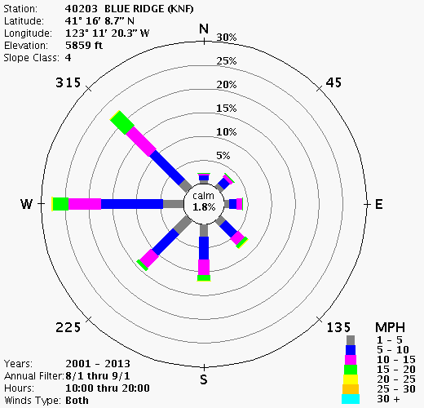
Blue Ridge RAWS – August 1 thru September 1, 2001-2013
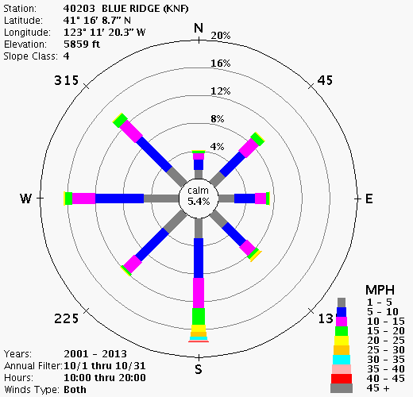
Blue Ridge RAWS – October 1 thru October 31, 2001-2013

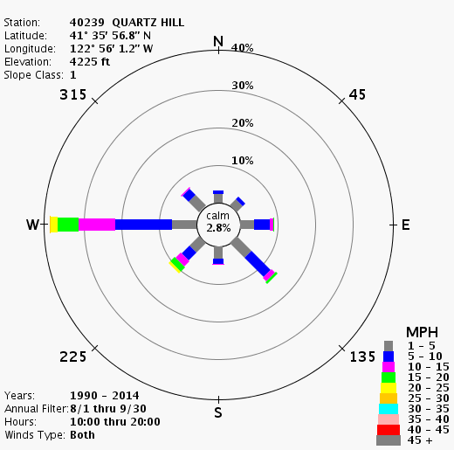
Quartz Hill RAWS – August 1 thru September 30, 1990-2014
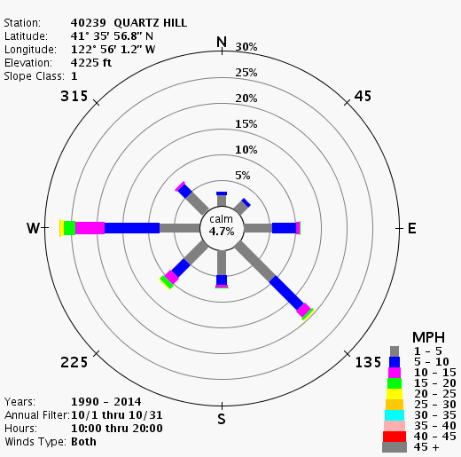
Quartz Hill RAWS – October 1 thru October 31, 1990-2014

WindNinja
WindNinja is a software program that computes spatially variable wind fields. Complex terrain, such as the Klamath Mountains, causes local changes in wind speed and direction that are not well predicted by most weather models. WindNinja was developed to help fire managers predict these winds within complex terrain. It does not account for leeward effects of terrain on wind (i.e. eddies on the leeward side of a ridge).
Log and Whites Fire WindNinja:
A WindNinja analysis was conducted for both the Log and Whites Fires. Wind directions (225, 270 and 315 azimuths) were based on predominant winds obtained from the representative RAWS stations as well as relationship of problem winds to identified values at risk (i.e. winds that would push fire toward high priority values at risk). Various wind speeds were also analyzed, however, 20 MPH winds at 20 feet above canopy level are the only ones displayed in this report. See Log and Whites Fire WindNinja Products at: ftp://ftp.nifc.gov/Incident_Specific_Data/CALIF_N/!2014_FEDERAL_Incidents/CA-KNF-005564_JulyComplex/SOP/SOP_080614/FireBehavior/
Season Ending Weather Event

Fire season commonly ends with a large scale rain event in the Klamath Mountains, but they can also end with the onset of shorter days and cooler/moister conditions. Often, a fire season fades away due to a combination of scattered, smaller precipitation events and changing day length and sun angle which, in turn, translates into lower maximum temperature, higher relative humidity, and a shorter burn period. Energy release component (ERC) can serve as an integrator of all these factors.
We developed criteria for estimating the end of fire season by talking with fire managers at the Klamath National Forest. The criteria selected included ½ inch of rain over a five day period, throughout which the ERC never climbed above 50. Using the dates from this analysis we developed a Term file for the probability of season-ending dates displayed in the graphic below.
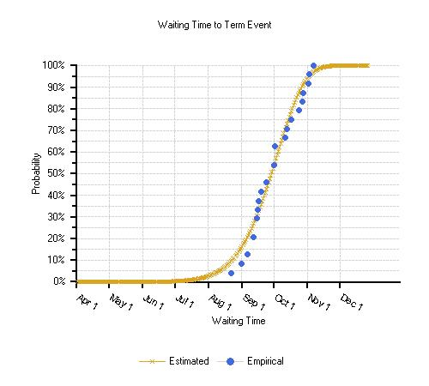
Fire Slowing Event
Along with season ending events, there is a possibility of fire-slowing precipitation events prior to the end of the fire season. Precipitation of at least 0.25 inches in a day might be expected to at least slow fire spread for two or three days, while greater amounts of rain (over 0.5 inches) could slow or check fire spread for several days. The probability of receiving greater than 0.25 inches of rain in one day was derived using the Blue Ridge RAWS. The likelihood of such events increases significantly in the latter part of September with the return of frontal systems moving in off the Pacific Ocean.

Time Period | Total Number of Days Recieiving >0.25 inches of Rain 1961-1979 & 1999-2010 Blue Ridge RAWS | Probability of Having at Least One Fire Slowing Event During this Time Period
Late August | 12 | 39%
Early September | 6 | 19%
Late September | 23 | 74%
Early October | 24 | 77%

Derived from http://plone.airfire.org/wfdss-aq/help/raws-wind-roses.
Energy release component (ERC) is a National Fire Danger Rating System (NFDRS) index related to how hot a fire could burn. It is derived from daily weather records and is associated with the worst case 24-hour potential energy at the flaming front of a given fire. This index tracks well with warming and drying as the season progresses and with the eventual cooling and lower fire potential as the season winds down. As the fuels dry through the season and become available to burn, adding to the potential energy, the ERC rises. As the days get shorter, temperatures fall, and nighttime humidity rises, the ERC falls.

