Happy Camp Complex
CA-KNF-005956
Strategic Operations Plan
09/03/14
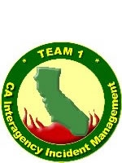

Management Action Points: 17 thru 25

Introduction
This strategic operations plan outlines the long-term management of the Happy Camp Complex located on the Happy Camp Ranger District of the Klamath National Forest. The strategic operating plan links strategic goals and objectives to tactical goals and objectives. It can help identify milestones, goals, objectives, and actions which all can be monitored to determine progress of the overall plan. The strategic plan can help define: where are we now, where do we want to be, how do we get there, and how do we measure our progress.
When prolific lightning strikes occurred on August 11th and resulted in the 20+ fires that comprise the Happy Camp Complex, fire-fighting resources were already scarce, limiting the ability to suppress many of these new starts. A Type 2 Incident Management Team (IMT) was activated 2 days later to manage the fires on the Happy Camp Ranger District of the Klamath National Forest and included the Huckleberry, Mill, Noranda, Ranch, Tims, China, Bear, El Capitan, Sutcliffe, Delta, Jackson, Thompson, Kemper, Frying Pan, and Falkstein fires. Hampered by smoke inversions, heavy fuels, and steep and inaccessible terrain, the fires spread to 400 acres with limited suppression options. On August 19th, more lightning resulted in 2 additional fires, the Luther 1 & 2 fires, which were added to the Happy Camp Complex and were quickly contained. As of August 22nd, the Frying Pan and Faulkstein fires remained the largest and most active.
Given multiple objectives based on their proximity to different values at risk, private lands, complex course of action items, and difficult logistical support of fires in remote areas a Type 1 Incident Management Team was ordered and in-briefed on August 23rd to supplement the management of the complex.
On August 29th the Frying Pan and Faulkstein fires merged. The fires became long-term events due to steep, rugged and largely inaccessible terrain coupled with current and expected weather and fire behavior. Past experiences and climatology records of the Klamath and Scott River drainage indicate a season ending fire event may not occur for a couple months.
Another Type 1 Incident Management Team, CA IIMT Team 1 was in-briefed on September 1st after the Type 2 Team timed-out. Current fire suppression efforts include a combination of direct, indirect and point suppression tactics to take advantage of opportunities that provide for a high probability of success. The complex is utilizing a full suppression strategy. The intent of the strategic operating plan is to further build on opportunities that will provide for the highest probability of success for the duration of this incident.
To successfully manage and communicate, the CA Interagency Incident Management Team – Team 1 continued with the development and implementation of the strategic operating plan. This tool can be used for informing and planning of ongoing suppression efforts as well as a communication tool for agency administrators, public information, and/or information for incoming incident management teams.

Objectives
Develop a strategic operating plan to assist in the short-term and long-term management (strategic and operational) of the KNF Happy Camp Complex.
Gather intelligence from the local public and fire agency resources including partners to provide a more robust knowledge/dataset of the area.
Produce timely products to assist the incident management team and agency administrators in the decision making process.
Develop a product that can be used as a communication tool for the concept of:
- The right plan, in the right place, at the right time, with the right assets, and for the right duration

Management Action Points

Management Action Points (MAPs) are mapped locations where the fire’s leading edge may reach. They are places where fire’s arrival identifies a specific fire mitigation action to limit fire spread, to protect values at risk and when to provide updated information. Each MAP’s description recommends the number and kinds of operational resources needed to accomplish the mitigation. MAPs can be accomplished sequentially or simultaneously, allowing for better utilization of resources.

MAP actions may be initiated at the discretion of an incident management organization. Implementation should not occur without consideration of current and predicted weather and fire behavior, and of other factors influencing the Happy Camp Complex fires and their management. These factors will determine the need for implementation of the management actions as well as drive the location, urgency, and intensity of the actions.

All firefighting resources listed in MAP descriptions should be considered as recommendations only. In order to be safe and effective, Incident Commanders and other fire managers need the flexibility to use any tactical resources needed to meet the objectives of managing these fires. They should give careful consideration to geographic area preparedness levels and draw-down levels. All fire management actions must be based on current and expected fire behavior, including in light of the time of year and season.

As needed in response to the changing fire situation, it is important to update the recommended plans outlined in this document. The Happy Camp Complex is not controlled and will grow in size and/or complexity until a season ending event occurs. New fires may start. Any of these fires may influence each other. In response to all of these changes, fire managers should reassess this document’s contingency plans. Each day’s operational priorities and planned strategic and tactical actions should be assessed in light of the location of the fire’s leading edge relative to MAPs. This document is dynamic; add new MAP’s or change existing ones as needed.

Happy Camp Complex Fire - Management Action Point 17: Johnny O’Neil and Sub-ridges

Condition:
The fire has crossed or is likely to cross Klamath River East MAP (MAP 7).

Location:
North of the fire’s current perimeter
From the Klamath River going Northeast up the Seiad.Valley, Road 46N50, to Johnny O’Neil then Southwest to Hamburg, Hwy. 96
Sub-ridges (17A and 17B) run to the Northeast from Hwy. 96 toward Johnny O’Neil Ridge

Management Intent:
The intent of this MAP is to be a contingency plan if the fire were to cross or likely to cross MAP 7 – Klamath River East. This includes noted sub-ridges 17A and 17B. Protect structures and infrastructure while limiting impacts to natural and cultural resources by utilizing direct, indirect and point protection tactics. Structures exist along this section of the Klamath River Corridor including population densities at Hamburg.

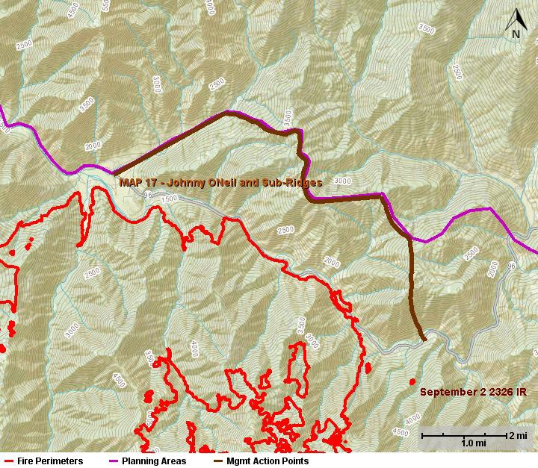

Suggested Actions:
Extinguish any spot fires or slop overs as quickly as possible, and provide point protection on structures and infrastructure.
Utilize sub-ridges to box-in fire depending on where it gets established.
Conduct strategic burning operations to secure the line and promote low intensity fire.
Coordinate with appropriate agencies on structure protection and any identified needs for evacuation.
Attain and utilize boats/rafts to gain access across the river
Utilize helicopter support and water pump operations from the Klamath River

Values to Protect:
Structures and infrastructure mainly along the Klamath River Corridor.
Wild and Scenic Klamath River and Scenic Byway Highway 96
Domestic Watershed to the greater Happy Camp and Seiad areas.
Increased impacts to recreational opportunities and closures
Impacts to alternative ingress and egress routes for the community and firefighters
Spotted owl cores and critical habitat
Grazing allotment
Current and on-going NEPA projects
Habitat for sensitive and endangered aquatic species.
Numerous cultural sites; identified by Resource Advisors
Habitat for threatened, endangered or sensitive plants

Probability of Success:
High.
The Klamath River and Highway 96 serve as a barrier to fire spread. Spotting may occur; however, is a low probability and resources are available to respond to any identified spotting. There is a road system that generally follows Johnny O’Neil Ridge.

Resources:
Resource needs will be determined by the IMT.

Consequences of Not Taking Action:
A much larger and more expensive fire
Potential for damage to homes, infrastructure and private property.
Impacts to natural and cultural resources; including threatened and endangered species.
Impacts on recreational opportunities and major travel routes.
Impacts to current and on-going NEPA projects including timber sales.

Notifications:
Agency Administrator
Forest fire duty officer
Resource advisors
Siskiyou Sheriff
Red Cross
California Highway Patrol
Office of Emergency Services
Community and tribal liaison
Community of Seiad, Hamburgand surrounding area
Fruit Growers – Terry Salvestro
Rogue- Siskiyou NF – Gary Smith
Timber Products – Chris Chase
CALTRAN
Seiad Fire Safe Council – George Jennings
Seiad Fire Chief
Pacific Power and Light Company – Jim Harkles
Community Member – Walt Robinson
Private Property of Section 26

Happy Camp Complex Fire - Management Action Point 18: Horse Creek

Condition:
The fire has crossed or is likely to cross Klamath River East, MAP 7, and/or Johnny O’Neil, MAP 17.

Location:
North of the fire’s current perimeter
From Road 46N50, Johnny O’Neil MAP 17 junction continuing Northeast then Southwest to Horse Creek, Hwy. 96
Sub-ridge (18A) that runs between Hamburg Gulch and Howards Gulch to Johnny O’Neil Ridge (MAP 17)

Management Intent:
The intent of this MAP is to be an additional contingency if the fire were to cross or likely to cross MAP 7 and/or MAP 17. This includes noted sub-ridge 18A. Protect checker boarded, federal and private, properties to the Northeast while limiting impacts to natural and cultural resources. Utilize direct, indirect and point protection tactics.

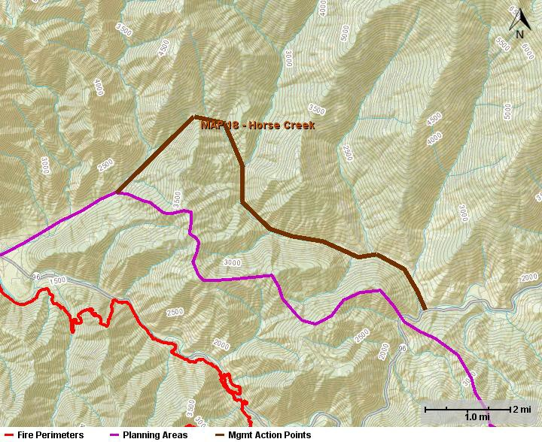

Suggested Actions:
Extinguish any spot fires or slop overs as quickly as possible, and provide point protection on structures and infrastructure.
Utilize sub-ridge to box-in fire depending on where it gets established.
Conduct strategic burning operations to secure the line and promote low intensity fire.
Coordinate with appropriate agencies on structure protection and any identified needs for evacuation.
Attain and utilize boats/rafts to gain access across the river

Values to Protect:
Structures and infrastructure mainly along the Klamath River Corridor, ie. Horse Creek.
Wild and Scenic Klamath River and Scenic Byway Highway 96
Domestic Watershed which is fed by Horse Creek into the Klamath River
Increased impacts to recreational opportunities and closures
Impacts to alternative ingress and egress routes for the community and firefighters
Special interest area
Spotted owl cores and critical habitat
Current and on-going NEPA projects
Habitat for sensitive and endangered aquatic species.
Numerous cultural sites; identified by Resource Advisors.

Probability of Success:
Moderate.
The Horse Creek Drainage is relatively wide and provides good access. Long range spotting may occur to the Northeast depending on fire intensity as it approaches Johnny O’Neil Ridge. Resources will likely be available to respond to any identified spotting. There is a road system that will provide access to portions of this MAP.

Resources:
Resource needs will be determined by the IMT.

Consequences of Not Taking Action:
A much larger and more expensive fire
Potential impacts to private property.
Impacts to natural and cultural resources; including threatened and endangered species.
Impacts on recreational opportunities and major travel routes.
Impacts to current and on-going NEPA projects including timber sales.

Notifications:
Agency Administrator
Forest fire duty officer
Resource advisors
Siskiyou Sheriff
Red Cross
California Highway Patrol
Office of Emergency Services
Community and tribal liaison
Community of Seiad, Hamburgand surrounding area
Siskiyou Fire Chief – Tom Mopis
Klamath River Fire Council
Pacific Power and Light Company
Rainey Ranch
Permittees - cattle

Happy Camp Complex Fire - Management Action Point 19: Steelhead/Bald Mtn. Loop

Condition:
The fire has crossed or is likely to cross the east end of Klamath River East, MAP 7, and/or Scott River, MAP 10.

Location:
Northeast of the fire’s current perimeter
From Steelhead to Horse Creek then east to Monument Point and finishing at Bald Mountain

Management Intent:
The intent of this MAP is to be an additional contingency and box the fire in proximity of MAPs 18 and 11. Protect checker boarded, federal and private, properties to the Northeast while limiting impacts to natural and cultural resources. Utilize direct, indirect and point protection tactics.

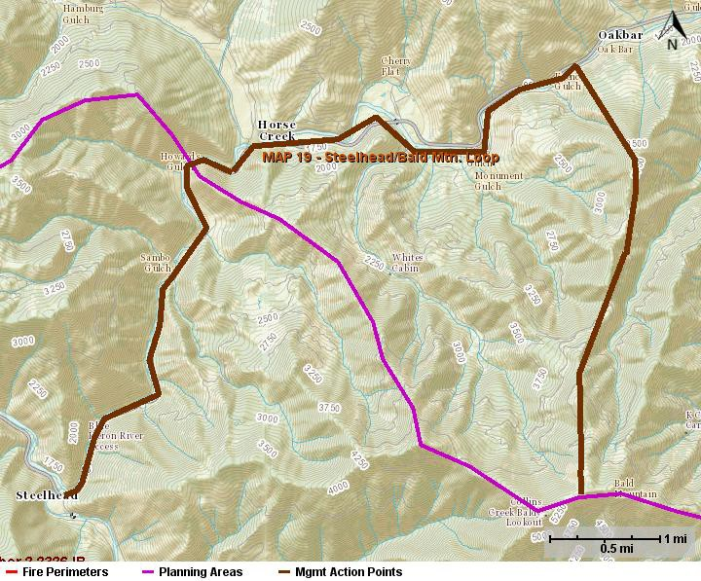

Suggested Actions:
Extinguish any spot fires or slop overs as quickly as possible, and provide point protection on structures and infrastructure.
Conduct strategic burning operations to secure the line and promote low intensity fire.
Coordinate with appropriate agencies on structure protection and any identified needs for evacuation.
Attain and utilize boats/rafts to gain access across the river

Values to Protect:
Structures and infrastructure mainly along the Klamath River Corridor, ie. Horse Creek.
Wild and Scenic Klamath River, Scenic Byway Highway 96, and the Scott River
Domestic Watershed for several nearby communities
Increased impacts to recreational opportunities and closures
Impacts to alternative ingress and egress routes for the community and firefighters
Spotted owl cores and habitat
Goshawk habitat and progeny sites
CalFire DPA
Habitat for sensitive and endangered aquatic species.
Numerous cultural sites; identified by Resource Advisors.

Probability of Success:
High.
There are multiple roads within this MAP which will allow for easy access and line building opportunities. The mix of fuel conditions will provide for the full realm of suppression alternatives – direct or indirect and confine, contain or control strategies.

Resources:
Resource needs will be determined by the IMT.

Consequences of Not Taking Action:
A much larger and more expensive fire
Potential impacts to private property; protect checker boarded, federal and private, properties while limiting impacts to natural and cultural resources.
Impacts to natural and cultural resources; including threatened and endangered species.
Impacts on recreational opportunities and major travel routes.
Impacts to current and on-going NEPA projects including timber sales.

Notifications:
Agency Administrator
Forest fire duty officer
Resource advisors
CalFire
Siskiyou Sheriff
Red Cross
California Highway Patrol
Office of Emergency Services
Community and tribal liaison
Community of Hamburg and surrounding area
Pacific Power and Light Company
Permittees - Cattle

Happy Camp Complex Fire - Management Action Point 20: Anderson Peak

Condition:
The fire has crossed or is likely to cross the east side of Scott Bar Mountain MAP 11 and/or the north side of Red Mountain MAP 21.

Location:
East of the fire’s current perimeter
South of MAP 10 past Anderson Peak to MAP 21 at Mile 21 Gaging Station.

Management Intent:
The intent of this MAP is to be an additional contingency and box the fire in proximity of MAPs 10 and 21. Limit impacts to natural and cultural resources. Utilize direct, indirect and point protection tactics.

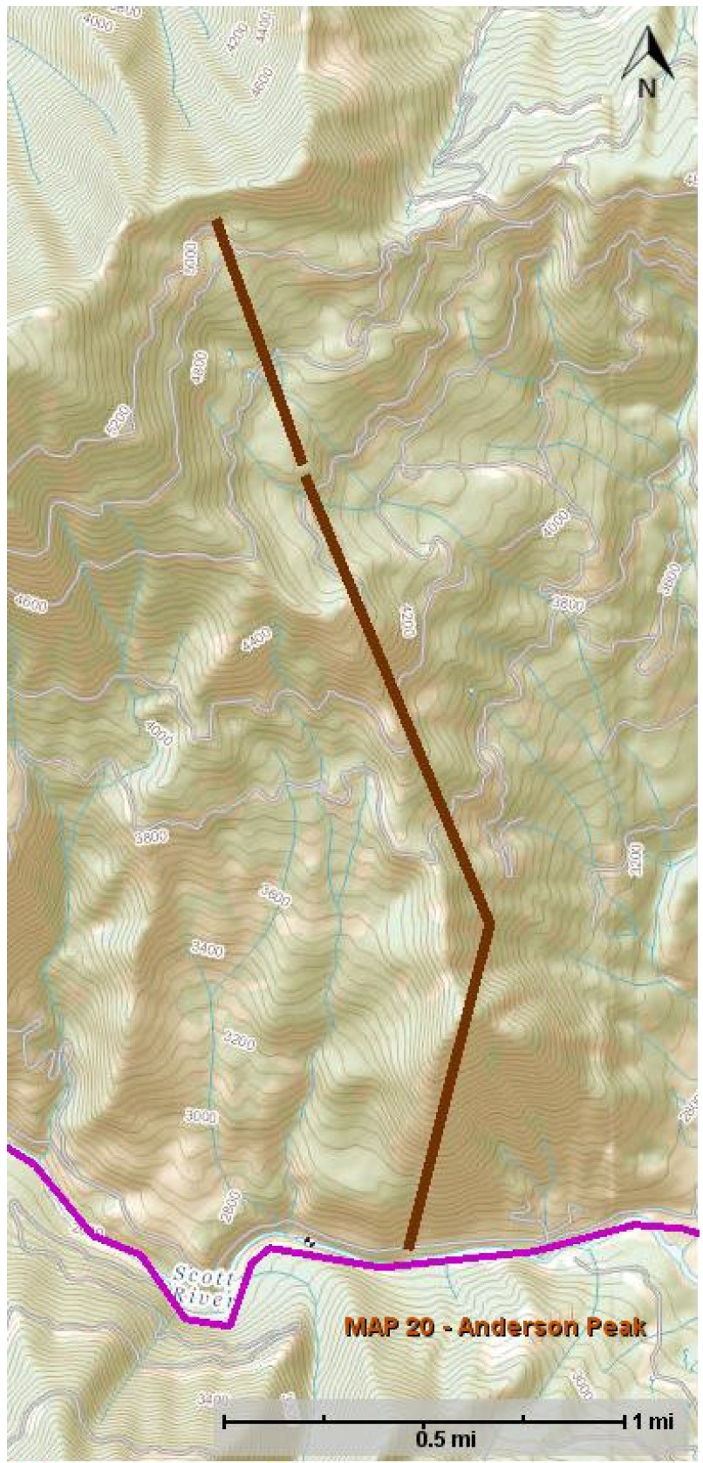

Suggested Actions:
Extinguish any spot fires or slop overs as quickly as possible, and provide point protection on structures and infrastructure.
Conduct strategic burning operations to secure the line and promote low intensity fire.
Attain and utilize boats/rafts to gain access across the river

Values to Protect:
Structures and infrastructure mainly along the Scott River, ie. Jones Beach Picnic area.
Domestic Watershed for several nearby communities
Increased impacts to recreational opportunities and closures
Impacts to alternative ingress and egress routes for the community and firefighters
Spotted owl cores and habitat
Habitat for sensitive and endangered aquatic species.
Numerous cultural sites; identified by Resource Advisors.

Probability of Success:
Moderate.
There are multiple roads within this MAP which will allow for easy access and line building opportunities. The mix of fuel conditions will provide for the full realm of suppression alternatives – direct or indirect and confine, contain or control strategies. The Scott River provides a water source to support suppression efforts.

Resources:
Resource needs will be determined by the IMT.

Consequences of Not Taking Action:
A much larger and more expensive fire
Potential impacts to private property; protect checker boarded, federal and private, properties while limiting impacts to natural and cultural resources.
Impacts to natural and cultural resources; including threatened and endangered species.
Impacts on recreational opportunities and major travel routes.
Impacts to current and on-going NEPA projects including timber sales.

Notifications:
Agency Administrator
Forest fire duty officer
Resource advisors
CalFire
Siskiyou Sheriff
Red Cross
California Highway Patrol
Office of Emergency Services
Community and tribal liaison
Communities in the surrounding area
Pacific Power and Light Company
Quartz Valley Community Leaders
Timber Products Companies
Fruit Growers
Quartz Valley Volunteer Fire Department

Happy Camp Complex Fire - Management Action Point 21: Red Mountain

Condition:
The fire has crossed or is likely to cross the south end of Scott River, MAP 10.

Location:
Northeast of the fire’s current perimeter
From Steelhead to Horse Creek then east to Monument Point and finishing at Bald Mountain

Management Intent:
The intent of this MAP is to be an additional contingency should the fire cross the Scott River or Canyon Creek. Limit impacts to natural and cultural resources. Utilize direct, indirect and point protection tactics.

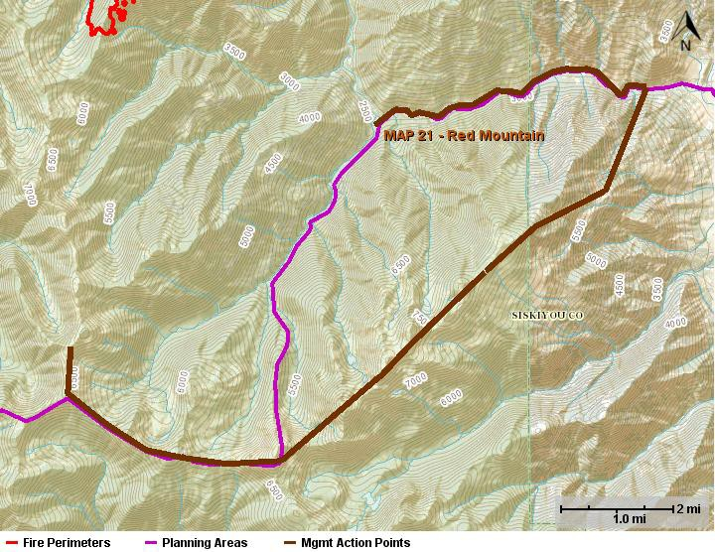
Suggested Actions:
Extinguish any spot fires or slop overs as quickly as possible, and provide point protection on structures and infrastructure.
Conduct strategic burning operations to secure the line and promote low intensity fire.
Coordinate with appropriate agencies on structure protection and any identified needs for evacuation.

Values to Protect:
Structures and infrastructure mainly along the Scott River Corridor, ie. Horse Creek.
Wild and Scenic Klamath River, Scenic Byway Highway 96, and the Scott River
Domestic Watershed for several nearby communities
Increased impacts to recreational opportunities and closures
Impacts to alternative ingress and egress routes for the community and firefighters
Spotted owl cores and critical habitat
Marble Valley Research Natural Area
Wilderness
Habitat for sensitive and endangered aquatic species.
Numerous cultural sites; identified by Resource Advisors.

Probability of Success:
Moderate.
The topography is steep with little fire history in this area and few access roads. Direct attack opportunities will be limited thus consider indirect and confine, contain or control strategies.

Resources:
Resource needs will be determined by the IMT.

Consequences of Not Taking Action:
A much larger and more expensive fire
Potential impacts to private property; protect checker boarded, federal and private, properties while limiting impacts to natural and cultural resources.
Impacts to natural and cultural resources; including threatened and endangered species.
Impacts on recreational opportunities and major travel routes.

Notifications:
Agency Administrator
Forest fire duty officer
Resource advisors
CalFire
Siskiyou Sheriff
Red Cross
California Highway Patrol
Office of Emergency Services
Community and tribal liaison
Pacific Power and Light Company

Happy Camp Complex Fire - Management Action Point 22: Box Camp Mountain

Condition:
The fire has crossed or is likely to cross Kelsey Martin, MAP 9..

Location:
Southeast of the fire’s current perimeter
From Kelsey Trailhead to the Southeast along Box Camp Mountain to Black Marble Mountain

Management Intent:
The intent of this MAP is to limit fire spread into the Marble Mountain Wilderness.

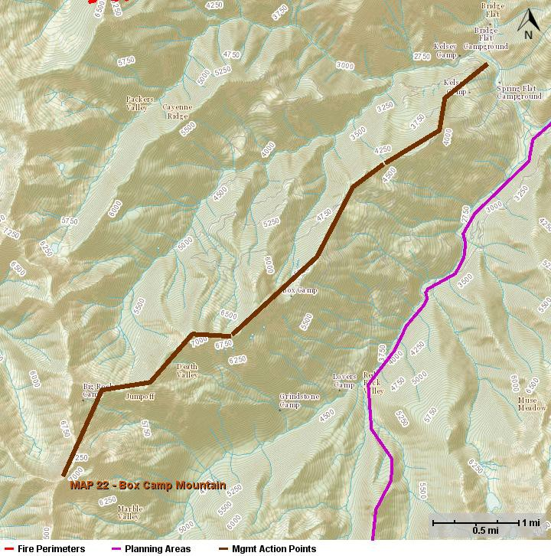
Suggested Actions:
Extinguish any spot fires or slop overs as quickly as possibleConduct strategic burning operations to secure the line and promote low intensity fire.
Coordinate with appropriate agencies on structure protection and any identified needs for backcountry evacuation.

Values to Protect:
Structures and infrastructure mainly along the Scott River Corridor.
Domestic Watershed for several nearby communities
Increased impacts to recreational opportunities and closures
Impacts to alternative ingress and egress routes for the community and firefighters
Spotted owl cores and critical habitat
Wilderness
Grazing allotment
Released Roadless Area
Progeny Sites
CalFire DPA
Habitat for sensitive and endangered aquatic species.
Numerous cultural sites; identified by Resource Advisors.

Probability of Success:
Moderate.
There a few roads within this MAP which will allow some access and line building opportunities. Direct or indirect and confine, contain or control strategies should be considered as the likely spread will be away from structures and into the wilderness

Resources:
Resource needs will be determined by the IMT.

Consequences of Not Taking Action:
A much larger and more expensive fire
Impacts to natural and cultural resources; including threatened and endangered species.
Impacts on recreational opportunities and travel routes.

Notifications:
Agency Administrator
Forest fire duty officer
Resource advisors
CalFire
Siskiyou Sheriff
Red Cross
California Highway Patrol
Office of Emergency Services
Community and tribal liaison
Community of Hamburg and surrounding area
Permittees – Cattle

Happy Camp Complex Fire - Management Action Point 23: Kings Castle

Condition:
The fire has crossed or is likely to cross MAPs 12, 15 or 22.

Location:
South of the fire’s current perimeter
Along the Pacific Crest Trail near Kings Castle

Management Intent:
The intent of this MAP is to be an additional contingency and box the fire in proximity of MAPs 12, 15, and 22. Limit impacts to natural and cultural resources. Utilize direct, indirect and point protection tactics.

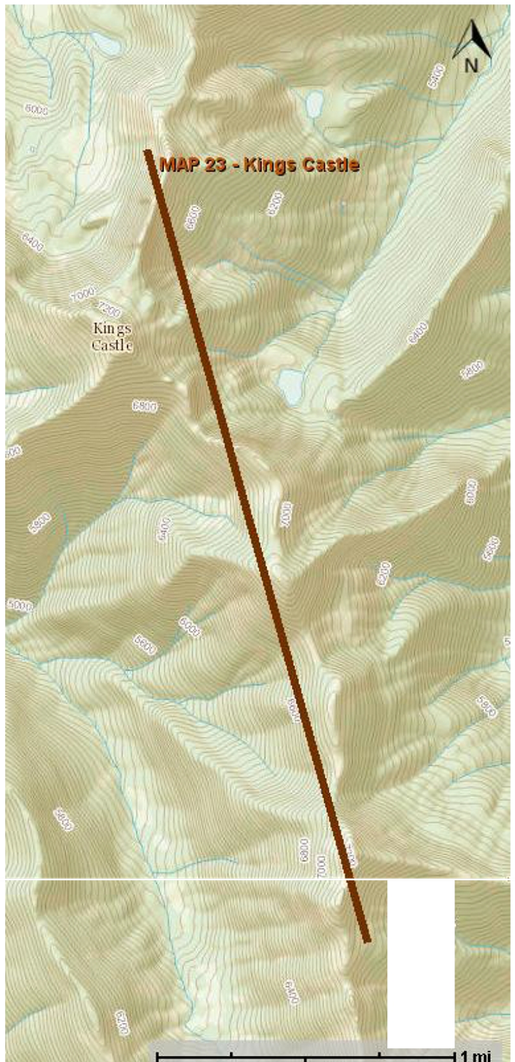
Suggested Actions:
Extinguish any spot fires or slop overs as quickly as possible, and provide point protection on structures and infrastructure.
Conduct strategic burning operations to secure the line and promote low intensity fire.
Coordinate with appropriate agencies on structure protection and any identified needs for evacuation.

Values to Protect:
Increased impacts to recreational opportunities and closures
Spotted owl cores and habitat
Habitat for sensitive and endangered aquatic species.
Numerous cultural sites; identified by Resource Advisors.

Probability of Success:
Moderate.
Access is limited an the area is remote within this MAP. Indirect and confine, contain or are the likely strategies to be considered along this MAP.y

Resources:
Resource needs will be determined by the IMT.

Consequences of Not Taking Action:
A much larger and more expensive fire
Impacts to natural and cultural resources; including threatened and endangered species.
Impacts on recreational opportunities and major travel routes.

Notifications:
Agency Administrator
Forest fire duty officer
Resource advisors
CalFire
Siskiyou Sheriff
Red Cross
California Highway Patrol
Office of Emergency Services
Community and tribal liaison
Pacific Power and Light Company
Pacific Crest Trail Association
Backcountry Horse Riders Association

Happy Camp Complex Fire - Management Action Point 24: Devils Peaks

Condition:
The fire has crossed or is likely to cross Klamath River North, MAP 16

Location:
North of the fire’s current perimeter
From Seiad Valley north along the Pacific Crest Trail
Management Intent:
The intent of this MAP is to be an additional contingency and box the fire in proximity of Seiad Valley, MAP 17 and the 2014 Goff Fire. . Protect checker boarded, federal and private, properties to the North while limiting impacts to natural and cultural resources. Utilize direct, indirect and point protection tactics.

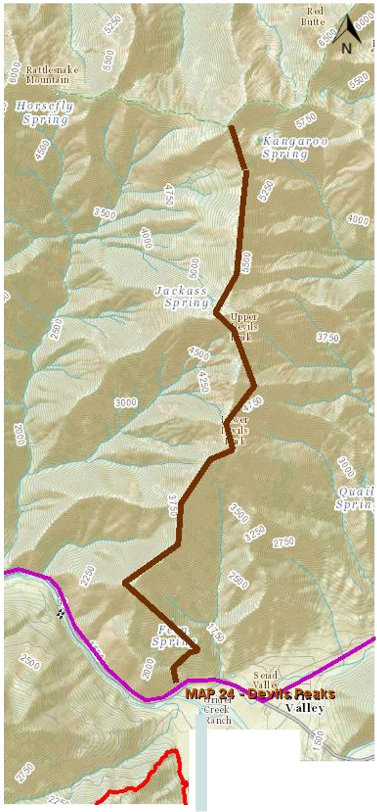
Suggested Actions:
Extinguish any spot fires or slop overs as quickly as possible, and provide point protection on structures and infrastructure.
Conduct strategic burning operations to secure the line and promote low intensity fire.
Coordinate with appropriate agencies on structure protection and any identified needs for evacuation.
Utilize helicopter support and water pump operations from the Klamath River

Values to Protect:
Structures and infrastructure mainly along the Klamath River Corridor, ie. Seiad Valley.
Wild and Scenic Klamath River, Scenic Byway Highway 96
Domestic Watershed for several nearby communities
Increased impacts to recreational opportunities and closures
Impacts to alternative ingress and egress routes for the community and firefighters
Spotted owl cores and habitat
Released Roadless Area
Grazing allotment
TES botanical species
CalFire DPA
Habitat for sensitive and endangered aquatic species.
Numerous cultural sites; identified by Resource Advisors.

Probability of Success:
High.
There are multiple roads and Goff Fire lines within this MAP which will allow for easy access and line building opportunities. The light fuel conditions will provide for the full realm of suppression alternatives – direct or indirect and confine, contain or control strategies.

Resources:
Resource needs will be determined by the IMT.

Consequences of Not Taking Action:
A much larger and more expensive fire
Potential impacts to private property; protect checker boarded, federal and private, properties while limiting impacts to natural and cultural resources.
Impacts to natural and cultural resources; including threatened and endangered species.
Impacts on recreational opportunities and major travel routes.
Impacts to current and on-going NEPA projects including timber sales.

Notifications:
Agency Administrator
Forest fire duty officer
Resource advisors
CalFire
Siskiyou Sheriff
Red Cross
California Highway Patrol
Office of Emergency Services
Community and tribal liaison
Community of Hamburg and surrounding area
Fruit Growers – Terry Salvestro
Rogue- Siskiyou NF – Gary Smith
Timber Products – Chris Chase
CALTRAN
Seiad Fire Safe Council – George Jennings
Seiad Fire Chief
Pacific Power and Light Company – Jim Harkles
Community Member – Walt Robinson
Private Property of Section 26

Happy Camp Complex Fire - Management Action Point 25: Elk

Condition:
The fire has crossed the main stem of Elk Creek (MAP 17) and/or NorCross (MAP 13) or is likely to be crossed.

Location:
South of the fire’s current perimeter
Titus Ridge continuing East to Black Marble

Management Intent:
The intent of this MAP is to be a contingency plan if the fire were to cross or likely to cross MAP 17 or 13 and continuing its progress into the Marble Mountain Wilderness.

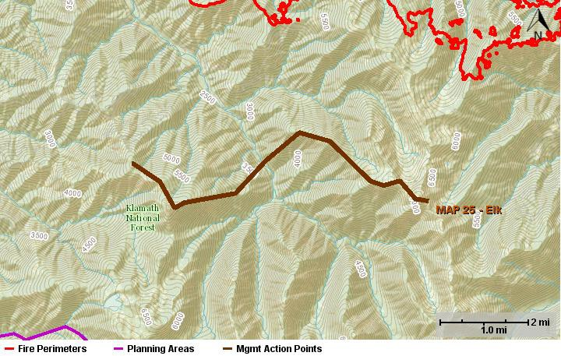

Suggested Actions:
Extinguish any spot fires or slop overs as quickly as possible, and provide point protection on structures and infrastructure
Scout and identify best line construction options on identified ridgelines, road system and trail systems. Begin indirect line construction to keep fire within identified MAP. Coordinate with READ on suggested line construction.
Conduct strategic burning operations to secure the line and promote low intensity fire
Coordinate with appropriate agencies on structure protection and any identified needs for evacuation.

Values to Protect:
Structures and infrastructure mainly along the Elk Creek Road System, Norcross Campground and Sulfer Springs Campground.
Domestic Watershed to the greater Happy Camp/Elk Creek areas.
Increased impacts to recreational opportunities and closures
Impacts to alternative ingress and egress routes for the community and firefighters
Spotted owl cores and habitat
Habitat for sensitive and endangered aquatic species.
Numerous cultural sites; identified by Resource Advisors.

Probability of Success:
Moderate.
Titus ridge system has some dozer line and historical fires that will assist with fire suppression. Cultural concerns may limit additional line construction on the ridge system.

Resources:
Resource needs will be determined by the IMT.

Consequences of Not Taking Action:
A much larger and more expensive fire
Impacts to natural and cultural resources; including threatened and endangered species and tribal cultural area.
Impacts on recreational opportunities and major travel routes.

Notifications:
Notifications:
Agency Administrator
Forest fire duty officer
Resource advisors
Siskiyou Sheriff
Red Cross
California Highway Patrol
Office of Emergency Services
Community and tribal liaison
Pacific Power and Light Company
Pacific Crest Trail Association
Backcountry Horse Riders Association

