Smoke Impact Report – Shasta-Trinity/Six Rivers National Forest August 7, 2015.
- Fire growth
Complex Names | Fire Growth Yesterday | Total Acre
Fork Complex | 1894 Acres | 15,151 Acres
Mad River Complex | 1282 Acres | 17,042 Acres
River Complex | 1612 Acres | 12,525 Acres
Route Complex | 1894 Acres | 15,587 Acres
South Complex | 1086 Acres | 15,011 Acres
Gasquet Complex | 388 Acres | 1,143 Acres
Total | 8078 Acres | 76,459 Acres
Information came from Infrared Flights

- Weather
With an upper level low is hovering off the coast of Northern California, the upper level air mass over the fires in Shasta-Trinity and Six Rivers National Forest is cool. This will encourage day time mixing. Upper level transport wind speed is likely to increase gradually from about 10 mph to 30 mph on Sunday. Transport wind direction will change from Northwest today to West/Southwest tomorrow and then to South/Southwesterly to Sunday.

- Fire Behavior
Fire behavior analysts are reporting moderate fire behaviors after the smoke clears in the middle of the day. Moisture recovery at night is good, up to 80% at some of the fires.

- Smoke
Each complex in the area has grown about 1000 acres per day. This will generate decent amount of smoke. Although there will be good day-time mixing in late afternoon, heavy smoke is expected hang around river drainage Shasta-Trinity and Six River National Forest. The drainages near the fires will be the most severely impacted and hazardous concentration of smoke may be observed.

Today: Northwesterly wind is expected to will bring smoke to the Southeast of the fires (Figure 1). After sunset, smoke will drift into the river drainages. Hyampon, Dinsmore and Hayfork will be the most severely impacted (Figure 2).

Tomorrow: Southwesterly wind is expected to bring smoke to the Northeast of the fires (Figure 3). Smoke condition will improve in the Northwest coast (Crescent City, and Klamath Glen). After sunset, smoke will drift into the river drainages. Hyampon, Dinsmore and Hayfork will be the most severely impacted (Figure 4) again.

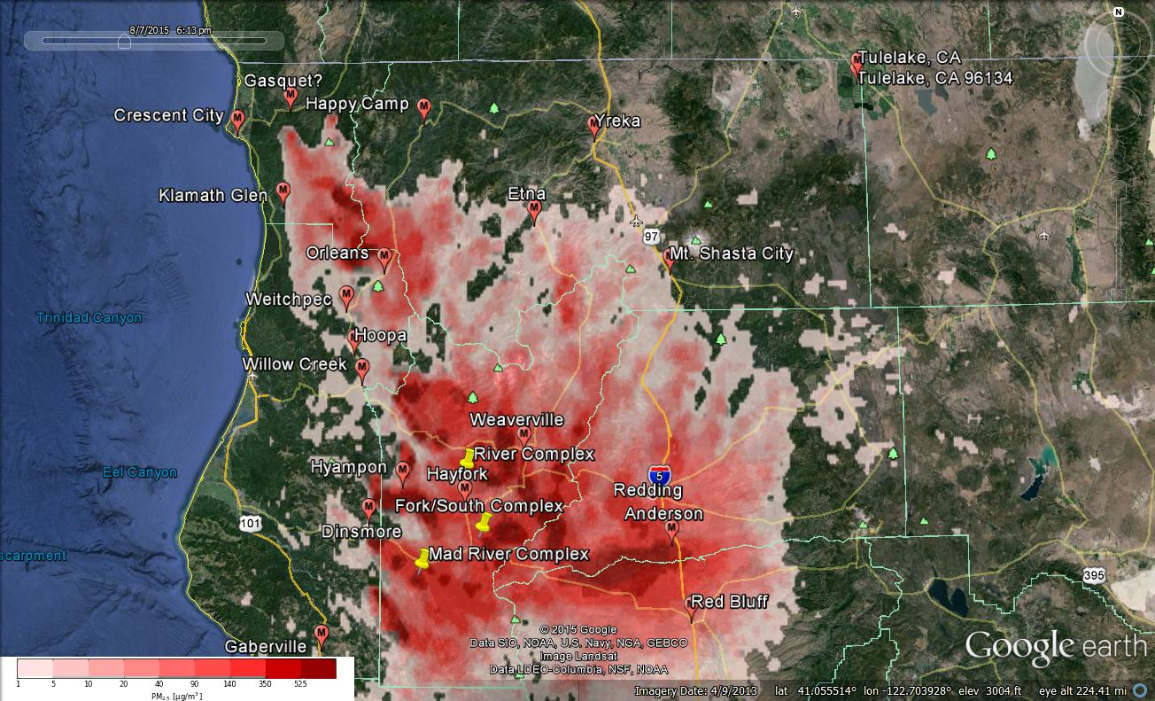
Figure 1: Bluesky run for 6pm on August 7, 2015

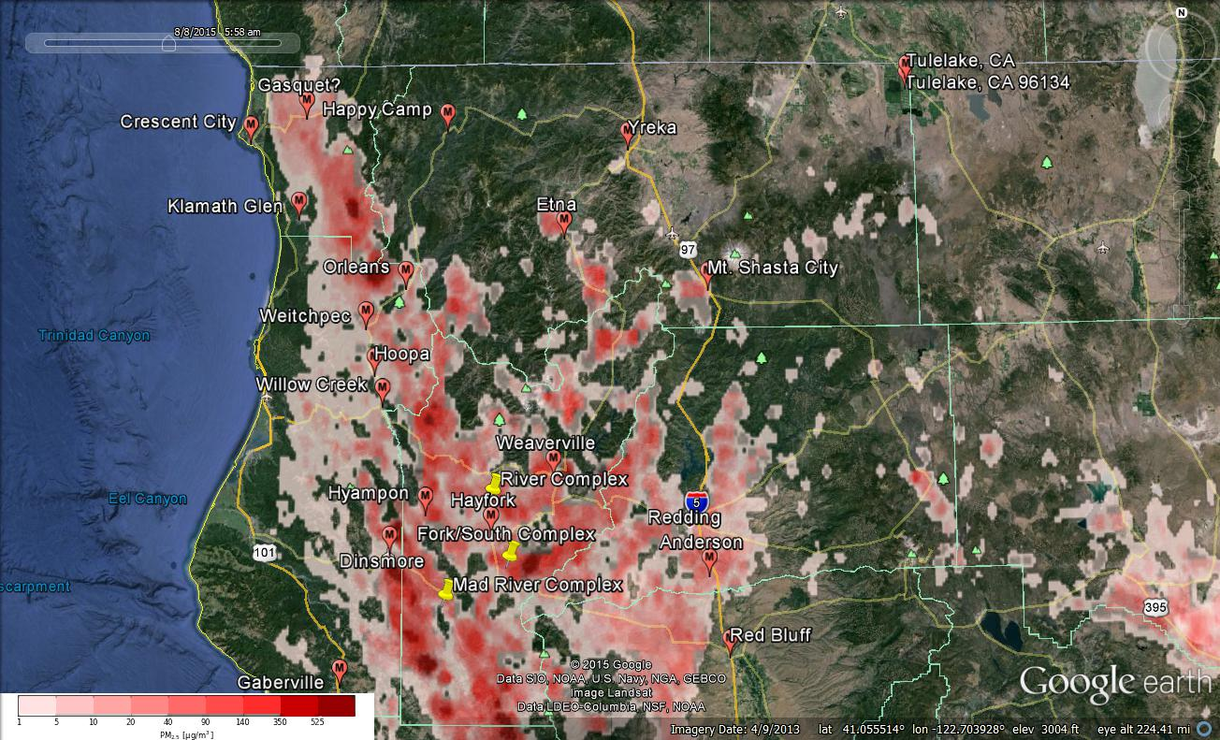
Figure 2: Bluesky run for 6am on August 8, 2015

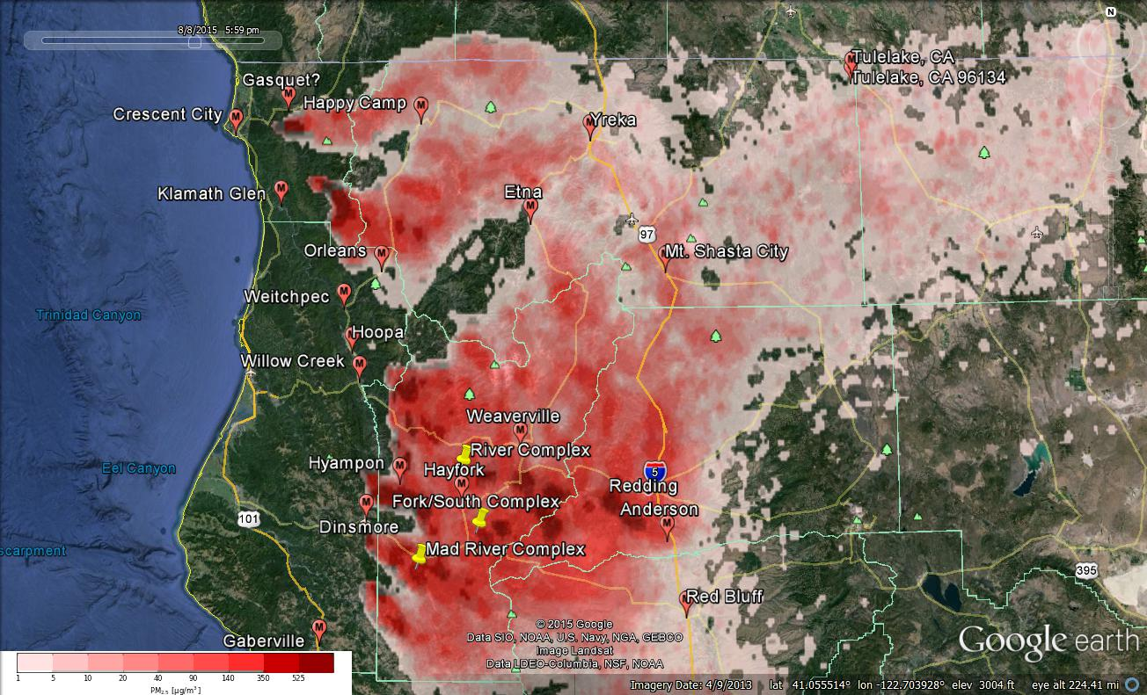
Figure 3: Bluesky run for 6pm on August 8, 2015

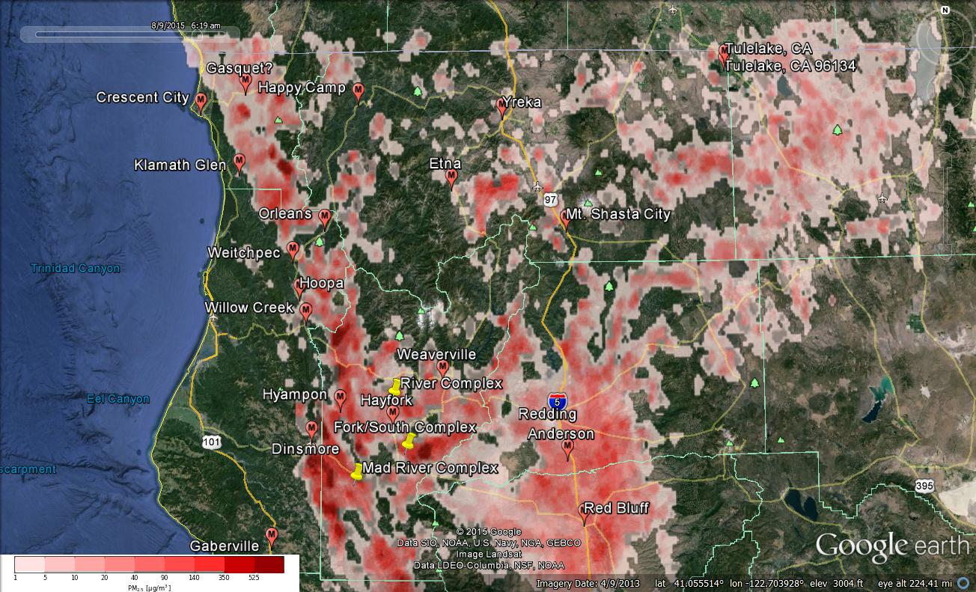Figure 4: Bluesky run for 6am on August 9, 2015

Smoke Synopsis: Friday morning update
Most stations in the area reached “Unhealthy” and “Unhealthy to Sensitive Groups” level yesterday. Hayfork was in “Hazardous” level. Good to excellent day-time mixing is expected during the day for the next few days. Transport wind speed will gradually increase from today through Monday. However, the transport wind direction will shift from Northwesterly today to Westerly tomorrow to Southerly flow on Sunday. Heavy smoke is still likely in river drainages in Shasta-Trinity National Forest during the overnight periods until inversion break the following morning.
Air Quality Outlook: Shasta-Trinity & Six Rivers Complexes
Site | Friday  August 7, 2015 | Saturday  August 8, 2015 | Sunday  August 9, 2016 | Comments
Anderson/Redding | USG | USG | Moderate
Crescent City | Moderate | Good | Good
Dinsmore | Very Unhealthy | Hazardous | Very Unhealthy-PM
Etna | USG | Unhealthy | USG-AM
Eureka | Moderate – AM | Good | Good -AM | Will clear in the afternoon of Aug 7
 | Good – PM
Gaberville | Moderate | Good | Good
Gasquet | USG | USG | USG
Happy Camp | USG | Unhealthy | USG
Hayfork | Hazardous | Unhealthy | USG-AM
Hoopa | Unhealthy | USG | USG
Hyampom | Hazardous | Unhealthy | Hazardous - AM
Mt. Shasta | USG | USG | USG-AM
Orleans | USG | USG | Moderate
Tulelake | Good | Moderate | Moderate
Weaverville | Very Unhealthy | Unhealthy | USG
Weitchpec | Unhealthy | USG | Moderate
Willow Creek | Very Unhealthy | Very Unhealthy | USG
Yreka | Unhealthy | Unhealthy | Unhealthy - AM
Disclaimer: Forecast conditions represent air quality levels affected by fine particulates; contribution from ozone and other pollutants is not reflected. Conditions may change quickly, these projections are based on anticipated weather and fire activity. Sensitive groups including individuals with asthma, lung or heart disease, children, older adults, and pregnant women should take precautions to avoid exposure to smoke. If you feel as though you are having health effects from smoke, see your doctor or health professional as needed. In some cases your eyes are your best tools. If it is smoky outside, you are being impacted. Use caution when driving in or around smoky areas.

AQI Index | Actions to Protect Yourself
Good | None
Moderate | Unusually sensitive people should consider reducing prolonged or heavy outdoor exertion.
Unhealthy for Sensitive Groups - USG | People with heart or lung disease, children and older adults should reduce prolonged or heavy outdoor exertion. Everyone else should limit prolonged or heavy exertion.
Unhealthy | The following groups should avoid all physical outdoor activity: People with heart or lung disease, children and older adults. Everyone else should avoid prolonged or heavy exertion.
Very Unhealthy | Everyone should avoid any outdoor exertion; people with respiratory or heart disease, the elderly and children should remain indoors.
Hazardous | The following groups should remain indoors and keep activity levels low: People with heart or lung disease; children and older adults. Everyone else should avoid prolonged or heavy exertion

Links:
AirNow - http://airnow.gov/index.cfm?action=airnow.local_state&stateid=5&tab=0
California Smoke Information Blog - http://californiasmokeinfo.blogspot.com/
North Coast Unified Air Quality Management District http://www.ncuaqmd.org/
Shasta County Air Pollution Control District - http://www.co.shasta.ca.us/index/drm_index/aq_index.aspx
Siskiyou County Air Pollution Control District http://www.co.siskiyou.ca.us/content/agriculture-air-pollution-control-district
Interagency Real Time Smoke Monitoring - http://app.airsis.com/usfs/fleet.aspx

