**Smoke Impact Report – Shasta-Trinity/Six Rivers National Forest August 9, 2015.**

1. **Fire growth**

|  |  |  |
| --- | --- | --- |
| **Complex Names** | **Fire Growth Yesterday** | **Total Acre** |
| Fork Complex | 1878 Acres | 19,220 Acres |
| Mad River Complex | 466 Acres | 18,318 Acres |
| River Complex | 2036 Acres | 15,863 Acres |
| Route Complex | 1820 Acres | 19,674 Acres |
| South Complex | 1042 Acres | 16,950 Acres |
| Gasquet Complex | 460 Acres | 2,162 Acres |
| Total | 7702 Acres | 92,187 Acres |

Information came from Infrared Flights

1. **Weather**

Generally onshore flow is expected for Northern California near the surface for today and tomorrow. As the onshore flow pushes inland, wind direction will be modified by the local terrain. The onshore flow can go as far inland to Weaverville and Douglas City. Upper level flow over Northern California will shift from Southwesterly today to Southerly Tuesday. Transport wind speed will also increase from today through Tuesday.

1. **Fire Behavior**

Fire behavior analysts are forecasting for more active fire behaviors today, especially in areas that are clear of smoke. Moisture recovery at night is good, between 60-80% around the fires. RH during the day is expected to be in the 20-30% range.

1. **Smoke**

Each complex in the area continues to grow about 1000 acres per day. This generates decent amount of smoke. Onshore flow today will continue until mid-afternoon. This will push smoke into Trinity River drainage and South Fork Trinity River drainages, where the most severe smoke impact is expected. Then, upper level Southwesterly wind will push the smoke further Northeast into Anderson, Redding, Etna and Yreka. At night fall, smoke will come down to the surface.

Condition for tomorrow is expected to be similar to today. But, Southerly transport wind is expected on Tuesday to push smoke from fires north of the fires.

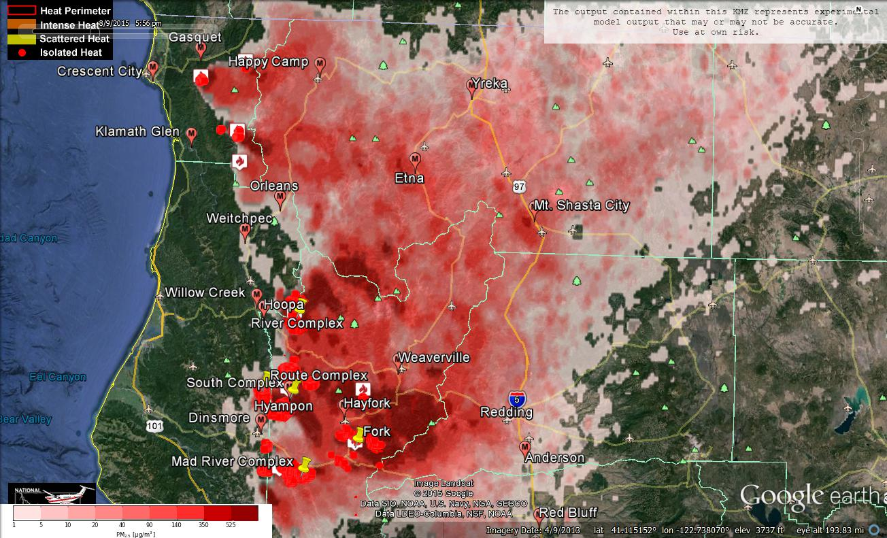

Figure 1: Bluesky run for 6pm on August 9, 2015

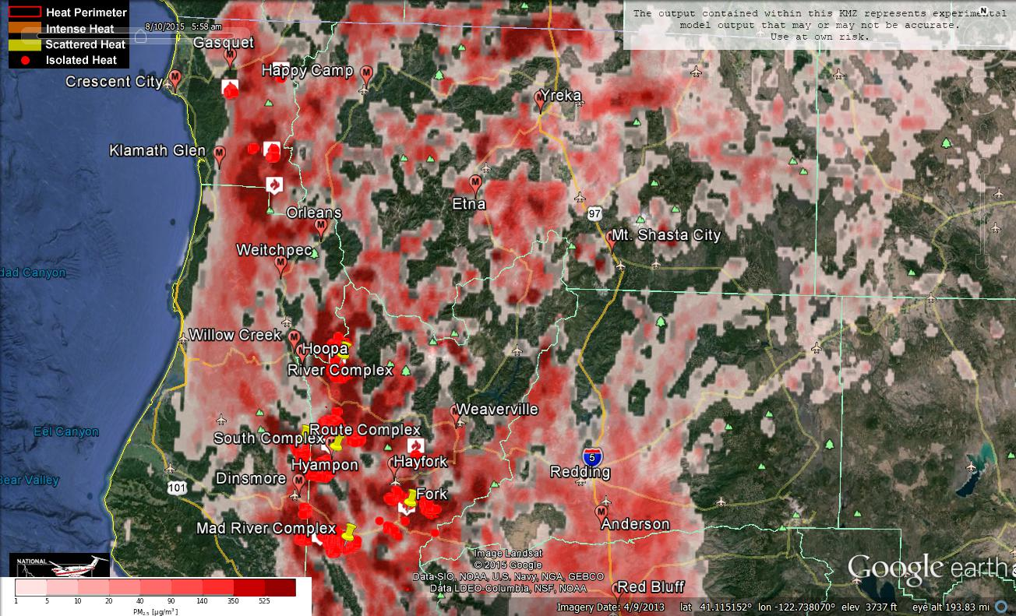

Figure 2: Bluesky run for 6am on August 10, 2015

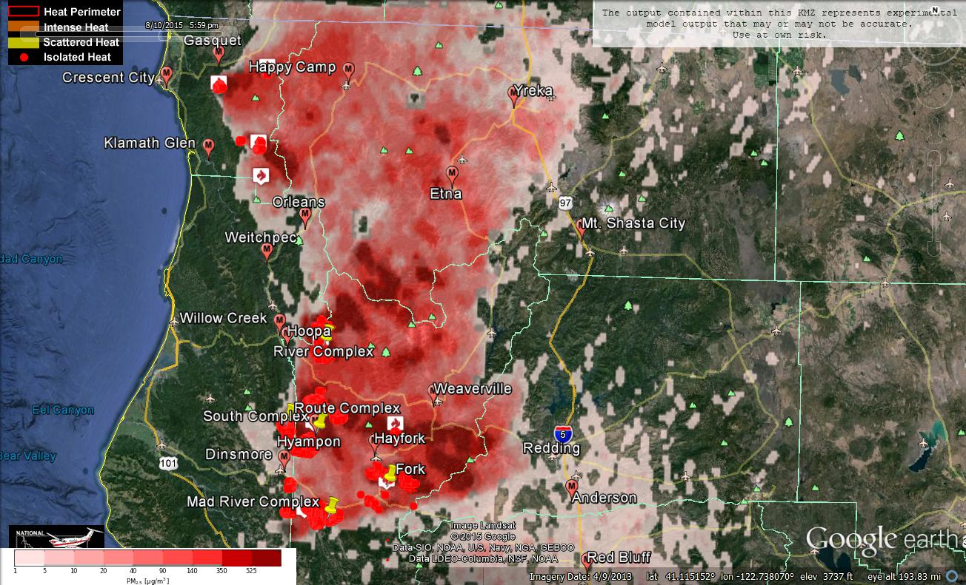

Figure 3: Bluesky run for 6pm on August 10, 2015

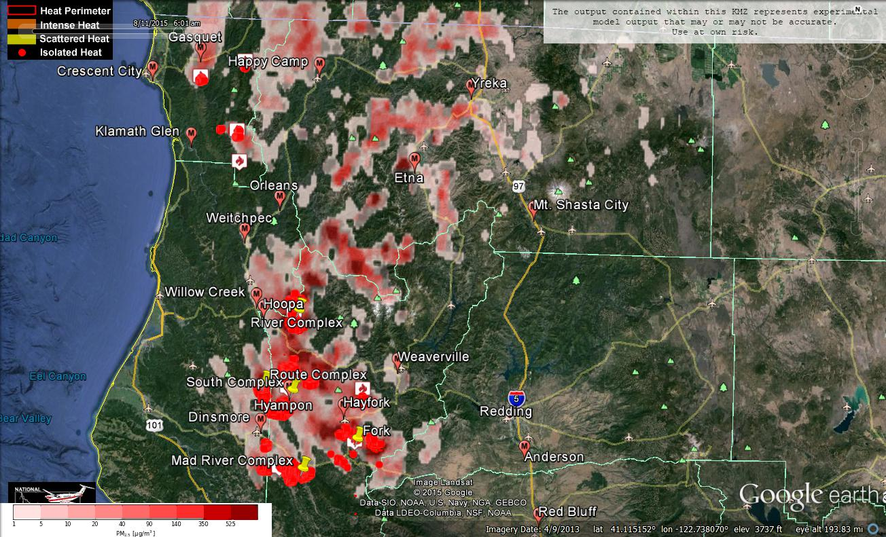Figure 4: Bluesky run for 6am on August 11, 2015

**Forecast conditions represent impacts from smoke. Contributions from ozone and other pollutants are not reflected.**

|  |  |  |  |  |
| --- | --- | --- | --- | --- |
| **Smoke Synopsis:** | | | | |
| Air quality in the area generally improved on Saturday compared to Friday due to better smoke dispersion. PM Monitors at Hoopa, Orleans and Weitchpec reported “Good” air quality on Saturday! Yet, areas in the Trinity River drainage and South Fork Trinity River drainage remained above “Unhealthy” range. Mad River improved from “Unhealthy” to “USG”. Hayfork improved from “Hazardous” to “Very Unhealthy”.  Onshore flow today is going bring clean air to Humboldt County, but push smoke from the fires into Trinity County, especially along the Trinity River drainage and South Fork Trinity River drainage. Then, Southwesterly transport wind aloft will bring smoke further Northeast in the late afternoon today. Smoky conditions are likely to persist at Hayfork and Hyampom due to fires nearby. Happy Camp may be impacted by smoke from Oregon.  Tomorrow’s condition is expected to be similar to Today.  Transport wind direction is expected to turn to Southerly on Tuesday. Yreka, Etna, Mt Shasta, Weaverville, and Anderson are likely to have much better air quality on Tuesday. | | | | |
|  | | | | |
| **Air Quality Outlook: Shasta-Trinity & Six Rivers Complexes** | | | | |
| **Site** | **Sunday**  **August 9, 2015** | **Monday**  **August 10, 2015** | **Tuesday**  **August 11, 2016** | **Comments** |
| **Crescent City** | Good | Good | Good |  |
| **Gasquet** | Moderate | Moderate | USG |  |
| **Happy Camp** | Unhealthy | USG | Unhealthy |  |
| **Etna** | Unhealthy | Unhealthy | Moderate | 8/9 & 8/10 Heaviest around sundown |
| **Mt. Shasta** | Unhealthy | Unhealthy | Moderate | 8/9 Heaviest during afternoon. 8/10 Heaviest after sunrise, clearest late afternoon. |
| **Tulelake** | Moderate | Moderate | Good |  |
| **Yreka** | Moderate | USG | Moderate |  |
| **Eureka** | Good | Good | Good |  |
| **Hoopa** | USG | Unhealthy | Unhealthy |  |
| **Mad River/Dinsmore** | Unhealthy | Very Unhealthy | Very Unhealthy |  |
| **Orleans** | Moderate | USG | USG |  |
| **Weitchpec** | Moderate | USG | USG |  |
| **Willow Creek** | Unhealthy | Very Unhealthy | Very Unhealthy |  |
| **Hayfork** | Hazardous | Hazardous | Hazardous | 8/9: Heaviest during afternoon 8/10 Heaviest after sunrise. |
| **Hyampom** | Hazardous | Hazardous | Hazardous | 8/9 & 8/10 Heaviest during afternoon |
| **Weaverville** | Hazardous | Hazardous | USG | 8/9 & 8/10 Heaviest during late afternoon |
| **Anderson/Redding** | Moderate | USG | Good |  |
| **Disclaimer: Forecast conditions represent air quality levels affected by fine particulates; contribution from ozone and other pollutants is not reflected.**  Conditions may change quickly, these projections are based on anticipated weather and fire activity. Sensitive groups including individuals with asthma, lung or heart disease, children, older adults, and pregnant women should take precautions to avoid exposure to smoke. If you feel as though you are having health effects from smoke, see your doctor or health professional as needed. In some cases your eyes are your best tools. If it is smoky outside, you are being impacted. Use caution when driving in or around smoky areas. | | | | |

|  |  |
| --- | --- |
| **AQI Index** | **Actions to Protect Yourself** |
| Good | None |
| Moderate | Unusually sensitive people should consider reducing prolonged or heavy outdoor exertion. |
| Unhealthy for Sensitive Groups - USG | People with heart or lung disease, children and older adults should reduce prolonged or heavy outdoor exertion. Everyone else should limit prolonged or heavy exertion. |
| Unhealthy | The following groups should avoid all physical outdoor activity: People with heart or lung disease, children and older adults. Everyone else should avoid prolonged or heavy exertion. |
| Very Unhealthy | Everyone should avoid any outdoor exertion; people with respiratory or heart disease, the elderly and children should remain indoors. |
| Hazardous | The following groups should remain indoors and keep activity levels low: People with heart or lung disease; children and older adults. Everyone else should avoid prolonged or heavy exertion |

**Links:**

AirNow - <http://airnow.gov/index.cfm?action=airnow.local_state&stateid=5&tab=0>

California Smoke Information Blog - <http://californiasmokeinfo.blogspot.com/>

North Coast Unified Air Quality Management District <http://www.ncuaqmd.org/>

Shasta County Air Pollution Control District - <http://www.co.shasta.ca.us/index/drm_index/aq_index.aspx>

Siskiyou County Air Pollution Control District <http://www.co.siskiyou.ca.us/content/agriculture-air-pollution-control-district>

[Interagency Real Time Smoke Monitoring - http://app.airsis.com/usfs/fleet.aspx](http://app.airsis.com/usfs/fleet.aspx)