Smoke Impact Report – Shasta-Trinity/Six Rivers National Forest August 11, 2015.
- Fire growth
Complex Names | Fire Growth Yesterday | Total Acre
Fork Complex | 2382 Acres | 24,695 Acres
Mad River Complex | 774 Acres | 19,963 Acres
River Complex | 2678 Acres | 20,913 Acres
Route Complex | NA | 14,705 Acres
South Complex | 1475Acres | 25,852 Acres
Gasquet Complex | 263 Acres | 2,598 Acres
Nickowtiz Fires | 321 Acres | 1,226 Acres
Total | 7572 Acres | 108,726 Acres
Information came from Infrared Flights
Route Complex transferred Pelletreau Fire to South Complex.

- Weather
Generally onshore flow is expected for Northern California near the surface for today and tomorrow. Also, southerly wind is expected from Sacramento Valley for today and tomorrow. These two winds will at Central Trinity County today and tomorrow. Overnight, smoke will settle into the Trinity River drainages and South Fork Trinity River drainages. Strong upper level southerly transport wind is forecast today and tomorrow. Good day time mixing is expected for today and tomorrow.

- Fire Behavior
Fire behavior analysts predicted that fire behavior may become intense when smoke is lifted in and forecast gusty wind, especially in high elevation.

- Smoke
All complexes/fire in the area grew about 7500 acres yesterday. This generates decent amount of smoke. With good day time mixing and strong upper level southerly transport wind, Trinity County may have slightly better air quality today and tomorrow, even at Hayfork and Hyampon, for today and tomorrow.

Upper level southerly wind is going to bring smoke to the north today (Figure 1) and tomorrow (Figure 3). Overnight, smoke is likely to settle in the river drainages in the area (Figure 2, 4).

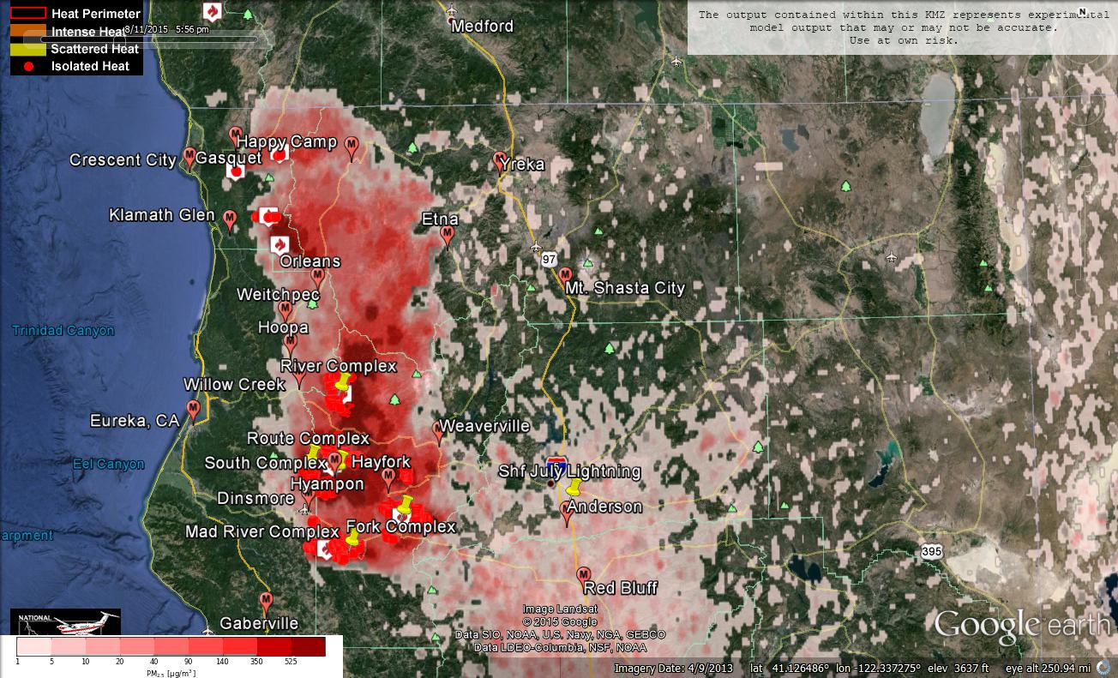
Figure 1: Bluesky run for 6pm on August 11, 2015.

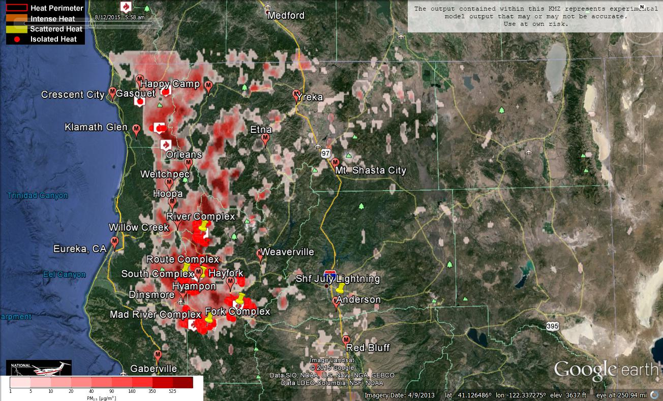
Figure 2: Bluesky run for 6am on August 12, 2015

Figure 3: Bluesky run for 6pm on August 12, 2015

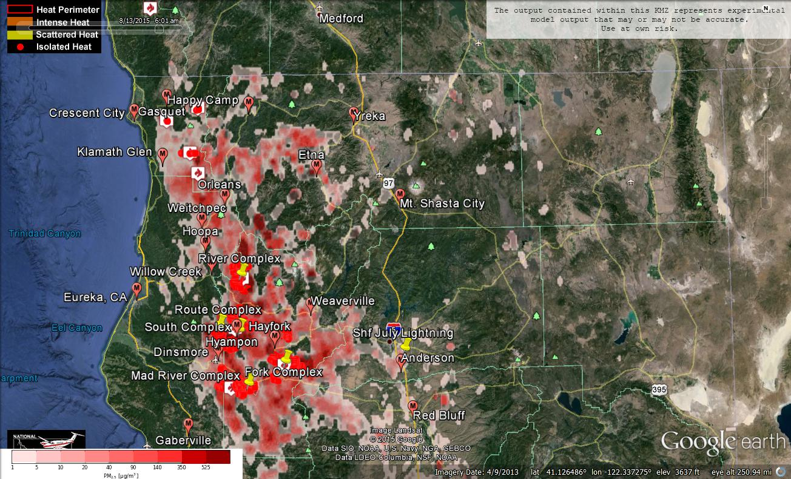Figure 4: Bluesky run for 6am on August 13, 2015
Forecast conditions represent impacts from smoke. Contributions from ozone and other pollutants are not reflected.
Smoke Synopsis:
On Monday, based on 24-hour averages, PM Monitors at Crescent City, Eureka, Hoopa, Orleans, Weitchpec and Willow Creek reported “Good” air quality! Air quality in the Trinity River drainage, South Fork Trinity River drainage, Shasta County, and Siskiyou County also improved yesterday. Based on 24-hour averages, Hayfork improved from “Very Unhealthy” to “Unhealthy”. Mad River improved from “Unhealthy” to “Moderate”. Etna improved from “Unhealthy” to ”Moderate”. Despite of hazy condition at Anderson/Redding in the morning, Anderson/Redding measured “Moderate” air quality only.

Onshore flow is going bring clean air to Humboldt County today and tomorrow. At the same time, surface southerly wind is going to come up from the Sacramento Valley today and tomorrow. These two winds are forecast to meet at Central Trinity County. Strong upper level southerly wind is forecast for today and tomorrow. As a result, smoke from fires in Trinity County is likely to stay in Trinity County near the ground. When the smoke is lifted due to day time mixing, it will be transported northward. Over nights,
smoke will settle into the South Fork Trinity River drainage and Trinity River drainage.

With good day time mixing, air quality at Hayfork, Hyampom, Mad River and Weaverville are likely to be slightly better than a few days ago.
Air Quality Outlook: Shasta-Trinity & Six Rivers Complexes
Site | Tuesday  August 11, 2015 | Wednesday  August 12, 2015 | Thursday  August 13, 2015 | Comments
Crescent City | Good | Moderate | Good
Gasquet | Moderate | USG | Moderate
Happy Camp | USG | USG | USG
Etna | Moderate | Moderate | USG | 8/11 Heavier surrounding ridges
Mt. Shasta | USG | Moderate | USG
Tulelake | Good | Good | Good
Yreka | Moderate | Moderate | Unhealthy
Eureka | Good | Good | Good
Hoopa | Moderate | Moderate | Moderate | Episodes of heavy smoke overnight
Mad River/Dinsmore | Moderate | Moderate | USG
Orleans | Moderate | Moderate | USG
Weitchpec | Moderate | Moderate | USG
Willow Creek | Moderate | Moderate | USG
Hayfork | Hazardous | Very Unhealthy | Very Unhealthy | 8/11: Heaviest around sunset
Hyampom | Hazardous | Hazardous | Hazardous | 8/11: Heaviest during afternoon & night
Weaverville | Very Unhealthy | Very Unhealthy | Very Unhealthy | 8/12: Heaviest around sunset
Anderson/Redding | Moderate | Moderate | USG
Disclaimer: Forecast conditions represent air quality levels affected by fine particulates; contribution from ozone and other pollutants is not reflected. Conditions may change quickly, these projections are based on anticipated weather and fire activity. Sensitive groups including individuals with asthma, lung or heart disease, children, older adults, and pregnant women should take precautions to avoid exposure to smoke. If you feel as though you are having health effects from smoke, see your doctor or health professional as needed. In some cases your eyes are your best tools. If it is smoky outside, you are being impacted. Use caution when driving in or around smoky areas.

AQI Index | Actions to Protect Yourself
Good | None
Moderate | Unusually sensitive people should consider reducing prolonged or heavy outdoor exertion.
Unhealthy for Sensitive Groups - USG | People with heart or lung disease, children and older adults should reduce prolonged or heavy outdoor exertion. Everyone else should limit prolonged or heavy exertion.
Unhealthy | The following groups should avoid all physical outdoor activity: People with heart or lung disease, children and older adults. Everyone else should avoid prolonged or heavy exertion.
Very Unhealthy | Everyone should avoid any outdoor exertion; people with respiratory or heart disease, the elderly and children should remain indoors.
Hazardous | The following groups should remain indoors and keep activity levels low: People with heart or lung disease; children and older adults. Everyone else should avoid prolonged or heavy exertion

Links:
AirNow - http://airnow.gov/index.cfm?action=airnow.local_state&stateid=5&tab=0
California Smoke Information Blog - http://californiasmokeinfo.blogspot.com/
North Coast Unified Air Quality Management District http://www.ncuaqmd.org/
Shasta County Air Pollution Control District - http://www.co.shasta.ca.us/index/drm_index/aq_index.aspx
Siskiyou County Air Pollution Control District http://www.co.siskiyou.ca.us/content/agriculture-air-pollution-control-district
Interagency Real Time Smoke Monitoring - http://app.airsis.com/usfs/fleet.aspx

