Smoke Impact Report – Shasta-Trinity/Six Rivers National Forest August 12, 2015.
- Fire growth
Complex Names | Fire Growth Yesterday | Total Acre
Fork Complex | 4030 Acres | 28,725 Acres
Mad River Complex | 563 Acres | 20,526 Acres
River Complex | 2708 Acres | 23,621 Acres
Route Complex | 1904 Acres | 14,705 Acres
South Complex | 611 Acres | 25,677 Acres
Gasquet Complex | 95 Acres | 2,693 Acres
Nickowtiz Fires | 123 Acres | 1,349 Acres
Total | 9911 Acres | 116,558 Acres
Information came from Infrared Flights
Correction: Route Complex transferred Pelletreau Fire to South Complex.

- Weather
Generally onshore flow is expected for Northern California near the surface for today and tomorrow. Also, southerly wind is expected from Sacramento Valley for today and tomorrow. These two winds will meet at Central Trinity County today and tomorrow. Overnight, smoke will settle into the Trinity River drainages and South Fork Trinity River drainages. Strong upper level southerly transport wind is forecast today and tomorrow. Good day time mixing is expected for today and tomorrow. But, on Friday, high pressure will establish over Northern California. The atmosphere will become more stable and much weaker transport wind speed is expected.

- Fire Behavior
Fire behavior analysts predicted that fire behavior may become intense when smoke is lifted in and forecast gusty wind, especially in high elevation. And they are also predicting longer active burn periods today due to less hazy conditions.

- Smoke
All complexes/fires in the area grew about 9911 acres yesterday. This generates decent amount of smoke. With good day time mixing and strong upper level southerly transport wind, Trinity County may have slightly better air quality today and tomorrow, even at Hayfork and Hyampon, for today and tomorrow. However, smoke dispersion will be much poorer on Friday.

Upper level southerly wind is going to bring smoke to the north today (Figure 1) and tomorrow (Figure 3). Overnight, smoke is likely to settle in the river drainages in the area (Figure 2, 4).

Figure 1: Bluesky run for 6pm on August 12, 2015.

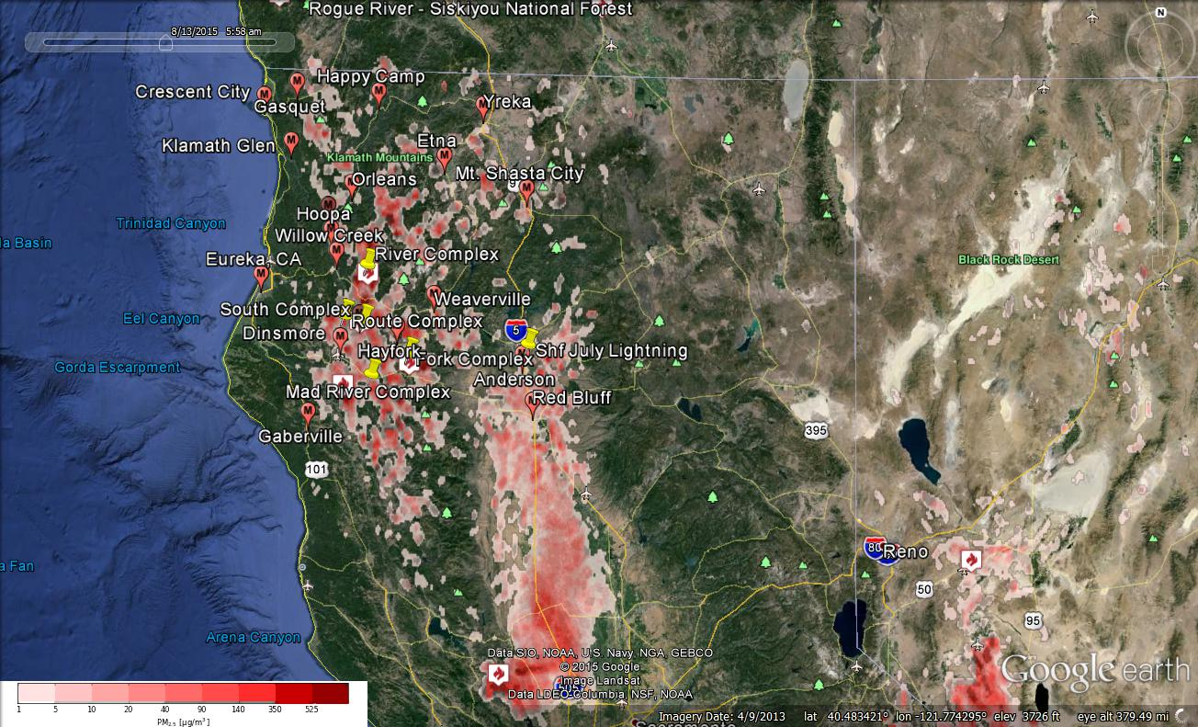
Figure 2: Bluesky run for 6am on August 12, 2015

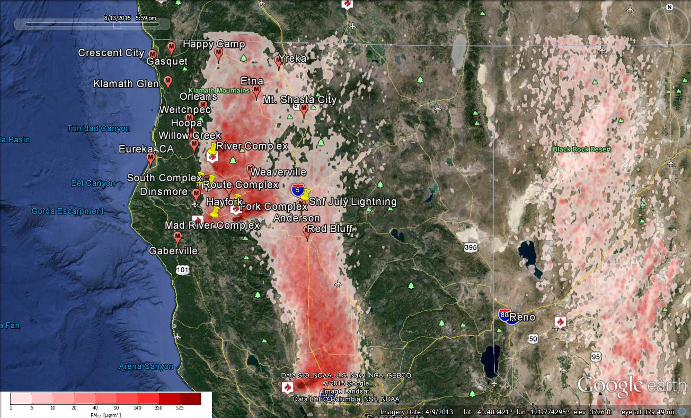
Figure 3: Bluesky run for 6pm on August 12, 2015

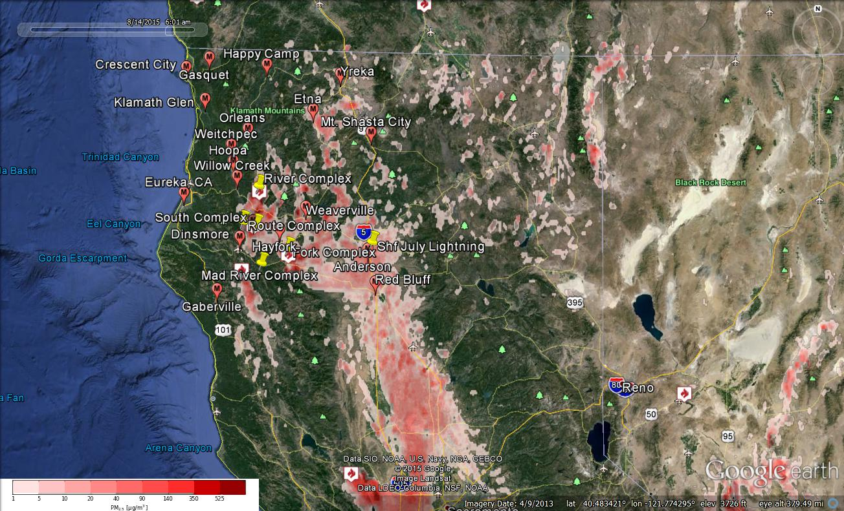Figure 4: Bluesky run for 6am on August 13, 2015

Forecast conditions represent impacts from smoke. Contributions from ozone and other pollutants are not reflected.
Smoke Synopsis:
On Tuesday, based on 24-hour averages, most PM Monitors reported “Good” or “Moderate” air quality in the area. Happy Camp reported “USG” condition. Hayfork, Hyampon, and Weaverville reported “Unhealthy” condition. This is a considerable improvement from a few days ago when “Hazardous” condition was reported at Hayfork.

Today/Tomorrow: Westerly onshore flow will meet Southerly Valley wind from Sacramento Valley in Central/Eastern Trinity County. Good mixing height and strong Southerly transport wind is expected for today and tomorrow. So, smoke from fires in Trinity County is likely to be lifted and transported to the North. The improved air quality in the area is likely to continue today and tomorrow. Over nights, smoke will settle into the South Fork Trinity River drainage and Trinity River drainage. Anderson may receive some smoke from the Rocky and Jerusalem fires in east of Clear Lake, CA, about 50 miles NW of Sacramento, CA.

Friday: Wind will become weak for the area as a high pressure is being established. The atmosphere will become more stable and thus, day time mixing will be substantially weaker.
Air Quality Outlook: Shasta-Trinity & Six Rivers Complexes
Site | Wednesday  August 12, 2015 | Thursday  August 13, 2015 | Friday  August 14, 2015 | Comments
Crescent City | Moderate | Good | Good
Gasquet | Moderate | Good | Good
Happy Camp | USG | USG | Moderate
Etna | Moderate | USG | Moderate-AM | 8/12: Short impacts late AM: 8/13 Heaviest before sundown.
Mt. Shasta | Moderate | USG | Moderate-AM | 8/13: Heaviest before sundown.
Tulelake | Good | Good | Good-AM
Yreka | Good | Moderate | Moderate-AM
Eureka | Good | Good | Good
Hoopa | Good | Good | Moderate
Mad River/Dinsmore | Moderate | USG | Unhealthy
Orleans | Good | Moderate | Moderate
Weitchpec | Good | Good | Moderate
Willow Creek | Moderate | Moderate | Moderate
Hayfork | Very Unhealthy | Very Unhealthy | Unhealthy-AM | 8/12: Heaviest near sundown. 8/13: Heaviest late afternoon
Hyampom | Hazardous | Very Unhealthy | Unhealthy-AM | 8/12 & 8/13 Heaviest late afternoon
Weaverville | Very Unhealthy | Very Unhealthy | Very Unhealthy | 8/12 Much lighter during daylight hours. 8/13 Much lighter during late afternoon
Anderson/Redding | Moderate | USG | Moderate
Disclaimer: Forecast conditions represent air quality levels affected by fine particulates; contribution from ozone and other pollutants is not reflected. Conditions may change quickly, these projections are based on anticipated weather and fire activity. Sensitive groups including individuals with asthma, lung or heart disease, children, older adults, and pregnant women should take precautions to avoid exposure to smoke. If you feel as though you are having health effects from smoke, see your doctor or health professional as needed. In some cases your eyes are your best tools. If it is smoky outside, you are being impacted. Use caution when driving in or around smoky areas.

AQI Index | Actions to Protect Yourself
Good | None
Moderate | Unusually sensitive people should consider reducing prolonged or heavy outdoor exertion.
Unhealthy for Sensitive Groups - USG | People with heart or lung disease, children and older adults should reduce prolonged or heavy outdoor exertion. Everyone else should limit prolonged or heavy exertion.
Unhealthy | The following groups should avoid all physical outdoor activity: People with heart or lung disease, children and older adults. Everyone else should avoid prolonged or heavy exertion.
Very Unhealthy | Everyone should avoid any outdoor exertion; people with respiratory or heart disease, the elderly and children should remain indoors.
Hazardous | The following groups should remain indoors and keep activity levels low: People with heart or lung disease; children and older adults. Everyone else should avoid prolonged or heavy exertion

Links:
AirNow - http://airnow.gov/index.cfm?action=airnow.local_state&stateid=5&tab=0
California Smoke Information Blog - http://californiasmokeinfo.blogspot.com/
North Coast Unified Air Quality Management District http://www.ncuaqmd.org/
Shasta County Air Pollution Control District - http://www.co.shasta.ca.us/index/drm_index/aq_index.aspx
Siskiyou County Air Pollution Control District http://www.co.siskiyou.ca.us/content/agriculture-air-pollution-control-district
Interagency Real Time Smoke Monitoring - http://app.airsis.com/usfs/fleet.aspx
Wildfire Smoke – A Guide for Public Health Official from California Air Resource Board
Wildland Fire Personnel Smoke Exposure Guidebook from National Interagency Fire Center
Smoke: Knowing the Risks video (14 minutes) from WFStar

