Smoke Impact Report – Shasta-Trinity/Six Rivers National Forest August 13, 2015.
- Fire growth
Complex Names | Fire Growth Yesterday | Total Acre
Fork Complex | 2589 Acres | 31,314 Acres
Mad River Complex | 739 Acres | 21,265 Acres
River Complex | 4812 Acres | 28,433 Acres
Route Complex | 782Acres | 26,459 Acres
South Complex | 1009 Acres | 16,325 Acres
Gasquet Complex | 347 Acres | 3,040 Acres
Nickowtiz Fires | 260 Acres | 1,609 Acres
Total | 10278 Acres | 126,836 Acres
Information came from Infrared Flights

- Weather
Generally onshore flow is expected for Northern California and southerly wind is expected from Sacramento Valley for today. These two winds will meet at Shasta/Trinity County line. Strong upper level southerly transport wind is forecast today. Good day time mixing is expected for today. Tomorrow, a high pressure will establish over Northern California. The atmosphere will become more stable with much weaker transport wind speed. This high pressure is likely to persist for few days.

- Fire Behavior
Fire behavior analysts predicted that fire behavior may become intense when smoke is lifted and wind is forecast to be gusty today, especially in high elevation. And they are also predicting longer active burn periods today due to less hazy conditions.

- Smoke
All complexes/fires in the area grew about 10278 acres yesterday. This generates decent amount of smoke. With good day time mixing and strong upper level southerly transport wind today, smoke dispersion will be good and is likely to bring at least a few hours of better air quality to the area this afternoon. However, smoke dispersion will be much poorer tomorrow and Saturday due to lower mixing height and weaker transport wind speed.

Strong upper level southerly wind is going to bring smoke to the north today (Figure 1), and upper level wind will shift to Northwest tomorrow (Figure 3) and become weak tomorrow. Overnight, smoke is likely to settle in the river drainages in the area (Figure 2, 4).

Figure 1: Bluesky run for 6pm on August 13, 2015.

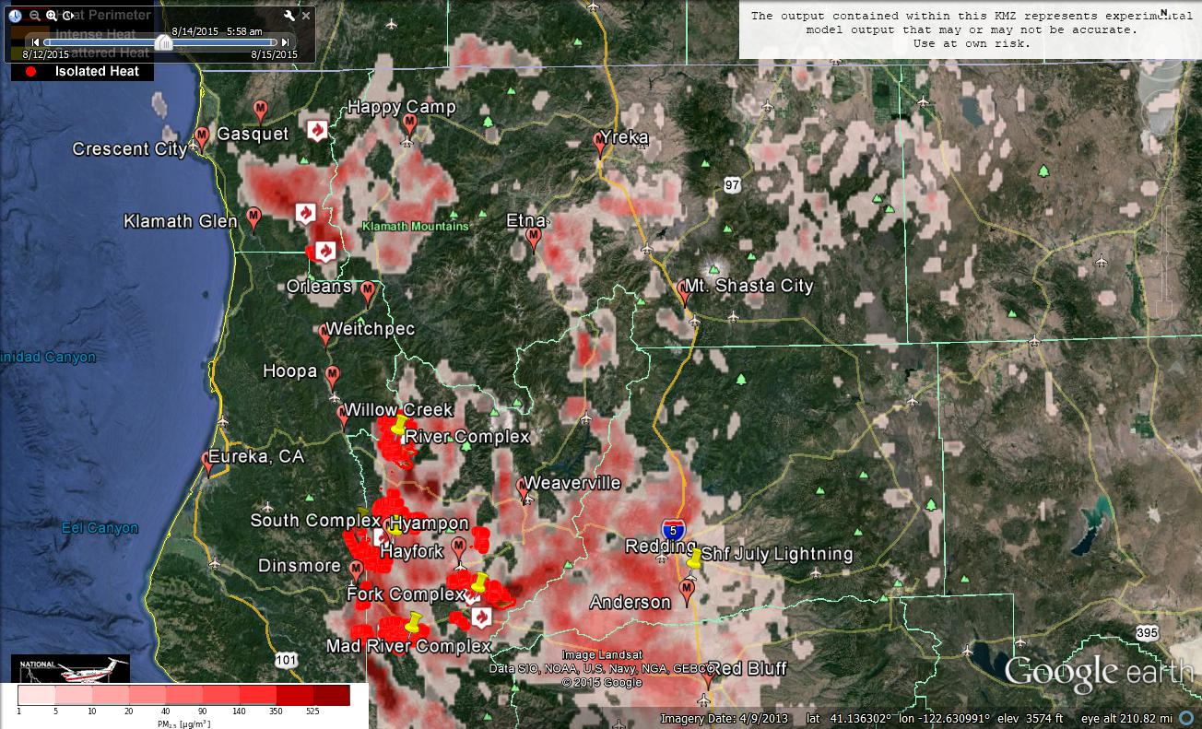
Figure 2: Bluesky run for 6am on August 14, 2015

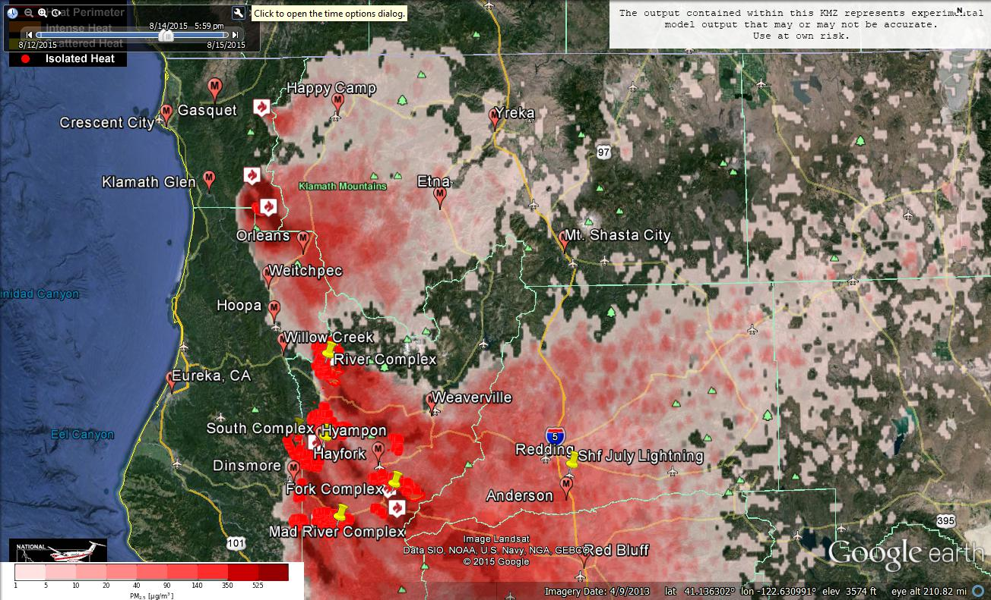
Figure 3: Bluesky run for 6pm on August 14, 2015

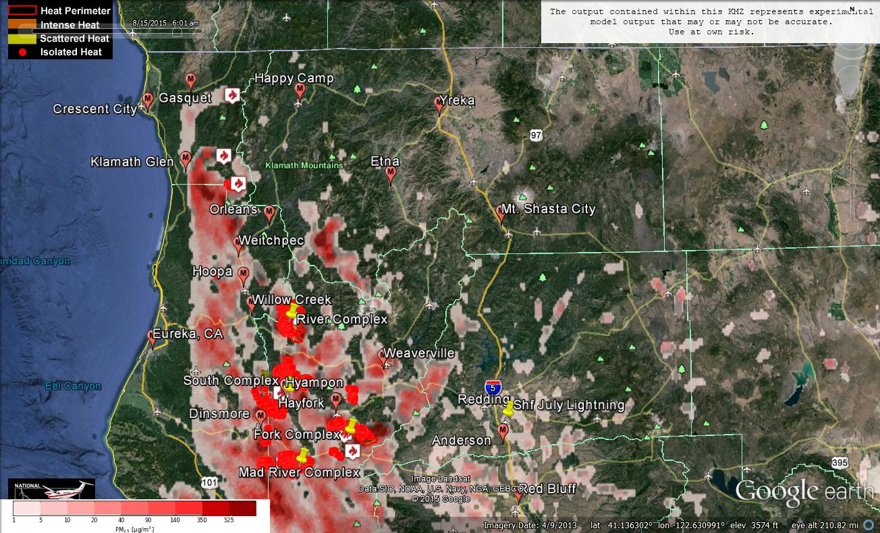Figure 4: Bluesky run for 6am on August 15, 2015

Forecast conditions represent impacts from smoke. Contributions from ozone and other pollutants are not reflected.
Smoke Synopsis:
On Tuesday, based on 24-hour averages, most PM Monitors reported “Good” or “Moderate” air quality in the area. Mad River reported “USG”. Happy Camp reported “Unhealthy”. Hayfork reported “Very Unhealthy”. Hyampon reported “Hazardous”. These four stations had a few hours of good air quality yesterday.

Today: Westerly onshore flow will meet Southerly Valley wind from Sacramento Valley at Trinity/Shasta County line. Good mixing height and strong Southerly transport wind is expected. So, smoke from fires in Trinity County is likely to be lifted and transported to the North. Hyampon, Hay Fork, and Mad River are likely to have a few hours of cleaner air, but overall air quality is likely to be similar to previous days. Over nights, smoke will settle into the South Fork Trinity River drainage and Trinity River drainage.

Tomorrow/Saturday: Day time mixing will be much poorer due to lower mixing height and transport wind speed due to establishment of high pressure over the area. Westerly onshore flow will flow all the way into Shasta County during the day, but it will be stronger tomorrow compared to Saturday. Strong Northerly wind is forecast to develop overnight. Air quality is likely to deteriorate in the area, especially in Trinity County where the fires are.
Air Quality Outlook: Shasta-Trinity & Six Rivers Complexes
Site | Thursday  August 13, 2015 | Friday  August 14, 2015 | Saturday  August 15, 2015 | Comments
Crescent City | Good | Good | Moderate
Gasquet | Good | Good | Moderate
Happy Camp | Unhealthy | USG | USG
Etna | Moderate | Good | Good
Mt. Shasta | Moderate | Good | Good
Tulelake | Good | Good | Good
Yreka | Good | Moderate | Good
Eureka | Good | Good | Good
Hoopa | Moderate | Moderate | USG
Mad River/Dinsmore | USG | Unhealthy | Very Unhealthy
Orleans | Moderate | Moderate | Unhealthy
Weitchpec | Moderate | Good | Moderate
Willow Creek | Moderate | USG | Unhealthy
Hayfork | Unhealthy | Unhealthy | Unhealthy-AM
Hyampom | Very Unhealthy | Unhealthy | Unhealthy
Weaverville | USG | USG | Unhealthy
Anderson/Redding | USG | Moderate | Moderate
Disclaimer: Forecast conditions represent air quality levels affected by fine particulates; contribution from ozone and other pollutants is not reflected. Conditions may change quickly, these projections are based on anticipated weather and fire activity. Sensitive groups including individuals with asthma, lung or heart disease, children, older adults, and pregnant women should take precautions to avoid exposure to smoke. If you feel as though you are having health effects from smoke, see your doctor or health professional as needed. In some cases your eyes are your best tools. If it is smoky outside, you are being impacted. Use caution when driving in or around smoky areas.

AQI Index | Actions to Protect Yourself
Good | None
Moderate | Unusually sensitive people should consider reducing prolonged or heavy outdoor exertion.
Unhealthy for Sensitive Groups - USG | People with heart or lung disease, children and older adults should reduce prolonged or heavy outdoor exertion. Everyone else should limit prolonged or heavy exertion.
Unhealthy | The following groups should avoid all physical outdoor activity: People with heart or lung disease, children and older adults. Everyone else should avoid prolonged or heavy exertion.
Very Unhealthy | Everyone should avoid any outdoor exertion; people with respiratory or heart disease, the elderly and children should remain indoors.
Hazardous | The following groups should remain indoors and keep activity levels low: People with heart or lung disease; children and older adults. Everyone else should avoid prolonged or heavy exertion

Links:
AirNow - http://airnow.gov/index.cfm?action=airnow.local_state&stateid=5&tab=0
California Smoke Information Blog - http://californiasmokeinfo.blogspot.com/
North Coast Unified Air Quality Management District http://www.ncuaqmd.org/
Shasta County Air Pollution Control District - http://www.co.shasta.ca.us/index/drm_index/aq_index.aspx
Siskiyou County Air Pollution Control District http://www.co.siskiyou.ca.us/content/agriculture-air-pollution-control-district
Interagency Real Time Smoke Monitoring - http://app.airsis.com/usfs/fleet.aspx
Wildfire Smoke – A Guide for Public Health Official from California Air Resource Board
Wildland Fire Personnel Smoke Exposure Guidebook from National Interagency Fire Center
Smoke: Knowing the Risks video (14 minutes) from WFStar

