Smoke Impact Report – Shasta-Trinity/Six Rivers National Forest August 14, 2015.
- Fire growth
Complex Names | Fire Growth Yesterday | Total Acre
Fork Complex | 2232 Acres | 30,891 Acres
Mad River Complex | 684 Acres | 21,949 Acres
River Complex | 4563 Acres | 32,996 Acres
Route Complex | 482Acres | 26,941 Acres
South Complex | 885 Acres | 17,210 Acres
Gasquet Complex | 141 Acres | 3,181 Acres
Nickowtiz Fires | N/A Acres* | 1,609 Acres*
Total | 8987 Acres | 133,168 Acres
Information came from Infrared Flights
*Due to cloud cover in the area. Acre kept as yesterday’s acres.

- Weather
Generally westerly/northwesterly onshore wind is expected for Northern California today, tomorrow and Sunday. This wind will flow all the way into Shasta County today, but only reach Trinity County tomorrow and Sunday. Strong Northerly wind is expected tonight in Sacramento Valley, but it will weaken by tomorrow. Much weaker transport wind speed and lower mixing height is forecast for tomorrow and Sunday, compared to the previous days.

- Fire Behavior
Fire behavior analysts predicted that moderate fire behavior when smoke is lifted and wind is forecast to be gusty today, especially in high elevation. And they are also predicting longer active burn periods today due to less hazy conditions.

- Smoke
All complexes/fires in the area grew about 8987 acres yesterday. This generates decent amount of smoke. Smoke dispersion will be poorer in the next few days, compared to previous few days due to lower mixing height and weaker transport wind speed. Air quality is likely to deteriorate over the forecast area, especially in Hyampon and Hayfork in Trinity County.

Onshore wind keep smoke away from the coast this afternoon (Figure 1). Tomorrow and Sunday, generally northwesterly wind bring smoke to the Southeast, but Yreka, Happy Camp and Etna are likely to have smoke impact from Oregon which is not modeled in this particular BlueSky run (Figure 2,3,4). At nights, smoke is likely to settle in the river drainages in the area.

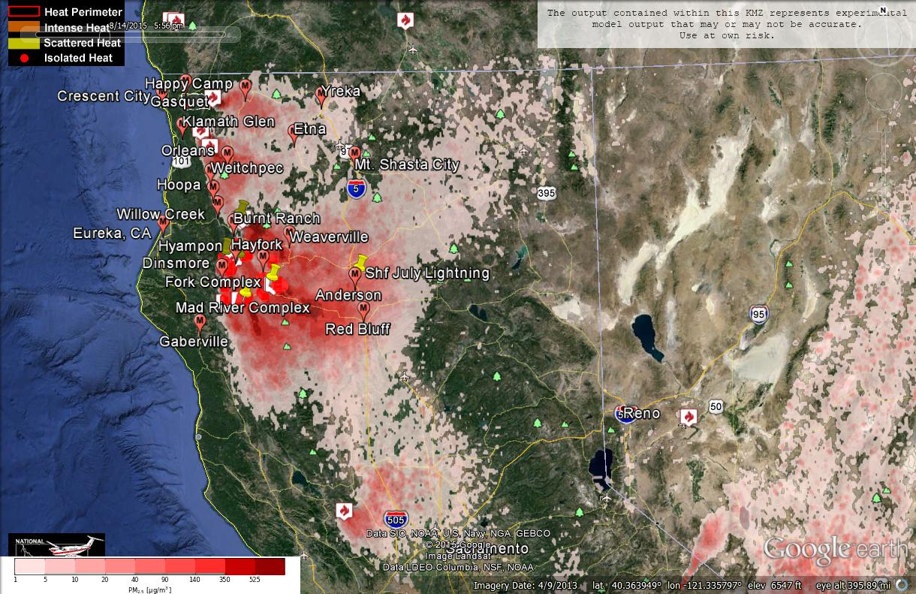
Figure 1: Bluesky run for 6pm on August 14, 2015.

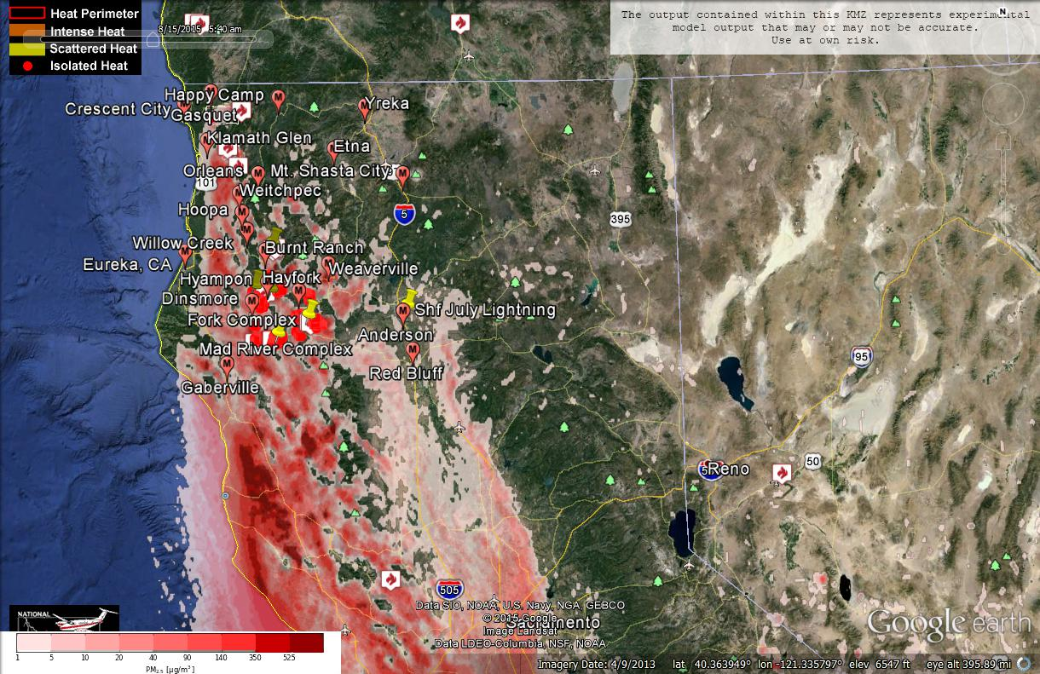
Figure 2: Bluesky run for 6am on August 15, 2015

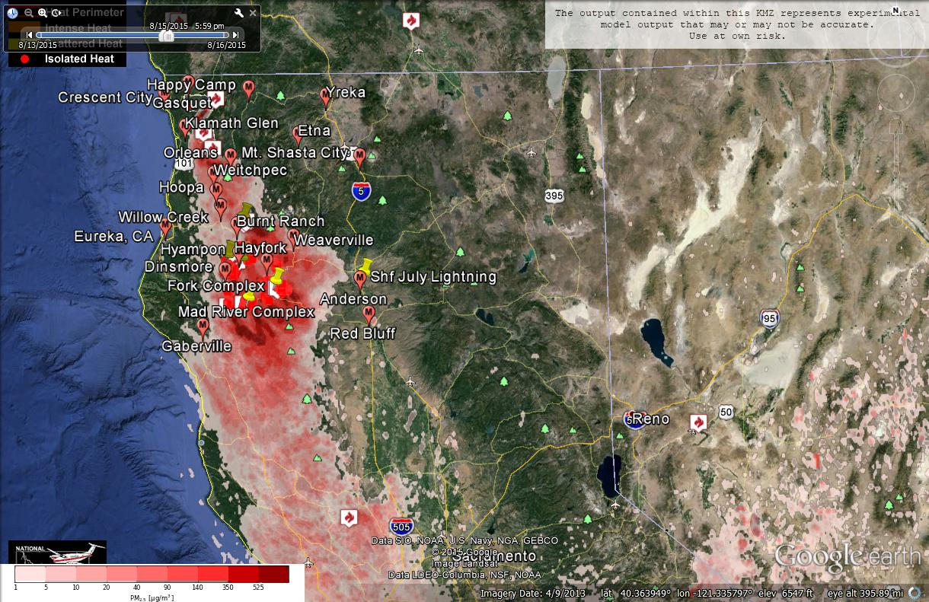
Figure 3: Bluesky run for 6pm on August 15, 2015

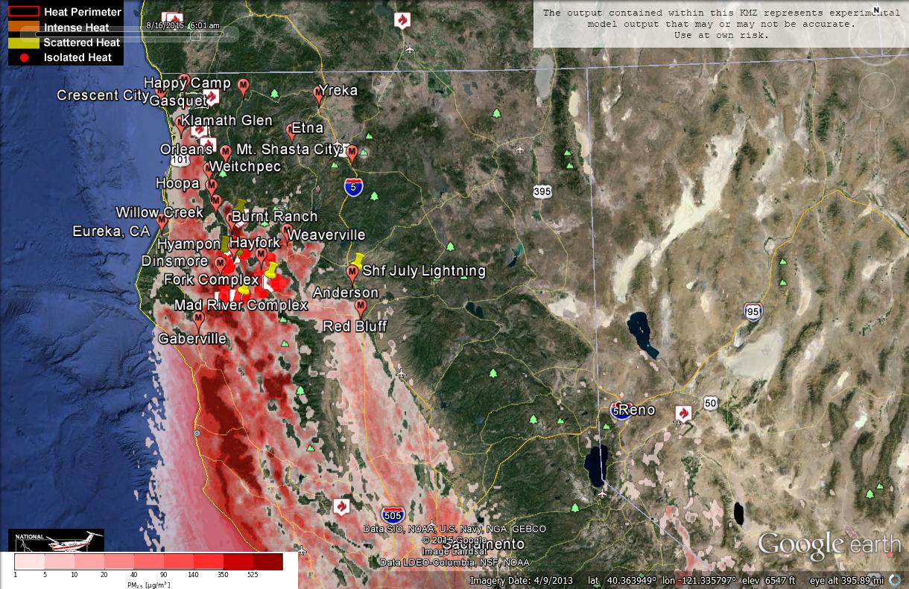Figure 4: Bluesky run for 6am on August 16, 2015
Forecast conditions represent impacts from smoke. Contributions from ozone and other pollutants are not reflected.
Smoke Synopsis:
On Tuesday, based on 24-hour averages, many PM Monitors reported “Good” or “Moderate” air quality in the area. Weaverville reported “USG” condition. “Unhealthy” condition was reported at Happy Camp, Yreka, and Etna. “Very Unhealthy” condition was reported at Hayfork and Hyampon. “Hazardous” condition was reported at Weitchpec.

Today/Tomorrow: Day time mixing will not be as good as the previous days due to lower mixing height and slower transport wind speed because of the establishment of high pressure over the area. Northweterly/Westerly onshore wind will flow all the way into Shasta County in late afternoon today, but it will be weaker tomorrow and only go into Humboldt/Trinity County line. Strong Northerly wind is forecast to develop tonight at the Sacramento Valley, but this wind is forecast to weaken tomorrow. Air quality is likely to deteriorate in the area, especially in Trinity County where the fires are.
Air Quality Outlook: Shasta-Trinity & Six Rivers Complexes
Site | Friday  August 14, 2015 | Saturday  August 15, 2015 | Sunday  August 16, 2015 | Comments
Crescent City | Good | Moderate | USG
Gasquet | Moderate | USG | Unhealthy
Happy Camp | USG | USG | Unhealthy
Etna | USG | Good | Good | 8/14: Very heavy in AM
Mt. Shasta | Moderate | Moderate | Good
Tulelake | Moderate | USG | Moderate
Yreka | Moderate | Moderate | Moderate
Eureka | Good | Good | Good
Hoopa | Moderate | USG | USG
Mad River/Dinsmore | USG | USG | USG
Orleans | Moderate | Moderate | Moderate
Weitchpec | Moderate | Moderate | Moderate
Willow Creek | Moderate | Moderate | Moderate
Burnt Ranch | Moderate | Moderate | Unhealthy
Hayfork | USG | Unhealthy | Unhealthy | 8/14 & 8/15 Heaviest near sundown
Hyampom | Very Unhealthy | Unhealthy | Unhealthy | 8/14: Heaviest late afternoon
Weaverville | USG | USG | USG | 8/14 & 8/15: Very heavy during AM
Anderson/Redding | Moderate | Moderate | Moderate
Disclaimer: Forecast conditions represent air quality levels affected by fine particulates; contribution from ozone and other pollutants is not reflected. Conditions may change quickly, these projections are based on anticipated weather and fire activity. Sensitive groups including individuals with asthma, lung or heart disease, children, older adults, and pregnant women should take precautions to avoid exposure to smoke. If you feel as though you are having health effects from smoke, see your doctor or health professional as needed. In some cases your eyes are your best tools. If it is smoky outside, you are being impacted. Use caution when driving in or around smoky areas.

AQI Index | Actions to Protect Yourself
Good | None
Moderate | Unusually sensitive people should consider reducing prolonged or heavy outdoor exertion.
Unhealthy for Sensitive Groups - USG | People with heart or lung disease, children and older adults should reduce prolonged or heavy outdoor exertion. Everyone else should limit prolonged or heavy exertion.
Unhealthy | The following groups should avoid all physical outdoor activity: People with heart or lung disease, children and older adults. Everyone else should avoid prolonged or heavy exertion.
Very Unhealthy | Everyone should avoid any outdoor exertion; people with respiratory or heart disease, the elderly and children should remain indoors.
Hazardous | The following groups should remain indoors and keep activity levels low: People with heart or lung disease; children and older adults. Everyone else should avoid prolonged or heavy exertion

Links:
AirNow - http://airnow.gov/index.cfm?action=airnow.local_state&stateid=5&tab=0
California Smoke Information Blog - http://californiasmokeinfo.blogspot.com/
North Coast Unified Air Quality Management District http://www.ncuaqmd.org/
Shasta County Air Pollution Control District - http://www.co.shasta.ca.us/index/drm_index/aq_index.aspx
Siskiyou County Air Pollution Control District http://www.co.siskiyou.ca.us/content/agriculture-air-pollution-control-district
Interagency Real Time Smoke Monitoring - http://app.airsis.com/usfs/fleet.aspx
Wildfire Smoke – A Guide for Public Health Official from California Air Resource Board
Wildland Fire Personnel Smoke Exposure Guidebook from National Interagency Fire Center
Smoke: Knowing the Risks video (14 minutes) from WFStar

