Smoke Impact Report – Shasta-Trinity/Six Rivers National Forest August 15, 2015.
- Fire growth
Complex Names | Fire Growth Yesterday | Total Acre
Fork Complex | 1033 Acres | 32,005 Acres
Mad River Complex | 460 Acres | 22,409 Acres
River Complex | 2795 Acres | 35,791 Acres
Route Complex | 397 Acres | 27,338 Acres
South Complex | 1796 Acres | 19,006 Acres
Gasquet Complex | 434 Acres | 3,615 Acres
Nickowtiz Fires | 575 Acres | 2,184 Acres
Total | 6915 Acres | 140,164 Acres
Information came from Infrared Flights

- Weather
Onshore Northwesterly wind is expected for today into Trinity/Shasta County line. Overnight, weak northeasterly wind will occur in Trinity, Humboldt and Del Norte County. Tomorrow, Northeasterly wind will persist in Del Norte County, but Northwesterly onshore wind is expected to develop into Trinity County. Northerly wind is expected in the Sacramento Valley in the night time period. Weak transport wind speed is forecast for the next few days.

- Fire Behavior
With generally hotter and drier weather, fire behavior analysts are predicting longer burn window today. This has the potential for more acreage burn and thus, generating more smoke.

- Smoke
All complexes/fires in the area grew about 6915 acres yesterday. This generates decent amount of smoke. Smoke dispersion will be limited in the next few days due to weak transport wind speed. Air quality is not likely to improve in the area.

Northwesterly onshore wind pushes smoke to the Southeast today (Figure 1,3). Overnight, smoke is likely to settle down in river drainages, but is pushed slightly to the west (Figure 2,4). The displayed model runs did not cover fires in Southern Oregon. With a southerly flow, Crescent City, Gasquet, Happy Camp, Yreka, Etna and Mt. Shasta may be impacted by smoke from these fires that are not included in this particular model run.
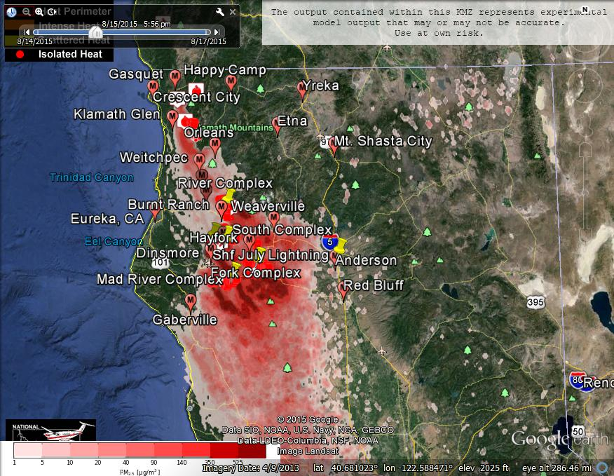
Figure 1: Bluesky run for 6pm on August 15, 2015.

Figure 2: Bluesky run for 6am on August 16, 2015

Figure 3: Bluesky run for 6pm on August 16, 2015

Figure 4: Bluesky run for 6am on August 17, 2015
Forecast conditions represent impacts from smoke. Contributions from ozone and other pollutants are not reflected.
Smoke Synopsis:
On Friday, based on 24-hour averages, a number of PM Monitors reported “Good” or “Moderate” air quality in the area. But, Mad River reported “USG” condition. “Unhealthy” condition was reported at Anderson/Redding. “Very Unhealthy” condition was reported at Hayfork, Hyampon, Burnt Ranch and Weaverville. With a High pressure established over the area, air quality is not likely to improve in the next few days.

Today: Smoke dispersion will be limited due to slow transport wind over the area. Northwesterly/Westerly onshore wind will flow to Trinity/Shasta County line today. Tonight, weak offshore Northeasterly wind is expected tonight in Del Norte, Humboldt and Trinity County and Northerly wind is expected in Siskiyou and Shasta County. Smoke will settle in Trinity River drainage, South Fork Trinity River drainage, Klamath River drainage and the Sacramento Valley tonight.

Tomorrow: Smoke dispersion will be limited due to slow transport wind over the area. Northeasterly offshore wind is expected in Del Norte County. Northerly wind is expected in Siskiyou County. Onshore Westerly/Northwesterly wind is likely to occur in Humboldt and Trinity County. Wind in Sacramento Valley is going to be weak. Tomorrow night, offshore northeasterly wind in Del Norte County will continue, but Northerly wind is expected in Shasta County. Smoke will settle in Trinity River drainage, South Fork Trinity River drainage, Klamath River drainage and the Sacramento Valley again tomorrow night.
Air Quality Outlook: Shasta-Trinity & Six Rivers Complexes
Site | Saturday  August 15, 2015 | Sunday  August 16, 2015 | Monday  August 17, 2015 | Comments
Crescent City | Moderate | USG | USG | Smoke impact from Oregon fires.
Gasquet | Moderate | USG | Moderate | Smoke impact from Oregon fires.
Happy Camp | Moderate | USG | USG | Smoke impact from Oregon fires.
Etna | Moderate | Moderate | Moderate | Smoke impact from Oregon fires.
Mt. Shasta | Moderate | Moderate | Moderate | Smoke impact from Oregon fires.
Tulelake | Moderate | Moderate | Moderate | Smoke impact from Oregon fires.
Yreka | Good | Unhealthy | Unhealthy | Smoke impact from Oregon fires.
Eureka | Good | Good | Moderate
Hoopa | Moderate | Moderate | Moderate
Mad River/Dinsmore | USG | USG | Unhealthy
Orleans | Moderate | Moderate | Moderate
Weitchpec | Moderate | Moderate | Moderate
Willow Creek | USG | USG | Moderate
Burnt Ranch | Unhealthy | Unhealthy | Unhealthy
Hayfork | Hazardous | Hazardous | Hazardous | 8/15 & 8/16: Varying little throughout
Hyampom | Hazardous | Hazardous | Hazardous | 8/15 & 8/16: Heaviest during afternoon
Weaverville | Unhealthy | Very Unhealthy | Hazardous
Anderson/Redding | Unhealthy | Unhealthy | Unhealthy
Disclaimer: Forecast conditions represent air quality levels affected by fine particulates; contribution from ozone and other pollutants is not reflected. Conditions may change quickly, these projections are based on anticipated weather and fire activity. Sensitive groups including individuals with asthma, lung or heart disease, children, older adults, and pregnant women should take precautions to avoid exposure to smoke. If you feel as though you are having health effects from smoke, see your doctor or health professional as needed. In some cases your eyes are your best tools. If it is smoky outside, you are being impacted. Use caution when driving in or around smoky areas.

AQI Index | Actions to Protect Yourself
Good | None
Moderate | Unusually sensitive people should consider reducing prolonged or heavy outdoor exertion.
Unhealthy for Sensitive Groups - USG | People with heart or lung disease, children and older adults should reduce prolonged or heavy outdoor exertion. Everyone else should limit prolonged or heavy exertion.
Unhealthy | The following groups should avoid all physical outdoor activity: People with heart or lung disease, children and older adults. Everyone else should avoid prolonged or heavy exertion.
Very Unhealthy | Everyone should avoid any outdoor exertion; people with respiratory or heart disease, the elderly and children should remain indoors.
Hazardous | The following groups should remain indoors and keep activity levels low: People with heart or lung disease; children and older adults. Everyone else should avoid prolonged or heavy exertion

Links:
AirNow - http://airnow.gov/index.cfm?action=airnow.local_state&stateid=5&tab=0
California Smoke Information Blog - http://californiasmokeinfo.blogspot.com/
North Coast Unified Air Quality Management District http://www.ncuaqmd.org/
Shasta County Air Pollution Control District - http://www.co.shasta.ca.us/index/drm_index/aq_index.aspx
Siskiyou County Air Pollution Control District http://www.co.siskiyou.ca.us/content/agriculture-air-pollution-control-district
Interagency Real Time Smoke Monitoring - http://app.airsis.com/usfs/fleet.aspx
Wildfire Smoke – A Guide for Public Health Official from California Air Resource Board
Wildland Fire Personnel Smoke Exposure Guidebook from National Interagency Fire Center
Smoke: Knowing the Risks video (14 minutes) from WFStar

