Smoke Impact Report – Shasta-Trinity/Six Rivers National Forest August 16, 2015.
- Fire growth
Complex Names | Fire Growth Yesterday | Total Acre
Fork Complex | 689 Acres | 32,694 Acres
Mad River Complex | 389 Acres | 22,807 Acres
River Complex | 1343 Acres | 37,134 Acres
Route Complex | 463 Acres | 27,801 Acres
South Complex | 1058 Acres | 20,064 Acres
Gasquet Complex | 305 Acres | 3,920 Acres
Nickowtiz Fires | NA Acres | 2,184 Acres
Total | 4256 Acres | 144,420 Acres
Information came from Infrared Flights

- Weather
Onshore Northwesterly wind is expected for today into Trinity/Shasta County line. Overnight, weak northeasterly wind will occur in Humboldt and Del Norte County. Tomorrow, Northeasterly wind will persist in Del Norte County, but Northwesterly onshore wind is expected to develop into Central Trinity County. Northerly wind is expected in the Sacramento Valley during the night. Weak transport wind speed is forecast for the next few days.

- Fire Behavior
With generally hotter and drier weather, fire behavior analysts are predicting a longer burn window today. This has the potential for more acreage burn, generating more smoke.

- Smoke
All complexes/fires in the area grew about 4,256 acres yesterday. This is the smallest growth in the last week, but this trend is likely to reverse due to hot and dry weather today and the next few days. Smoke dispersion will be limited in the next few days due to weak transport wind speed. Air quality is likely to deteriorate in the area especially in Trinity County.

Weak Northwesterly transport wind pushes smoke to the Southeast today and tomorrow (Figures 1,3). Overnight, smoke is likely to settle down in river drainages, but is pushed slightly to the west (Figures 2,4). The displayed model runs did not cover fires in Southern Oregon. With a southerly flow, Crescent City, Gasquet, Happy Camp, Yreka, Etna and Mt. Shasta may be impacted by smoke from these fires that are not included in this particular model run.
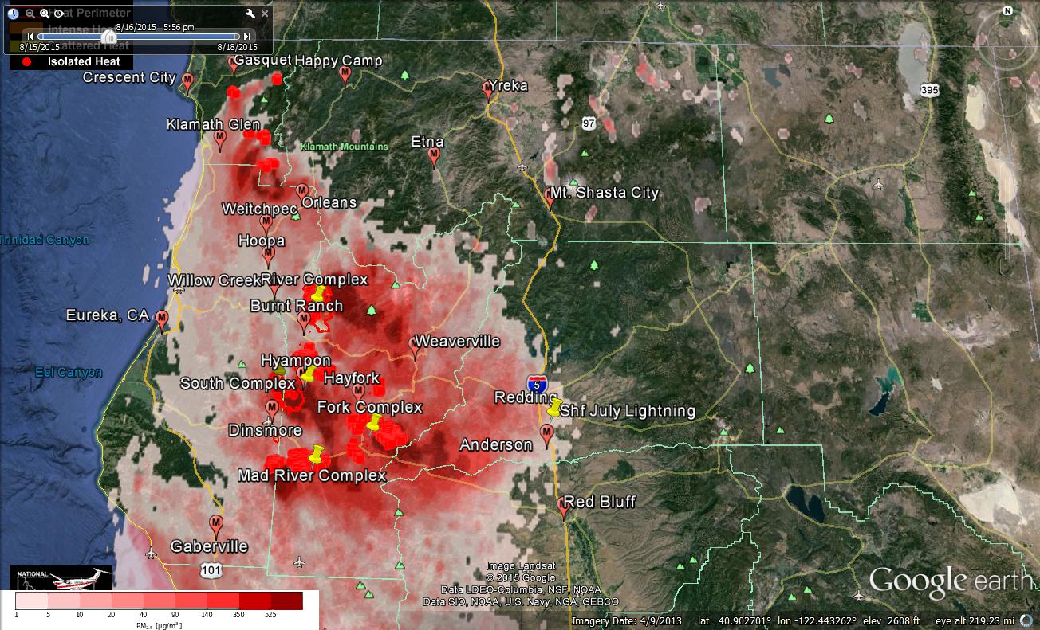
Figure 1: Bluesky run for 6pm on August 16, 2015.

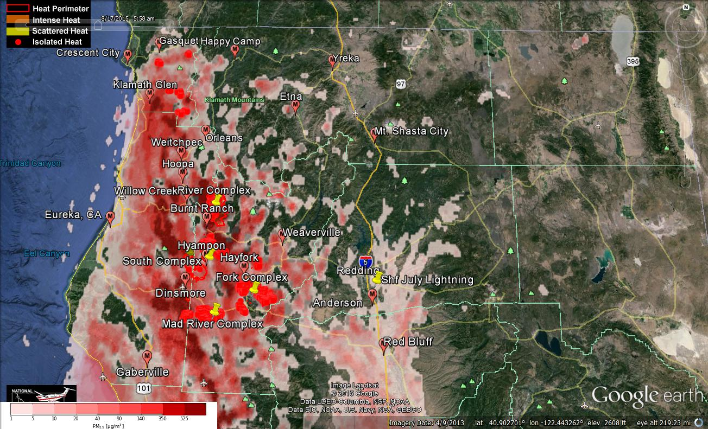
Figure 2: Bluesky run for 6am on August 17, 2015

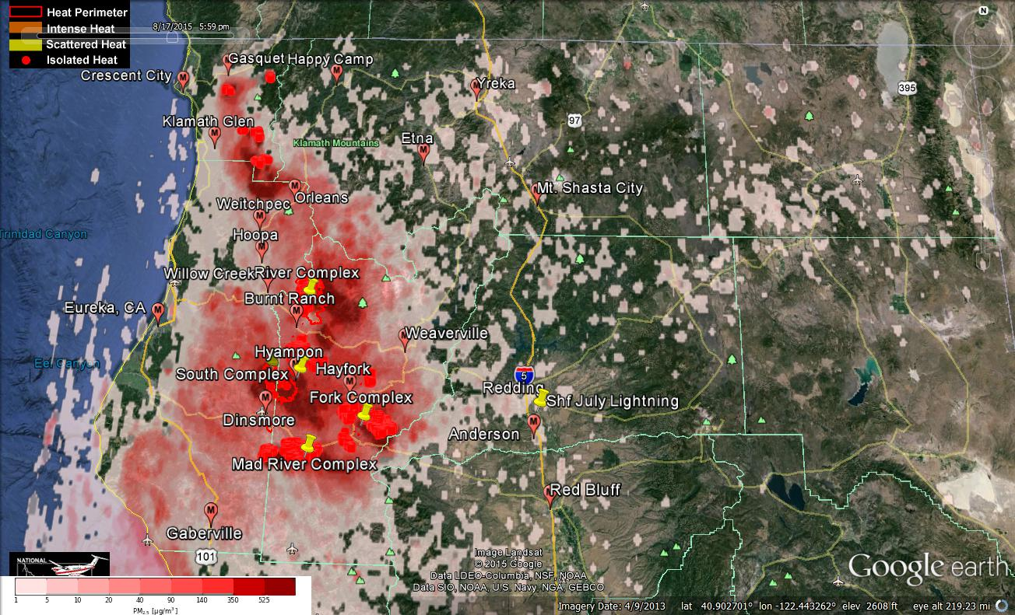
Figure 3: Bluesky run for 6pm on August 17, 2015

Figure 4: Bluesky run for 6am on August 18, 2015
Forecast conditions represent impacts from smoke. Contributions from ozone and other pollutants are not reflected.
Smoke Synopsis:
On Saturday, based on 24-hour averages, air quality in the area deteriorated. Hyampom, and Hayfork reported “Hazardous” conditions. Weaverville reported “Very Unhealthy” conditions. Burnt Ranch and Mad River/Dinsmore reported “Unhealthy” conditions. Weitchpec reported “USG” conditions. Air quality is not likely to improve for the next few days as a high pressure is over the area with weak transport wind speed.

Today: Smoke dispersion will be limited due to weak Northwest transport wind over the area. North/Northeasterly wind is expected in Del Norte County, Siskiyou County and Shasta County. Northwesterly/Westerly onshore wind is expected in Humboldt and Trinity County. At night, North weak is expected in Sacramento Valley, but weak in Trinity County. So, smoke will settle in Trinity River drainage, South Fork Trinity River drainage, Klamath River drainage and the Sacramento Valley tonight. PM Monitors in Trinity County such as Hayfork and Hyampom may measure over 750 µg/m3 for a few hours.

Tomorrow: Smoke dispersion will be limited due to slow transport wind over the area. Weak Northwesterly/Westerly onshore wind is expected to go into Central Trinity County only. With weak wind overnight, smoke will settle in Trinity River drainage, South Fork Trinity River drainage, Klamath River drainage and the Sacramento Valley again tomorrow night. PM Monitors in Trinity County such as Hayfork and Hyampom may measure over 750 µg/m3 for a few hours.

Air Quality Outlook: Shasta-Trinity & Six Rivers Complexes
Site | Sunday  August 16, 2015 | Monday  August 17, 2015 | Tuesday  August 18, 2015 | Comments
Crescent City | Moderate | USG | USG
Gasquet | Moderate | USG | USG
Happy Camp | Moderate | Moderate | Moderate
Etna | Good | Moderate | Good
Mt. Shasta | Good | Good | Good
Tulelake | Good | Good | Good | 8/17: Heaviest around noon
Yreka | Moderate | Moderate | Good
Eureka | Good | Moderate | Moderate | 8/17: Heaviest after sunrise
Hoopa | Moderate | USG | USG
Mad River/Dinsmore | Unhealthy | Very Unhealthy | Very Unhealthy
Orleans | USG | USG | Unhealthy
Weitchpec | USG | USG | Unhealthy
Willow Creek | Moderate | USG | USG
Burnt Ranch | Very Unhealthy | Very Unhealthy | Very Unhealthy
Hayfork | Unhealthy | Very Unhealthy | Hazardous
Hyampom | Hazardous | Hazardous | Hazardous
Weaverville | Unhealthy | Unhealthy | Moderate
Anderson/Redding | Moderate | Moderate | Good
Disclaimer: Forecast conditions represent air quality levels affected by fine particulates; contribution from ozone and other pollutants is not reflected. Conditions may change quickly, these projections are based on anticipated weather and fire activity. Sensitive groups including individuals with asthma, lung or heart disease, children, older adults, and pregnant women should take precautions to avoid exposure to smoke. If you feel as though you are having health effects from smoke, see your doctor or health professional as needed. In some cases your eyes are your best tools. If it is smoky outside, you are being impacted. Use caution when driving in or around smoky areas.

AQI Index | Actions to Protect Yourself
Good | None
Moderate | Unusually sensitive people should consider reducing prolonged or heavy outdoor exertion.
Unhealthy for Sensitive Groups - USG | People with heart or lung disease, children and older adults should reduce prolonged or heavy outdoor exertion. Everyone else should limit prolonged or heavy exertion.
Unhealthy | The following groups should avoid all physical outdoor activity: People with heart or lung disease, children and older adults. Everyone else should avoid prolonged or heavy exertion.
Very Unhealthy | Everyone should avoid any outdoor exertion; people with respiratory or heart disease, the elderly and children should remain indoors.
Hazardous | The following groups should remain indoors and keep activity levels low: People with heart or lung disease; children and older adults. Everyone else should avoid prolonged or heavy exertion

Links:
AirNow - http://airnow.gov/index.cfm?action=airnow.local_state&stateid=5&tab=0
California Smoke Information Blog - http://californiasmokeinfo.blogspot.com/
North Coast Unified Air Quality Management District http://www.ncuaqmd.org/
Shasta County Air Pollution Control District - http://www.co.shasta.ca.us/index/drm_index/aq_index.aspx
Siskiyou County Air Pollution Control District http://www.co.siskiyou.ca.us/content/agriculture-air-pollution-control-district
Interagency Real Time Smoke Monitoring - http://app.airsis.com/usfs/fleet.aspx
Wildfire Smoke – A Guide for Public Health Official from California Air Resource Board
Wildland Fire Personnel Smoke Exposure Guidebook from National Interagency Fire Center
Smoke: Knowing the Risks video (14 minutes) from WFStar

