Smoke Impact Report – Shasta-Trinity/Six Rivers National Forest August 17, 2015.
- Fire growth
Complex Names | Fire Growth Yesterday | Total Acre
Fork Complex | 662 Acres | 33,356 Acres
Mad River Complex | 816 Acres | 23,623 Acres
River Complex | 2311 Acres | 39,445 Acres
Route Complex | 1060 Acres | 28,861 Acres
South Complex | 894 Acres | 20,958 Acres
Gasquet Complex | 931 Acres | 4,851 Acres
Nickowtiz Fires | 482 Acres | 2,855 Acres
Total | 6674 Acres | 151,094 Acres
Information came from Infrared Flights

- Weather
High pressure is firmly over Northern California today and tomorrow. As a result, transport wind speed is very weak. A weak upper level trough will move through the area Wednesday through Friday. Smoke dispersion may be improved slightly then.

- Fire Behavior
Fire Behavior Analysts at the Complexes are predicting excellent burn conditions when inversion breaks. Further, fire activities may be intense on steep slopes and crown is a possibility today.

- Smoke
All complexes/fires in the area grew about 6,674 acres yesterday. Smoke dispersion will be limited today and tomorrow due to weak transport wind speed. Air quality is not likely to improve in the area especially in Trinity County.

Weak Northwesterly transport wind pushes smoke to the Southeast today and tomorrow (Figures 1,3). Overnight, smoke is likely to settle down in river drainages, but is pushed slightly to the west (Figures 2,4). The displayed model runs did not cover fires in Southern Oregon. With a southerly flow, Crescent City, Gasquet, Happy Camp, Yreka, Etna and Mt. Shasta may be impacted by smoke from these fires that are not included in this particular model run.
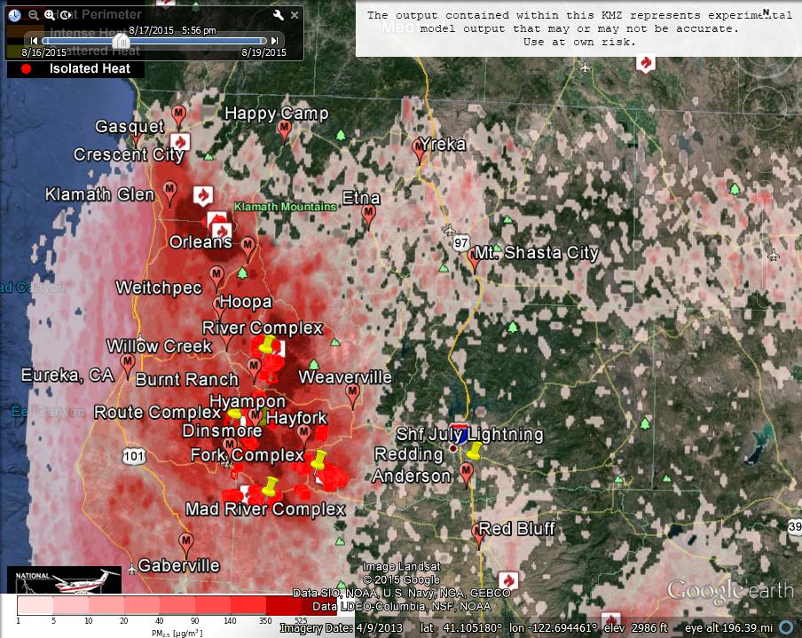
Figure 1: Bluesky run for 6pm on August 17, 2015.

Figure 2: Bluesky run for 6am on August 18, 2015
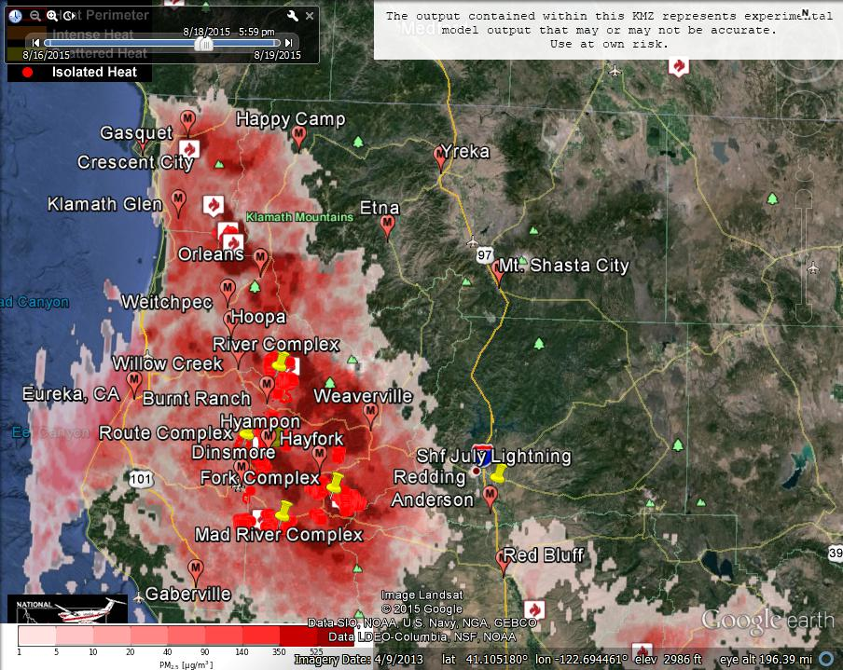
Figure 3: Bluesky run for 6pm on August 18, 2015

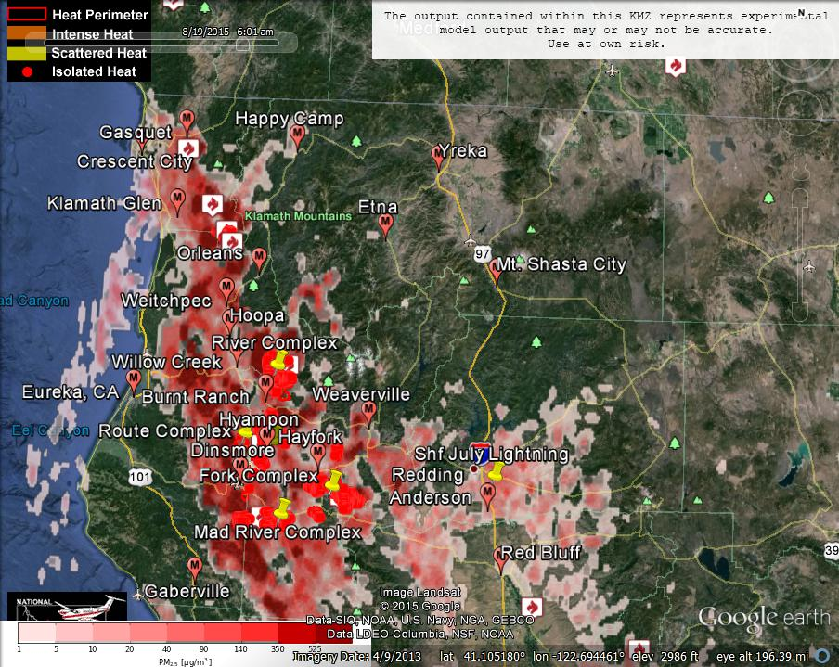
Figure 4: Bluesky run for 6am on August 19, 2015
Forecast conditions represent impacts from smoke. Contributions from ozone and other pollutants are not reflected.
Smoke Synopsis:
On Sunday, based on 24-hour averages, Hyampom reported “Hazardous” conditions. Hayfork reported “Very Unhealthy” conditions. Burnt Ranch, Mad River/Dinsmore and Weaverville reported “Unhealthy” conditions. Willow Creek, Hoopa, Orleans, and Etna reported “USG” conditions. However, for a few hours on Sunday, stations in Trinity County measured very high level (i.e.. over 250 µg/m3) of PM2.5 concentration and this usually happens in early afternoon before daytime mixing occurs. Air quality is not likely to improve before Wednesday when an upper level trough moves through the area.

Today/Tomorrow: Smoke dispersion will be limited due to weak transport wind over the area. Smoke will be the worst in early afternoon. PM2.5 stations in Trinity County may measure very high level of PM2.5 concentration during this time period. Air quality should improve somewhat after daytime mixing begins. But, after sunset, air quality will deteriorate until day time mixing begins the following day.

Wednesday: Transport wind speed will increase slightly on Wednesday, which may help with smoke dispersion.
Air Quality Outlook: Shasta-Trinity & Six Rivers Complexes
Site | Monday  August 17, 2015 | Tuesday  August 18, 2015 | Wednesday  August 19, 2015 | Comments
Crescent City | Moderate | USG | Moderate
Gasquet | Moderate | USG | USG
Happy Camp | Moderate | Moderate | Moderate
Etna | Moderate | Moderate | Moderate
Mt. Shasta | Moderate | Good | Moderate
Tulelake | Good | Good | Good
Yreka | Moderate | Moderate | Moderate
Eureka | Moderate | Unhealthy | Moderate | 8/17: Heaviest before midnight  8/18: Heaviest late afternoon
Hoopa | USG | Unhealthy | USG | Worst conditions usually occur early afternoon
Mad River/Dinsmore | Unhealthy | Unhealthy | USG | Worst conditions usually occur early afternoon
Orleans | USG | Unhealthy | USG | Worst conditions usually occur early afternoon
Weitchpec | USG | Unhealthy | USG | Worst conditions usually occur early afternoon
Willow Creek | USG | Unhealthy | USG | Worst conditions usually occur early afternoon
Burnt Ranch | USG | Unhealthy | USG | Worst conditions usually occur early afternoon
Hayfork | Very Unhealthy | Hazardous | Hazardous | Worst conditions usually occur early afternoon
Hyampom | Hazardous | Hazardous | Hazardous | Worst conditions usually occur early afternoon
Weaverville | Unhealthy | Unhealthy | Hazardous
Anderson/Redding | Moderate | Moderate | Moderate
Disclaimer: Forecast conditions represent air quality levels affected by fine particulates; contribution from ozone and other pollutants is not reflected. Conditions may change quickly, these projections are based on anticipated weather and fire activity. Sensitive groups including individuals with asthma, lung or heart disease, children, older adults, and pregnant women should take precautions to avoid exposure to smoke. If you feel as though you are having health effects from smoke, see your doctor or health professional as needed. In some cases your eyes are your best tools. If it is smoky outside, you are being impacted. Use caution when driving in or around smoky areas.

AQI Index | Actions to Protect Yourself
Good | None
Moderate | Unusually sensitive people should consider reducing prolonged or heavy outdoor exertion.
Unhealthy for Sensitive Groups - USG | People with heart or lung disease, children and older adults should reduce prolonged or heavy outdoor exertion. Everyone else should limit prolonged or heavy exertion.
Unhealthy | The following groups should avoid all physical outdoor activity: People with heart or lung disease, children and older adults. Everyone else should avoid prolonged or heavy exertion.
Very Unhealthy | Everyone should avoid any outdoor exertion; people with respiratory or heart disease, the elderly and children should remain indoors.
Hazardous | The following groups should remain indoors and keep activity levels low: People with heart or lung disease; children and older adults. Everyone else should avoid prolonged or heavy exertion

Links:
AirNow - http://airnow.gov/index.cfm?action=airnow.local_state&stateid=5&tab=0
California Smoke Information Blog - http://californiasmokeinfo.blogspot.com/
North Coast Unified Air Quality Management District http://www.ncuaqmd.org/
Shasta County Air Pollution Control District - http://www.co.shasta.ca.us/index/drm_index/aq_index.aspx
Siskiyou County Air Pollution Control District http://www.co.siskiyou.ca.us/content/agriculture-air-pollution-control-district
Interagency Real Time Smoke Monitoring - http://app.airsis.com/usfs/fleet.aspx
Wildfire Smoke – A Guide for Public Health Official from California Air Resource Board
Wildland Fire Personnel Smoke Exposure Guidebook from National Interagency Fire Center
Smoke: Knowing the Risks video (14 minutes) from WFStar

