Gap Fire 2016
  - Strategic Operational Plan

Summary of Fire Incident
The Gap Fire started Saturday, August 27, 2017 at 1744 pm about 5 miles east of Seiad and 2 miles north of Oneil Campground (on Highway 96) in Siskiyou County, CA. Resources responded to the scene Saturday evening and began initial attack activities. Fire behavior has been problematic and primarily influenced by heavy fuel accumulations, many years of drought, and strong erratic winds. There are NO mandatory evacuations at this time. All have been reduced to advisory. The previous advisory evacuations remain in effect. These are for Hamburg, Horse Creek, and Scott Bar. Highway 96 is now open to traffic through the fire area. Drivers are urged to use extreme caution because burned material, rocks, and vegetation, loosened by the fire, may roll onto the road. The road may be closed at any time, should fire conditions change.
The fire has shown capability to consume 4400 acres of timber type fuels within 2.5 hours with the largest run occurring on 8-28-16. The environmental trigger for the extreme fire behavior seems to be a combination of higher than average temperatures and a Haines index of 5 or greater. When these conditions occur the fire develops a significant pyro-cumulus and pronounced downdrafts, especially late in the day as the sun angle changes and convective lift is reduced. Spotting is problematic during these events and has resulted in spot fires occurring south of the river during each operational period with the exception of 8-31 where temperatures were low, 74 degrees; RH was high 51% and 100% high level cloud cover remained in place throughout the operational period. Although these spots were suppressed and contained within the same operational period, access to these spot fires will continue to challenge crews’ ability to suppress any future problematic spotting south of the Klamath River. Overall fire spread has been in an East direction down through Horse Creek drainage and making a turn to the North East up Buckhorn Creek drainage. Each one of the major runs was associated with high pyro-cumulus formation, crown fire, and long rage spotting.
Where the fire has impacted the old fire scars of the 2014 Beaver, fire spread has slowed and has been very susceptible to suppression efforts. Taking advantage of the change in fire behavior associated with these fire scars has allowed the first opportunities for containment. In contrast, the majority of the fire continues to burn in an area with no recorded fire history. Direct attack has not been feasible in many of these areas due to flame lengths, gusty erratic winds and, problematic spotting.
For the next week temperatures are expected to climb and overnight humidity recovery to be reduced; however, instability to drive extreme fire behavior has not been clearly forecasted. Indirect lines with planned nighttime burning operations are expected to be successful. These operations will provide the fire with a modest increase in acreage and increased containment.

Incident specific objectives
- Ensure that strategies and tactics provide for firefighter and public safety through the application of sound risk management principles.
- Establish and strengthen cooperator, partner and stakeholder relationships:
- Provide information resources for the public
- Implement a communication strategy to inform public, cooperators, and key stakeholders on current fire status and planned actions.
- Utilize the Klamath National Forest community liaison program.
- Property Protection: Ensure all suppression action are commensurate with values at risk
- Protect and minimize fire effects to residential structures and private property within the fire area to the extent possible.
- Protect infrastructure threatened by the incident.
- Minimize acreage and fire effects within private timber lands to NE of project.
- Effectively manage cost by implementing strategies and tactics that have a high probability of success.
- Minimize undesirable suppression impacts by employing only tactics that have the highest probability of success while minimizing firefighter exposure.
- Minimize direct effects to Range Resources
- Protect permittee cattle through evacuation notification to permittees as necessary.
- Ensure notifications and communications with permittees occur.
- Minimize impacts to vegetation management projects including:
- Johnny O Project near the current fire perimeter
- Tribal and Cultural Resources:
- Limit damage to identified cultural areas and archeological sites by ground disturbance and utilizing a Heritage Resource Advisor(s).
- Limit damage to Harlow Cabin (Elliott Creek drainage on RRSNF)
- Natural Resource Protection:
- Reduce the risk of introducing noxious weeds into the planning area on suppression equipment.
- Promote low intensity fire effects and minimize fire suppression tactics through avoidance as necessary to the following resources:
  - Botanical special interest areas located and identified in planning area.
  - Sensitive Plant Species
  - Threatened Endangered and Sensitive species including: Coho Salmon, Spotted Owl, Bald Eagle, Siskiyou Salamander, Goshawk, and other species.

Strategic Objectives
- Keep the Fire:
- North of Highway 96 by containing any spot fires and develop contingency lines.
- South of the Siskiyou Crest to keep the fire out of another major watershed.
- East of Seiad Creek by taking advantage of existing fuels reduction and private property protection work.
- West of the footprint of the 2014 Beaver fire to minimize size and to reduce the threat to private property.

Summary of Strategic Operations Plan
This Strategic Operations Plan has a two-step approach. First a Condition Assessment is conducted and then Strategic Operations are formulated utilizing the information of that assessment and operational evaluation.
A Condition Assessment is intended to inform the decision making process as it pertains to determining the appropriate management action. Risk is defined as the probability multiplied by consequence, and the assessment provides agency administrators and the incident management team with the necessary information to assist with mitigating risk while meeting incident objectives. This Condition Assessment is intended to inform the decision making process for formulating the Strategic Operations Plan.
The Strategic Operations Plan is designed to suggest a primary action to be taken based on the risk assessment and also identify possible alternate plans. This plan follows a P.A.C.E. concept in its development, identifying Primary, Alternate, Contingency, Emergency strategies. Primary being the current plan of action based on the situation. Alternate being an as viable, or nearly as viable, plan as the primary but allows some changes for certain circumstances. Contingency being enacted should Primary and Alternate become unviable; the method will not be as fast/easy/inexpensive/convenient but is capable of accomplishing the task in an acceptable time frame. Emergency plan is a method of last resort and typically has more significant delays, costs, and/or impacts.

Condition Assessment

Weather conditions
- This is an above normal season based on fire danger indicators.
- Season end in a normal season is likely to occur by mid-to-late October.
- Recent ONCC Predictive Services products indicate normal potential for significant fire growth for this area.
- Little to no rainfall is expected in September, October is expected to be drier than normal.
- Sept-Oct tend to see an increase in larger scale north wind movement over northern California. This can create some problematic circumstances for fire control but is more commonly associated with events in the valleys and foothills. As the Siskiyou Crest is approximately 6000’ elevation and runs east-west, it also aids in providing a buffer for these winds events.

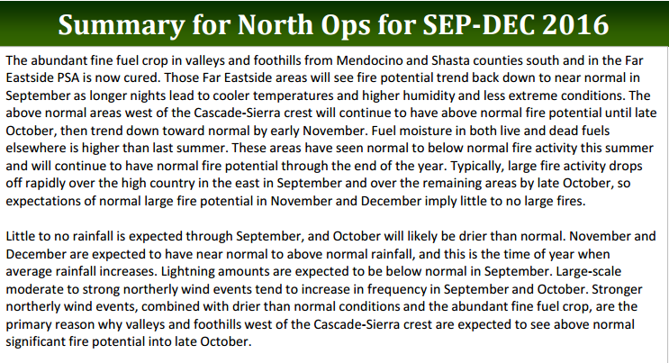
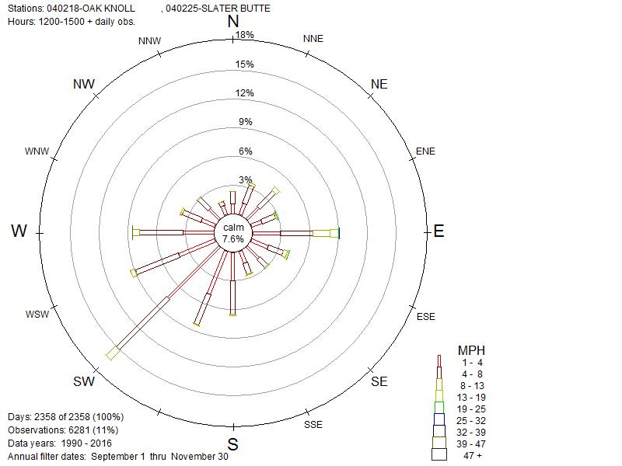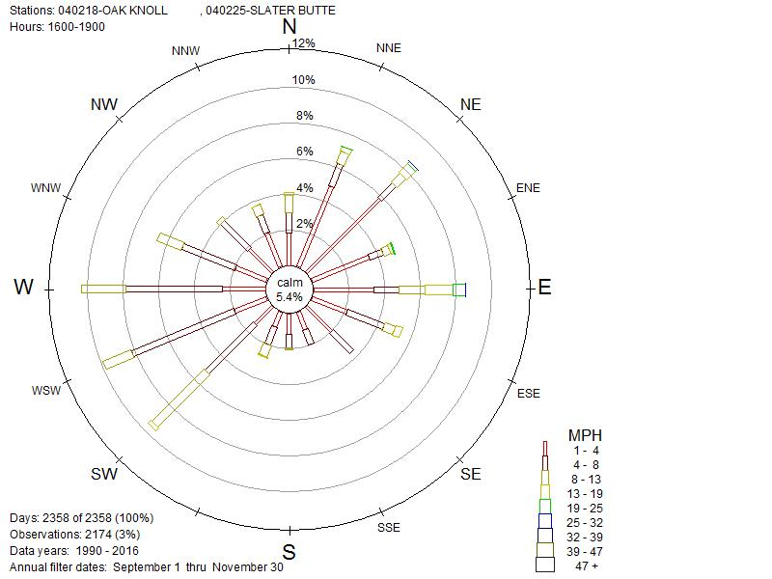
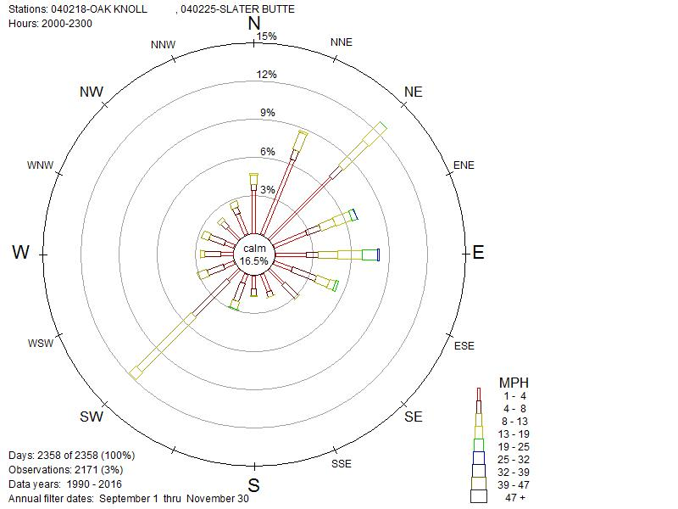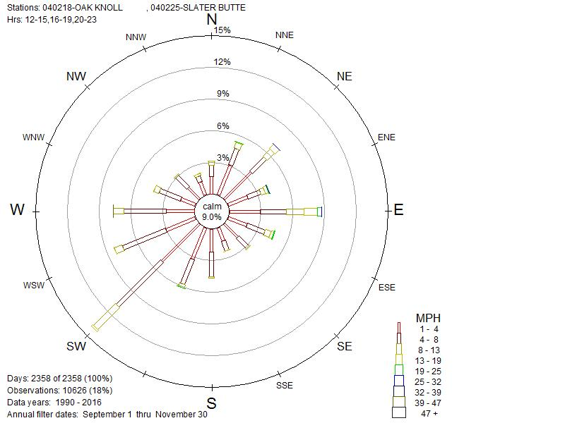
Figure 1: Wind rose for Slater Butte & Oak Knoll 1990-2016 Sept 1-Nov 31. Clockwise: 1200-1500, 1600-1900, 2000-2300, all 3 combined.
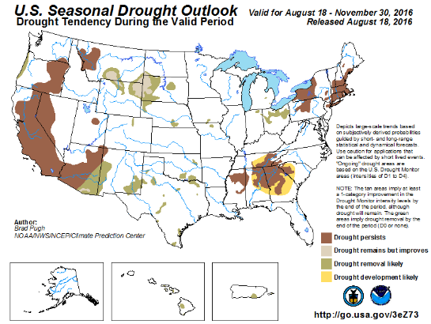
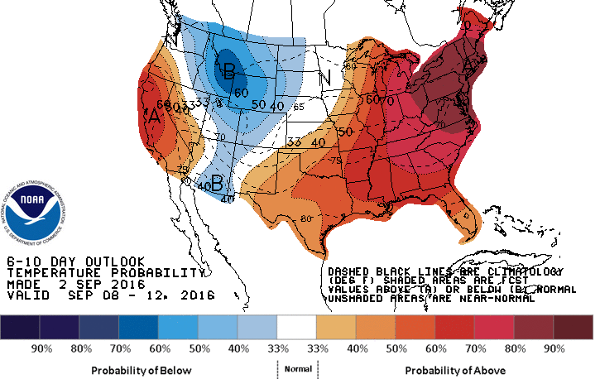
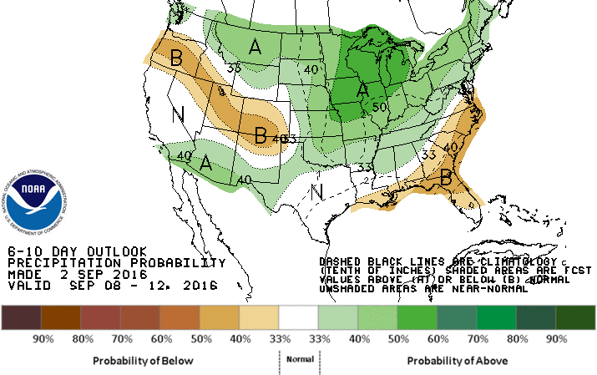
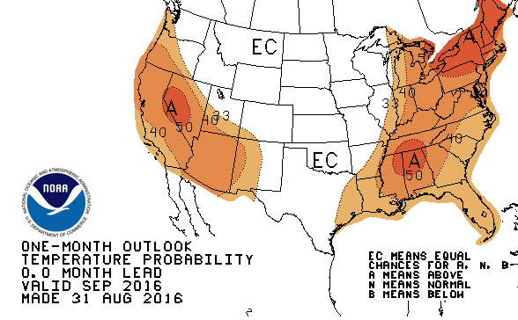
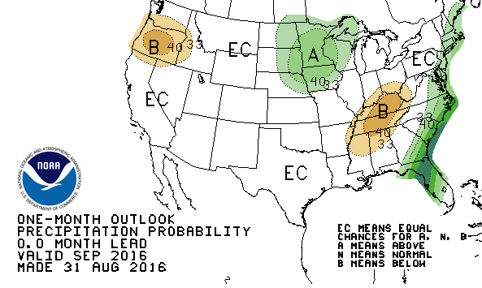

Seasonal Severity
- This is an above normal season based on fire danger indicators.
- Dead fuels are very dry.
- ERCs have set new records.

Energy release component (ERC) is a National Fire Danger Rating System (NFDRS) Index related to the potential energy of a fire at the flaming front and is generated from weather and fuels inputs. It is considered a good measure for seasonal dryness trends in large fuels making it a good indicator of potential fire length and severity, particularly in timbered areas. While ERC measures fuel dryness well, it doesn’t incorporate the effects of drought or long term dryness which can stress live fuels and make them more susceptible to disturbance, including fire, disease and insects. It’s likely these prolonged drought effects and warmer than average spring and summer temperatures can contribute in increased fire behavior and longer potential period of active fire behavior.

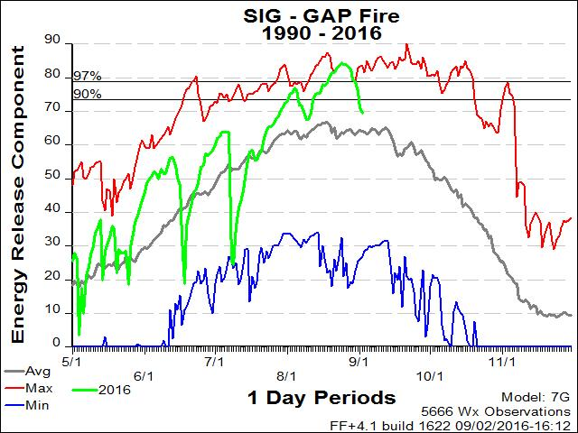
Figure 2: ERC graph for Slater Butte and Oak Knoll. Depicts the above average time and setting of new record ERC values for the combined RAWS stations.

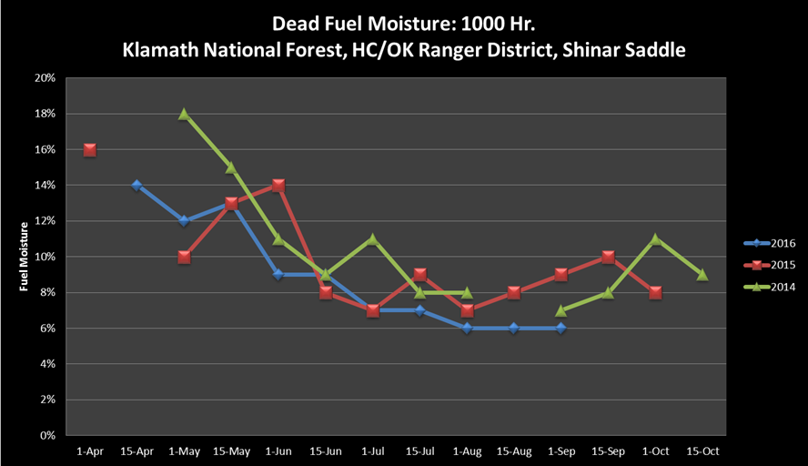
Figure 3: 1,000hr fuels moistures taken Sept. 1 by Klamath NF fuels monitoring program.

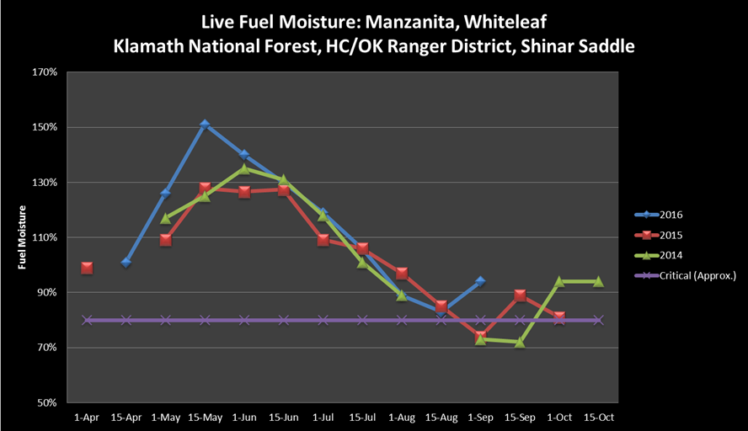
Figure 4: Live fuel moistures for Manzanita taken Sept. 1 by Klamath NF fuels monitoring program.

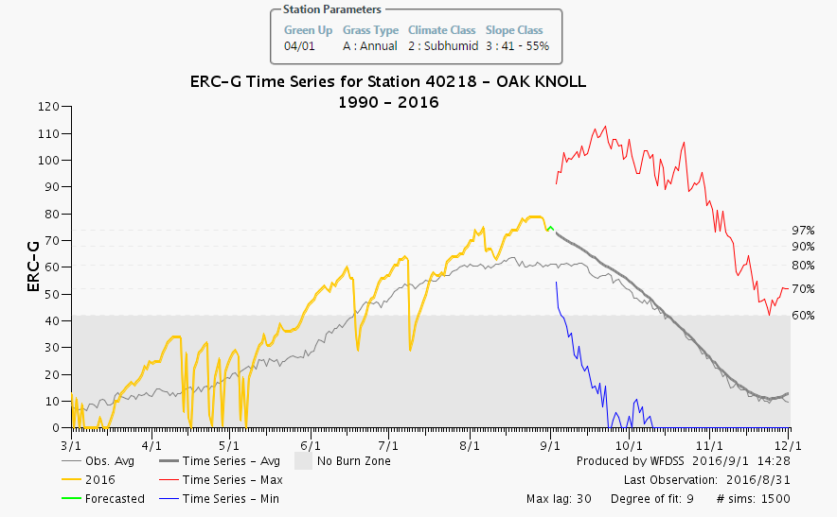
Figure 5: Auto-generated ERC chart from WFDSS for Oak Knoll.

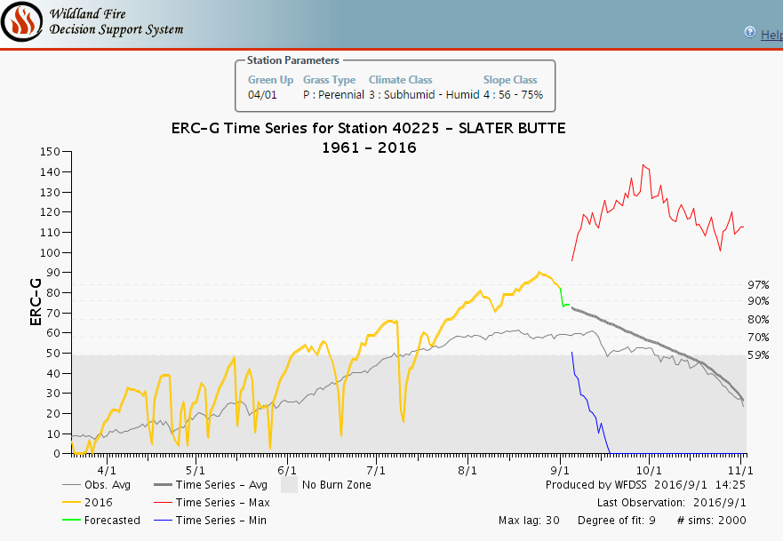
Figure 6: Auto-generated ERC chart from WFDSS for Slater Butte.

Season-Ending Event
- Likely not until mid-to-late October.
Fire season commonly ends with a large scale rain event in the Klamath Mountains, but they can also end with the onset of shorter days with cool and moist conditions. Often a fire season fades away due to a combination of scattered, smaller precipitation events and changing day length and sun angle which, in turn, translates into lower maximum temperature, higher relative humidity, and a shorter burn period. Energy release component can serve as an integrator of all these factors.
The Klamath National Forest developed criteria for estimating the end of fire season by talking with fire managers on the Forest and reviewing historic fire ending events. The criteria selected included ½ inch of rain over a five day period, throughout which the ERC never climbed above 50. Using the dates from this analysis we developed a term file for the probability of season-ending dates displayed in the graphic.
Time Period | Probability of Season Ending Event
October 5 | 25%
October 19 | 50%
October 30 | 75%
November 8 | 90%
November 20 | 99%

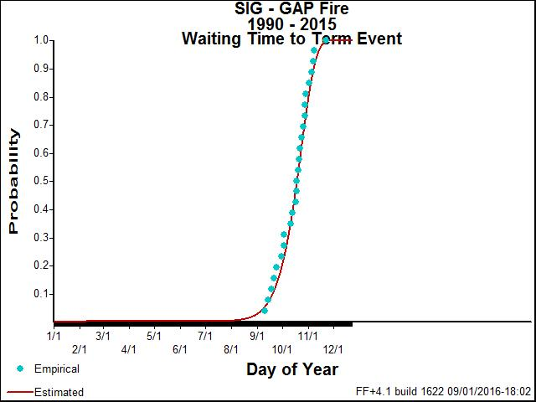
Figure 7: Probability of Fire Season Ending Event. Run from combined stations of Oak Knoll and Slater Butte.
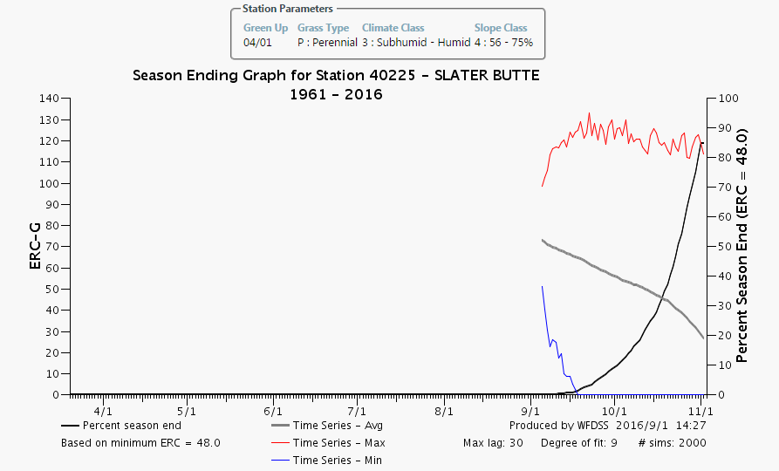
Figure 8: WFDSS automated run for Probability of season ending event for Slater Butte RAWS.
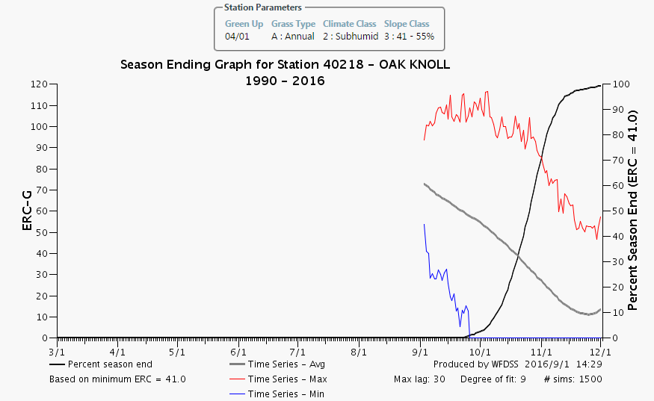
Figure 9: WFDSS automated run for probability of season ending event for Oak Knoll RAWS.

Fire-Slowing Event
- Not very likely until early October.
A fire-slowing weather event is one that at least temporarily halts fire spread, but may not extinguish all heat. A lower amount of precipitation over a longer duration is more effective than a heavy amount of rain over a single day or two.
Along with season ending events, there is a possibility of fire-slowing precipitation events prior to the end of the fire season. Precipitation of at least 0.25 inches in a day might be expected to at least slow fire spread for two or three days, while greater amounts of rain (over 0.5 inches) could slow or check fire spread for several days. The probability of receiving greater than 0.25 inches of rain in one day was derived using a series of Klamath N.F. RAWS. For specificity of this particular fire, Slater Butte & Oak Knoll RAWS were used, calculating from 1990 to current. The likelihood of such events increases significantly in the latter part of September with the return of frontal systems moving in off the Pacific Ocean.
Time Period | Probability Of Fire Slowing event
Mid-September | 25%
Early October | 50%
Mid-October | 75%
Late October | 90%

Probability and Indicators of Significant Event Day(s)
- Live Fuel Moisture Below 100%, 1,000hr Fuels below 10%
- Probability of Ignition >70%
- Temps >79 degrees, Relative Humidity <22%, 20’ winds over 4mph
- Haines 5 or greater.
Indicators for Large Fire Growth on the Klamath National Forest
- Indicators conducive to large fire growth include but not limited to the following criteria. When two or more indicators align personnel assigned to the fire should be on high alert. Live fuel moisture near or below 100 percent (historically around July 15th) and 10 percent or lower 1000 hour fuel moisture can contribute to large fire growth. A dry fuel bed (1, 10, 100 and 1000 hour size classes) are very susceptible to spotting especially when the probability of ignition is greater than 70 percent. Heavy dry, fuel loadings can contribute to large fire growth and control difficulties. Unstable atmosphere with a high Haines Index, passage of thunderstorms with strong, gusty outflow winds can lend well to large fire growth. Often times on the Klamath National Forest inversions occur and when the cap lifts it usually lends well to increased fire behavior and large fire growth. Frontal winds can also contribute to large fire growth increasing wind speeds and the potential for channeling along river and canyon corridors, increased spotting distances, rapid rates of spread where terrain, fuels and winds align. Inherently, high temperatures and low humidity combined with these indicators increase the potential for large fire growth. Based on findings from the Red Rock Escape Prescribed Fire in August of 2009, a combination of ERCs at or near the 90th percentile and winds can be a trigger for large fire growth. The moisture of small diameter dead fuels is associated with probability of ignition and fire spread and tends to fluctuate with daily changes in weather. Live and large down and dead fuel moistures are associated with season-long or even multi-year weather conditions and have been linked to large fire potential, fire intensity, and resistance to control (Red Rock Escape Prescribed Fire Review, 2009).
- During the life of the fire, increase in smoke observed from known points that have been burning, or new smokes become present in other areas it is highly recommended to increase the number of resources assigned to the incident. New smoke adjacent to containment lines should be evaluated to determine appropriate actions in terms of location, potential of it growing and risk to aviators and firefighters on the ground if action was taken. Any of the scenarios above coupled with the indicators mentioned above under the section for large fire growth; it is highly recommended to stay alert and to keep a watchful eye on the fire.

Fire Growth and Fire Behavior
- Fire is not likely to reach Siskiyou Crest within 7 days.
- Taller ridge-knobs near Klamath River pose potential spotting issue areas. (above Schutts Creek, Hicks Gulch, and Negro Creek)
- Confluence of Klamath and Scott rivers, and associated wind eddy, poses at potential spotting problem area. (Near Kinsman Creek)
- Spotting across the Klamath River may establish and move readily unless suppressed.
Predicted Fire Growth

The assumptions that supported the FSPRO, WFDSS- Near Term Analysis (NTFB) and Fire Family Plus analyses are subject to change as conditions change. The models are only valid for the fuel and weather conditions for which they were run and for the timeframe for which they represent. Major wind or precipitation events may occur and alter the predicted spread rates. The head of the fire may move to new and unpredicted locations. Live fuel moisture's may change dramatically. As the fire season progresses, the decision environment will also change. Such changes and others may invalidate the assumptions underlying the initial analyses. As a result, previous risk estimates will no longer be accurate. Over time, it is essential that the assumptions underlying the risk estimates are periodically revalidated and that the simulations are re-run accordingly.

NTFB
What is NTFB?
- NTFB – Fire Area Simulator models fire perimeters and associated fire behavior (rate of spread, flame length, etc.) for a specific ignition during a user-defined time period where weather, winds, and fuel moistures are dynamic. NTFB is unique in that it incorporates the timing of fire spread across the landscape.

What does NTFB do?
- NTFB simulates fire spread across a landscape using complex interactions of surface fuels, canopy fuels, topography, fuel moisture, and weather.
- NTFB simulates a single fire event where weather, wind, and fuel moisture are dynamic.
- NTFB does not simulate fire spread through rolling material and does not simulate diurnal, terrain-influenced winds.
- NTFB can simulate spotting fire behavior; therefore, a different perimeter can be expected for each NTFB run.

How does NTFB help decision-making?

- Managers can understand what portions of a fire may grow under a variety of wind and weather scenarios (dry cold front passage v. moderate weather).
- Managers can see what day a fire may potentially breach a Management Action Point or how long it might take to get there.
- Managers can see if a Management Action Point breach is by surface fire or spotting.
- If point protection is an objective, managers can see the fire behavior expected around that point and design appropriate mitigations to protect assets.

When should NTFB be used?
- If there is a time element needed for decision-making, NTFB is an appropriate tool. Unlike other fire spread predictive models, NTFB does not output a probability of an event occurring (FSPro), but tells a manager the outcome of a specific scenario over time.
- If a manager wants to understand what the fire might do under a specific weather scenario, such as if the forecasted dry cold front materializes, NTFB is the most appropriate tool.

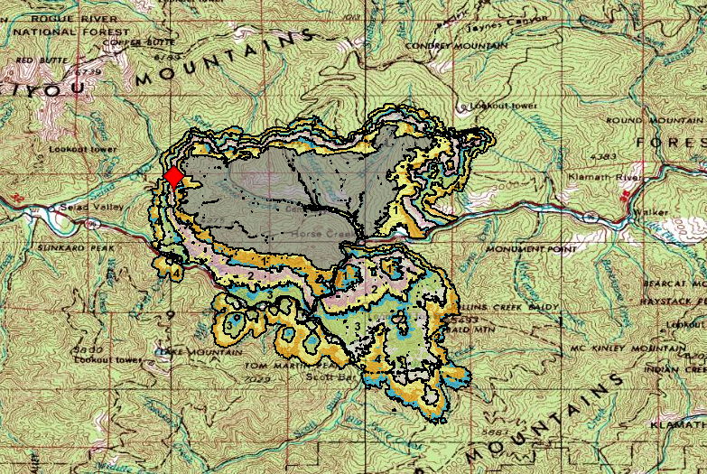
Figure 10: Updated 4 day Near Term fire behavior analysis. Uses 09/01 00:50 IR perimeters as ignition file (~17,000 acres) 10 hour burn periods; 14:00-24:00. Landscape was edited; Beaver, and Happy Camp Complex fire scars changed to fuel model 121 (low load, dry climate grass-shrub model) because recent disturbance not reflected in 2012 Land Fire data. Barrier file was used along the highway 96 corridor. Oak Knoll RAWS used for weather. Spotting potential was increased to .10. Model assumes no suppression.
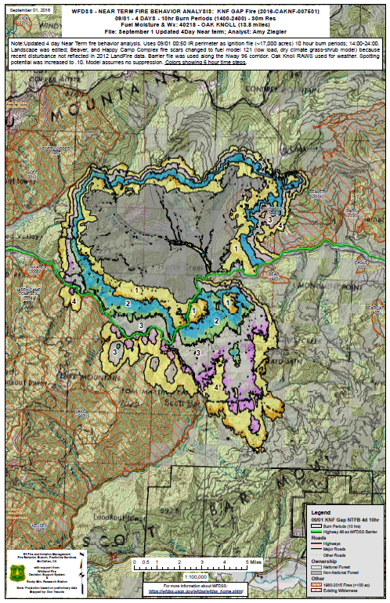

FSPro
What is FSPro?
- WFDSS-FSPro is a spatial model that calculates and maps the probability of fire spread, in the absence of suppression, from a current fire perimeter or ignition point for a specified time period.

What does FSPro do?
- WFDSS-FSPro combines data layers including, the standard fuel models (13 or 40), current weather projections, historical weather scenarios, fuel moisture classifications, and wind speed and direction,
- FSPro can project probabilities of fire spread in specified increments up to 30 days,
- FSPro is a probabilistic model that calculates the probability of the fire getting into certain areas during a set amount of time. It does not predict actual perimeters after a certain amount of time like Near Term.

How does FSPro help decision-making?
- The model helps to assess a fire’s growth potential by visually indicating the highest probability for spatial spread,
- Managers can develop appropriate strategies and tactics to meet objectives consistent with resource allocations,
- The model identifies probabilities of fire spread which potentially will provide managers a sound basis for prioritizing firefighting resources,
- It can also aid in communications with affected partners, the media, and the public.

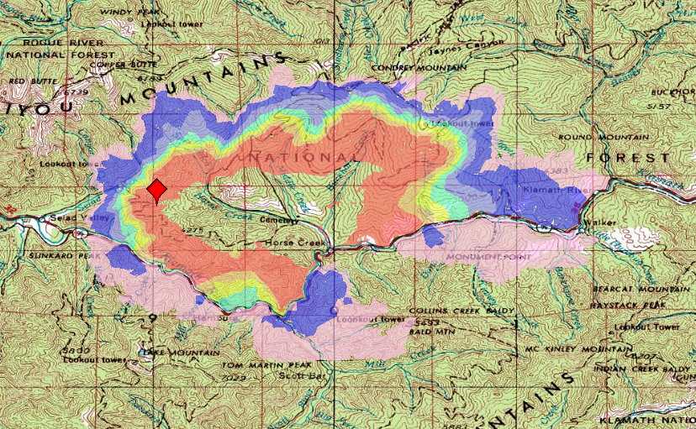
Figure 11: Updated 7 day FSPro analysis. Uses 8.30 2201 IR perimeter as ignition file but excludes the two spot fires south of Hwy 96 as they are lined. Line barrier file used on Highway/Klamath River. Fire has spotted across this twice and results indicate additional locations where this may occur again. Model assumes no suppression action.
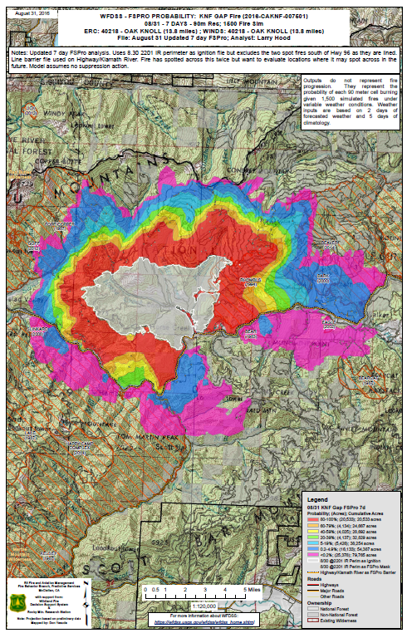

Identification of values to protect
- Communities of Seiad, Hamburg, Horse Creek, Scott Bar, Elliot Creek (residential structures, private property, critical infrastructure)
- Sensitive Botanical areas.
- Private Timber Lands
- Communication Towers
- Sensitive species areas, threatened and endangered species areas
- Vegetation Management Projects
- Critical travel corridor
- Cultural Heritage Sites and Archeological Sites

- (Please see WFDSS Decision for a more specific list of Highly Valuable Resources and Assets)

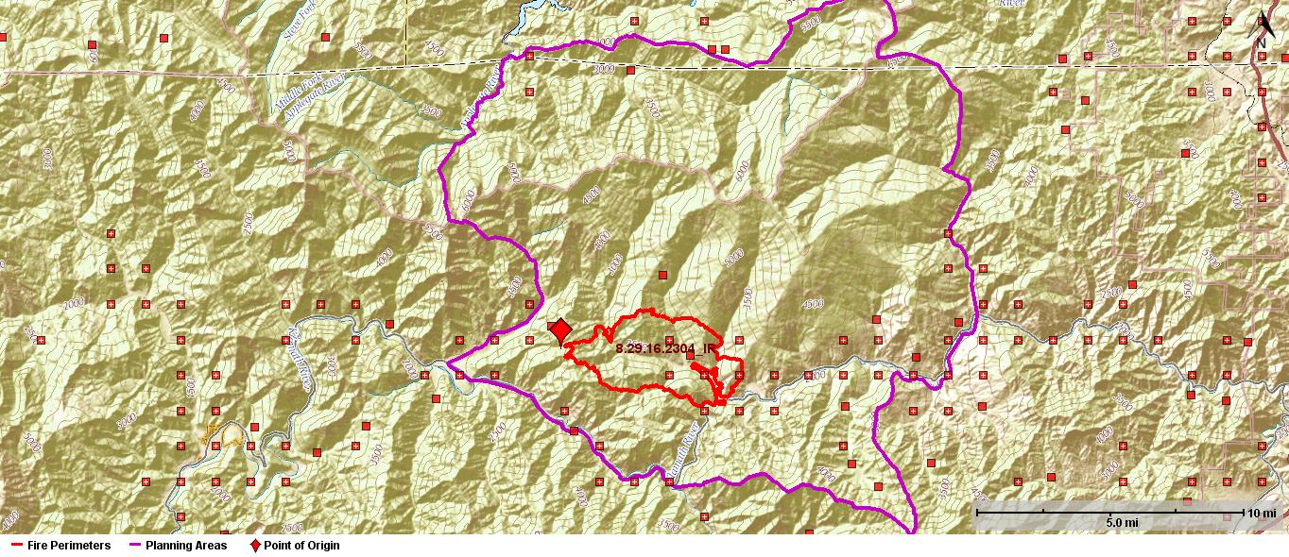
Figure 12: Structure and Infrastructure within fire area.
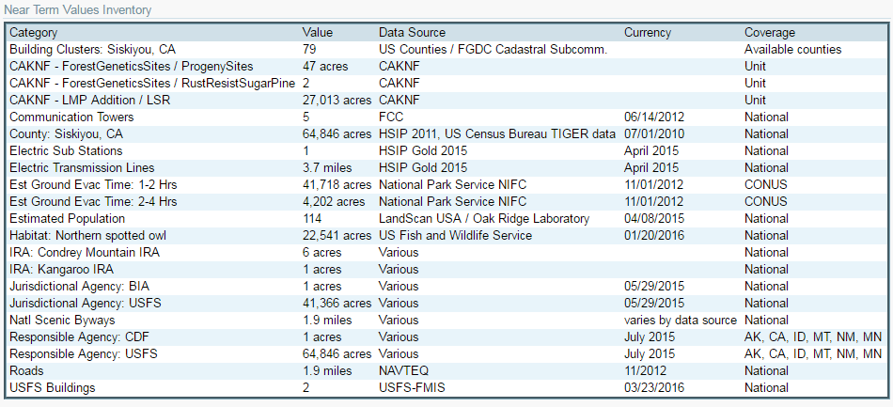
Figure 13: Values inventory from NTFB WFDSS.

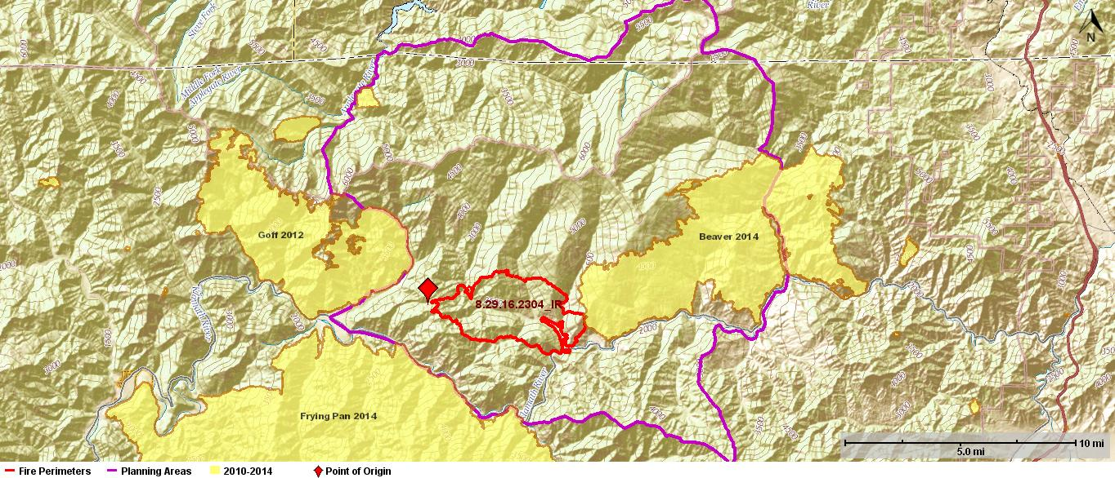
Figure 14: Recent Fire History (2010-Present) 8.30.16
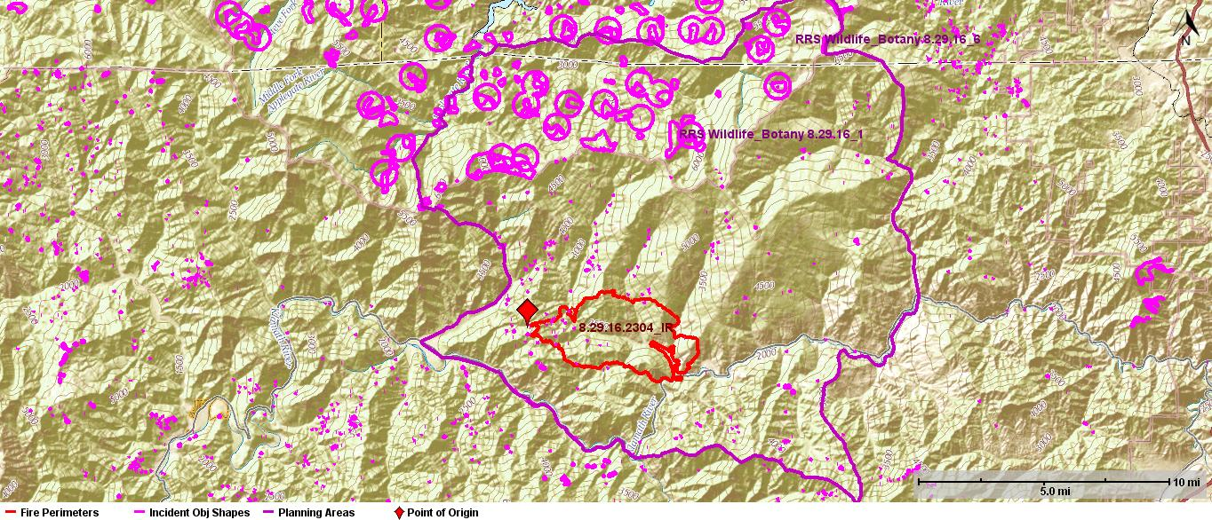
Figure 15: Wildlife and Botany Sensitive Areas 8.30.16
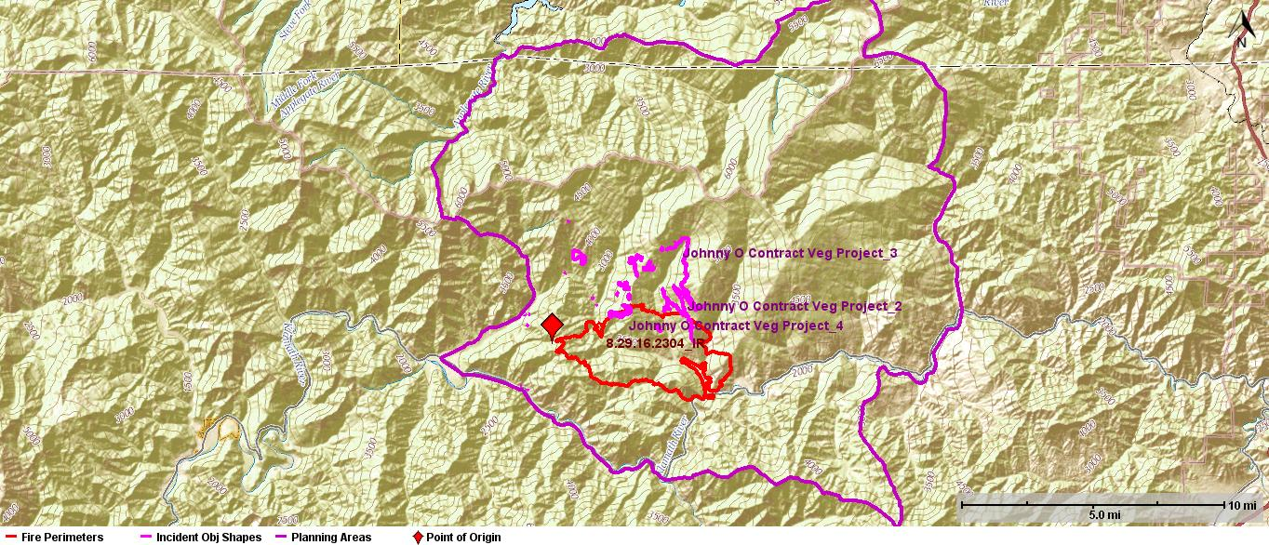
Figure 16: Johnny O NEPA Project 8.30.16

Strategic Operations (PACE Concept)

Primary
- Indirect line is being constructed on the ridge adjacent to Hicks Gulch to Sambo Gulch.
- Indirect line is being constructed from Maplesden Ranch Road to the Siskiyou Crest.
- Indirect line is being constructed from the Dogget Middle Road to the Siskiyou Crest.
- Combination of indirect and direct line is being constructed from Walker Gulch to the Seiad Low Gap.
- Indirect line is being constructed from the ridge adjacent to Schutts Gulch down to the Klamath River.
- Direct line is being constructed from Sambo Gulch up to Maplesden Ranch Road.

Alternative
- Direct line to be constructed across Buckhorn and Middle Creek drainages using network of logging roads and favorable weather.
- Direct line to be constructed along the Klamath River corridor using natural barriers to fire spread.
- Indirect line construction is constructed from Walker Gulch to Panther Gulch.
- Indirect line is constructed from Walker Gulch to Lightning Gulch near the Klamath River.
- Indirect line is planned for the ridge adjacent to Salt Lick Gulch, from the Klamath River to the Siskiyou Crest.

Contingency
- Indirect line to be constructed from the Klamath River along the ridgeline adjacent to the Seiad Creek drainage.
- Indirect line is planned for from the Klamath River south along Slinkard Ridge, bending to the east and tying into the Scott River.
- Indirect line is being constructed along the ridge system, up to Little Baldy and down to Little Gulch along the Klamath River.

Emergency
- Indirect line will be constructed along the road system adjacent to Elliot Creek.
- Indirect line will be constructed along the Scott Bar Mountain Ridge system.
- Indirect line will be constructed adjacent to Beaver Creek up to the Siskiyou Crest.
- Indirect line will be constructed along Cypress ridge to the road system along the Applegate River.

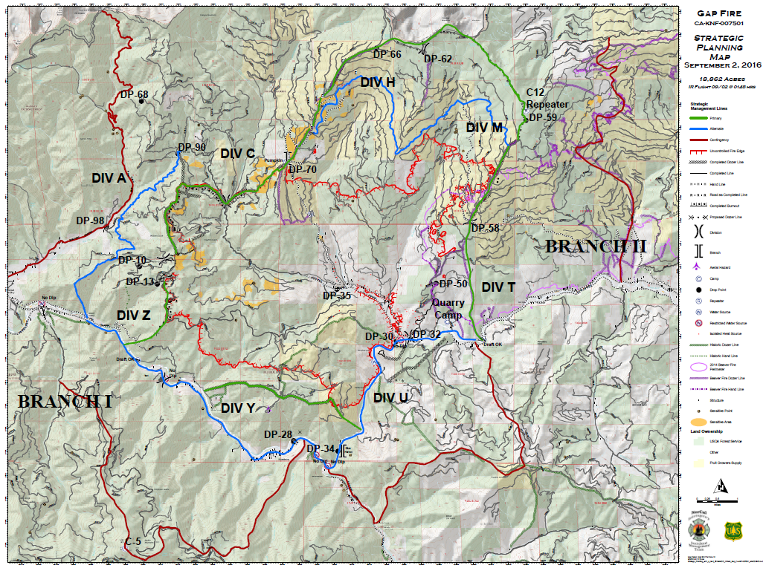
Figure 17: PACE concept strategic planning map 9/2/16 for fire area.
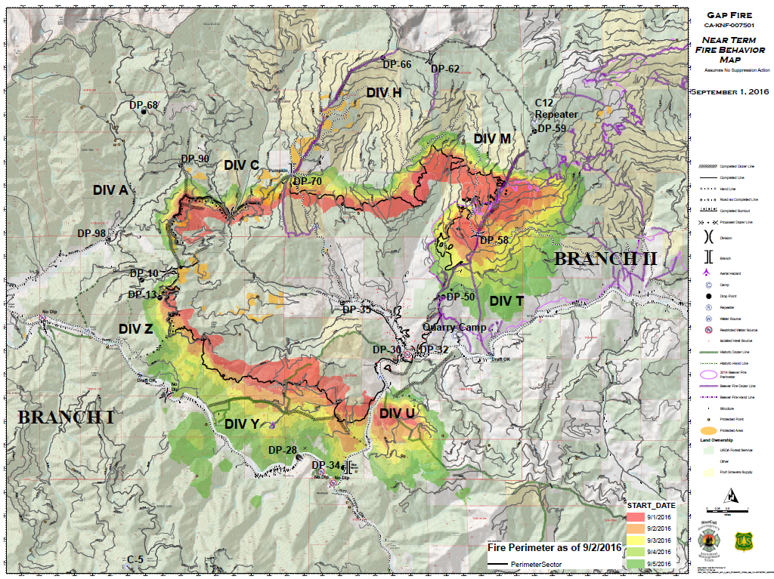
Figure 18: NTFB modelling utilized for aid in strategic planning PACE concept 9/2/16.

Management Action Points

MAP: Siskiyou Crest Ridge (MAP 1)
  - Condition: Fire has become significantly established to the north of Siskiyou Crest Ridge before October 15th.
  - Actions: Reassess fire behavior prediction models. If significant growth is anticipated consider need to address joint delegations involving Rogue River-Siskiyou National Forest.
MAP: Scott Bar Mountain Ridge (MAP 2)
  - Condition: Fire becomes significantly established to the south of Scott Bar Mountain Ridge before October 15th.
  - Actions:
    - Asses fire behavior prediction models.
    - If significant growth is anticipated to continue:
      - Coordinate and communicate with state and local agencies.
      - Determine protection responsibilities, coordinate suppression response.
      - Consider the need for unified command or joint delegation of authority.

  - 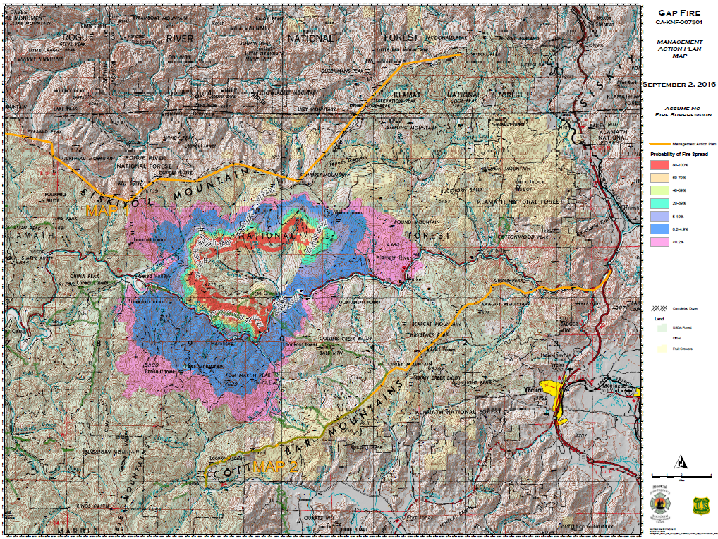
Figure 19: FSPro modelling utilized to create MAP1 & MAP2.

Strategic Operations Analysis and Plan Team members
Jason Fallon-SOPL
Matt Brown- LTAN (t)

Operations Utilization/ Implementation Sheet

Bullet Points
- This is an above normal fire season, dead fuels are very dry, ERCs have set new records.
- Critical Threshold: Temps >79 degrees, Relative Humidity <22%, 20’ winds over 4mph, Haines 5.
- Siskiyou Crest is approx. 6000’ elevation, runs east-west, aid to provide buffer for north winds.

P.A.C.E. Concept

Primary
- Indirect line is being constructed on the ridge adjacent to Hicks Gulch to Sambo Gulch.
- Indirect line is being constructed from Maplesden Ranch Road to the Siskiyou Crest.
- Indirect line is being constructed from the Dogget Middle Road to the Siskiyou Crest.
- Combination of indirect and direct line is being constructed from Walker Gulch to the Seiad Low Gap.
- Indirect line is being constructed from the ridge adjacent to Schutts Gulch down to the Klamath River.
- Direct line is being constructed from Sambo Gulch up to Maplesden Ranch Road.

Alternative
- Direct line to be constructed across Buckhorn and Middle Creek drainages using network of logging roads and favorable weather.
- Direct line to be constructed along the Klamath River corridor using natural barriers to fire spread.
- Indirect line construction is constructed from Walker Gulch to Panther Gulch.
- Indirect line is constructed from Walker Gulch to Lightning Gulch near the Klamath River.
- Indirect line is planned for the ridge adjacent to Salt Lick Gulch, from the Klamath River to the Siskiyou Crest.

Contingency
- Indirect line to be constructed from the Klamath River along the ridgeline adjacent to the Seiad Creek drainage.
- Indirect line is planned for from the Klamath River south along Slinkard Ridge, bending to the east and tying into the Scott River.
- Indirect line is being constructed along the ridge system, up to Little Baldy and down to Little Gulch along the Klamath River.

Emergency
- Indirect line will be constructed along the road system adjacent to Elliot Creek.
- Indirect line will be constructed along the Scott Bar Mountain Ridge system.
- Indirect line will be constructed adjacent to Beaver Creek up to the Siskiyou Crest.
- Indirect line will be constructed along Cypress ridge to the road system along the Applegate River.

