Long Term Fire Assessment for Red Rock Fire Area
Klamath National Forest
September through October, 2009

Background

In late August 2009 the Klamath National Forest (KNF) had two large fires burning. The Harrington Fire (150 ac) and the Red Rock Fire (1000 ac).

The Red Rock Fire, in the Marble Mountain Wilderness, was ignited between June 26 and June 28th. The fire received about 0.2” rain in the 30 days prior to the escape, including 0.10” rain on August 7th. In mid-August, spot fires occurred outside of the burn unit on the south perimeter. These spots were contained. On August 21, SW winds (with low relative humidity (11% between 1000 and 1100) contributed to fire runs to the northeast along the west flank and numerous spot fires outside of the planned burn unit to the N-NE (spot fires covered more than 50 acres outside of the burn unit on August 22, 2009).

KNF managers recognized that active fire behavior typically continues in Northern California through late September and occasionally persists into November. Weather conditions associated with large fire growth events occur almost every year in September and some years occur multiple times during the September – October time period. It is prudent to assume that the two fires will experience severe fire weather at least once in the next 60 days. Both fires present logistical problems due to their wilderness setting which can cause delays in responding to problem fire behavior. Because of the large fire growth potential and significant values-at-risk (primarily for the Red Rock Fire) on August 22, 2009, a Type II IMT was assigned to manage both fires. Because of the length of remaining fire season and potential for additional lightning starts on the Forest, a NIMO team was ordered to provide overall long term management for both fires.

This document provides an outlook for large fire growth for the remainder of the fire season. The outlook is based on current vegetation and forest fuel conditions, forecasted weather and climatological analysis. Recommendations for management are based on potential single event fire growth/spread distances and the known values-at-risk.

The assessment provides a view of W-NE fire spread which would occur from strong SW winds associated with frontal system passage. Fire spread to the SW to SE directions is not considered a great threat due to absence of values-at-risk in those directions and presence of recently burned areas. Consequently, even though there will likely be multiple episodes of foehn winds from the NE, this assessment will not consider them in detail. These recent burns can be viewed as an investment in providing greater flexibility in managing fires this year and into the future.
Conditions Associated With large Fire Growth

Review of past large fire activity on the Klamath NF indicates that sustained winds of 10 to 20 mph (20-ft height) coupled with RH less 20% are associated with fire growth of 1000 acres or more in a single burning period. John Snook (North Zone Predictive Services) estimated that the above listed threshold weather conditions occur on the Klamath NF on average twice in September and twice in October before rainy weather diminishes their impact on wildland fire.

A recent example of threshold weather on a late-season wildfire is the Panther Fire run of October 1, 2008. This fire was located about 8 miles to the west of the Red Rock Fire and about 20 miles ESE of the Harrington Fire. It had been exhibiting very little movement and low fire intensity when strong dry winds pushed it more than 12 miles to the NNW, covering about 12, 000 acres. Most of the fire spread occurred in a six hour period from 1000 to 1600. ERC was 79 (about 97th percentile); 1000 FM was 8%; elevation where run commenced was about 6,000 ft, burning downslope to 3,000 ft; fuels were a continuous forest of mature to decadent true fir. The fuel and topography conditions are very similar to those conditions north of the Red Rock and Harrington Fires. Actual RAWS observations during the run reveal that from 1000-1600 winds were S at 20-27 mph (10 min avg) and RH was 21% at 1000, increasing to 27% by 1600.

Fire Danger Conditions

National, regional, and local dryness measures all agree that live vegetation and dead fuels on the Klamath National Forest are currently drier than average.

- Relative greenness in that area is 31-50%. Indicating that live fuels are drier than average for this area
- National Drought map indicates this area is in a persistent moderate to severe drought.
- 1000-hr TL fuels are at 8-9 % which is near historic minimums.
- Energy Release Component (ERC) was calculated to be 83 (97th percentile) on Aug 21 and remains at or near that level. See chart below.

Energy Release Component for conditions in the Red Rock Fire area. (Based on three high elevation RAWS sites at 4500-6000’ Blue Ridge; Collins Baldy and Slater Butte)

Fire Danger Outlook

Predictive Services has provided several fire weather and danger outlooks for the September through October time period. These indicators suggest that conditions that contribute to intense fire behavior will be more severe than average

Temperature is expected to be above average and precipitation is expected to below average. We should not expect any appreciable rainfall during September, nor the first part of October.

 | September | October
Temperature Departure From Normal | +2-5 degrees | +2-5 degrees
Precipitation Departure From Normal | 15-75% | 30-90%
From North Zone GAC Predictive Services

Fire Behavior Predictions

Under “Panther Fire” simulated conditions, the Red Rock Fire would spread rapidly, as much as 3-4 miles to the north in one burning period. The fire would likely burn through Lovers Camp (USFS campground) and could reach the Timber Vest industrial forestlands about 4 miles to the NE. The simulated conditions mimic sustain runs of 25 mph over a 10 hour period with critically dry fuels.

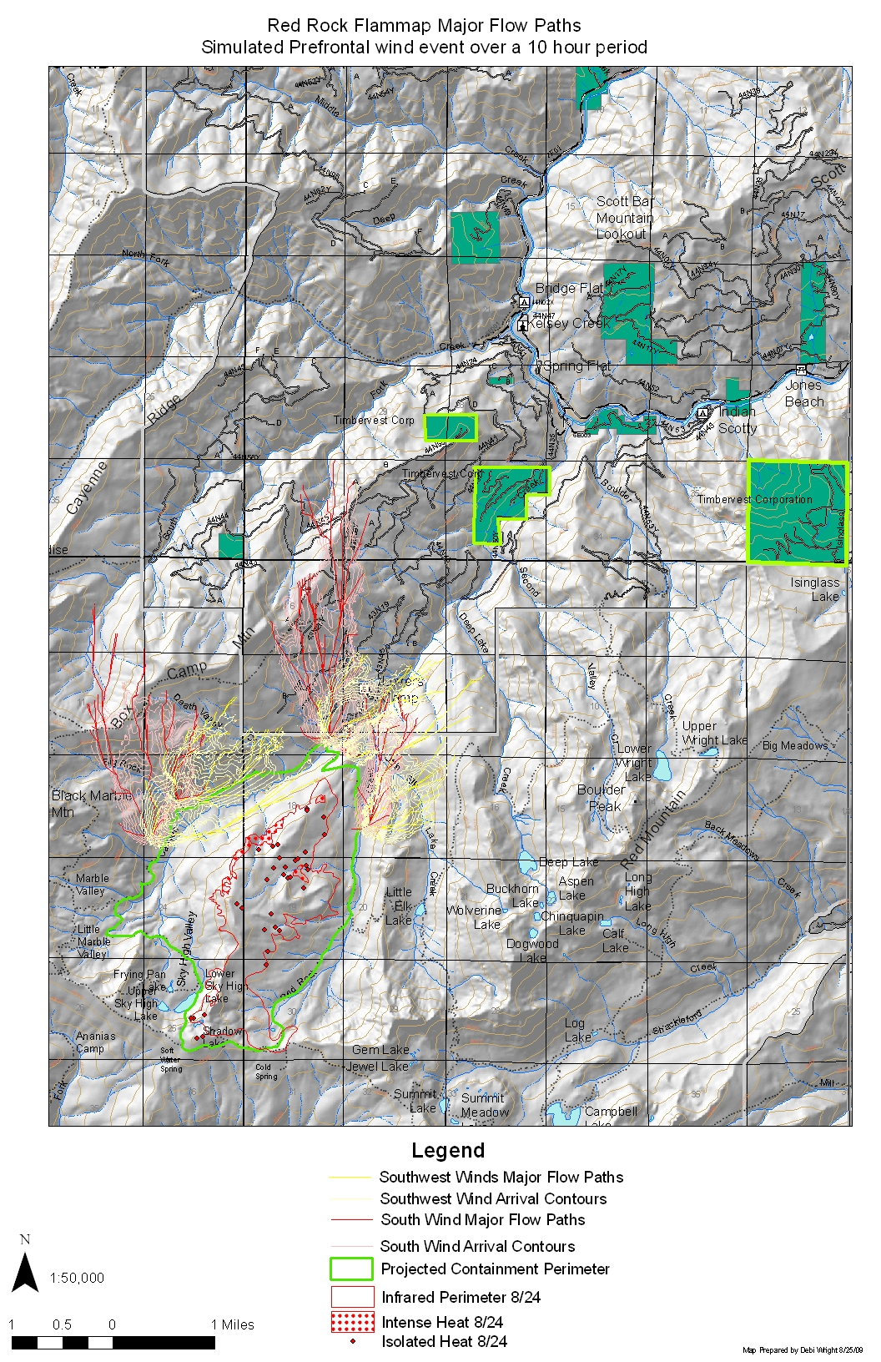
Values-at-risk

Continued fire spread to the NW-NE would threaten dwellings and small communities. Approximately nine inholdings with more than 40 dwellings are within 7 miles (N-NE) of the Red Rock Fire.

Description | Residence | Approximate Dist From Fire
Lovers Camp | No | 1 mile (NE)
Box Camp | No | 2 miles (N)
Commercial Forest Enclosure- Timber Vest | No | 2 miles (NE)
44N44 Enclosure- Castle Family | Yes | 2 miles (NW)
44N41 Enclosure – Timber Vest | No | 4 miles (N)
Buker Ranch 44N41 Buker Rd | Yes | 4 miles (NE)
6E 002 Enclosure (Residences) | Yes | 5 miles (NE)
Indian Scotty CG | No | 5 miles (NE)
Indian Scotty Enclosure | Yes | 5.5 miles (NE)
Beauty Flat (Residences) | Yes | 5.5 miles (NE)
Jones Beach | No | 6 miles (ENE)
Jones Beach Enclosure | Yes | 6 miles (ENE)
44N49 Enclosure | Yes | 5.5 miles (NNE)
Scott Bar Lookout | No | 6 miles (NNE)

Values-at-Risk Descriptions

West of Indian Scotty/South Side of Scott River- 6 parcels with residences
Parcel straddling Scott River adjacent to Indian Scott- single parcel/residence
Timber Vest – industrial timberlands in several parcels/locations
Castle Family (Evans, Castle, and Carillo) Absentee Owners
Buker Ranch – likely occupied
Beauty Flat – 16 parcels, numerous residences
Long parcel north of Jones Beach – 6 residences/parcels
The Scott Bar Lookout is located approximately 6 miles NE of the Red Rock Fire. The lookout is no longer staffed and structure is dilapidated.

Management Action Points and Mopup Standards

This assessment provides management action points which identify fire activity and locations coupled with fire weather and fire danger conditions and forecasts which would trigger mitigation actions. The mitigation actions are presented as recommendations to consider. This assessment assumes that the Red Rock Fire has been successfully contained, the IMT has been released and the fire is in “monitor” status.

Predisposing conditions for problem fire behavior on the Klamath National Forest during September –October include:

- Poor nighttime humidity recovery (maximum RH staying below 35) especially when recovery is poor on more than one night successively
- Frost-kill or shrubs and forbs
- Low 1000-hr timelag fuel moisture (<10%)
- High Energy Release Component (>70)

Poor relative humidity recovery (RH does not exceed 35%) will likely occur about 5-6 times during the Sept 1-Oct 15th period. Successive nights with poor RH recovery should signal extra vigilance the following day, especially if winds are forecasted for more than 5 mph.

Killing Frost

A killing frost will increase available fuel which may enable fire spread in areas previously considered non-flammable. Particular attention should be paid to riparian areas on the northern perimeter and the scattered meadows along the south and east perimeters following a killing frost. Weather records for the last decade indicate that the first killing frost has occurred as early as September 1st, but most often does not occur until October.

Recommended Mopup Standards

The Red Rock Fire strategy used Canyon Creek as the NW and North containment line. A firing operation was implemented south of Canyon Creek to widen the containment effect of the creek. A sizeable portion of the south side of Canyon Creek did not burn due to high levels of live and dead fuel moisture. In some places this unburned area extended more than 500 feet upslope to the south from the edge of Canyon Creek. Refer to map on next page when reviewing recommended mopup priorities and standards.

Priority 1: The NE corner of the fire perimeter has the greatest exposure to SW winds and has the narrowest creek-riparian area (where fire will not spread). Values-at-risk outside the fireline to the north include private industrial timberlands, ranchlands, and numerous residences. None of these values would likely be reached by a single burning period fire run. On the north portion of this perimeter, the firing operation brought active fire almost to the creek edge, leaving a relatively narrow strip of riparian area to broaden the containment effect of Canyon Creek. The intersection of the east handline with Canyon Creek is a right-angle portion of fireline (aka “dogleg”) which exposes dry fuels across the line in a wide arc. The east handline is narrow and there are dry fuels immediately across the line to the east and across the creek 100 to 300 feet to the north. Creek bottom location and continuous forest canopy substantially reduces gradient winds in this area. Maximum spotting distance was modeled under historic “worst case” conditions producing spot fires as far as 500 feet. This distance should be used for patrolling outside of the fireline should torching trees cast embers across the fireline. Because it is a “worst case” it should not be used for mopup standards. Rather our experience (with the model and with burning in this area) suggests that almost all embers would fall no more than 50% of the max spotting distance. Consequently, we recommend mopping up all heat sources within 250 feet of the north side of the Canyon Creek riparian area and the east handline.

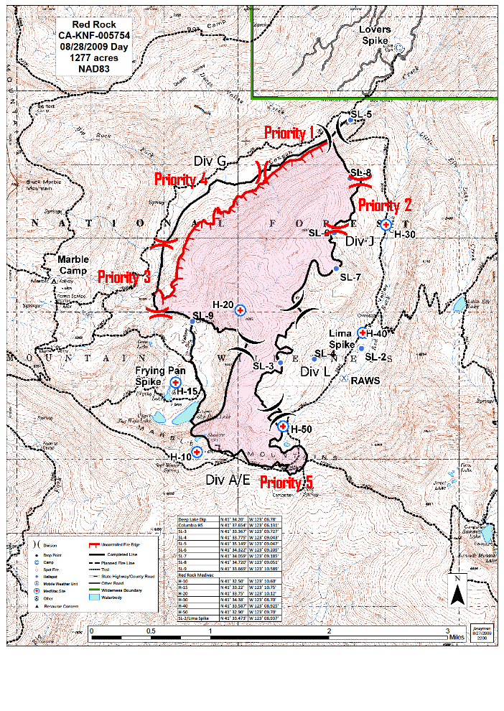
Priority 2: The handline on the NE side of the fire where it descends into Canyon Creek is constructed through continuous forest canopy. This area was burned out and is relatively clean. There are dry fuels immediately across the handline to the east. Values-at-risk to the east include private property which is more than 5 miles from the fire edge and beyond the barrier presented b Red Mountain. The most recent infrared map indicates only a few heat sources and these are over 500 feet from the handline. However, there is increased exposure to wind associated with midslope terrain features in this area. This portion of fire perimeter poses a moderate risk of escape if strong, dry SW-W winds surface for extended periods of time (characteristic of pre-frontal passage conditions) and heat sources are within about 250 feet of the fireline. Maximum spotting distances are consistent with Priority 1modeling. Consequently, we recommend mopping all heat sources within 250 feet of the handline.

Priority 3: The western upper reaches of Canyon Creek bend to the SW and become much narrower in overall creek width and moist fuel/vegetation. Although the width of effective barrier to fire spread narrows, the containment line in this area is “out of alignment” with wind and slope, countering some of the narrowing effect. Wilderness extends to the west for at least 7-8 miles and no significant values-at-risk are present in that direction. A private enclosure is located about 4 miles to the north on the 44N44 Road (Castle family parcel). A fire running in the direction of this parcel would be slowed by topographic features beyond Box Canyon Mountain. Winds during the September to October time period come out of the east about 1/3 of the time. However, these winds are mostly light (<5 mph) and are reduced at this location to only 1-2 mph. Spotting distances in this area are anticipated to be no more than about 150 feet. Recommend mopping all heat sources within 150 feet of the handline.

Priority 4: Canyon Creek serves as the primary containment line along this section. It runs from a point about 2000 feet west of Div J/G break to the W and SW ending at the confluence of Canyon Creek and a small tributary in the NW corner of section 24. The firing operation left a wide unburned area along Canyon Creek in this area due to moist live and dead fuels. This wet, unburned area broadens the containment effect of Canyon Creek, reducing potential escape. Values-at-risk are similar to Priority 1, but likelihood of fire spread to the north towards the values is extremely unlikely. This area is well sheltered from southerly winds. Modeling indicates that spotting would not go beyond the Canyon Creek/riparian area containment line. Recommend no additional mopup due to the wide buffer.

Priority 5: The southern line from Canyon Creek to the east poses very little risk despite the narrow stream channel and continuous forest. Wilderness extends to the south and many recent burns provide barriers to fire spread. No significant values-at-risk are within reach of a fire run outside the current southern perimeter of the Red Rock Fire. Wind records indicate very few days (likely no more than 3 days) during the Sept 1-Oct 15 period with NNW to NE winds and when these winds occur during afternoon periods (1200-1500) they are relatively light (<5 mph). See Wind rose in appendix.

The handline on the E and SE fire perimeter (to the south of the area described above) runs though conifers, meadows and rocks. It has received substantial work and holds little threat of escape. Infrared assessments have indicated very little heat in this area and none adjacent to firelines. The area outside the fireline to the east is characterized by broken terrain and very rocky surface conditions making an extended fire run to the east very unlikely.

The southern edge of the fire utilizes the Pacific Crest trail for a portion of the fireline. This area has been worked intensively by crews over the past week. No heat signatures were identified in the area by recent infrared scans. Strong northerly winds (>10 mph at 20-ft) coupled with low RH (< 20%) may cause problems. This combination is likely to occur no more than 2 times between September 1 and October 15. Previous spot fire problems in this area originated from fuels burning within 100 feet of the fire edge. If dry, northerly winds are forecasted, patrols should be assigned to extinguish any spot fires or rekindles along the handline/PCT

The SW fire perimeter from Shadow Lake north to where the perimeter intersects canon Creek has had fire in the area for many days/weeks with no problems. Much of the area outside the fire perimeter is meadow, very patchy conifer, and rock. Easterly winds coupled with low RH are uncommon during September and October.

Recommend no additional mopup for all of Priority 5. Recommend patrol status with squad level staffing if forecast calls for strong winds (>10 mph at 20-ft) with RH below 25%. (strong wind direction should be matched with specific perimeter location for suggested patrol staffing).

Management Action Points

The firing operation along Canyon Creek will not extend completely to the creek. There will be a 100-400 ft unburned strip along the creek where the fuels are too moist to carry fire. Fuels in the strip along the creek will likely become drier with continued lack of precipitation. As the fuels dry the outer edge of the unburned strip (furthest from the creek) will become flammable. Residual heat in the area that was fired by the IMT will likely cause fire to spread into the drying edge of the unburned strip in the next few weeks. Fire will continue to spread toward the creek until significant precipitation occurs. Individual tree torching and group tree torching may occur when wind and relative humidity reach threshold levels (wind>5mph and RH <30). Torching trees could produce embers which could be transported across Canyon Creek to the dry fuels on the south-facing slope north of Canyon Creek.

Management Action Point #1

Fire is active in the Canyon Creek drainage (south side within containment lines) and the following fire danger and weather conditions are predicted or exist:

- 20-ft winds > 10 mph
- RH < 30%
- ERC > 70

Note: these weather conditions are expected to occur several times between September 1 and October 15th.

Recommendation: assign mopup and patrol resources to the fire to prevent or limit torching and to extinguish any spots which might occur to the north across Canyon Creek.

Management Action Point #2

Fire becomes established across Canyon Creek and conditions or forecasts are:

- 20-ft winds > 20 mph
- RH < 25%
- ERC > 75

Note: it is assumed that MAP 1 has already been triggered and personnel are on the ground at the fire. The weather conditions listed occurred last year during the Panther Fire run and have a moderate likelihood of occurring at least once between September 1 and October 15th.

Recommendation: consider ordering an IMT for fire containment and structural protection for residences to the north.

