Cougar Fire
IAP
Friday, June 10, 2011
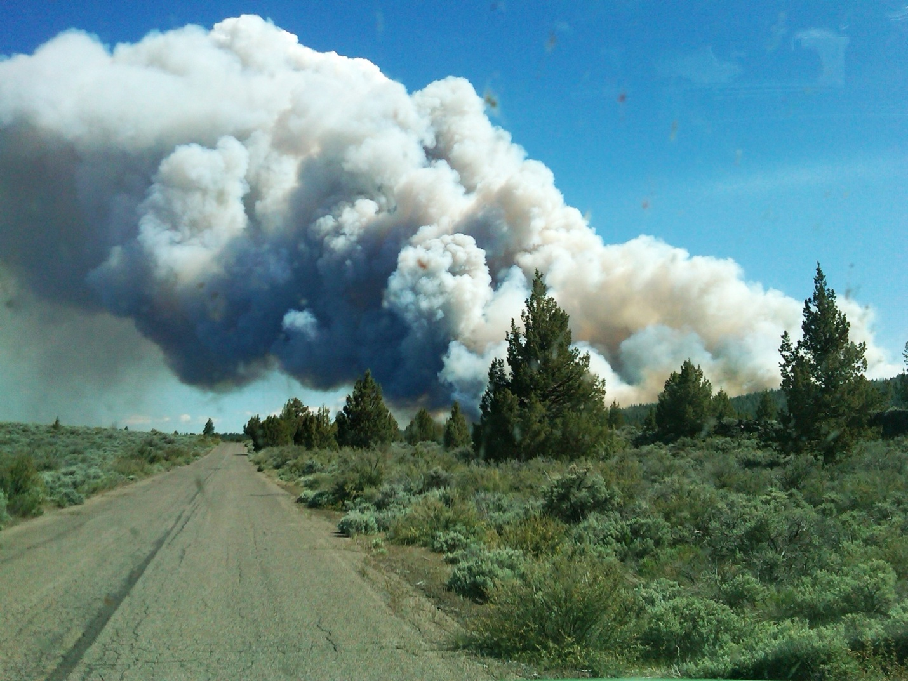

CA-MDF-181
(0509) P5F4RX

