What is a BARC?

A Burned Area Reflectance Classification (BARC) is a satellite-derived map of postfire vegetation condition. The BARC has four classes: high, moderate, low, and unburned. This map product is used as an input to the burn severity map produced by the Burned Area Emergency Response (BAER) teams. It is available in both raster and vector format.

How are BARC maps generated?

BARC maps are made by comparing satellite near and mid infrared reflectance values. The logic behind the process is as follows:

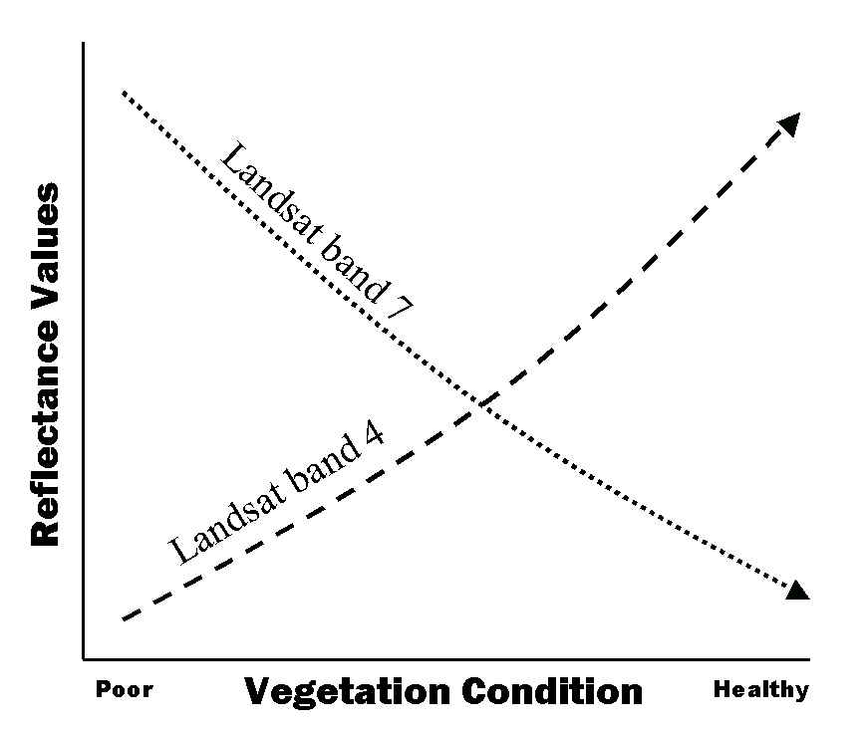
- Near infrared light is largely reflected by healthy green vegetation. That means that near infrared bands will be very high in areas of healthy green vegetation and low in areas where there is little vegetation.
- Mid infrared light is largely reflected by rock and bare soil. That means that mid infrared band values will be very high in bare, rocky areas with little vegetation and low in areas of healthy green vegetation.
- Imagery collected over a forest in a pre-fire condition will have very high near infrared band values and very low mid infrared band values. Imagery collected over a forest after a fire will have very low near infrared band values and very high mid infrared band values.

It is the relationship between these two bands that BARC mapping attempts to exploit. The best way to do this is to measure the relationship between these bands prior to the fire and then again post fire. The areas where the relationship between the two bands has changed the most are most likely to be severely burned. The areas where that relationship has changed little are likely to be unburned or very lightly burned. To determine this relationship, analysts perform a band ratio between the mid and near infrared bands. The result is a classification of burned areas.

How should BARC data be used?

In the immediate aftermath of a wildfire, a Forest Service Burned Area Emergency Response (BAER) team is dispatched to the site to prepare an emergency rehabilitation and restoration plan. They do this by making an initial assessment of burn severity and to estimate the likely future downstream impacts due to flooding, landslides, and soil erosion. One of the first tasks for this team is the creation of a burn severity map that highlights the areas of high, moderate, and low burn severity. This map then serves as a key component in the subsequent flood modeling and Geographic Information System (GIS) analysis. The BARC data are meant to be used as a main input into the development of the final burn severity map.

What is the BARC256 and how do I use it?

In addition to delivering the 4-class BARC data to field teams, RSAC also provides field users a continuous 256-class version of the BARC. This is called the BARC256. This data set provides users the ability to adjust the break points between reflectance classes. Analysts at RSAC will color code the BARC256 image using the same classification scheme used for the BARC4 data, but the BARC256 will not be recoded into 4 classes. The breakpoints for the BARC256 will nearly always be the following:

- Unburned / Very Low = < 75
- Low = 76 – 109
- Moderate = 110 – 187
- High = > 187

The color-coding on the BARC256 done by RSAC is meant to act as a starting point for field team members. Users can view the color scheme and adjust these break points as desired. This can easily be done in ArcMap.

The data will also typically be sent as a square or rectangular subset that covers land outside the fire perimeter. This can easily be clipped to the fire perimeter of choice using ArcMap’s Spatial Analyst extension.

Using ArcGIS ArcMap 8.x or 9:

- Double-click on the BARC256 image name in the Table of Contents.
- Click on the “Symbology” tab.
- Click on the color box and change colors where appropriate. For example, if you believe not enough “unburned” pixels are represented in the image, in the “Symbol” field, click on a few of the “low” colored boxes and change the color to dark green. Observe how the BARC patterns change as you change the thresholds.

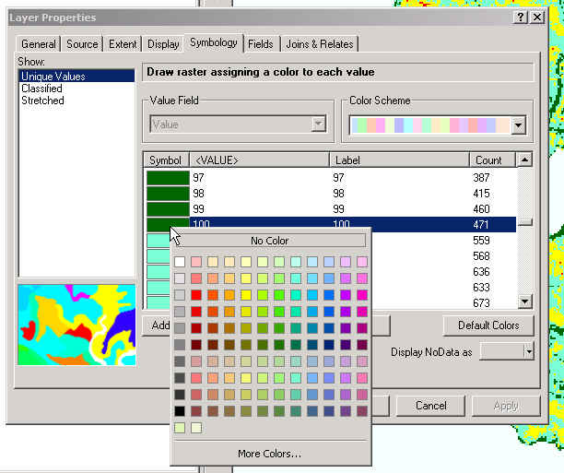

- After looking at your ancillary data and deciding more changes need to be made, continue with the same process as described above.
- Before reclassifying the BARC256 to a new four-class image, set your fire perimeter as the analysis mask (Spatial Analyst | Options | Analysis Mask). This will clip the BARC product to the perimeter any time you perform any analysis using Spatial Analyst.
- Users can recode the BARC256 into a four-class image using the new breakpoints (Spatial Analyst | Reclassify).
- After converting the BARC256 into a 4-class raster image, you can convert it to a vector shapefile (Spatial Analyst | Convert | Raster to Feature…)
- In the vector format, you can make locational edits, such as in areas covered by clouds or smoke in the satellite imagery. This could by done by doing a union or intersect with shapefiles with known severity attributes, in essence, burning in the correct severity attribute to the vector BARC layer.

Who do I contact to get BARC maps?

The Forest Service Remote Sensing Applications Center (RSAC) and the US Geological Survey Center for Earth Resources Observation and Science (EROS) both provide satellite imagery and BARC mapping services to BAER teams. RSAC is responsible for all wildland fires on Forest Service lands, while EROS is responsible for all Department of Interior lands. However, depending on workload, each office may assist the other for fires on lands not under their stewardship.

To order BARC data for fires on FS lands, contact Jess Clark (801-975-3769; jtclark@fs.fed.us). For fires on DOI lands, contact Randy McKinley (605-594-2745; rmckinley@usgs.gov).

