Risk Report for the Mokelumne River

Assessment Name: | Clover II
Assessment Date: | 9/17/2007
Total Distance (ch): | 255
Total Risk: | <1%

Description

Clover II fire

Term File Information
Season Start Date: | 5/1/2007
Alpha Value: | 3.2
Beta Value: | 0.0066
File name:

Summary of Results by Time Period

Period # | Start Date | Name |  | Risk
1 | 5/1/2007 | Clover II |  | <1%

Segment Descriptions

Seg # | Map ID | Veg Type | Fuel Model | Length (ch) | Slope % | Aspect | Elev | Shelter | Shade | Wind Vector | Spread Dir
1 | A | SH | 5 | 106 | 3 | S | L | U | U | 180 | 180
2 | B | SH | 4 | 24 | 10 | S | L | U | U | 180 | 180
3 | C | TL | 8 | 12 | 20 | S | L | S | S | 180 | 180
4 | D | SH | 4 | 1 | 33 | S | L | U | U | 180 | 180
5 | E | TL | 8 | 42 | 20 | S | L | S | S | 180 | 180
6 | F | SH | 4 | 18 | 27 | S | L | U | U | 180 | 180
7 | G | TL | 8 | 4 | 16 | S | L | S | S | 180 | 180
8 | H | SH | 4 | 18 | 53 | S | L | U | U | 180 | 180
9 | I | TL | 8 | 15 | 48 | S | L | S | S | 180 | 180
10 | I | TL | 10 | 15 | 32 | S | L | S | S | 180 | 180

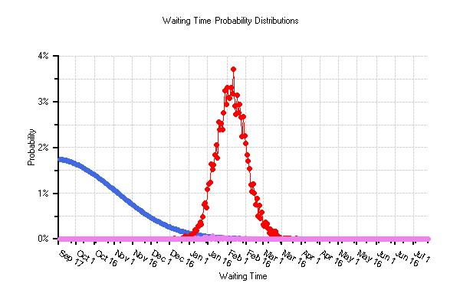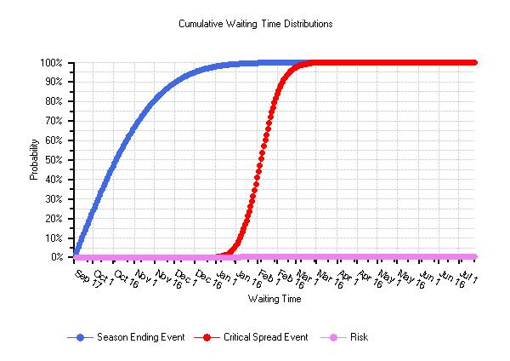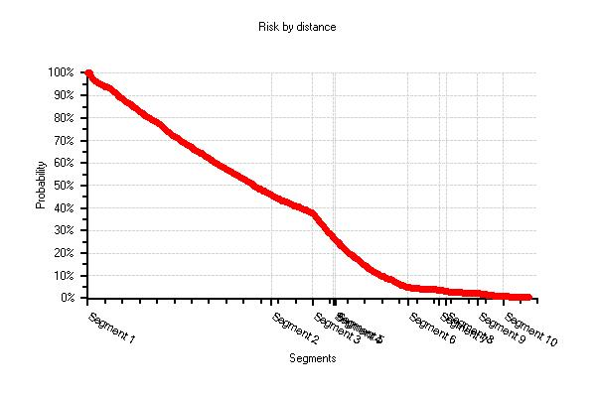

Risk by Segment

Segment Number | Chains from Current Fire Position | Probability of Fire Reaching End of Segment Before a Season Ending Event
1 | 106 | 46 %
2 | 130 | 38 %
3 | 142 | 27 %
4 | 143 | 26 %
5 | 185 | 5 %
6 | 203 | 4 %
7 | 207 | 3 %
8 | 225 | 2 %
9 | 240 | 1 %
10 | 255 | < 1 %

Time Period Details

Time Period: | 1
Start Date: | 5/1/2007
Period Name | Clover II

Weather Observations (days): | 6151
Aligned Observations (days): | 1200
Aligned Percent: | 20%

Conditions by Severity Level

 | Low | Mod | High | Ext
Probability | 15 | 75 | 7 | 3
Uncorrected 1 hour FM % | 7 | 6 | 6 | 5
10 hour Fuel Moisture % | 11 | 7 | 8 | 11
100 hour FM % | 15 | 13 | 13 | 12
Herbaceous FM % | 129 | 87 | 62 | 51
Woody FM % | 133 | 109 | 96 | 93
20' wind speed | 3 | 6 | 14 | 18
1000 hour FM % | 19 | 16 | 16 | 14

Data by Time Period, Severity Level, and Segment

Seg # | Map ID | Moisture Correction |  |  |  | Wind Adjustment |  |  |  | Flame Length
 |  | Low | Mod | High | Ext | Low | Mod | High | Ext | Low | Mod | High | Ext
1 | A | 0 |  |  |  | 0.4 |  |  |  | 1.0
2 | B | 0 |  |  |  | 0.6 |  |  |  | 9.2
3 | C | 3 | 3 | 3 | 3 | 0.2 | 0.2 | 0.2 | 0.2 | 0.2 | 0.4 | 0.6 | 0.8
4 | D | 1 |  |  |  | 0.6 |  |  |  | 6.1
5 | E | 3 | 3 | 3 | 3 | 0.2 | 0.2 | 0.2 | 0.2 | 0.2 | 0.4 | 0.6 | 0.8
6 | F | 0 |  |  |  | 0.6 |  |  |  | 7.5
7 | G | 3 | 3 | 3 | 3 | 0.2 | 0.2 | 0.2 | 0.2 | 0.3 | 0.4 | 0.7 | 0.8
8 | H | 1 |  |  |  | 0.6 |  |  |  | 4.0
9 | I | 3 | 3 | 3 | 3 | 0.2 | 0.2 | 0.2 | 0.2 | 0.2 | 0.2 | 0.3 | 0.5
10 | I | 3 | 3 | 3 | 3 | 0.2 | 0.2 | 0.2 | 0.2 | 1.0 | 1.1 | 2.8 | 3.5

Seg # | Map ID | Hourly Rate of Spread (ch) |  |  |  |  | Burn Period (hrs/day)
 |  | Low | Mod | High | Ext | Unsel | Low | Mod | High | Ext | Unsel
1 | A | 1.3 | 3 M | 4 M | 5 M | 1 | 3 | 4 | 5 | 6 | 1
2 | B | 16 | 3 M | 4 M | 5 M | 1 | 3 | 4 | 5 | 6 | 1
3 | C | 0.1 | 0.3 | 0.7 | 1.0 | 1 | 3 | 4 | 5 | 6 | 1
4 | D | 6 | 3 M | 4 M | 5 M | 1 | 3 | 4 | 5 | 6 | 1
5 | E | 0.1 | 0.3 | 0.7 | 1.0 | 1 | 3 | 4 | 5 | 6 | 1
6 | F | 10 | 3 M | 4 M | 5 M | 1 | 3 | 4 | 5 | 6 | 1
7 | G | 0.1 | 0.3 | 0.7 | 1.1 | 1 | 3 | 4 | 5 | 6 | 1
8 | H | 2.5 | 3 M | 4 M | 5 M | 1 | 3 | 4 | 5 | 6 | 1
9 | I | 0.1 | 0.1 | 0.1 | 0.5 | 1 | 3 | 4 | 5 | 6 | 1
10 | I | 0.3 | 0.3 | 2.5 | 4.0 | 1 | 3 | 4 | 5 | 6 | 1

Seg # | Map ID | Daily Spread (ch)
 |  | Low | Mod | High | Ext | Unsel
1 | A | 3.9 | 12 | 20 | 30 | 1
2 | B | 48 | 12 | 20 | 30 | 1
3 | C | 0.3 | 1.2 | 3.5 | 6 | 1
4 | D | 18 | 12 | 20 | 30 | 1
5 | E | 0.3 | 1.2 | 3.5 | 6 | 1
6 | F | 30 | 12 | 20 | 30 | 1
7 | G | 0.3 | 1.2 | 3.5 | 6.6 | 1
8 | H | 7.5 | 12 | 20 | 30 | 1
9 | I | 0.3 | 0.4 | 0.5 | 3 | 1
10 | I | 0.9 | 1.2 | 12.5 | 24 | 1

