Butte Lightning Complex

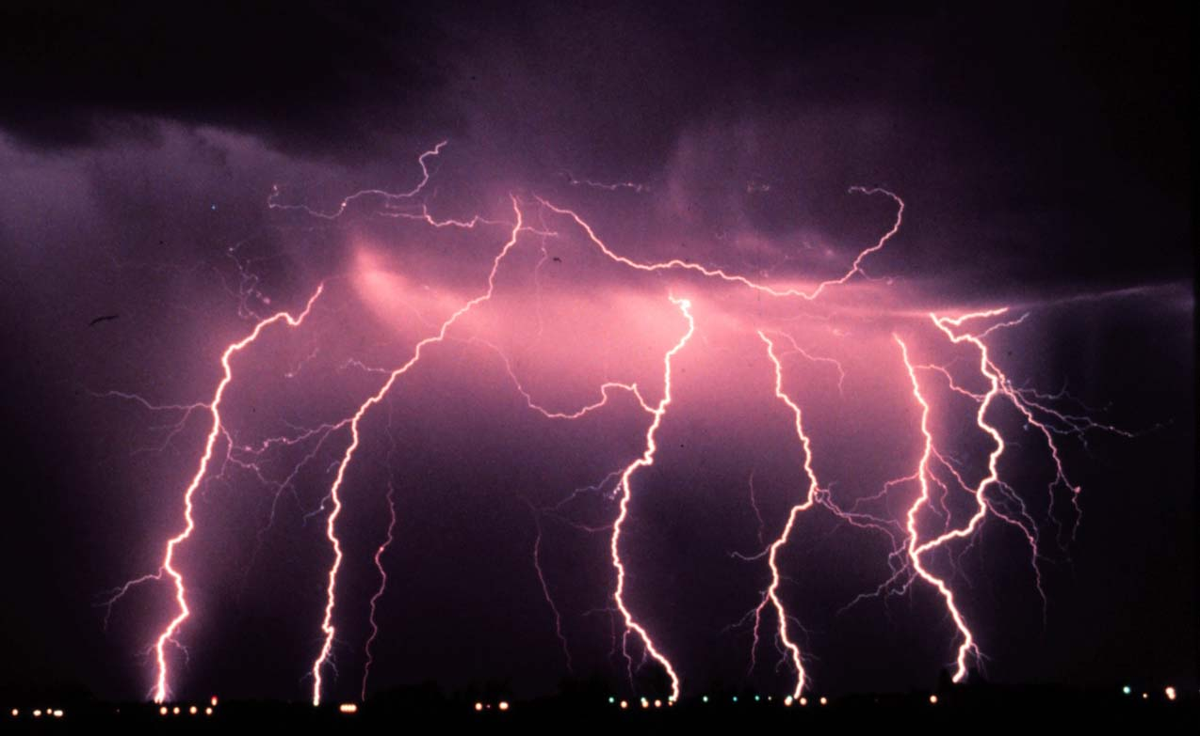

CABTU007660
Incident Action Plan
6-30-08
0600-0600

