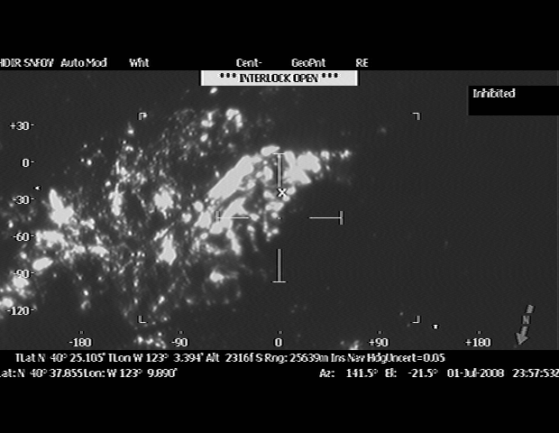

Actual Lat/Long of the cursor cursor Zulu Time (subtract 7 hours for Pacific time)
Compass
The tiff photo above is an example of the photo’s that are shot by the RC 26. These files are on the FTP site in folders by complexes. We are working complexes by the GACC priority list.

