Strategic Implementation Plan
Siskiyou-Blue2 and Ukonom Fires
August 2, 2008

Fire Description

An intense lightning storm occurred in northern California on June 20-21, 2008. Several of the fires that escaped initial attack grew into the Blue2 Fire, Siskiyou Complex and Ukonom Complex. These fires are burning in heavy conifer dead and down fuel, hardwood leaf litter, and a variety of shrubs (fuel models 4, 5, 6, 9, and 10). Conifer plantations are scattered throughout all fire areas. Topography is complex and very steep.

The Blue Fire is located on Six Rivers National Forest, Gasquet Ranger District. The Siskiyou and Ukonom Fires are burning on Klamath National. The Siskiyou is on the Happy Camp Ranger District and the Ukonom is managed by the Orleans Ranger District of the Six Rivers National Forest.

INSERT MAP OF AREA (FIRE PERIMETERS) WITH INSET OF NORTHERN CALIFORNIA

Hazards and Safety Concerns

The terrain is extremely steep and rugged. Operations personnel have reported numerous incidents of falling snags, rolling rocks and rolling debris. The forest vegetation is very dense and can limit one’s ability to see fire, adverse weather, aviation operations, poison oak and other fire-related hazards. Many of the roads used by fire personnel are steep with sharp curves and in some areas are one-lane. Rapid increases in fire spread and intensity have occurred during wind shifts and when the nighttime inversion lifts (as late as 1400). Terrain has influenced the need for a complex radio system which occasionally limits radio communications. Cellphone usage is limited to Happy Camp, Gasquet, Orleans and sporadic locations along ridgetops.

Resource Availability

Current resource availability is impacted by National Planning Level 4 and Northern California GACC planning Level 5. Type I crews and many individual overhead positions are not available in sufficient numbers to implement some strategic alternatives on these fires. Strategies and tactics have been modified and containment locations and dates have been pushed back to accommodate resource insufficiencies. Historically, the month of August experiences the highest demand for firefighting resources. It is anticipated that availability of resources will be limited throughout the next four to six weeks.

Current and Predicted Weather

6 to 14 Day Outlook for Monday August 4 through Monday August 12th

30 Day Outlook
August will start off with much of the continental U.S. dominated by a huge and strong high pressure system aloft. This is a typical pattern for this time of year. The high will initially be of greatest strength over the Four Corner states, but after the 5-6th could shift to the middle of the nation. August will likely see a few periods of 1-3 days in length, where moisture near the Colorado River Valley and Baja moves NW or north and up into the Sierra Nevada. Again, this is not uncommon for this time of year. The present thinking is that associated thunderstorms would be of about average moisture content east of the Cascade/ Sierra crest, which would mean a range from mixed wet-and-dry to locally fairly wet cells. However, to the west of the Cascade/Sierra ranges there would be greater potential for drier type lightning events. August is not typically a month with significant larger-scale gradient winds in northern California. Therefore the strongest winds or gusts in North Ops could end up being those localized and short-lived (but often very significant) thunderstorm downdraft winds. Sea breezes and up river afternoon\ winds will combine for local 20-30 mph gusts west of the coast range, whenever there is a marine layer of above average depth, or when the thermal trough is most pronounced.

Temperatures in the region are forecast to be near normal, and precipitation for the month of August is forecast to range from zero to isolated showers or thunderstorm amounts that may exceed ½ inch.

60 to 90 Day Outlook
The outlook for August through October calls for normal to slightly below-normal temperatures along the Northern California/SW Oregon border, and below-normal precipitation.

Current and Predicted Fire Behavior

Currently the fires are burning in litter and down logs in a fuels complex composed of brush and brush with conifer overstory. Backing fire behavior observed to date has been low flame lengths (1-2’) and moderate rates of spread (5 chains/hour) with enough heat to stress kill some of the overstory. In some areas, short periods of head spread as passive crown fire has occurred with high flame lengths (50-60’).

Blue 2 Fire
The coastal marine air seems to influence the Blue 2 fire more than the other two fires in the complex. This fire has exhibited the slowest growth rate and generally has higher humidity and lower temperature than the Siskiyou and Ukonom fires. However, because Blue 2 is located on the margin of the marine weather zone, this influence may vary, making weather forecasts problematic.

The fire continues to be topography-driven. Fire behavior has consisted mostly of smoldering and low-intensity ground fire, with of short uphill runs as the humidity drops and temperature increases. Fire activity usually picks up mid-afternoon after the inversion breaks, and generally lasts from 4 to 6 hours. Burning is more active from mid-slope to ridgetops where fuels are drier. The valley bottoms and riparian areas are still too moist to contribute to sustained fire spread, unless burnouts are conducted.

As seasonal drying occurs, expect an increase in fire behavior, with increasing spread rate, fire intensity, and severity. Riparian areas may no longer serve as barriers to fire spread.

Siskiyou Complex
The fire is topography-driven, with fire behavior currently consisting of slow surface spread with isolated torching. Fuels are in various stages of curing and this affects fire behavior. Lower and mid-slope fuels (less than 4000’) are burning readily. As fuels continue to dry at upper elevations, fire activity will increase. However, due to the complex terrain features, fire behavior will vary greatly depending on aspect, slope shading, and shelter from the prevailing winds.

Ukonom Complex
Fire behavior is similar to the Siskiyou with low-to moderate rates of spread and flame lengths. As the air mass becomes less stable, the fire behavior could increase, resulting in a potential for short to medium range crown fire runs and convection column development and long range spotting.

See Appendices….Fire progression Maps for Blue2, Siskiyou, and Ukonom

Weather Conditions for Burnout Operations
Burnouts have generally been successful when the relative humidity is in the 30% to 50% range. On the north-facing aspects of the southern perimeter of the Siskiyou-Blue2 Fire, windspeeds of less than 10 miles per hour coupled with a relative humidity range of 35-45% have been associated with good surface fuel cleanup with little torching of mature trees. Under these conditions, the best results were obtained when firing strips were narrow (50 feet or less) or the fire was allowed to back downslope. Burnouts conducted when humidity was below 30% have resulted in high overstory mortality and frequent spot fires especially when 20-ft winds were greater than 10 mph. South-facing aspects will require a higher humidity range 40-50%) to achieve similar results.

Most burnouts have been conducted during late afternoon through early evening hours. On the
North end of the Blue 2 Fire, downslope winds or additional firing strip are necessary to carry the fire deep enough to ensure a good black line.

Weather Conditions for Large Spread Events
Predicting the occurrence of conditions conducive to large fire growth is problematic in this area, due to the complex topography and fuels combined with the ever-changing influence of the moist coastal marine area vs the warmer drier air of the Sacramento Valley. The following factors are believed to have the greatest contribution to large fire growth:
- Unstable air
  - after inversions lift
  - in advance of frontal passages
- Afternoon winds of 15 mph or greater with RH below 25% for at least two consecutive days
- Alignment of winds with slope or major drainages
- Live fuel moisture in shrubs below 100%

Large spread events generally are associated with high winds and low relative humidity. For example, a period of rapid fire growth from July 7 through July 12 was correlated with low humidity and higher average wind speeds during those dates (see Figure). During much of this time the humidity at the Slater Butte RAWS was between 15 and 30%, and mean wind speed was 12 to 24 mph. Fires can be expected to spread 1-2 miles during these events. The frequency of high wind events (days with wind speed greater than 15 mph) with low RH (below 20%) between August and the end of October is a little over once a month We can expect an event like this to occur approximately every 3 weeks. It is important to maintain contact with the local meteorologists in order to anticipate these occurrences.

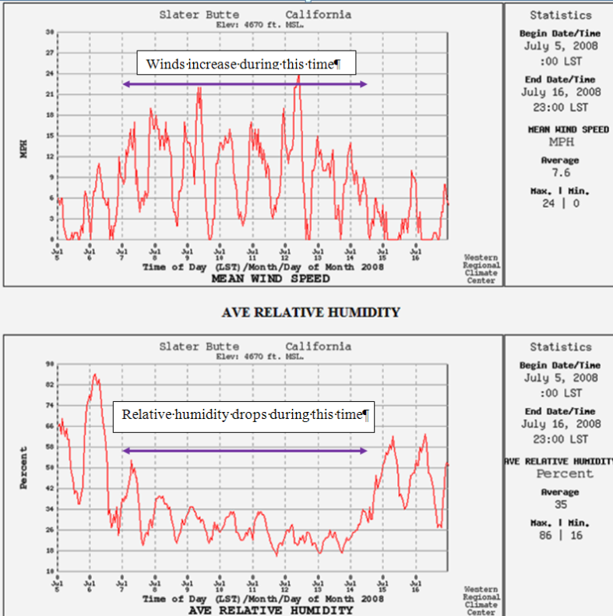

Blue Fire
Most of the large fire growth episodes occurred during the second week of July. The fire is currently contained on the west and north sides. It is spreading slowly (less than 5 chains/day) backing into the Blue Creek drainage, assisted by burnout operations. If burnout operations are unsuccessful or are not completed prior to a strong, dry northeast wind event, the fire could spread 1-2 miles, to the southwest down the Blue Creek drainage. Historical weather records indicate that this has a low probability of occurrence during the month of August.

FS Pro uses the Ship Mtn RAWS to model historic winds on the Blue Fire.

Siskiyou Complex
Most of the large fire growth episodes occurred during the second week of July. The fire is currently contained on the north, south, and east sides. It is spreading slowly to the southwest, much like the Blue 2 Fire. Spread is mostly due to firing operations along the southern indirect fireline that will eventually tie the fire in with the Blue 2 fire. The firing operation should reach a depth of ¼ to ½ mile to be effective in stopping a head fire runt the south.

Although, FS Pro uses the Ship Mtn RAWS to model historic winds on the Siskiyou, the Incident Meteorologist feels that Slater RAWS may be more representative of winds in the area.

Ukonom Complex
The fire is currently contained on the west and south sides along the Klamath and Salmon Rivers. It continues to spread to the east and north. Firing operations are being utilized along an indirect containment line on Yellowjacket Ridge to contain the SE portion of the fire perimeter. The fire is burning on both sides of the Hancock Fire (2006) spreading to the northeast further into the Marble Mountain Wilderness. Currently, the fire is approximately 10-15 miles from the eastern Wilderness boundary. It would likely require 2 to 3 high wind events in order for the fire to exit the wilderness on the north-northeast side. The probability of this is very low for the month of August.

The Panther Fire burning north of the Ukonom Complex could have a significant effect on fire behavior on the Ukonom Fire. Smoke from the Panther fire may slow fire spread on the Ukonom by shading the fire. However, there is a moderate to high probability that the two fires will burn together (only five miles separate them) on the western edge of the Marble Mountain Wilderness.

Although FS Pro has used the Ship Mtn RAWS to model historic winds on the Ukonom Complex, the Incident Meteorologist recommends that Blue Ridge RAWS gives a better representation.

Summary of Expected Fire Behavior
- If the dry weather pattern persists, expect shrubs to become more available for burning as live fuel moisture declines. Unburned or partially burned shrub fields are adjacent to many portions of the fire containment lines. These areas should be monitored for flareup and escape potential. Expect increased intensity, spread rates and daily growth on all aspects to increase over the next nine to ten weeks, then a gradual reduction of spread and intensity as the shorter days and deeper inversions make fire spread less likely.
- Sustained winds of >10 mph were a primary factor for fire spread on the Somes, Uncles and Hancock Fires of 2006. This pattern seems to be the same for the Ukonom of 2008. When winds align with drainages and exceed 10 mph and relative humidity values drop below 20%, expect fire behavior to transition from the surface to passive and active crowning with mid to long-range spotting (p to ½ mile).
- Expect the complex to grow slowly, with mainly backing either from flaming fronts or from roll-out. Flanking fire spread is also possible, enhanced by the mid-slope canyon winds. Based on the time of season, there is a high probability that most of the segments of concern will be affected over the next 30 days. A pre-frontal wind event may move the fires up the drainage into the Marble Mountain Wilderness and quickly impact the Wooley and Marble Mountain Segments. The fronts begin to occur during mid to late August.

FSPRO RUNS
The assumptions that supported the FSPRO and FARSITE analyses are subject to change as conditions change. Some of these reasons are:
- The models are only valid for the fuel and weather conditions for which they were run and for the timeframe they represent.
- Wind events may occur.
- The head of the fire may move to new and unpredicted locations. Live fuel moisture's may change dramatically.
- As the fire season progresses, the decision environment will also change.
- Such changes and others may invalidate the assumptions underlying the initial analyses.

As a result, previous risk estimates will no longer be accurate. Over time, it is essential that the assumptions underlying the risk estimates are periodically revalidated and that the simulations are re-run accordingly.

Season Ending Events
Fire seasons commonly end with a large scale rain event, but they can also end with the onset of shorter fall days and cooler/moister conditions. A useful indicator that is associated with seasonal fire potential is the Energy Release Component (ERC). When the ERC drops in the fall, they eventually reach a point which indicates that significant fire spread is unlikely. A fire analysis in Firefamily Plus was conducted using the Gasquet and Camp Six RAWS. The analysis indicated that fires over 100 acres occurred when the ERC is greater than 40. Season ending events were defined as ERC dropping below 40 and not recovering for more than a 5 day period. That criterion was used to establish season ending dates for the years 1998-2007.

The season ending events and historical timing were used as inputs for the “Term” portion of the Rare Event Risk Assessment Process (RERAP). This program creates a curved line depicting the probability of the termination of the season for different dates. The results are displayed below.

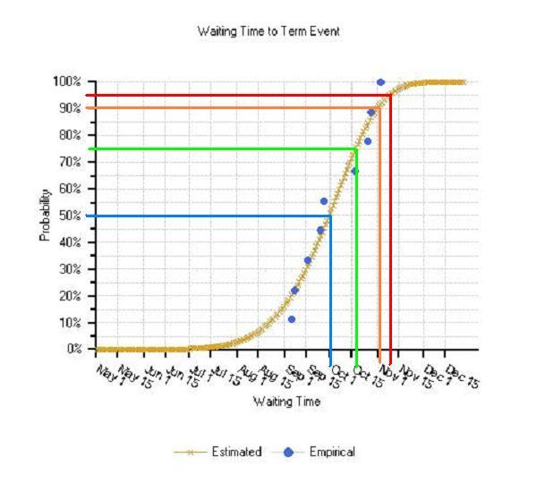

Fig. XX. Probability graph for season end, based on Gasquet and Camp Six RAWS dropping and remaining below and ERC of 40, and not recovering for more than 5 days again that season.

The above graph shows the following:

- 50% probability of a fire ending event by September 30th
- 75% probability of a fire ending event by October 18th.
- 90% probability of a fire ending event by November 1st.
- 95% probability of a fire ending event by November 9th

Fire-Slowing Events
Along with season ending events, there is a possibility of fire-slowing precipitation events prior to the end of the fire season. Precipitation of at least 0.25 inch in a day might be expected to at least slow fire spread for two or three days, while greater amounts of rain (over 0.50 inch) could slow or check fire spread for several days. The probabilities of receiving greater than 0.25 inch of rain in one day were derived using Sawyers Bar weather station precipitation data due to the proximity of the station to the fire area. Based on historical weather records, it is most likely that precipitation will occur in late September, as that is the time period when cold front passages are most common.

Time of Year | Total Number of Days Receiving >0.25 Inches of Rain 1971-2007  SAWYERS BAR RAWS
Early August | 10
Late August | 8
Early September | 9
Late September | 37
Early October | 18
Late October | 32
Table of Fire Slowing Events by Month, 1971-2007.

Decision Summary

Blue2 and Siskiyou Fires: The current strategy for the Blue2 and Siskiyou Fires is to implement firing operations along indirect containment lines and natural features to allow the two fires to merge. The planned containment perimeter and firing operation is displayed on the map below.

INSERT MAP OF BLUE-SISKIYOU WITH CURRENT PERIMTERE, PLANNED CONTAINMENT LINES, AND PLANNED FIRING

Note that the area immediately south and east of Chimney Rock will receive no further action. If the fire escapes the handline/trail system in this area, no action would be taken unless it burns beyond the Sawtooth Mountain to Harrington Mountain Ridgeline. If suppression action is needed, it should be located downslope to the west of the ridgeline to avoid cultural areas along the ridge.

The southern perimeter containment line runs along roads on ridgetops connected by handlines and dozerlines. The topographic features of this southern perimeter from east to west include Beans Ridge, Lonesome Ridge, and Nickowitz Peak. The containment line terminates near the confluence of Crescent City Fork and Blue Creek. Most of the planned firing will be on ridgetops and north-facing aspects in relatively moist fuels. An exception to road is the Nickowitz peak area which will be fired from the top down a south-facing aspect to FS Road 14N02. This critical portion of the southern containment line will require patience and the ability to respond rapidly to spot fires below the road (helicopter buckets would be the safest and most effective tool for spot fire containment).

Direct attack was considered but eliminated as a viable alternative due to:

- Hazards
  - Lack of safety zones
  - Steep terrain
  - Lack of lookout points
  - Rapid transitions from inactive fire behavior to rapid fire runs when inversions lift
- Lack of sufficient resources; specifically, Type I Handcrews
- Difficulties in avoiding damage to cultural resources
- Difficulties in avoiding damage to wilderness values

Ukonom Complex: The current strategy for the Ukonom Complex is to complete containment lines along the northwest perimeter to No Man’s Mountain; utilize the Salmon River along the southwest perimeter and utilize firing operations along Yellowjacket Ridge to secure the southeast perimeter. Much of the eastern perimeter is held in check by the 2006 Hancock Fire scar. An indirect containment line is being constructed (with followup firing operations planned) along a trail running to the northwest near Crapo Mountain. This indirect fireline can be tied into the Hancock ire scar near Clear Lakes.

The northern perimeter (south and west of No Man’s Mountain) will be allowed to burn into the Marble Mountain Wilderness to the northeast. The wilderness extends 12-15 miles over broken fuel and topography to the northeast. This fire has burned about five miles to the northeast since it’s ignition over forty days ago.

Planning Area

Map of fires (similar to previous map of general area with fire perimeters)

STRATEGIC IMPLEMENTATION PLAN ANALYSIS AREA PERIMETERS AS OF AUGUST XX, 2008…note: extend planning area to include all of Siskiyou and ukonom Wildfires

Decision Support Information
- Describe what tools were used and summarize outputs (or attach map products)

Values at Risk

Priority | Identifier | Value to Protect  (immediately threatened or at risk) | Consequence of  Damage or Loss  (dollars, loss time, on-site, down stream)
1 | V1 | Cultural Values in ElkValley and the other portions of the NCAU
2 | V2 | Green Diamond Timberland
3 | V3 | Red Mountain Electronic Site
 |  | Residences along Klamath River
 |  | Residences along Salmon River
 |  | Residences along the North Fork Salmon (Siskiyou County Road 1C 01)

Note: vegetation has been removed from the immediate vicinity of several wilderness structures. In addition, some of them have been wrapped with fire shelter material.

Courses of Action

This information can be displayed in a tabular format, see the attached table.

- Identify scenarios under which the IMT could achieve the stated objectives.
Scenario 1 | Firefighting resource limited, moderate fire behavior, with episodes of high intensity.

- Identify actions and assumptions common to all scenarios.

Continued management by IMT until all containment lines have been secured

- Management Action Points (MAP) are tactical decision points

- Mitigation Actions
Risk can be mitigated or eliminated in three central ways: reduce the hazard, reduce the probability of the hazardous event occurring, and reduce the value of potential losses that could occur from the risk. The first two risk mitigation types are the most frequently utilized actions.

Mitigation actions are on-the-ground activities that serve to increase the defensibility of a particular point, area, or line, like a planning area boundary (to reduce the probability of the hazardous event occurring); to check, direct, or delay the spread of fire (reduce the hazard); and to minimize threats to life, property, and resources (reduce value of potential losses or impacts). Mitigation Actions serve to mitigate or eliminate identified threats and may include non-fire tasks (such as closures, evacuations, management actions to reduce impacts from smoke, etc.) and specific fire applications.

- Suppression Tactics
- Suppression methods e.g. minimum impact, heavy equipment, etc
- Structure protection responsibilities
- Contingency Actions

- Resources Needed
Based on the Monitoring and Mitigation Actions, the Information Plan, and management oversight and qualifications needed to accomplish the objectives, resources needed to implement the plan and accomplish the objectives must be identified in this section. Resources identified here include those needed for the projected duration of operations

Scenario 1 |  | Firefighting resource rich, moderate fire behavior
Value Identifier | Probability that Value Affected |  | Time to Value Affected | Management Action Points | Management Actions | Resources Needed  (#s and Types) | Time to Accomplish | Cost
V1 | 85% |  | 14 days | MAP1 | Construct handline from Zeigler Point to Crab Creek and dozer lines from DP 5 to 7. Burn out handline. Support burnout operations with helicopter and bucket. | 10 - T1 crews, 4 dozers, type 3 helicopter, DC-10, bla, bla, bla | 4 shifts | $1,000,000
V2
V3

Reference Budget

Communications Plan
- Plan for the possibility of a long-term wildland fire event and the communication needs and expectations required for this potential circumstance.
- Provide a coordinated approach to communications associated with management of the Incident to the public, agency personnel, elected officials, cooperators, news media, and other identified internal and external audiences.
- Provide current, accurate and timely information using a variety of communication methods, including but not limited to internet, community meetings, briefings, media tours, and operation of the joint information call center.

Information Plan

Situation

On the afternoon of Friday, June 20, 2008, the Six Rivers National Forest began to experience numerous dry lightning strikes. Shortly after the lightning strikes were detected, fires were spotted and reported. The lightning continued through Saturday and Sunday, resulting in well over 800 fires across all of northern California, including the Blue fire on the Gasquet Ranger District.

Ranger District personnel were able to put some resources on the fire within a few days but were stretched thin with other fire activity. Several days later the District turned command of the Blue fire over to the team managing the Ukonom complex several miles to the east. A 4-hour distance between the fires made management problematic for this team. Another team was ordered to manage the Blue fire, and Svalberg’s team assumed command July 7.

The Blue fire lies partly within the Siskiyou Wilderness in an area rich with values that could be at risk:
- Heritage resources eligible for the National Historic Register
- Cultural and spiritual areas of the Karuk, Yurok and Tolowa Indian tribes
- Endangered and sensitive species
- Anadromous fisheries habitat
- Old growth timber
- Wild and Scenic River corridor
- Recreation use

In addition, values that lie to the west of the fire that could be affected include:
- Red Mountain Lookout and associated communication site servicing the Office of Emergency Services, Cal Fire, Del Norte County and private cellular phone providers
- Privately owned lands
- Scattered residences

Objectives

- Provide local communities, landowners, agencies, and media and user groups with timely, accurate information on current and predicted fire behavior on the Blue 2 fire.
- Provide information to target audiences on strategy and tactics and the expected results.
- Consult and work with Kurok, Yurok and Tolowa Indian tribal representatives regarding appropriate fire management in areas with significant cultural resources.
- Strengthen understanding of and support for the Forest’s fire management program.

Audiences

External
- Media (newspaper, radio and television)
- Local communities and scattered residences interfacing with wildlands
- Private landowners
- Yurok, Karuk and Tolowa Indian tribes
- Interested groups and individuals via e-mail and fax
- Recreationists
- Travelers

Internal
- Six Rivers National Forest and Smith River National Recreation Area
- Incident employees
- Agency employees
- Joint information center for Northern California

Messages

- Safety is the primary concern.
- Given the fire situation in California and limited firefighting resources, strategies reflect the goal of deploying available firefighting resources in the most effective, efficient and safest means possible.
- Strategies and tactics include consideration of firefighter and public health and safety, fire cause, current and predicted weather and potential fire behavior, values to be protected from fire, resource availability and cost effectiveness.
- The management team works closely with a team managing the Siskiyou complex to share resources and coordinate efforts.
- This team has a cadre of trained experts who utilize their knowledge, experience and computer modeling tools to predict fire behavior and simulate the predicted direction of fire spread over time.

Strategies

- Communicate clear, consistent messages about current and expected fire behavior and the effectiveness of current and planned actions.
- Explain the reasons behind selected strategies and tactics.

Tactics

- Provide daily update (trap line, media, visitor center, District Ranger, Forest fire information team, bulletin board on way to G-O road and in spike camp), including an updated map showing fire location in relation to communities and other fires in the area.
- Update Inciweb; post maps and pictures.
- Participate in radio interviews to provide information and emphasize messages.
- Provide media escort to fire in coordination with operations.
- Provide maps for agency administrator to use in discussions with public officials (maps labeled to identify local communities in relation to fires in the area, road and trail closures, points of interest).

Signatures
Name / Position

Date

Appendices
- Modeling Report, Long-Term Assessment, outputs
- Costing Analysis
- Periodic Fire Assessment
  - Relative Risk Assessment
  - Incident Complexity Analysis
  - Management Response Decision Rationale
  - Signature(s)

