
National Preparedness Level: 2
Incident: KNF South Ukonom
Welcome: Jay Perkins | Sign out
Analysis: Marbles Salt Log Creek English Peak update

Analysis Report
Incident Information


Incident Name: | KNF South Ukonom | Author Name: | Isbell, Clint
Start Date: | 09/12/2008 | Contained: | No
Latitude: | 41.3 | Longitude: | 123.0
Geographic Area: | Northern California | Jurisdiction: | USFS
Nationally Significant: | No | Forest Name: | Klamath National Forest

FSPro Analysis Information

Analysis Name: | Marbles Salt Log Creek English Peak update | Analyst Name: | Isbell, Clint
Requested: | 09/25/2008 12:47 CDT | Completed: | 09/25/2008 13:20 CDT
Analysis Type: | FSPro

  FSPro Results
  Probability Detail(acres)
  Zone |  | In Zone | Cumulative
   | 80-100% | 127 | 127
   | 60-79% | 165 | 292
   | 40-59% | 193 | 485
   | 20-39% | 368 | 853
   | 5-19% | 1,194 | 2,047
   | 0.2-4.9% | 3,964 | 6,011
   | < 0.2% | 1,028 | 7,039

Fire Size (acres)
Average Size: | 609
90th Percentile: | 1,383
70th Percentile: | 619
50th Percentile: | 404
30th Percentile: | 207
10th Percentile: | 96
Largest Fire: | 5,995

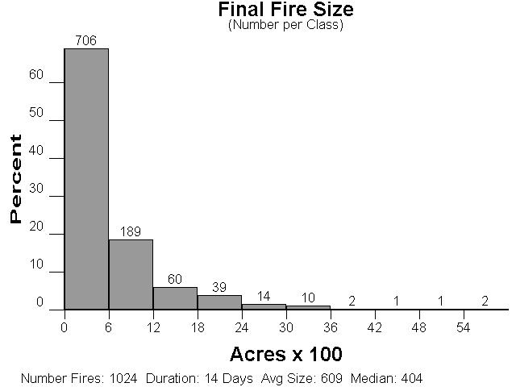

FSPro General Input

Analysis Start: | 9/25/08 | Duration: | 14 days
Resolution: | 90.0 meters | Simulations: | 1024 fires
ERC Station: | 40237 - COLLINS BALDY LO | Wind Station: | 40203 - BLUE RIDGE (KNF)

FSPro General Annotations
No FSPro General Annotations exist.

FSPro ERC Classes

ERC Station: | 40237 - COLLINS BALDY LO | Climate Class: | 3 : Subhumid - Humid
Green-up Date: | May 26 | Grass Type: | P : Perennial
Slope Class: | 3 : 41 - 55% | Position on Slope: | 3
Station Latitude: | 41.7751658 | Station Longitude: | 122.9519285
Station Elevation: | 5493 | Station Aspect: | 4
Station Avg. Precip.: | 35.0 | Station Forecast Zone: | 587
Filter Start Date: | 05/01/1980 | Filter End Date: | 10/31/2008

ERC Classes
%ile | Min ERC | Max ERC | 1 Hour FM | 10 Hour FM | 100 Hour FM | Herb FM | Woody FM | Burn Period | Spot Prob. | Delay
97 | 85 | 98 | 3.0 | 3.7 | 4.8 | 65.0 | 80.0 | 300 | 0.15 | 0
90 | 78 | 85 | 3.7 | 4.3 | 6.0 | 75.0 | 90.0 | 240 | 0.10 | 0
79 | 72 | 78 | 4.3 | 5.0 | 6.8 | 85.0 | 105.0 | 180 | 0.05 | 0
70 | 67 | 72 | 4.9 | 5.8 | 7.7 | 95.0 | 115.0 | 120 | 0.01 | 0
60 | 61 | 67 | 5.4 | 6.4 | 8.5 | 110.0 | 125.0 | 80 | 0.00 | 0

ERC Classes Annotations
No ERC Classes Annotations exist.

FSPro ERC Streams

Generated ERC Streams
Date | Avg ERC | Std Dev | Current Erc
5/1/08 | 21.45 | 15.59 | 0
5/2/08 | 20.44 | 15.47 | 0
5/3/08 | 20.56 | 14.78 | 0
5/4/08 | 25.13 | 16.68 | 6
5/5/08 | 22.17 | 18.40 | 12
5/6/08 | 23.25 | 19.26 | 14
5/7/08 | 22.20 | 19.65 | 17
5/8/08 | 23.40 | 19.78 | 22
5/9/08 | 25.62 | 18.61 | 0
5/10/08 | 25.84 | 20.50 | 0
5/11/08 | 27.68 | 21.11 | 12
5/12/08 | 26.38 | 20.50 | 15
5/13/08 | 25.50 | 19.32 | 18
5/14/08 | 21.85 | 14.89 | 19
5/15/08 | 26.29 | 16.49 | 23
5/16/08 | 23.82 | 16.53 | 29
5/17/08 | 24.18 | 16.54 | 33
5/18/08 | 25.14 | 16.61 | 36
5/19/08 | 23.96 | 17.96 | 38
5/20/08 | 27.00 | 20.99 | 32
5/21/08 | 28.74 | 19.79 | 32
5/22/08 | 27.63 | 18.09 | 31
5/23/08 | 28.70 | 20.77 | 19
5/24/08 | 30.70 | 19.52 | 28
5/25/08 | 31.63 | 21.13 | 26
5/26/08 | 29.42 | 21.55 | 25
5/27/08 | 29.67 | 20.95 | 2
5/28/08 | 30.09 | 24.06 | 0
5/29/08 | 31.88 | 22.19 | 0
5/30/08 | 32.33 | 22.77 | 5
5/31/08 | 34.79 | 20.41 | 8
6/1/08 | 35.38 | 20.02 | 11
6/2/08 | 32.67 | 19.11 | 16
6/3/08 | 34.19 | 19.84 | 0
6/4/08 | 33.54 | 20.06 | 18
6/5/08 | 34.96 | 22.21 | 18
6/6/08 | 32.15 | 22.14 | 20
6/7/08 | 34.58 | 21.70 | 22
6/8/08 | 36.08 | 20.64 | 25
6/9/08 | 35.33 | 21.93 | 23
6/10/08 | 35.42 | 21.25 | 26
6/11/08 | 33.71 | 17.93 | 29
6/12/08 | 32.40 | 18.48 | 34
6/13/08 | 32.48 | 18.90 | 37
6/14/08 | 34.21 | 18.01 | 39
6/15/08 | 36.38 | 15.89 | 41
6/16/08 | 36.35 | 18.18 | 42
6/17/08 | 35.84 | 18.35 | 44
6/18/08 | 37.15 | 19.32 | 48
6/19/08 | 38.35 | 18.74 | 49
6/20/08 | 40.48 | 17.93 | 52
6/21/08 | 43.00 | 15.86 | 51
6/22/08 | 43.69 | 16.07 | 55
6/23/08 | 42.81 | 16.45 | 55
6/24/08 | 42.63 | 16.26 | 56
6/25/08 | 43.38 | 16.65 | 60
6/26/08 | 42.74 | 16.79 | 58
6/27/08 | 42.23 | 17.67 | 59
6/28/08 | 45.56 | 15.19 | 62
6/29/08 | 45.52 | 17.22 | 58
6/30/08 | 45.56 | 18.89 | 61
7/1/08 | 45.48 | 18.15 | 59
7/2/08 | 47.52 | 17.45 | 61
7/3/08 | 47.50 | 16.48 | 59
7/4/08 | 49.16 | 17.33 | 54
7/5/08 | 50.29 | 16.74 | 55
7/6/08 | 51.63 | 16.71 | 56
7/7/08 | 50.58 | 17.89 | 59
7/8/08 | 49.44 | 18.05 | 63
7/9/08 | 53.22 | 18.32 | 67
7/10/08 | 52.79 | 18.16 | 69
7/11/08 | 53.93 | 18.58 | 73
7/12/08 | 53.93 | 19.13 | 75
7/13/08 | 56.48 | 18.37 | 77
7/14/08 | 55.26 | 17.93 | 75
7/15/08 | 52.54 | 18.71 | 72
7/16/08 | 54.08 | 20.53 | 72
7/17/08 | 52.32 | 20.00 | 72
7/18/08 | 53.74 | 19.61 | 72
7/19/08 | 54.93 | 18.78 | 74
7/20/08 | 56.08 | 18.15 | 77
7/21/08 | 55.00 | 17.55 | 77
7/22/08 | 56.00 | 18.84 | 73
7/23/08 | 56.81 | 18.37 | 74
7/24/08 | 57.61 | 17.86 | 75
7/25/08 | 60.11 | 17.33 | 75
7/26/08 | 61.35 | 17.27 | 75
7/27/08 | 61.04 | 16.67 | 74
7/28/08 | 59.80 | 16.25 | 71
7/29/08 | 60.23 | 15.56 | 71
7/30/08 | 61.04 | 17.57 | 72
7/31/08 | 62.00 | 15.77 | 73
8/1/08 | 62.59 | 15.47 | 74
8/2/08 | 61.89 | 15.50 | 70
8/3/08 | 61.63 | 14.69 | 71
8/4/08 | 62.44 | 15.02 | 75
8/5/08 | 62.07 | 14.55 | 80
8/6/08 | 60.41 | 15.04 | 75
8/7/08 | 61.81 | 16.19 | 76
8/8/08 | 63.30 | 16.22 | 73
8/9/08 | 64.12 | 16.12 | 71
8/10/08 | 64.56 | 16.62 | 73
8/11/08 | 63.67 | 16.64 | 74
8/12/08 | 64.44 | 17.11 | 74
8/13/08 | 66.36 | 17.97 | 76
8/14/08 | 66.11 | 18.98 | 79
8/15/08 | 66.07 | 18.40 | 82
8/16/08 | 66.18 | 18.11 | 80
8/17/08 | 65.54 | 18.89 | 75
8/18/08 | 64.29 | 18.90 | 75
8/19/08 | 62.37 | 19.04 | 71
8/20/08 | 63.77 | 18.46 | 62
8/21/08 | 63.04 | 18.41 | 61
8/22/08 | 61.21 | 20.85 | 66
8/23/08 | 62.36 | 18.59 | 67
8/24/08 | 63.25 | 18.69 | 68
8/25/08 | 62.85 | 20.35 | 67
8/26/08 | 64.43 | 19.61 | 67
8/27/08 | 64.48 | 19.95 | 72
8/28/08 | 63.21 | 20.70 | 74
8/29/08 | 63.88 | 18.94 | 75
8/30/08 | 66.12 | 18.37 | 70
8/31/08 | 63.33 | 21.98 | 68
9/1/08 | 63.77 | 21.28 | 68
9/2/08 | 63.63 | 19.95 | 73
9/3/08 | 62.28 | 19.89 | 74
9/4/08 | 62.78 | 18.86 | 76
9/5/08 | 65.07 | 18.07 | 78
9/6/08 | 65.11 | 17.77 | 78
9/7/08 | 64.21 | 19.30 | 79
9/8/08 | 62.14 | 20.44 | 80
9/9/08 | 62.68 | 18.82 | 77
9/10/08 | 63.56 | 20.38 | 79
9/11/08 | 62.85 | 19.95 | 83
9/12/08 | 62.29 | 19.72 | 83
9/13/08 | 61.96 | 19.69 | 83
9/14/08 | 58.19 | 20.71 | 85
9/15/08 | 57.48 | 20.09 | 86
9/16/08 | 57.31 | 20.25 | 87
9/17/08 | 57.19 | 22.14 | 89
9/18/08 | 54.33 | 23.12 | 93
9/19/08 | 55.11 | 21.13 | 83
9/20/08 | 57.19 | 20.83 | 71
9/21/08 | 58.81 | 20.37 | 64
9/22/08 | 59.74 | 20.12 | 65
9/23/08 | 60.38 | 20.73 | 70
9/24/08 | 60.00 | 19.48 | 74
9/25/08 | 56.71 | 22.41 | -1
9/26/08 | 60.50 | 20.71 | -1
9/27/08 | 60.32 | 20.17 | -1
9/28/08 | 60.96 | 20.29 | -1
9/29/08 | 60.65 | 21.55 | -1
9/30/08 | 58.58 | 19.23 | -1
10/1/08 | 54.96 | 20.65 | -1
10/2/08 | 53.56 | 19.39 | -1
10/3/08 | 53.00 | 19.44 | -1
10/4/08 | 52.20 | 18.41 | -1
10/5/08 | 53.80 | 18.97 | -1
10/6/08 | 53.48 | 20.18 | -1
10/7/08 | 52.22 | 22.54 | -1
10/8/08 | 53.80 | 21.94 | -1
10/9/08 | 53.17 | 20.35 | -1
10/10/08 | 50.38 | 20.75 | -1
10/11/08 | 49.54 | 20.87 | -1
10/12/08 | 51.65 | 21.93 | -1
10/13/08 | 50.33 | 20.44 | -1
10/14/08 | 48.08 | 22.24 | -1
10/15/08 | 50.50 | 22.67 | -1
10/16/08 | 51.65 | 21.65 | -1
10/17/08 | 50.22 | 23.61 | -1
10/18/08 | 47.91 | 22.25 | -1
10/19/08 | 47.00 | 22.86 | -1
10/20/08 | 44.30 | 24.63 | -1
10/21/08 | 46.62 | 24.44 | -1
10/22/08 | 44.62 | 24.34 | -1
10/23/08 | 44.33 | 25.48 | -1
10/24/08 | 45.38 | 25.75 | -1
10/25/08 | 41.40 | 25.23 | -1
10/26/08 | 41.85 | 26.34 | -1
10/27/08 | 41.76 | 27.23 | -1
10/28/08 | 38.75 | 26.35 | -1
10/29/08 | 37.55 | 25.42 | -1
10/30/08 | 37.20 | 25.72 | -1
10/31/08 | 37.85 | 25.55 | -1

Weather Forecast Data
Date | ERC | Speed | Direction
09/25/2008 | 76 | 10 | 300
09/26/2008 | 77 | 10 | 225
09/27/2008 | 77 | 10 | 225

ERC Streams Annotations
No ERC Streams Annotations exist.

FSPro Winds

Wind Station: | 40203 - BLUE RIDGE (KNF) | Pos. on Slope: | 3.0
Station Latitude: | 41.2690822 | Station Longitude: | 123.1890015
Station Elevation: | 5880 | Station Aspect: | 4
Avg. Precip.: | 35.0 | Forecast Zone: | 586
Filter Start Date: | 09/01/2001 | Filter End Date: | 10/15/2007
Winds Type: | Ten Min Avg and Gusts | Calm Wind Threshhold: | 1
Calm Weight: | 5.66 | Total Weight: | 100

Generated Winds Data
Speed | 45 | 90 | 135 | 180 | 225 | 270 | 315 | 360
5 | 2.35 | 2.63 | 1.89 | 1.56 | 2.70 | 4.87 | 3.98 | 1.17
10 | 5.47 | 2.80 | 2.46 | 2.46 | 3.57 | 10.56 | 9.60 | 1.77
15 | 2.94 | 1.15 | 1.28 | 1.92 | 2.27 | 5.47 | 6.93 | 1.09
20 | 1.27 | 0.52 | 0.53 | 0.75 | 0.53 | 1.99 | 2.92 | 0.37
25 | 0.28 | 0.19 | 0.21 | 0.25 | 0.09 | 0.35 | 0.37 | 0.03
30 | 0.07 | 0.01 | 0.07 | 0.24 | 0.03 | 0.00 | 0.03 | 0.00
35 | 0.01 | 0.00 | 0.04 | 0.09 | 0.00 | 0.00 | 0.01 | 0.00
40 | 0.00 | 0.00 | 0.01 | 0.07 | 0.00 | 0.00 | 0.03 | 0.00

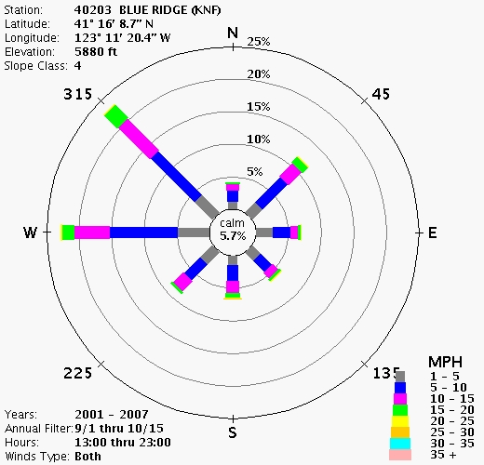

FsPro Winds Annotations
No FsPro Winds Annotations exist.

FSPro Landscape

Upper Left Latitude: | 41.5183 | Upper Left Longitude: | 123.3421
Lower Right Latitude: | 41.2325 | Lower Right Longitude: | 123.0294
Fuel Model: | Fuel Model 40

FsPro Landscape Annotations
No FsPro Landscape Annotations exist.

FSPro Landscape Editor

Attribute | Rule Description
Fuel Model | If (LCP intersects 2005-2007fires) Set Fuel Model to 181
Fuel Model | Else If (Fuel Model is 165, 188 or 189) Set Fuel Model to 187
Fuel Model | Else If (Fuel Model is 144 or 146) AND (Elevation >= 1500) Set Fuel Model to 142

Landscape Editor Annotations
No Landscape Editor Annotations exist.

Analysis Log

Time (CDT) | Status | User | Comments
09/25/2008 12:47 | Assigned | Isbell, Clint | update needed for salt log creek
09/25/2008 13:00 | Queued
09/25/2008 13:01 | In Process
09/25/2008 13:12 | Review
09/25/2008 13:20 | Complete | Isbell, Clint

