
National Preparedness Level: 2
Incident: SRF Ukonom Complex
Welcome: Jay Perkins | Sign out
Analysis: Sisq_Blue2_Harrington Mtn 14 day 1000fire update
I
Analysis Report
Incident Information


Incident Name: | SRF Ukonom Complex | Author Name: | Ziegler, Amy
Start Date: | 06/20/2008 | Contained: | No
Latitude: | 41.3564 | Longitude: | 123.3761
Geographic Area: | Northern California | Jurisdiction: | USFS
Nationally Significant: | Yes | Forest Name: | Six Rivers NF

FSPro Analysis Information

Analysis Name: | Sisq_Blue2_Harrington Mtn 14 day 1000fire update | Analyst Name: | Isbell, Clint
Requested: | 09/25/2008 11:37 CDT | Completed: | 09/25/2008 12:56 CDT
Analysis Type: | FSPro

  FSPro Results
  Probability Detail(acres)
  Zone |  | In Zone | Cumulative
   | 80-100% | 2,478 | 2,478
   | 60-79% | 1,772 | 4,250
   | 40-59% | 1,805 | 6,055
   | 20-39% | 2,536 | 8,591
   | 5-19% | 3,676 | 12,267
   | 0.2-4.9% | 10,857 | 23,124
   | < 0.2% | 9,666 | 32,790

Fire Size (acres)
Average Size: | 5,732
90th Percentile: | 10,584
70th Percentile: | 7,201
50th Percentile: | 5,207
30th Percentile: | 3,362
10th Percentile: | 1,758
Largest Fire: | 20,868

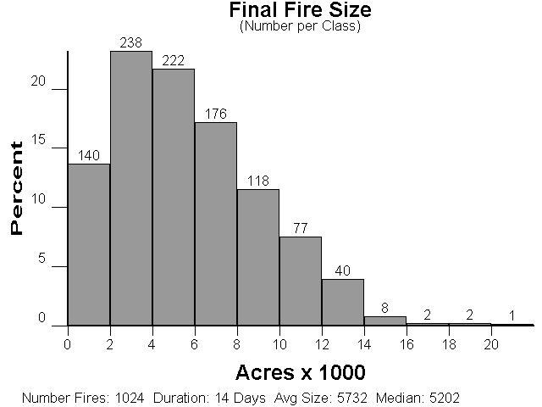

FSPro General Input

Analysis Start: | 9/25/08 | Duration: | 14 days
Resolution: | 90.0 meters | Simulations: | 1024 fires
ERC Station: | 40231 - SOMES BAR | Wind Station: | 40203 - BLUE RIDGE (KNF)

FSPro General Annotations
No FSPro General Annotations exist.

FSPro ERC Classes

ERC Station: | 40231 - SOMES BAR | Climate Class: | 3 : Subhumid - Humid
Green-up Date: | April 16 | Grass Type: | P : Perennial
Slope Class: | 4 : 56 - 75% | Position on Slope: | 1
Station Latitude: | 41.3903605 | Station Longitude: | 123.4922101
Station Elevation: | 920 | Station Aspect: | 4
Station Avg. Precip.: | 59.8 | Station Forecast Zone: | 586
Filter Start Date: | 05/01/1980 | Filter End Date: | 10/30/2008

ERC Classes
%ile | Min ERC | Max ERC | 1 Hour FM | 10 Hour FM | 100 Hour FM | Herb FM | Woody FM | Burn Period | Spot Prob. | Delay
97 | 65 | 76 | 3.4 | 4.5 | 7.7 | 65.0 | 80.0 | 300 | 0.15 | 0
90 | 57 | 65 | 3.8 | 5.0 | 9.7 | 75.0 | 90.0 | 240 | 0.10 | 0
79 | 51 | 57 | 4.4 | 5.7 | 11.2 | 85.0 | 105.0 | 180 | 0.05 | 0
70 | 47 | 51 | 4.8 | 6.2 | 12.2 | 95.0 | 115.0 | 120 | 0.01 | 0
58 | 42 | 47 | 5.2 | 6.9 | 13.0 | 110.0 | 125.0 | 80 | 0.00 | 0

ERC Classes Annotations
No ERC Classes Annotations exist.

FSPro ERC Streams

Generated ERC Streams
Date | Avg ERC | Std Dev | Current Erc
5/1/08 | 10.94 | 9.65 | 19
5/2/08 | 10.18 | 10.17 | 19
5/3/08 | 10.67 | 9.71 | 20
5/4/08 | 11.82 | 9.49 | 21
5/5/08 | 14.28 | 10.49 | 24
5/6/08 | 14.56 | 10.63 | 25
5/7/08 | 14.61 | 10.64 | 29
5/8/08 | 15.00 | 11.06 | 29
5/9/08 | 14.33 | 11.02 | 28
5/10/08 | 14.94 | 11.14 | 28
5/11/08 | 15.59 | 10.24 | 28
5/12/08 | 15.86 | 11.22 | 30
5/13/08 | 14.85 | 10.01 | 31
5/14/08 | 15.19 | 11.45 | 32
5/15/08 | 16.14 | 11.23 | 35
5/16/08 | 16.17 | 12.12 | 37
5/17/08 | 17.00 | 12.28 | 40
5/18/08 | 17.58 | 11.65 | 41
5/19/08 | 17.92 | 11.91 | 43
5/20/08 | 18.26 | 12.56 | 39
5/21/08 | 19.45 | 12.41 | 40
5/22/08 | 18.36 | 13.18 | 42
5/23/08 | 18.52 | 12.87 | 19
5/24/08 | 20.22 | 11.59 | 17
5/25/08 | 21.57 | 11.77 | 35
5/26/08 | 21.78 | 12.40 | 34
5/27/08 | 20.65 | 12.78 | 35
5/28/08 | 20.68 | 14.07 | 28
5/29/08 | 23.50 | 13.88 | 28
5/30/08 | 23.82 | 13.51 | 32
5/31/08 | 24.48 | 13.78 | 31
6/1/08 | 24.63 | 14.11 | 33
6/2/08 | 24.83 | 14.97 | 35
6/3/08 | 24.33 | 14.15 | 29
6/4/08 | 24.63 | 13.20 | 35
6/5/08 | 23.63 | 14.92 | 34
6/6/08 | 22.17 | 14.30 | 36
6/7/08 | 23.60 | 13.16 | 38
6/8/08 | 24.56 | 12.77 | 40
6/9/08 | 24.46 | 12.80 | 40
6/10/08 | 25.04 | 12.41 | 43
6/11/08 | 25.78 | 12.12 | 45
6/12/08 | 27.48 | 11.78 | 49
6/13/08 | 26.00 | 11.64 | 51
6/14/08 | 28.12 | 10.37 | 52
6/15/08 | 29.28 | 10.66 | 52
6/16/08 | 29.60 | 12.02 | 51
6/17/08 | 30.33 | 12.78 | 49
6/18/08 | 29.48 | 13.57 | 50
6/19/08 | 31.76 | 12.07 | 53
6/20/08 | 32.88 | 11.82 | 55
6/21/08 | 34.08 | 11.53 | 50
6/22/08 | 35.52 | 11.65 | 54
6/23/08 | 35.08 | 10.89 | 53
6/24/08 | 34.40 | 12.48 | 54
6/25/08 | 34.52 | 10.97 | 53
6/26/08 | 35.31 | 11.40 | 52
6/27/08 | 34.88 | 12.02 | 56
6/28/08 | 36.12 | 10.82 | 55
6/29/08 | 35.35 | 11.67 | 51
6/30/08 | 35.36 | 12.31 | 51
7/1/08 | 36.44 | 10.86 | 50
7/2/08 | 37.48 | 10.16 | 51
7/3/08 | 37.76 | 9.67 | 52
7/4/08 | 37.88 | 10.27 | 53
7/5/08 | 37.88 | 10.37 | 51
7/6/08 | 40.00 | 9.74 | 52
7/7/08 | 40.32 | 9.81 | 55
7/8/08 | 39.96 | 11.48 | 59
7/9/08 | 41.15 | 10.84 | 60
7/10/08 | 41.11 | 10.24 | 63
7/11/08 | 41.26 | 10.87 | 65
7/12/08 | 42.27 | 10.90 | 66
7/13/08 | 42.96 | 11.13 | 63
7/14/08 | 43.48 | 10.78 | 58
7/15/08 | 43.37 | 11.71 | 55
7/16/08 | 43.88 | 11.03 | 56
7/17/08 | 43.41 | 10.40 | 56
7/18/08 | 43.67 | 11.36 | 57
7/19/08 | 44.30 | 10.70 | 57
7/20/08 | 44.85 | 9.84 | 58
7/21/08 | 44.70 | 9.87 | 57
7/22/08 | 45.42 | 10.15 | 53
7/23/08 | 45.44 | 10.06 | 55
7/24/08 | 46.85 | 9.82 | 55
7/25/08 | 47.85 | 9.90 | 56
7/26/08 | 48.54 | 9.62 | 58
7/27/08 | 48.69 | 9.16 | 58
7/28/08 | 48.16 | 9.30 | 56
7/29/08 | 48.46 | 9.20 | 58
7/30/08 | 48.28 | 10.01 | 59
7/31/08 | 48.42 | 8.79 | 59
8/1/08 | 49.48 | 8.27 | 60
8/2/08 | 49.21 | 8.26 | 58
8/3/08 | 49.72 | 8.06 | 57
8/4/08 | 49.00 | 8.94 | 58
8/5/08 | 48.56 | 8.82 | 57
8/6/08 | 47.88 | 9.20 | 60
8/7/08 | 49.52 | 8.84 | 61
8/8/08 | 49.52 | 9.65 | 63
8/9/08 | 49.56 | 9.11 | 61
8/10/08 | 49.74 | 9.16 | 59
8/11/08 | 49.62 | 9.96 | 57
8/12/08 | 50.40 | 10.33 | 57
8/13/08 | 50.37 | 10.41 | 58
8/14/08 | 50.62 | 10.64 | 61
8/15/08 | 50.00 | 10.44 | 60
8/16/08 | 49.15 | 10.51 | 62
8/17/08 | 47.70 | 11.44 | 63
8/18/08 | 47.11 | 11.27 | 60
8/19/08 | 47.23 | 10.81 | 61
8/20/08 | 47.08 | 10.81 | 29
8/21/08 | 46.78 | 11.30 | 56
8/22/08 | 46.07 | 9.56 | 55
8/23/08 | 47.15 | 9.25 | 53
8/24/08 | 47.67 | 9.52 | 55
8/25/08 | 45.93 | 11.97 | 56
8/26/08 | 47.04 | 12.17 | 61
8/27/08 | 46.60 | 13.22 | 61
8/28/08 | 46.04 | 13.57 | 66
8/29/08 | 45.69 | 14.63 | 67
8/30/08 | 45.92 | 14.81 | 64
8/31/08 | 45.81 | 15.03 | 68
9/1/08 | 46.42 | 14.90 | 68
9/2/08 | 45.96 | 14.68 | 71
9/3/08 | 45.63 | 14.49 | 72
9/4/08 | 46.12 | 13.48 | 74
9/5/08 | 47.11 | 13.09 | 74
9/6/08 | 47.44 | 13.25 | 75
9/7/08 | 47.70 | 12.36 | 76
9/8/08 | 46.37 | 13.01 | 75
9/9/08 | 47.12 | 11.23 | 73
9/10/08 | 45.96 | 12.39 | 75
9/11/08 | 45.46 | 12.31 | 76
9/12/08 | 46.58 | 11.93 | 75
9/13/08 | 44.96 | 14.79 | 76
9/14/08 | 42.65 | 14.48 | 76
9/15/08 | 41.48 | 13.96 | 76
9/16/08 | 40.48 | 14.90 | 75
9/17/08 | 39.38 | 15.00 | 74
9/18/08 | 39.77 | 14.54 | 71
9/19/08 | 39.81 | 14.54 | 62
9/20/08 | 41.23 | 14.31 | 65
9/21/08 | 42.69 | 14.31 | 63
9/22/08 | 41.37 | 15.09 | 64
9/23/08 | 41.31 | 14.42 | 64
9/24/08 | 40.69 | 15.08 | 67
9/25/08 | 39.52 | 16.11 | -1
9/26/08 | 41.56 | 15.01 | -1
9/27/08 | 40.32 | 14.76 | -1
9/28/08 | 40.16 | 15.24 | -1
9/29/08 | 39.96 | 14.36 | -1
9/30/08 | 39.17 | 12.53 | -1
10/1/08 | 37.46 | 13.07 | -1
10/2/08 | 36.16 | 11.43 | -1
10/3/08 | 37.17 | 10.23 | -1
10/4/08 | 35.72 | 11.08 | -1
10/5/08 | 33.42 | 13.74 | -1
10/6/08 | 36.00 | 13.30 | -1
10/7/08 | 34.46 | 14.53 | -1
10/8/08 | 35.57 | 15.86 | -1
10/9/08 | 35.00 | 14.72 | -1
10/10/08 | 32.43 | 16.47 | -1
10/11/08 | 32.71 | 15.17 | -1
10/12/08 | 31.44 | 16.35 | -1
10/13/08 | 31.96 | 15.10 | -1
10/14/08 | 30.39 | 17.48 | -1
10/15/08 | 32.52 | 16.18 | -1
10/16/08 | 32.55 | 16.22 | -1
10/17/08 | 30.32 | 16.07 | -1
10/18/08 | 29.09 | 16.32 | -1
10/19/08 | 28.48 | 16.61 | -1
10/20/08 | 24.68 | 14.34 | -1
10/21/08 | 25.60 | 13.48 | -1
10/22/08 | 24.55 | 13.07 | -1
10/23/08 | 22.60 | 14.89 | -1
10/24/08 | 22.80 | 14.19 | -1
10/25/08 | 22.40 | 13.75 | -1
10/26/08 | 21.50 | 13.59 | -1
10/27/08 | 18.75 | 15.26 | -1
10/28/08 | 17.80 | 11.74 | -1
10/29/08 | 15.95 | 12.44 | -1
10/30/08 | 14.26 | 12.89 | -1

Weather Forecast Data
Date | ERC | Speed | Direction
09/25/2008 | 69 | 10 | 300
09/26/2008 | 71 | 10 | 225
09/27/2008 | 72 | 10 | 225

ERC Streams Annotations
No ERC Streams Annotations exist.

FSPro Winds

Wind Station: | 40203 - BLUE RIDGE (KNF) | Pos. on Slope: | 3.0
Station Latitude: | 41.2690822 | Station Longitude: | 123.1890015
Station Elevation: | 5880 | Station Aspect: | 4
Avg. Precip.: | 35.0 | Forecast Zone: | 586
Filter Start Date: | 09/01/2001 | Filter End Date: | 10/15/2007
Winds Type: | Ten Min Avg and Gusts | Calm Wind Threshhold: | 1
Calm Weight: | 5.26 | Total Weight: | 100

Generated Winds Data
Speed | 45 | 90 | 135 | 180 | 225 | 270 | 315 | 360
5 | 2.34 | 2.55 | 1.96 | 1.74 | 3.15 | 5.27 | 3.82 | 1.19
10 | 5.22 | 2.69 | 2.64 | 2.97 | 4.15 | 10.15 | 9.09 | 1.70
15 | 2.82 | 1.22 | 1.46 | 2.46 | 2.39 | 5.08 | 6.50 | 1.09
20 | 1.24 | 0.54 | 0.57 | 0.80 | 0.49 | 1.84 | 2.73 | 0.36
25 | 0.27 | 0.18 | 0.22 | 0.27 | 0.09 | 0.32 | 0.35 | 0.03
30 | 0.07 | 0.01 | 0.07 | 0.24 | 0.03 | 0.01 | 0.03 | 0.00
35 | 0.01 | 0.00 | 0.04 | 0.08 | 0.00 | 0.00 | 0.01 | 0.00
40 | 0.00 | 0.00 | 0.01 | 0.07 | 0.00 | 0.00 | 0.03 | 0.00

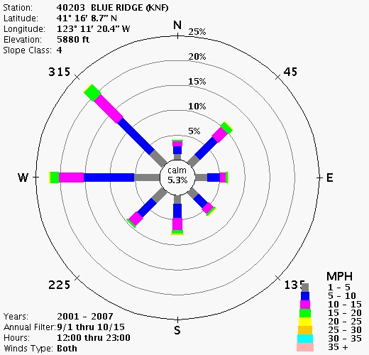

FsPro Winds Annotations
No FsPro Winds Annotations exist.

FSPro Landscape

Upper Left Latitude: | 41.7652 | Upper Left Longitude: | 124.1345
Lower Right Latitude: | 41.2604 | Lower Right Longitude: | 123.4345
Fuel Model: | Fuel Model 40

FsPro Landscape Annotations
No FsPro Landscape Annotations exist.

FSPro Landscape Editor

Attribute | Rule Description
Fuel Model | If (LCP intersects salm_riv) Set Fuel Model to 98
Fuel Model | Else If (Fuel Model is 144 or 146) AND (Elevation >= 1500) Set Fuel Model to 142
Fuel Model | Else If (LCP intersects 2005-2007 fires) Set Fuel Model to 181
Fuel Model | Else If (Fuel Model is 102) AND (Elevation >= 1500) Set Fuel Model to 101

Landscape Editor Annotations
No Landscape Editor Annotations exist.

Analysis Log

Time (CDT) | Status | User | Comments
09/25/2008 11:37 | Assigned | Isbell, Clint | 14 day update for siskiyou Blue 2, Harington Gulch area.
09/25/2008 12:15 | Queued
09/25/2008 12:16 | In Process
09/25/2008 12:49 | Review
09/25/2008 12:56 | Complete | Isbell, Clint

