Fire Modeling

An analysis using FlamMap and FARSITE was done on a portion of the Yolla Bolly Fire.

The assumptions that supported the Gridded Wind, FARSITE, and FlamMap analyses are subject to change as conditions change. The models are only valid for the fuel and weather conditions for which they were run and for the timeframe for which they represent (August 8th, 2008 or earlier for all runs). Major wind events may occur. The head of the fire may move to new and unpredicted locations. Live fuel moisture's may change dramatically. As the fire season progresses, the decision environment will also change. Such changes and others may invalidate the assumptions underlying the initial analyses. As a result, previous risk estimates will no longer be accurate. Over time, it is essential that the assumptions underlying the risk estimates are periodically revalidated and that the simulations are re-run accordingly.

GRIDDED WINDS
What is WindNinja?
- WindNinja is an interface to a mass displacement model to simulate the mechanical influence terrain has on air flow. This technology was initially developed by the aerospace and automotive industries to simulate fluid flow around and through aircraft, automobiles, pipes, etc. These programs were modified to provide data that shows how terrain features influence wind for use by wildland fire managers.
- In layman’s term, WindNinja treats wind streams much like water. In pushing a ‘flood’ of wind across the landscape at varying windspeeds, fire managers can observe how localized terrain features cause wind speed and direction to ‘swirl’, ‘eddy’ and ‘flow’ in very localized patterns across the landscape. In steep terrain it can be particularly interesting to see how the local winds can shift 90 to 180 degrees from the dominant flow.

What does WindNinja do?
- WindNinja produces an output that shows 20 foot wind velocity and direction in raster and vector format that can be displayed on a variety of maps.
- Surface winds for an instant in time are calculated using terrain information obtained from a digital elevation model (DEM) and a user-defined upper-level wind speed and direction.

Many contemporary fire modeling programs, like FARSITE and FLAMMAP will take this gridded wind. Variegated terrain plays a very important role in channeling winds. Simulations with gridded winds assume a neutrally stable atmosphere and do not include buoyancy effects (diurnal and fire induced winds). Gridded wind is not a forecast, but a snapshot in time of what the local surface winds may be given the synoptic wind scenario.

Gridded winds were used in the FARSITE and FlamMap runs for the Yolla Bolly Fire. As the illustration below denotes, more accurate projections can be made with gridded wind.
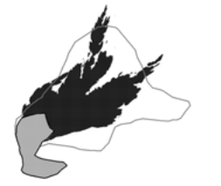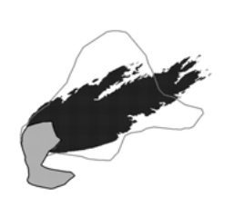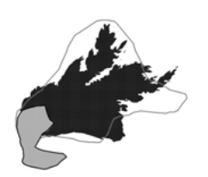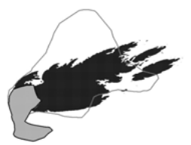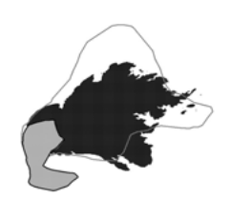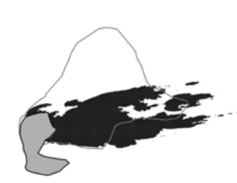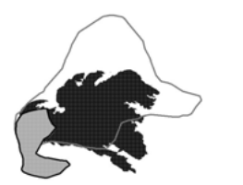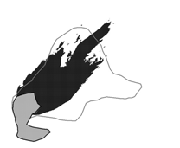
225°
240°
250°
260°
Uniform Wind
Wind Ninja
Wind Direction
From Jason M. Forthofer’s Master’s Thesis, MODELING WIND IN COMPLEX TERRAIN FOR USE IN FIRE SPREAD PREDICTION.

FARSITE
What is FARSITE?
- FARSITE – Fire Area Simulator models fire perimeters and associated fire behavior (rate of spread, flame length, etc.) for a specific ignition during a user-defined time period where weather, winds, and fuel moistures are dynamic. FARSITE is unique in that it incorporates the timing of fire spread across the landscape.

What does FARSITE do?
- FARSITE simulates fire spread across a landscape using complex interactions of surface fuels, canopy fuels, topography, fuel moisture, and weather.
- FARSITE simulates a single fire event where weather, wind, and fuel moisture are dynamic.
- FARSITE does not simulate fire spread through rolling material and does not simulate diurnal, terrain-influenced winds.
- FARSITE can simulate spotting fire behavior; therefore, a different perimeter can be expected for each FARSITE run.

How does FARSITE help decision-making?
- Managers can understand what portions of a fire may grow under a variety of wind and weather scenarios (dry cold front passage v. moderate weather).
- Managers can see what day a fire may potentially breach a Management Action Point or how long it might take to get there.
- Managers can see if a Management Action Point breach is by surface fire or spotting.
- If point protection is an objective, managers can see the fire behavior expected around that point and design appropriate mitigations to protect assets.

When should FARSITE be used?
- If there is a time element needed for decision-making, FARSITE is an appropriate tool. Unlike other fire spread predictive models, FARSITE does not output a probability of an event occurring (FSPro, RERAP), but tells a manager the outcome of a specific scenario over time.
- If a manager wants to understand what the fire might do under a specific weather scenario, such as if the forecasted dry cold front materializes, FARSITE is the most appropriate tool.

FARSITE Assumptions Used for the Yolla Bolly Fire:
- Fire spread was initiated from Heat Points for the fire obtained on 8/2/08.
- An LCP file was obtained from WFDSS and is derived from the Original Landfire Landscape layer. Surface and canopy fuels were obtained from the LCP files.
- All simulations were run with crown fire enabled, embers from torching trees enabled, and 1% of embers ignited into spot fires (this is a high setting).
- Parameters used include a 30 minute time-step, 60m perimeter resolution, and 30m distance resolution.

The simulation was designed to simulate fire spread based on current and expected weather conditions.

- Forecasted weather and wind was requested from the NWS Farsite Interface to populate the model for 8/2 through 8/8. The wind file was converted to a gridded wind file (ATM) by replacing the forecast speed and direction values with the equivalent gridded wind files.
- Fuel moistures were conditioned from 7/20 through 8/2 with hourly observations from the Eel River RAWS.
- Live herbaceous fuel moistures were set to 30%, live woody was set at 60% for shrubs and 120% for timber. 1, 10, and 100 hour fuels were assigned 5%, 8%, and 12%, respectively, (these were then conditioned by the model).
- Burn period was set from 1400 to 1900.
- Simulations were run for 7 days of fire spread because that is the timeframe of a reasonably accurate fire weather forecast.
- If managers desire to understand when and where the fire will reach MAPs, the simulation could be re-run with immediate past weather, forecast weather, and a new perimeter file showing the fire’s current location.

The FARSITE Run for the Yolla Bolly fire used the forecast weather for the next 7 days beginning August 2nd. Each color contour represents the projected perimeter for that day. Gridded winds that matched the forecast windspeed and direction were used in the model.

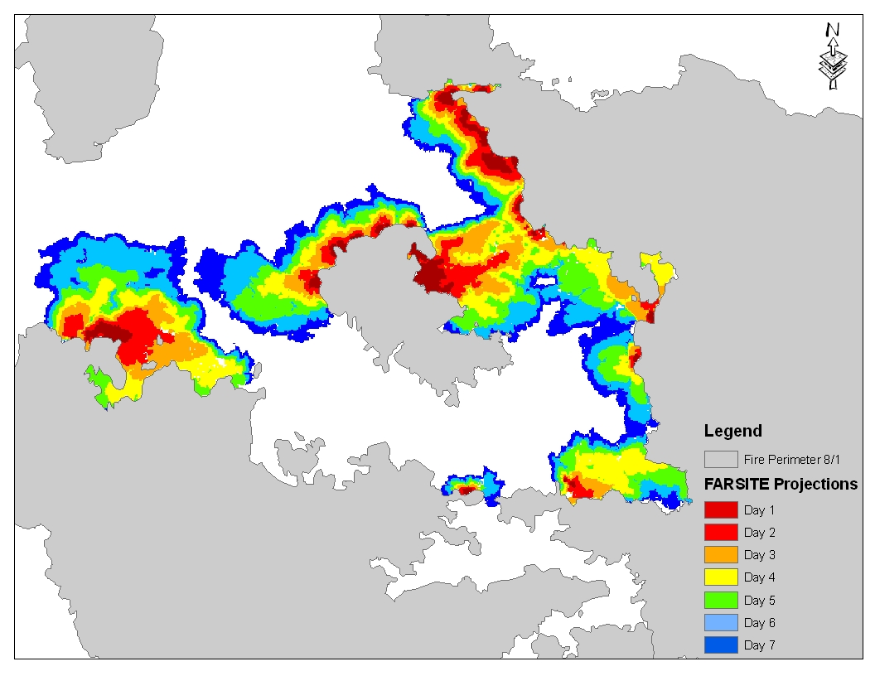

What is FlamMap?
- FlamMap computes potential fire behavior characteristics (spread rate, flame length, fireline intensity, etc.) over an entire area, using constant weather and fuel moisture conditions. A fire perimeter is not predicted because there is no time element in FlamMap.
- An additional module in FlamMap predicts fire flow pathways (MTT: Minimum Travel Time), displaying the fastest, most likely route of a fire through a landscape.

What does FlamMap do?
- FlamMap simulates fire behavior (for example, fireline intensity, flame length) for every point on a landscape using complex interactions of surface fuels, canopy fuels, topography, fuel moisture, and weather.
- FlamMap calculates fire behavior for every location, regardless of whether the fire is expected to arrive at that point.
- MTT uses the FlamMap rate of spread output to draw the fastest fire routes across the landscape. The final output shows an outer fire edge, which is the cumulative effect of several “days” of burning at the specified wind/weather condition. It is not the same as a fire perimeter simulated under constantly changing weather conditions as in FARSITE.
How does FlamMap help decision-making?
- FlamMap answers the question: if the fire arrived here under these specified conditions, how would it behave at this point? FlamMap can display potential fire behavior over a large area.
- The minimum travel time (MTT) feature displays the minimum fire spread travel paths; a manager can decide where the most appropriate “choke-point” might be for a portion of the fire.

The FlamMap Minimum Travel Time (MTT) run for the Yolla Bolly fire was made based on a 5 hour burn period for 7 days. The Black lines on the map below are the major flow paths. The colored contours represent each 5 hour interval. This run was done using 5 mph gridded wind from the west. This direction and speed were chosen because it is the dominant direction and speed on the wind rose for the Mendocino Pass RAWS used in the FSPro run for this fire. All other inputs were the same as those used for the FARSITE run.



