HEALTH AND SAFETY MESSAGE
SAFETY starts with YOU
What can go wrong will go wrong

INCIDENT: LOCKHEED | DATE: AUG 14,2009 TIME: 0700-0700
Major Hazards and Risks: Rocky /Steep Terrain, Dehydration/Fatigue, Fire Behavior / Weather (HOT ), Narrow Mountain Roads,

Fire Order of the Day – Stay ALERT, keep CALM, THINK clearly, ACT decisively .

Narrative:

DRINK WATER EARLY take frequent breaks and pace yourself, remember you are the only one that knows your limitation.

MAINTAIN L.C.E.S AT ALL TIMES.

USE CAUTION while traveling to and from Incident Base, watch your speed.

Terrain and fuels make escape to safety zones difficult. Brief all resources on locations
of escape routes and safety zones.

Watch Out Situation of the Day  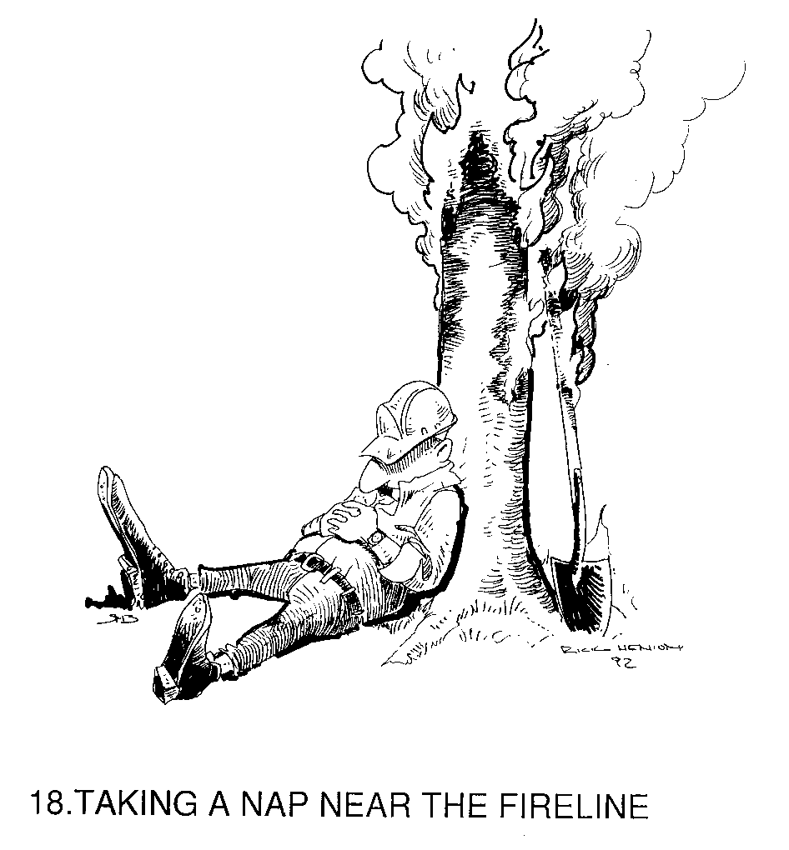 | ESCAPE ROUTES  - More than one escape route  - Avoid steep uphill escape routes  - Scouted:  -loose soils  -rocks  -vegetation  - Timed:  -slowest person  -fatigue & temperature factors  - Evaluate:  -escape time vs. rate of speed  - Marked:  -flagged for day or night  - Vehicles parked for escape

A Firefighter with good situational awareness is a safe firefighter.

Incident Safety Officer: Danny Suarez (T) Barry Parker ICT #9

