SAFETY MESSAGE
SAFETY starts with YOU
We are ALL accountable for SAFE behaviors

INCIDENT: LOCKHEED | DATE: 08/20/09 Operational Period: 0700-0700
Major Hazards and Risks: Steep Terrain, Rolling material on roadways and fire lines. Drive slow and defensively.
- Ensure your lookouts are experienced and qualified.
- Ash pots, stump holes.
- SNAGS/HAZARD TREES!!!!!!!

GENERAL SAFETY MESSAGE: Do not get complacent stay alert at all times. All crews should receive a safety briefing before engaging in fire suppression and/or mop up. Document safety briefing on all 214’s.

- All Personnel on the line must be in PPE. NO EXCEPTIONS.
- Scout assigned areas prior to any work activity.
- All personnel double check communications plan to ensure safe communications.
- Safety checks on apparatus/vehicles prior to assignment and before any highway driving.
- Ensure all equipment is stored properly on all apparatus.
- Mark all Hazard Tree’s with proper hazard tape.

“No Cell Phone Use While Driving”
Watch Out Situation of the Day  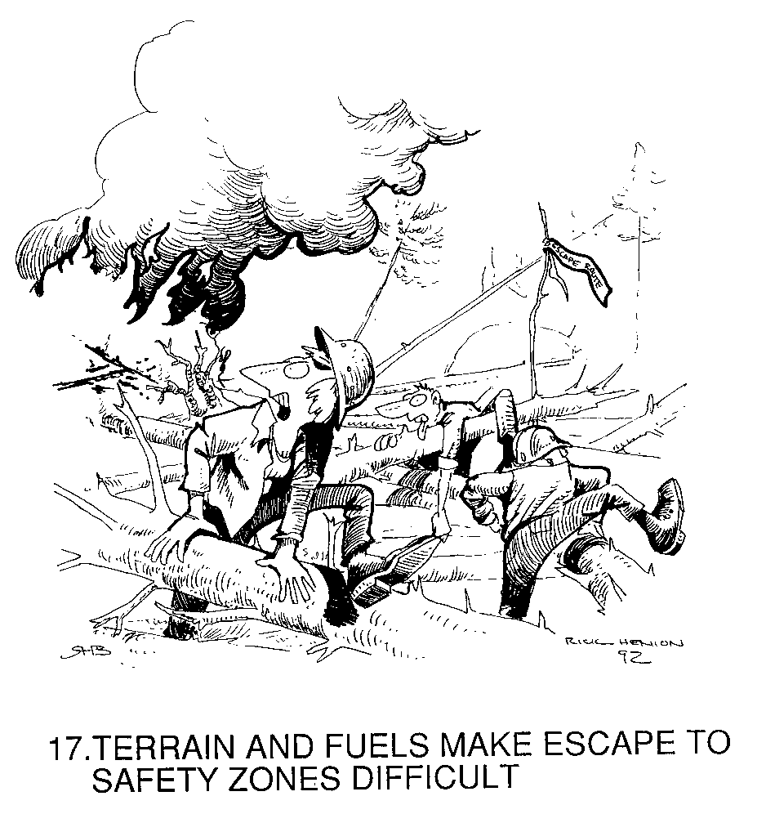 | General Safety Tips  - Check Apparatus Duals for rocks prior to leaving the line.  - Make sure all compartment doors are secured.  - Try to ensure windows/mirrors are clear of debris and dusts  - Report all injuries to your supervisor.  - Wear Seat Belts at all times
Incident Safety Officer: Danny Suarez(T) Barry Parker ICT 9

