LOCKHEED INCIDENT
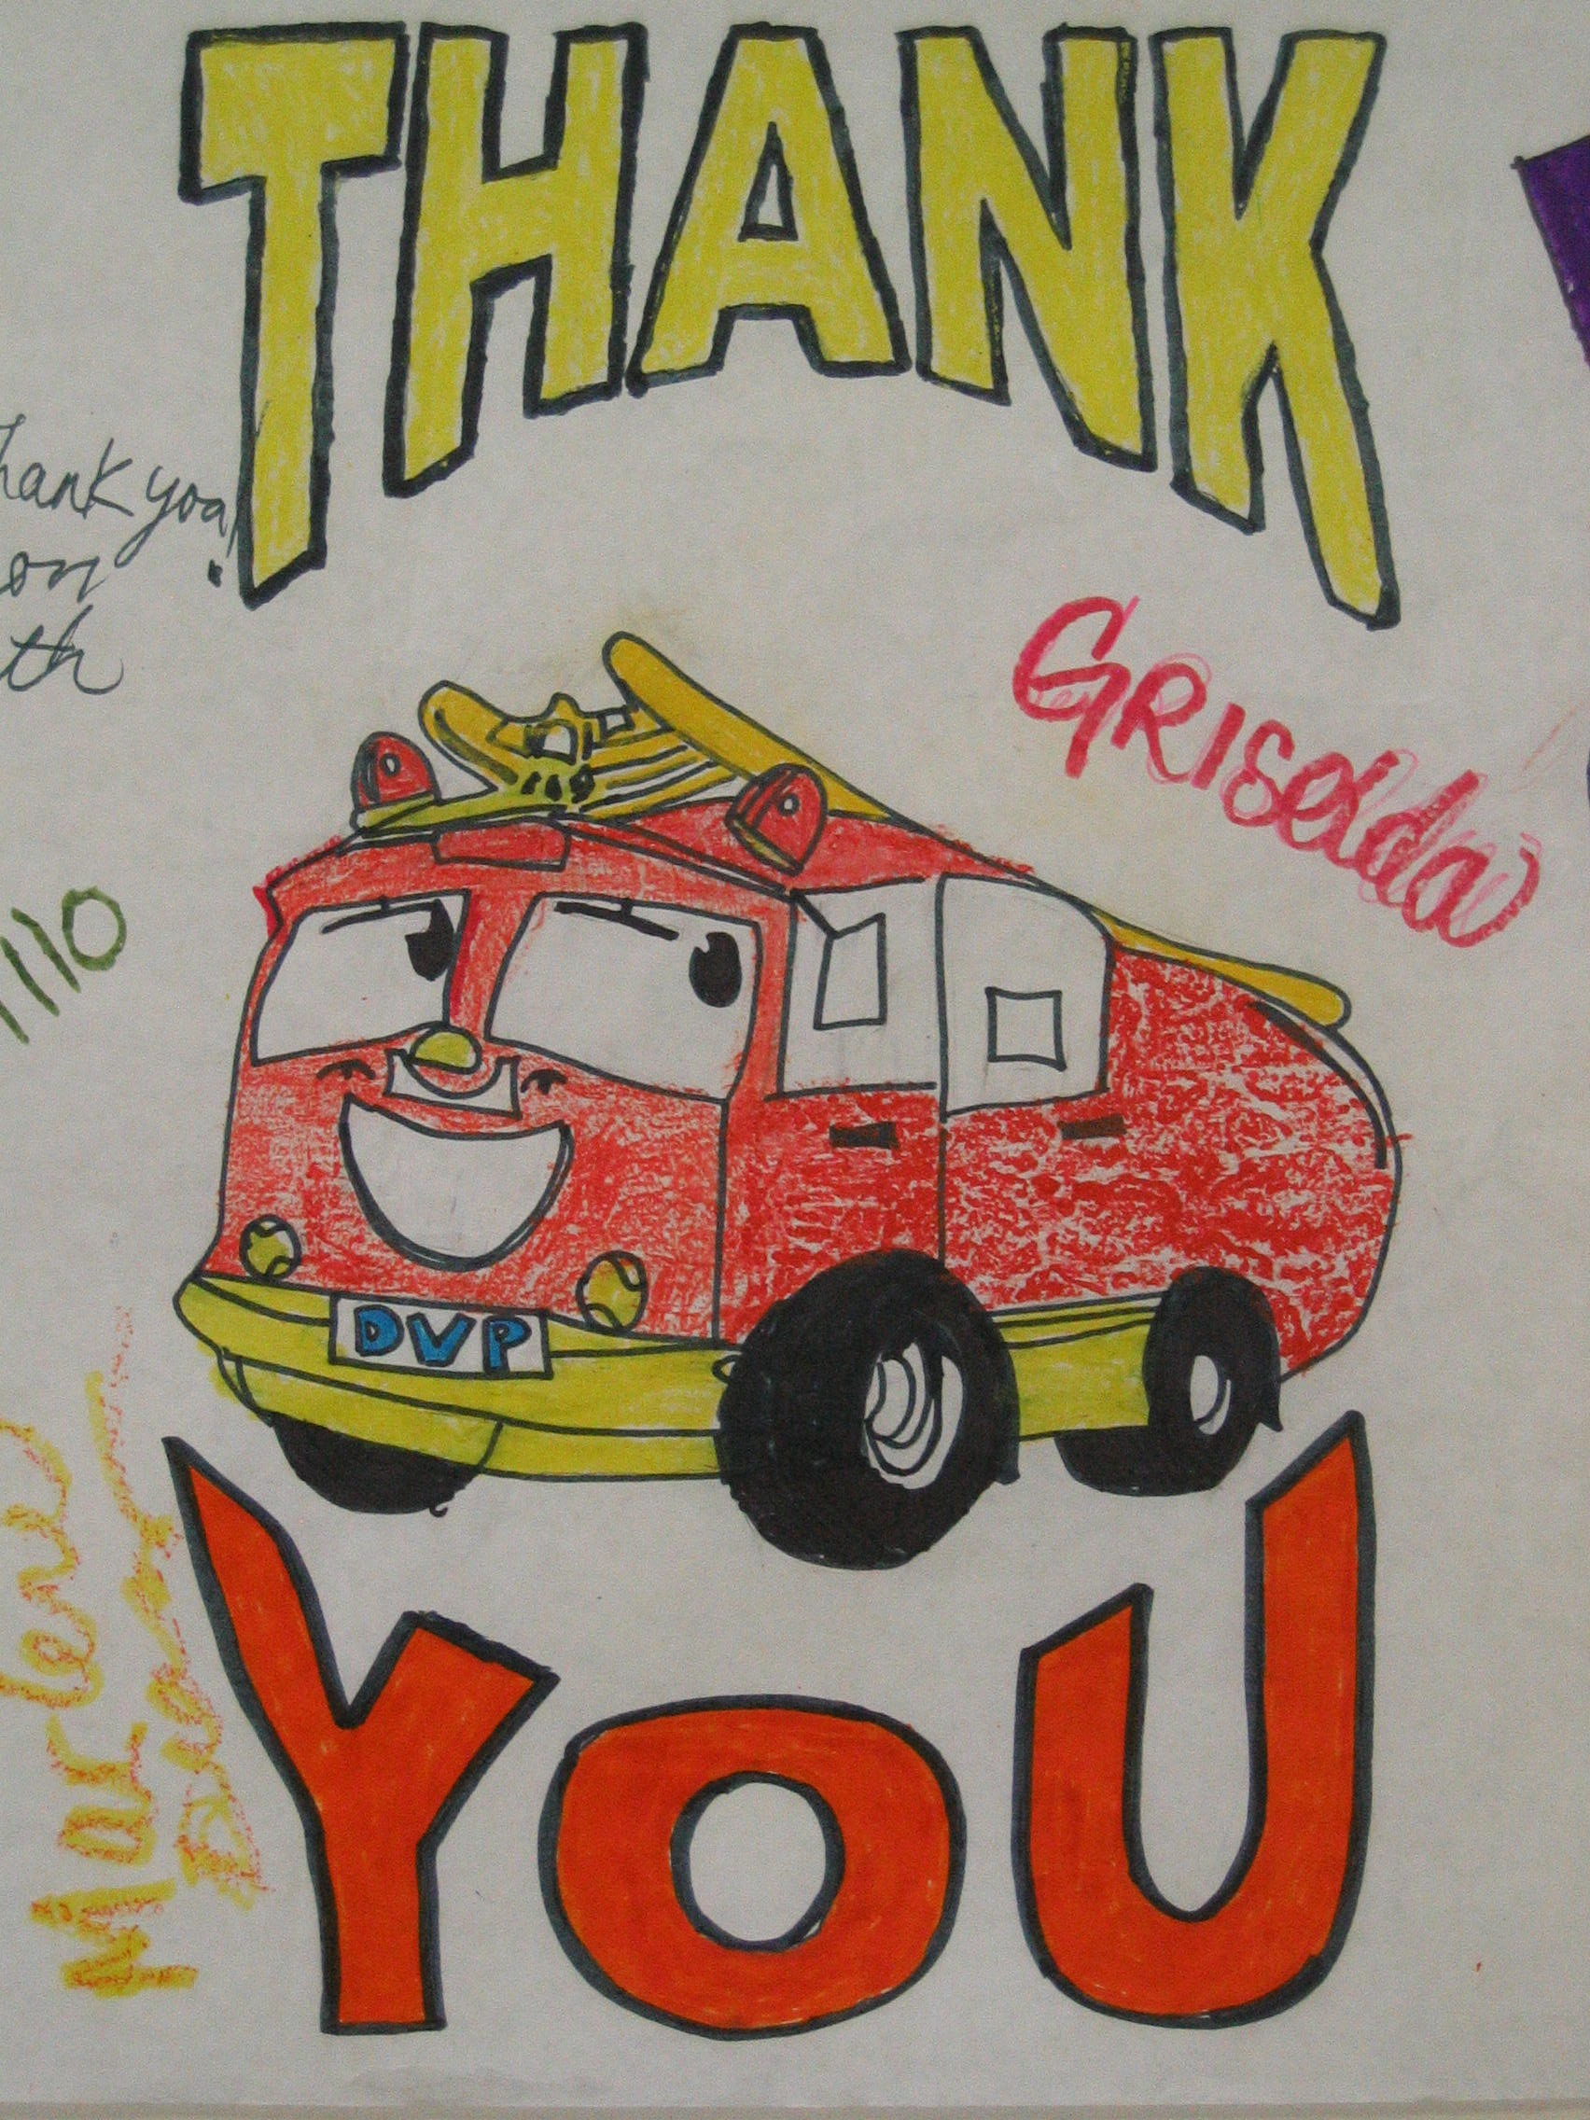

Incident Action Plan

August 21, 2009
TO

August 22, 2009
0700 – 0700 HOURS

CA-CZU-007246

