EPILOGUE

As the firefight against the thousands of fires from the June lightning siege extended into July and then into August, wildland fire managers everywhere waited for the “other shoe to drop.”

California wildland fire managers faced with both dozens of empty fire stations and major fires that still had inadequate resources to achieve timely control worried about when the normal summertime activity level of 25-75 new human-caused fires a day would kick in and overwhelm the system. It didn’t happen. Whether it was because most of the people who start fires (both accidentally and on purpose) were gainfully employed fighting the lightning fires, staying indoors out of the smoke, or on vacation in cooler climes, new wildfire activity stayed at remarkably low levels throughout the siege.

Regional wildland fire managers across the nation worried about the potential for serious outbreaks of new fires in their areas while so many of their suppression resources were assigned to the California fires. It didn’t happen. While there were indeed sporadic outbreaks of new fires in various parts of the country, most of them were randomly distributed and not of significant numbers or magnitude to overwhelm the drawn down initial attack system.

National level fire coordinators walked a thin line between giving the California fires everything that they needed and maintaining enough resources in each region to cope with expected new fires. There was potential for multiple disasters if major new wildfires started simultaneously in one or more regions. It didn’t happen. Even with an estimated 80% of all federal wildland fire suppression forces assigned to the California lightning fires, new fire outbursts were of limited number and magnitude throughout the summer. Sure, there were times when the few resources held in ready reserve had to be deployed to new fire outbreaks in lightning-plagued Nevada and Oregon, or to the drought-stricken Southeast, but overall, while the numbers of fires were near the average, the acres burned remained well below the average. This was probably the result of some combination of favorable weather conditions, increased emphasis on aggressive initial attack by fire managers with few tools left in their toolboxes, increased inter-agency cooperation due to resource drawdown, and greater public awareness of fire danger due to the extensive media coverage of the California lightning fire siege.

There were indeed a few times when new fire outbreaks meant that resources in ready reserve or R&R status had to be deployed to new fires. When the Gap Fire started on July 2nd in Santa Barbara County and became an immediate threat to densely populated areas, large numbers of fire engines assigned to structure protection duties on existing fires or held in ready reserve had to be immediately redeployed, some over large distances. Likewise, when the Summit Fire started in heavy timber in an inaccessible area near Saratoga in the San Mateo-Santa Cruz Unit (CZU) on July 15th, a heavy commitment of already scarce resources, especially aircraft, was committed to quickly contain what could easily have become another major fire. Thus it was that travelers on the freeways of Northern California were surprised to see strike teams of fire engines headed south, away from the still-raging lightning fires visible in the distant mountains. Similarly, when Washington and Oregon were hit with a spate of new lightning fires in July, precious air tankers and hand crews had to be sent north to combat this new threat.

When new lightning fires broke out simultaneously in both California and Nevada, air tankers flew the “hump” over the Sierras many times each day, mimicking the US airlift over the Himalayas into China during WWII, while contributing to successful initial attacks on new fires.

Sadly, on September 1st, one of these airtankers crashed while taking off from the Minden, NV air tanker base, enroute to a new fire in Calaveras County. Tanker 09, a P2-V operated by Neptune Aviation of Missoula, MT under a Forest Service Contract, apparently suffered a catastrophic failure of one jet engine and crashed shortly after takeoff, killing three members of the flight crew. The dead aerial firefighters were:
Gene Wahlstrom, Pilot
Greg Gonsioroski, Co-pilot
Zachary VanderGriend, Mechanic

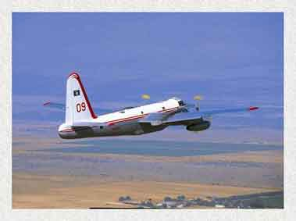
Airtanker 09, a P2-V Neptune (Neptune Aviation).

Not every new fire was successfully attacked. The Panther Fire, which started on July 24th in the Klamath National Forest southwest of the community of Happy Camp, quickly burned several hundred acres in very remote, rugged terrain. This fire would become a burden on the system and result in a fatality. The Telegraph Fire, which started on July 26th in the Merced River Canyon near Mariposa immediately jumped the river and raced through decadent fields of chaparral in two directions at once. This fire was an immediate threat to structures in the communities of Midpines, Mariposa, Bear Valley, and Mt. Bullion, and a longer term threat to Yosemite National Park. Huge numbers of local government fire engines and many airtankers were needed to keep the fire out of downtown Mariposa. The Rich Fire, which started on July 29th in the Plumas National Forest about 20 miles west of the town of Quincy, was immediately “off to the races.” Fanned by winds gusting to 30 miles per hour, the fire spread rapidly up steep slopes in heavy drought-parched fuels on both sides of the South Fork of the Feather River canyon. A new complex would be added to the already unbelievable coordination load at NorCal GACC in Redding.

The already fire plagued Shasta-Trinity National Forest, with two of the largest fire complexes in state history still burning after two months, suffered a near catastrophic event on September 7th, when two new fires started almost simultaneously in different parts of the forest under dangerous burning conditions. The Elmore Fire, along I-5 near Lakehead in Shasta County, and the Gulch Fire near Wildwood in Trinity County, seriously challenged the weakened initial attack system. Only a swift response of aircraft, local government fire engines, and handcrews and fire engines quickly diverted from their off-shift rest at other fires kept these fires from becoming new major fires.

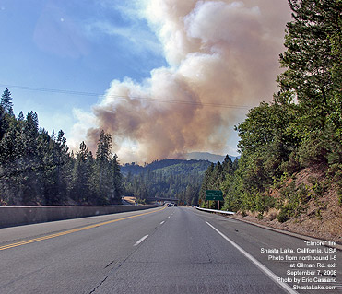
The Elmore Fire burned near I-5 north of Lake Shasta (Eric Cassano@ShastaLake.com).

As the fire season began to wind down in the fall, and the last of the fires burning in remote wilderness areas finally received wetting rain, fire managers came to the realization that, despite the magnitude of the June lightning fire siege, the fire season as a whole for California would not be quite the all-time new record of devastation that many had feared. While a spate of several major fires did occur during one period of Santa Anna winds in Southern California in November, all-in-all the fall proved to be relatively anticlimactic.

When wetting rains finally came to Northern California in late October and November, fire managers could finally relax, and, gathering around the table at coffee break, begin to contemplate the lightning siege of 2008. Several factors were identified as critical to preventing the lightning fires from becoming the totally catastrophic event that many had feared:

- Weather – Despite the fact that California was in severe drought conditions by June, and that fuel moistures and Energy Release Components were at record levels for many areas for much of the summer, the wind was less severe than normal. While there were indeed many scorching hot, bone dry summer days when fires burned actively, there were few periods of sustained high winds. Strong north winds only plagued firefighters in Northern California for about one 5-day stretch in July, with the most significant wind event being the nighttime winds down the Feather River Canyon that spread fire into the community of Concow. Many days during the summer there was not enough wind to scour out the smoke or break the canyon inversion layers. While the smoke layers hampered aerial fire operations, they also shaded the fires to some degree, reducing fire intensity. Wet thunderstorms in Southern California helped hold down several fires.

- Mutual aid – California’s statewide mutual aid system responded to the call with massive numbers of local government fire apparatus, in addition to the state’s OES fire apparatus assigned to and operated by local fire agencies. Not only did this mutual aid force fight fire, but they provided structure protection standby for days on end, and staffed otherwise vacant CAL FIRE stations for weeks. The first engines available to cover vacant CAL FIRE stations in Mendocino County were from local fire agencies in San Diego County, nearly 600 miles away. Additional fire engines were contributed by state wildland fire agencies from several western states under interstate mutual aid compacts, and even more fire engines came from all across the country under FEMA tasking.

- California National Guard (CANG) – While a small contingent of National Guard resources (primarily MAFFS air tankers, helicopters and bulldozers) is always prepared for fire assignments, the governor’s commitment of 2,000 CANG soldiers to be trained and deployed as firefighter hand crews was a record. This has not happened since 1977, and fire managers were pleasantly surprised by the performance of the National Guard fire crews. Apparently, the Guard has changed dramatically, possibly because of its commitment to overseas combat duties. Fire managers and crew supervisors repeatedly commented on the enthusiasm, willingness to work, endurance, competitive spirit, and dedication of the National Guard soldier/firefighters who made substantial contributions to the firefight.

- Contract resources – The availability of large numbers of properly equipped and trained contract wildland fire engines and handcrews contributed significantly to fire control operations. Few state fire organizations and none of the federal fire agencies are as fortunate as California, which has almost 200 inmate fire crews. Many areas must rely on contract hand crews for the dirty, tedious work of manual fireline construction and mop-up. In recent years, the Forest Service has made a concerted effort to tighten equipment standards, increase training levels, and make more frequent inspections of private contract fire resources. These engine companies and crews are now frequently capable of performing high quality work with minimal supervision, freeing up fire agency resources for the most critical suppression tasks. Unfortunately, despite these successes, one contract fire crew had several members killed in a helicopter crash.

- New technologies – The capability to use remote sensing tools such as the NASA Ikhana UAV and the National Guard RC-26 fixed-wing aircraft to provide fire managers with real-time or at least timely data on fire location and intensity behind or under the smoke screen that is impenetrable by the naked eye is a key factor in effective decision-making. The increasing computer capabilities that allow varied data sources (IR, GIS, GPS, etc.) to be combined to create a detailed picture of the wildfire that can be made available to firefighters at the scene and/or fire coordinators back in the command centers greatly improves efficiency. So does the ability to digitally/electronically track the thousands of orders for equipment, personnel, and supplies that are necessary to support fire operations. The ability to generate high quality maps on demand improves decision support, and allows better information flow to the media and to the public. New software products being developed will help improve the efficiency and provide tracking of the decision process for triaging fires and setting priorities. The disadvantages of the new technologies are that they require many highly skilled technicians as system operators and they are subject to “crashes” that interrupt the timely flow of data.

- Industrial timberland owners/operators – Not only did the timber industry provide many bulldozers, water tenders, excavators, skidgines, and fallers to the firefight, but many of the large timberland owners took independent action (while maintaining close coordination with the responsible fire agency) for fires on their lands. This allowed many more agency fire resources to concentrate on fire situations that were immediate threats to life and property, which resulted in a surprisingly low number of structures destroyed, considering the number and magnitude of the lightning fires. Many resource management personnel of the private timber companies also contributed to the suppression effort by providing line scouting, mapping, GIS, and post-incident resource rehabilitation planning services.

- FEMA – The Federal Emergency Management Agency, following the President’s disaster declaration, was able to tap a large pool of fire suppression resources from all over the country. Thus fire engines from Maine, New Jersey, and Texas and fire hand crews from Florida, Tennessee, and Minnesota were deployed to the California lightning fires. FEMA officials were cooperative, efficient, and helpful in obtaining, inspecting, and paying for many resources that were beyond the reach of CAL FIRE and the federal wildland fire agencies.
Creativity – The ability of firefighters at all levels to “think outside the box,” and come up with innovative ways to get the job done under the most difficult set of circumstances in a generation contributed greatly to the success of the firefight. The willingness of firefighters to adapt to the circumstances, whether it was 16-hour work shifts with no relief in sight, making do with what you had with you or could scrounge up, and working flexibly in support of each other regardless of agency affiliation was a major contributing factor. Whether it was borrowing a homeowner’s rototiller to scratch out a fireline, using a “grower’s” water tank and black plastic pipe to attack a fire, reorganizing city fire department engine companies into hand crews, or using their personal GPS units or ATVs to improve efficiency, the firefighters somehow got the job done. As CAL FIRE’s Northern Region Chief Bill Hoehman, a veteran of 40+ fire seasons put it: “The thing that still amazes me, after all these years, is that no matter how difficult or unusual the situation, our people just go out and make things happen. They get creative, they get innovative, and they get things done.”

So, how did the June 2008 California Lightning Siege stack up when compared to other historical fire sieges? California has suffered severe wildland fires as a result of lightning storms several times since WWII.

The 1955 siege consisted of 436 fires that started between August 27th and September 13th that burned a total of 307,113 acres. While 302 of the fires were controlled at less than ten acres, 41 of the fires grew to more than 300 acres. Surprisingly, only 59 of these fires were caused by lightning. The two biggest fires that year were the Haystack Fire on the Klamath National Forest at 87,000 acres and the Refugio Fire on the Los Padres National Forest at 75,690 acres. Despite moderate drought conditions, none of the fires exceeded 100,000 acres. A force of 18,400 firefighters use 919 fire engines, 529 bulldozers, 47 fixed wing aircraft, and 10 helicopters during this fire siege. (Editors note: Try to find 529 bulldozers in California now.)

The 1977 lightning fire siege, which started in early August, was similar to the 2008 event, in that major fires were concentrated in north and northeastern part of the state, but also with a major fire on the Monterey District of the Los Padres National Forest. The Marble-Cone fire burned 177,866 acres and was at that time the second largest wildfire in California’s recorded history. Other major lightning fires during this siege included the Pondosa and Horrs Corner fires in the Shasta-Trinity Unit (SHU), and the Eagle Lake, Scarface, and Gerig fires in the Lassen-Modoc Unit (LMU). These five major fires burned more than 456 million board feet of timber, then valued at about $70 million. During the 1977 fire siege, _____________firefighters use _______ fire engines, _______ bulldozers, ________ handcrews, and _______ aircraft to battle the fires.
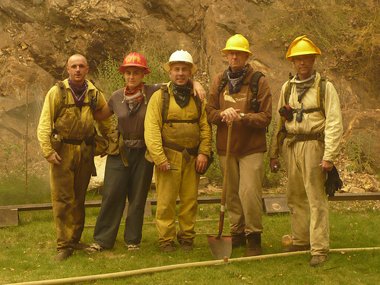
The “Tassajara Five” crew of Buddhist monks in non-traditional garb defended the mountain Zen center from the Basin Fire in a rerun of the 1977 Marble Cone Fire (Mako Voelkel).

The 1987 lightning fire siege resulted in over 1,500 fires concentrated primarily at higher elevations in the national forests of Northern California. Hardest hit were the Klamath and Stanislaus National Forests. These fires burned more than 600,000 acres.
A force of _______ firefighters, using ____ fire engines, _______ bulldozers, ______ hand crews, and _____ aircraft battled these fires for more than three months.

In 1999, lightning fires hit the Klamath, Plumas, and Shasta-Trinity national forest hard, with the Big Bar Complex on the Shasta-Trinity National Forest in Trinity County burning about 140,000 acres.

In 2001, there were more than 3,000 wildfires caused by lightning in California, but the combination of favorable fuel and weather conditions, along with readily available suppression resources kept the area burned by these fires to about 273,000 acres. This compares favorably to the Eastern Great Basin region, where 2,400 lightning fires burned more than 507,000 acres that year.

Again in 2006, lightning fires plagued the National Forests in far Northern California. Another Big Bar Complex burned more than 100,000 acres on the Shasta-Trinity National Forest. Of the 1,357 lightning fires that year, 237 fires burned 94,181 acres in CAL FIRE’s direct protection area. The remaining 1,120 fires in the federal DPA burned 104,705 acres. The big lightning siege of 2006 was in the Northern Rockies, Eastern Great Basin, and Western Great Basin regions where more than 5,000 lightning fires burned more than 3,300,000 acres.

While large numbers of lightning fires certainly present significant potential, the fire numbers and acres burned don’t necessarily match up, as fuel and weather conditions at the time of the lightning event can vary greatly. For example, in 2004, there were 11,384 lightning fires nationwide that burned 7,011,023 acres. In 2005, some 3,000 fewer lightning fires burned 150,000 more acres. In this century, the largest number of lightning fires (16,165) occurred in 2006, but the greatest area burned by lightning fires (7,168,062 acres) was in 2005. The largest number of lightning fires recently in California occurred in 2001, when 3,070 fires burned only 322,667 acres.

The June 2008 California Lightning Fire Siege was unique in that, even though it occurred in June, the burning conditions were more like those of a typical August, due to the effects of drought. Another unique aspect was that the storms on June 2nd remained relatively stationary, concentrating large numbers of wildfires in a relatively small region (Mendocino, Humboldt, Butte, Tehama, Shasta, Trinity, and Lassen counties). These fires were spread over a wide range of elevations, from the Sacramento Valley floor all the way up to the high country wilderness of the Trinity Alps, generously scattering fires about both state and federal protection areas simultaneously. Especially at the lower elevations, these fires had tremendous potential for large fire development and exhibited high resistance to control efforts. Only the lack of long-term high wind events prevented this siege from becoming catastrophic.

As the fires came under containment, repair and rehabilitation efforts got underway. On the state side, State Emergency Assessment Teams (SEATs) coordinated by the Office of Emergency Services were tasked under the Governor’s Executive Order S-07-08 “…to facilitate the mitigation of the effects of the fires and the environmental restoration of the affected areas.” Each team was comprised of combinations of geologists, hydrologists, soil scientists, archaeologists, foresters, GIS technicians, wildlife and fisheries biologists, and civil engineers. During their 14-day emergency assignment, the teams developed plans and implemented actions for rapid post-fire watershed assessment and recovery operations to:
- Identify on-site and downstream threats to public health and safety from landslides, mudslides, debris torrents, flooding, damaged infrastructure (e.g. roads and bridges), and other public safety hazards resulting from the fires.
- Identify impacts and threats to: soil productivity from erosion, impaired water quality, wildlife/fisheries habitat, native plant species, and prehistoric and cultural resources.
- Develop a report and recommendations for local jurisdictions to be used to guide implementation of timely mitigation of potential impacts.

SEAT specialists conducted rapid surveys on burned areas to determine if emergency rehabilitation treatment was needed to minimize the risk of threats to life and property. These surveys were used in conjunction with other relevant, reliable sources of information to assess if emergency rehabilitation treatment was needed. Each report contained data and maps to help local officials quickly identify threatened areas.

The recommendations found in each SEAT report fell into one of two broad categories: treatments considered temporary (short-term) measures designed as inexpensive “quick fixes”; and long-term treatments designed to facilitate the recovery of entire watersheds while concurrently minimizing the exposure of the values at risk to the threats identified.
Commonly identified threats identified included: increased risk of in-channel flooding; debris torrents; mudslides; landslides; and rock falls. In addition, manmade structures such as pedestrian bridges, homes, commercial buildings, highway bridges, roads and public gathering places were identified as at risk in several locations. Many of these structures were located within the confluence of natural drainages, near areas of natural instability that were further weakened by the loss of vegetation, or predisposed to mass movement from hydrophobic soils created by the fires.

The final SEAT reports for the 2008 fire siege can be found at OES’ Hazard Mitigation website: http://hazardmitigation.oes.ca.gov/state_emergency-assessment-team.

On federal lands, Burned Area Environmental Rehabilitation (BAER) teams undertook similar tasks to determine if significant emergency threats to either human health and safety, or natural resources existed. As these areas were identified, plans were implemented alleviate emergency conditions to stabilize soil; control water, sediment, and debris movement; prevent impairment of ecosystems; and mitigate threats to life, health, property, and downstream infrastructure and natural resource values at risk. The teams were also tasked to monitor the effectiveness of the implementation measures. More information about federal BAER teams can be found at www.fs.fed.us/r5/baer.

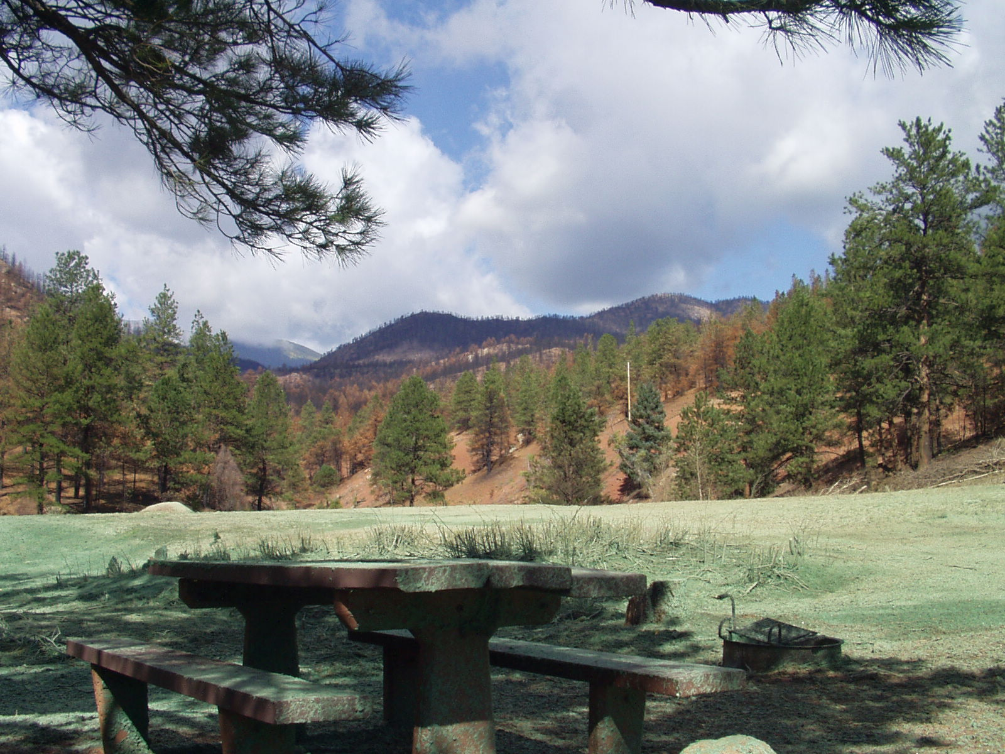
A public use area reseeded with native grasses in hydro mulch after a wildfire (Brian Weatherford)

Thus, even before the fires were out, work had begun in earnest to repair the damages caused by the fire suppression operations, to mitigate the hazards and risks associated with the fire/flood cycle, and to begin restoration of environmental quality. Additional work was quickly undertaken by private timberland owners to begin immediate salvage logging of damaged timber stands, and make repairs to logging roads and bridges.

In all cases, the state SEAT and Federal BAER teams closely coordinated their efforts with each other, with appropriate local agencies (e.g. county road departments), and with private landowners to ensure continuity of repair and rehabilitation operations across property boundaries and to achieve economies of scale. In several instances, the personnel and equipment being used by timberland owners to conduct post-fire salvage logging operations assisted the fire agencies in mitigating flare-ups inside the contained, but not yet fully controlled wildfires.

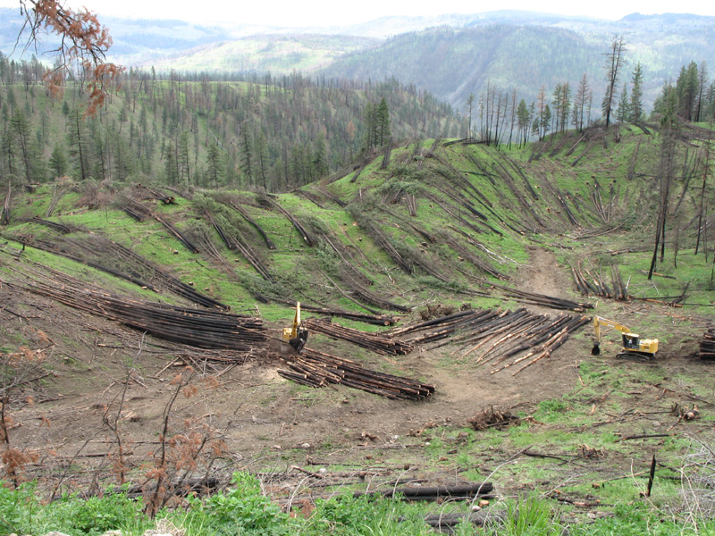
A post-fire salvage logging operation.

For additional information about the June 2008 California lightning fire siege, see:
List links to other reports.

