This DVD contains all of the GIS data, ArcMap documents (mxds) and map products generated during the Gobblers Fire incident (CA-BDF-11417), in the vicinity of Lytle Creek, CA from 8/21/2013 through 8/27/2013. This dataset was created under the direction of the Situation Unit of the Southern California Incident Management Team 1 during the suppression of the Gobblers Fire incident.
The file organization and naming conventions used in this data packet follow The National Wildland Fire Coordinating Group’s (NWCG) recommended structure delineated in the 2013 Geospatial Standard Operating Procedures (GSTOP) document. More information on the GSTOP can be found at http://www.nwcg.gov/ under the GIS section of the website. In addition, all data included in this packet was posted to the National Interagency Fire Council’s (NIFC) FTP site located at ftp://ftp.nifc.gov/Incident_Specific_Data/CALIF_S/2013_Incidents/2013_Gobblers_CA-BDF-011/GIS/
For more information contact Southern California Incident Management Team 1 lead GISS, Tracy Tennant at ttennant@fs.fed.us.

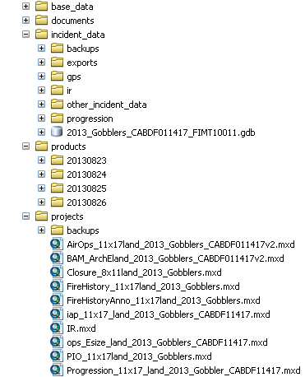
Figure 1. File structure of the DVD disc containing GIS data and products for the Gobblers Fire, August 2013.

The data structure is pictured to the left in Figure 1.
Base data: This includes topo map, hillshade and forest map backgrounds and vector-based base layers such as roads, place names, fire history, land status, and administrative boundaries, etc.
Documents: Folder containing this document.
Incident_data: Contains all incident-specific GIS data. The “backups” subfolder contains daily backups of the FIMT geodatabase files with date and time stamps. The “exports” subfolder contains daily backups of shapefile copies of the FIMT geodatabase. The “gps” subfolder stores gis data collected from field observers, resource advisors, and operations personnel – these data were used to update the status and position of the fire perimeter, dozer lines, containment line, and other operational features such as Helispots, etc. The “ir” folder contains all infrared data collected for the incident. The “progression” subfolder contains the polygon shapefiles used to generate the fire progression map. The fire grew from its start date on 8/19/2013 to its final containment size on 8/27/2013 at 413 acres. The Forest Service Update Fire Progression Tool (2013) was used to generate the fire progression dataset (shapefile named, “Gobblers_FireProgression.shp”). Data concerning aerial retardant drops, Temporary Flight Restrictions (TFR), and Forest Closure can be found in the “Other Incident Data” folder.
Products: All finished map products (pdf and/or JPG format) are arranged in dated folders, yyyymmdd for each operational period. Files with “RFS” in their name indicate “reduced file size” for ease of sharing via email.
Projects: The root of this folder contains the master copies of all ArcMap projects generated during the incident. Daily back-up copies of these ArcMap documents (mxds) are stored in the dated folders, (yyymmdd) for each operational period.

