Incident Name:  Woolsey Fire  CA-LAC-338981 | IR Interpreter(s):  Kyle Felker | Local Dispatch Phone: | Interpreted Size:  100,873 Acre  Growth last period:  1,031 Acres
Flight Time:  2046  Flight Date:  2018/11/13 | Interpreter(s) location:  Remote  Interpreter(s) Phone:  530-251-6112 | GACC IR Liaison:  Kyle Felker  GACC IR Liaison Phone:  530-251-6112 | National Coordinator:  Tom Mellin  National Coord. Phone:  505-301-8167
Ordered By:  Evan Conklin  805 813-5058 | A Number:  A -222 | Aircraft/Scanner System:  N149z/Phoenix | Pilots/Techs:  N149Z Flight Crew  Pilot: Nelson  Pilot: Netcher  Tech: Brian
IRIN Comments on imagery:  There were no issues with the imagery |  | Weather at time of flight:  Clear | Flight Objective:  Identify and map heat perimeter and Heat  Sources.
Date and Time Imagery Received by Interpreter:  2018/11/13 2055 |  | Type of media for final product:  shapefile.zip, KMZ, log and PDF  Digital files sent to:  http://ftp.nifc.gov/incident_specific_data/calif_s/!2018_Incidents/CA-LAC-338981_Woolsey
Date and Time Products Delivered to Incident:
2018/11/13 1100
Comments /notes on tonight’s mission and this interpretation:
IR Flight Box: is adequate to capture growth
Starting Perimeter was created from the incident
2018_Woolsey_CALAC338981_Event.gdb

1,031 areas of growth on the West side. South of Hidden Valley it’s the only Intense Heat tonight.
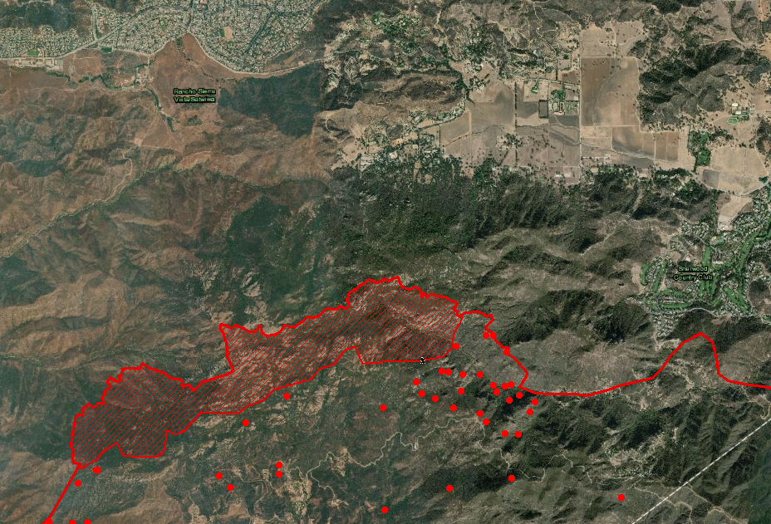

Comments, or suggestions to help improve the IR products (and my skills) are welcome. Thank you.
Kyle Felker
Infrared Interpreter
Calif R5 IR Regional Coordinator/GACC IR Liaison
mapit400@gmail.com
530 251-6112

