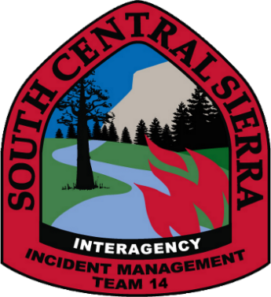

Today or in the past 24 hours, have you had any of the following symptoms?

- Cough more than expected?
- Sore throat?
- New loss of taste or smell?
- Nausea, Vomiting, or Diarrhea?
- Abnormally Short of Breath or Difficulty breathing?
- Headache, Fatigue, Congestion or runny nose, outside your normal for firefighting?

If YES to any of the above, please DO NOT enter the ICP. Please notify medical personnel immediately.

