APPENDIX A
Trails -Watershed Assessment
Basin-Indians Fire BAER

The BAER recreation and wilderness/trails assessment team combined with BAER watershed specialists (Hydrology and Soils) to develop a method for identifying sections of Forest system trails within the fire perimeter that are at risk of flood damage and could contribute to watershed degradation. Once identified, trail sections could be then be considered for suitable BAER treatments based on certain criteria and summarized.

The team and watershed specialists visited a representative trail segment within the fire area (Mount Manuel Trail, Big Sur) to assess trail conditions that would be suitable for proposed treatments. Approximately 2.5 miles of trail were observed and various trail conditions were discussed. The trail was found in an area of the fire where trail erosion potential was high. Based on observations verified in the field, a method to identify other trail sections in fire area could be developed and used the categorize/prioritize treatments by following the criteria below:

- Areas of high and moderate burn severity on slopes greater than 30%
- Reaches of trail situated below long runs of burned slopes susceptible to slope runoff concentration
- Potential for trail interception of runoff from stream channels (ephemeral, intermittent or perennial)
- Slopes with high erosion hazard and increased sediment and water yields attributed by burn severity
- Ability of trail sections to lead to off trail slope erosion and gully formation (loss of water control)

Findings

Trail sections found on steep, severely burned slopes that were in the process of being covered over with loose soil and rock (soil dry ravel) are likely to be subject to continual dry ravel effects and potential slope failures are not suitable for treatments. These sections will need to be reevaluated after the onset of severe storms the first winter season to determine future treatments. Long reaches of trail on grades greater than 10% subject to concentrations of slope wash and not subject to excessive dry ravel or slope failure are suitable for treatments.

These sites cost effective as treatments along these sections have a higher probability of success to offset post-fire runoff impacts than sections subject to excessive dry ravel deposition. Trail sections that intercept stream drainages that have an ability to intercept stream flow on the trail were identified for water control treatments in order to keep runoff off trail sections. Channels found in sites where the trail descends and ascends from the crossing were identified for no treatment.

Treatment methods include grade stabilizer structures (log or rock steps) or water control structures (rock or log waterbars, rolling dip/earth berms with armored points of drainage exit) per Forest Service trail construction standards. Stream crossings able to intercept flow can be maintained to increase the ability to pass flow, down slope berms of rock, log and soil can be placed to reduce the potential on-trail runoff.

A model was created to assist with identifying trail sections at risk using an approximation of post-fire soil erosion hazard based on steepness of slope and burned severity. A map was developed and trail treatment sections were included and prioritized by three levels, high being the highest priority, moderate, and low, shown on the map as highlighted colors (Figure 1). Using this tool, trail treatment section could be summarized and costs estimated.
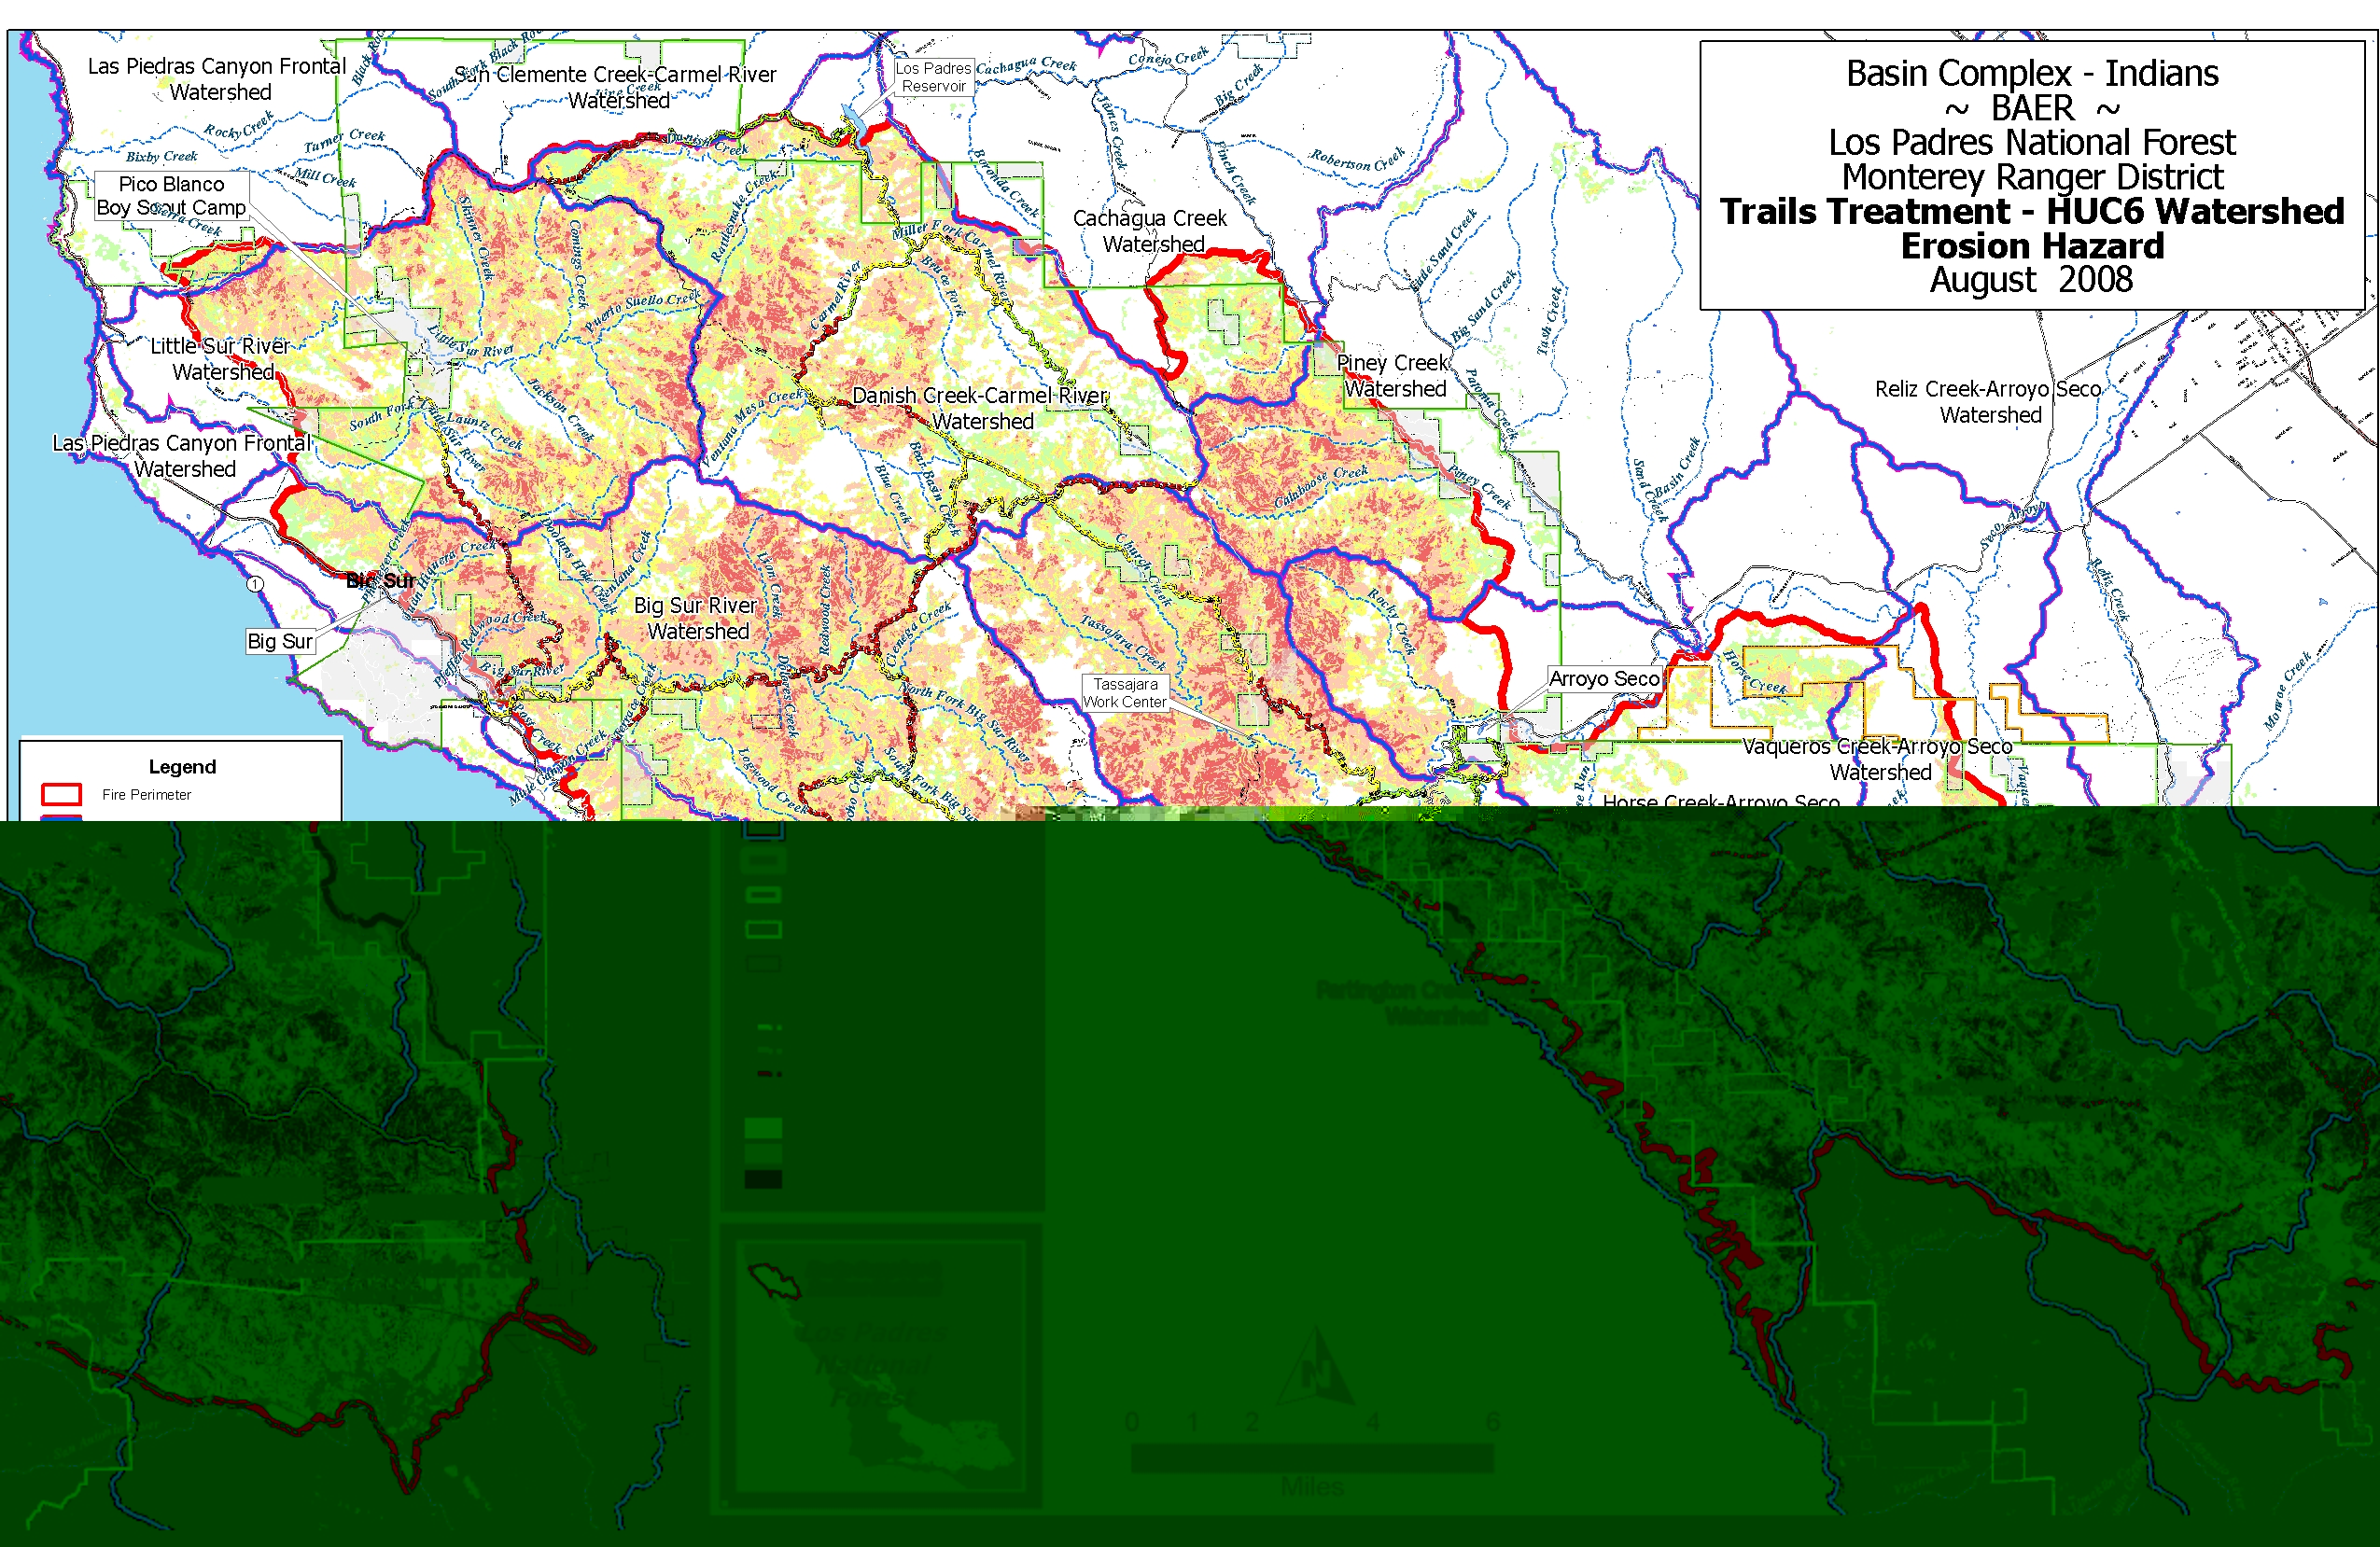

Figure 1: Trail Treatment map showing burn severity classes and identified trail sections

