Piute Fire SQF FSPro Model Calibrations

My cell phone received a voice mail from Brent Skaggs on the afternoon of Saturday 6/28/2008. I had taken a good part of the day off because WFDSS was down in the AM and Larry Hood suggested taking some time off. I checked my voice mail on Sunday morning after the 0730 South Ops conference call. Brent Skaggs said that there was a fire near Piute Peak and I should contact Judy Forbes for information on this fire. I got enough information from Judy to create an incident in WFDSS.

The first simulation’s 3 days weather was based on the forecasted wind direction, I did adjust these winds a little south but not that much. I had adjusted the winds because of Dave Bartlett’s FBAN input. The spot weather that was issued late that day seemed to support the decision to use the forecasted wind. The run was done with the following:

- The run was for 7 days with 800 fire simulations.
- Perimeter from Scott Williams’ map plus some Modus heat.
- A barrier was used along Piute Peak road then to near the top of Piute Peak. This barrier did not stop the fire because I inadvertently use an earlier perimeter that crossed this barrier.
- The FSPro analysis resulted in high probabilities of simulated fire spread to the south and southeast. At the time most of the limited feedback was that this could happen but that it would be worst case if the fire crossed the road. One of the fuel models - TL2 (182) north of the fire which has slow spread rates; this also had some effects on spread of the fire simulation to the north.
- RAVAR was done based on this FSPro run.
- Democrat RAWS was used for ERC
- Piute Peak RAWS was used for Winds.

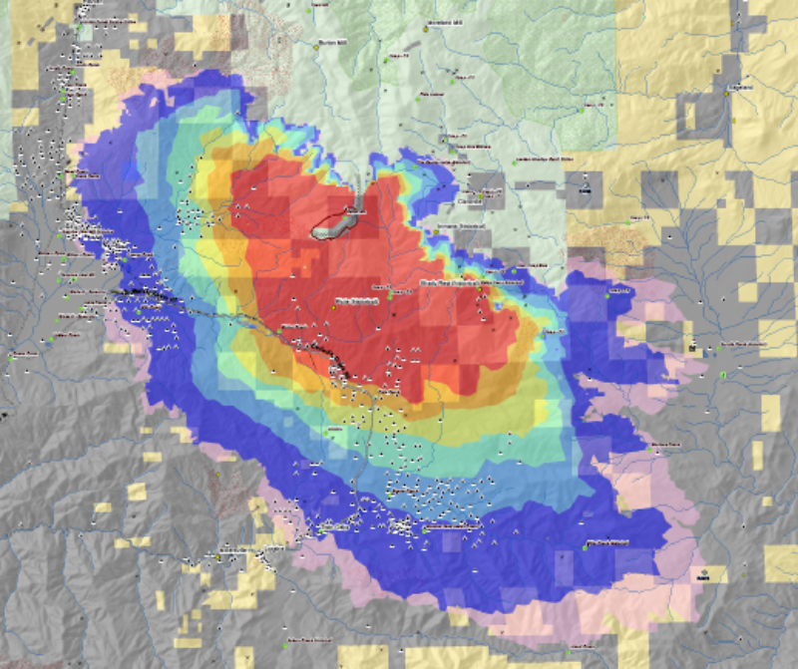

On Monday morning 6/30/08 after the 0730 South Ops conference call, I received a call from Piute Fire FBAN – Dan Ardoin who wanted some info on the FSPro run that vhad been done and he also let me know that the fire was moving north and a little east. He said the fire was mostly spreading by torching and spotting and that the wind was more out of the south. I looked at Modus heat in WFDSS and it show that the fire had moved north a few miles. Dan faxed me a perimeter map from yesterday afternoon. With this information I started another run after a few calibration runs:

- The run was for 7 days with 800 fire simulations.
- Perimeter based on yesterday’s maps and Modus heat form WFDSS.
- I increased the spotting probability in the ERC classes
- I changed the Fuel Model - Low Load Broadleaf Litter TL2 (182) to Very high Load Timber-Shrub TU5 (165) to adjust spread rates in the area north of Piute Peak to better reflect what was happening.
- Changed wind direction to south for 6/30/08, southwest for 7/1/08, and west for 7/2/08.
- Democrat RAWS was used for ERC
- Piute Peak RAWS was used for Winds. This also accounts for some of the SE fire spread in the first run. See Windrose below:
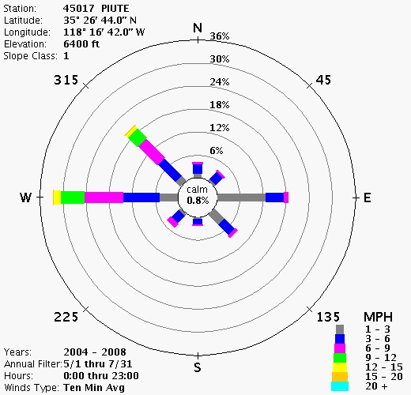
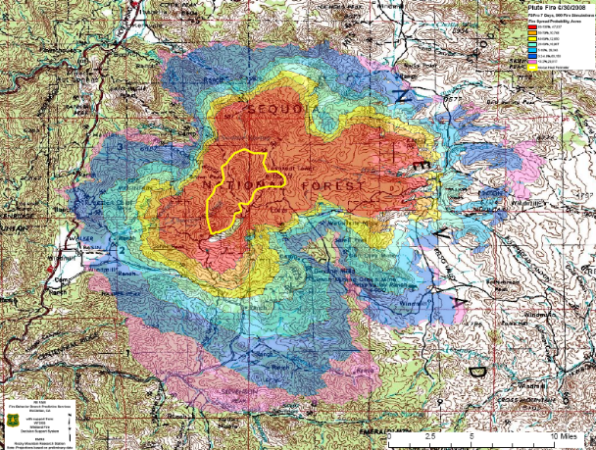
This run seems to be much better as far as modeling observed fire behavior. A word of caution is that winds are forecasted to be a little north of west by Tuesday afternoon, so if the Piute road will not hold the fire it could move more ESE.

Phil Bowden
Acting Fuels Coordinator
Pacific Southwest Region
1323 Club Drive
Vallejo CA 94592
Phone: (707) 562-8917
Cell: (916) 217-5012
McClellan Phone: (916) 640-1119

